**Smart Home Application using Arduino UNO & Node ESP8266**

**Group Members**

1. Mohamed Ahmed Galal Mohamed
2. Adham Sayed

**Table of Contents**

1. Introduction
2. Project Overview
3. Project Goals
4. Components and Resources
5. Project Implementation
6. Block Diagram
7. Simulation Schematic
8. Practical Approach
9. Challenges and Considerations
10. Future Extensions
11. Conclusion

**Introduction**

The concept of smart homes has grown in popularity due to the advancement of technology and the increasing demand for automation, security, and convenience in residential environments. This project demonstrates a simple yet comprehensive smart home system using common microcontrollers (Arduino UNO and NodeMCU ESP8266) and various sensors and output devices. This discussion will cover the key aspects of the project, its benefits, challenges, and potential extensions.

**Project Overview**

The objective of this project is to design and build a comprehensive smart home system that integrates multiple functionalities such as security, automation, and monitoring. By combining Arduino UNO for sensor control and NodeMCU ESP8266 for Wi-Fi connectivity and remote access, the project aims to create a scalable and modular smart home solution. The system will feature various sensors, relays, and user interfaces, providing a robust platform for smart home applications.

**Project Goals**

1. **Automation and Monitoring**: Implement automated control of home systems such as lighting, water pumps, and fans, with monitoring capabilities for environmental conditions like temperature, humidity, and light levels.
2. **Security and Safety**: Incorporate safety sensors (gas, flame, water) to detect potential hazards, with alarms and remote alerts for immediate response.
3. **Remote Control and Access**: Establish a web-based interface for remote monitoring and control of the smart home system, allowing users to manage their home from anywhere.

**Components and Resources**

1. **Microcontrollers**:
   * Arduino UNO for sensor integration and local control.
   * NodeMCU ESP8266 for Wi-Fi connectivity and remote control.
2. **Sensors**:
   * LDR Sensor Module for ambient light detection.
   * Gas Sensor Module for gas leak detection.
   * Flame Sensor Module for fire detection.
   * Water Sensor Module for water leak detection.
   * RTC Module for real-time clock functionality.
3. **Input / Output Devices**:
   * 1x 1-Channel Relay for controlling the Exhaust Fan.
   * 2x 2-Channel Relays for controlling lights or other appliances.
   * 16x2 LCD with I2C for system status display.
   * 4x4 Keypad for user input.
   * Buzzer for alarms.
   * LEDs for visual indicators.
4. **Power Supply**:
   * 3x 16500 Li-Ion 3.7V Batteries for portability.
   * Appropriate power sources for Arduino and NodeMCU.
5. **Communication and Connectivity**:
   * Serial communication between Arduino and NodeMCU for data exchange.
   * Wi-Fi connectivity via NodeMCU for remote control.
   * I2C communication interface to transfer the information required to the LCD to display the content.

**Project Implementation**

1. **Sensor Integration with Arduino UNO and the ESP8266**:
   * Connect the sensors to the Arduino UNO for local control and monitoring.
   * Develop code to manage sensor data and trigger relays or alarms based on sensor readings.
2. **Output Device Control**:
   * Use relays to control external devices like water pumps and lights.
   * Integrate user interaction through a keypad and LCD for local control.
3. **Communication with NodeMCU ESP8266**:
   * Establish serial communication between Arduino and NodeMCU for data transfer.
   * Build a simple web server with NodeMCU to allow remote access and control.
4. **Automation and Security Features**:
   * Implement automation logic to control lights, water pumps, etc., based on sensor readings and time schedules.
   * Integrate safety features to trigger alarms and send alerts in case of gas leaks, fire, or water leaks.

**Block Diagram**

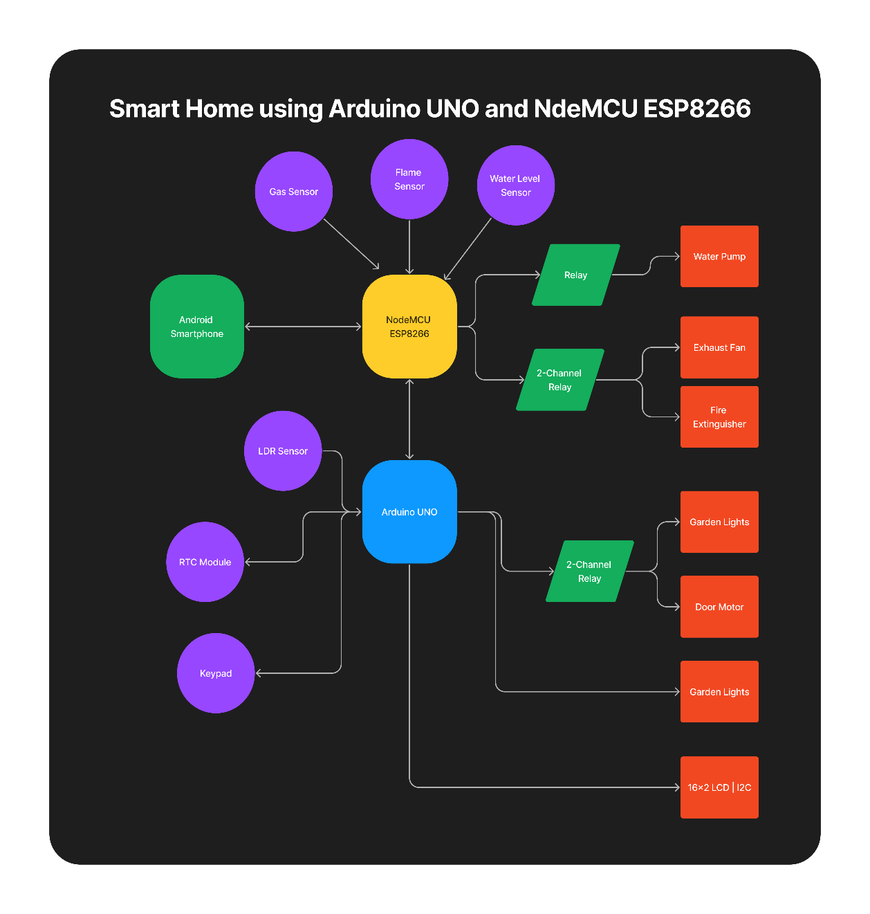

Figure 1: System Block Diagram

**Simulation Schematic**

Figure 2: Simulation Schematic Circuit Diagram

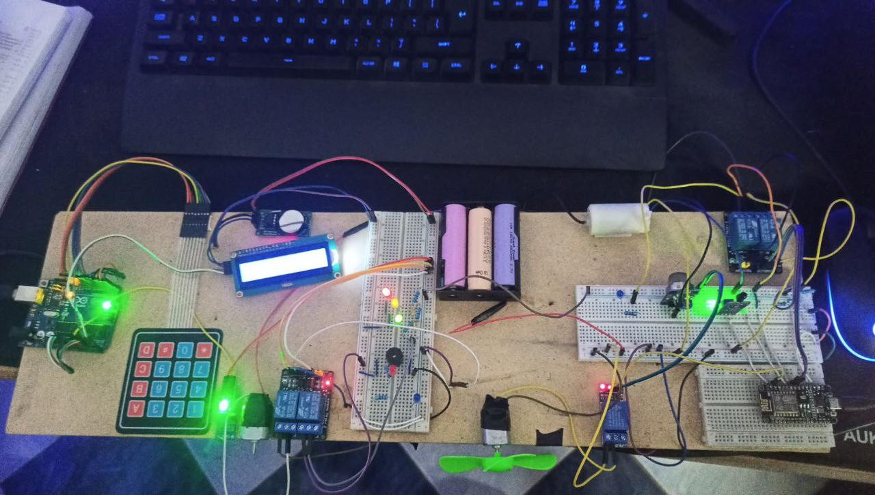**Practical Approach**

Figure 3: Practical Approach using Arduino Uno and NodeMCU ESP8266

**Challenges and Considerations**

While this project offers many benefits, there are several challenges and considerations to address:

1. **Security Risks**: Smart home systems connected to the internet can be vulnerable to hacking and unauthorized access. Secure coding practices and encryption are crucial to protect user data and control systems.
2. **Reliability**: The system must be designed for robustness, ensuring consistent operation and handling sensor or communication failures gracefully.
3. **Scalability**: As the smart home system grows, it should accommodate additional sensors, devices, and functionalities without significant redesign.

**Future Extensions**

This project can be extended in several ways:

* **Additional Sensors**: Incorporate more sensors like temperature, humidity, or motion detectors to expand the system's capabilities.
* **Integration with Smart Home Platforms**: Connect to popular platforms like Google Home or Amazon Alexa to allow voice control and broader integration with other smart home devices.
* **Advanced Automation**: Implement machine learning or artificial intelligence to enable more complex automation, such as predicting user behavior or optimizing energy usage.

**Conclusion**

This smart home project offers a comprehensive solution that combines the simplicity and versatility of Arduino with the connectivity of NodeMCU ESP8266. With integrated security and automation features, along with remote control capabilities, the project demonstrates a practical approach to building a modern smart home system.