|  |  |  |  |
| --- | --- | --- | --- |
| 1. | **Atlantic Charter** |  | 1941-Pledge signed by US president FDR and British prime minister Winston Churchill not to acquire new territory as a result of WWII and to work for peace after the war |
| 2. | **Bracero program** |  | United States labor agents recruited thousands of farm and railroad workers from Mexico. The program stimulated emigration for Mexico. |
| 3. | **D-Day** |  | (FDR) , June 6, 1944, 160,000 Allied troops landed along a 50-mile stretch of heavily-fortified French coastline to fight Nazi Germany on the beaches of Normandy, France. General Dwight D. Eisenhower called the operation a crusade in which "we will accept nothing less than full victory." More than 5,000 Ships and 13,000 aircraft supported the D-Day invasion, and by day's end on June 6, the Allies gained a foot- hold in Normandy. |
| 4. | **Development of Sonar** |  | sound navigation that measures depth and identifying objects |
| 5. | **"double-V"** |  | phrase that symbolized black attitudes during the war, victory over Germany and Japan, must be accompanied by victory over segregation in US, - In February 1942, the Pittsburgh Courier coined this phrase which came to symbolize black attitudes during the war |
| 6. | **Executive Order 8802** |  | In 1941 FDR passed it which prohibited discriminatory employment practices by fed agencies and all unions and companies engaged in war related work. It established the Fair Employment Practices Commission to enforce the new policy. |
| 7. | **Executive Order 9066** |  | 2/19/42; 112,000 Japanese-Americans forced into camps causing loss of homes & businesses, 600K more renounced citizenship; demonstrated fear of Japanese invasion |
| 8. | **Four Freedoms** |  | Declared by President FDR; 1. Freedom of speech and expression; 2. Freedom of every person to worship in his own way; 3. Freedom from want; 4. Freedom from fear |
| 9. | **GI Bill of Rights** |  | A name given to the Servicemen's Readjustment Act, a 1944 law that provided financial and educational benefits for World War II veterans. |
| 10. | **Isolationism** |  | A policy of avoiding political or military involvement with other countries |
| 11. | **Issei and Nisei** |  | 1st generation immigrants from Japan; naturalized or native-born citizens of US ; experienced racial animosity |

|  |  |  |  |
| --- | --- | --- | --- |
| 12. | **Korematsu vs. United States** |  | 1944 Supreme Court case where the Supreme Court upheld the order providing for the relocation of Japaneese Americans. It was not until 1988 that Congress formally apologized and agreed to pay $20,000 to each survivor. |
| 13. | **Lend-Lease Act** |  | 1941 law that authorized the president to aid any nation whose defense he believed was vital to American security |
| 14. | **Manhattan Project** |  | code name for the secret United States project set up in 1942 to develop atomic bombs for use in World War II |
| 15. | **Nye committee and Neutrality Acts** |  | Senate hearings in 1934-1935 headed by Gerald P. Nye of North Dakota revealed that international bankers and arms exporters had pressed the Wilson administration to enter that war and had profited handsomely from it. / Beginning in 1935, lawmakers passed a series of Neutrality Acts that banned travel on belligerents' ships and the sale of arms to countries at war. |
| 16. | **Yalta conference** |  | 1945 Meeting with US president FDR, British Prime Minister(PM) Winston Churchill, and and Soviet Leader Stalin during WWII to plan for post-war |
| 12. | **Holocaust** |  | Hitler embarked on the final solution the mass extermination of undesirable peoples Slavs, gypsies, homosexuals, and, above all, Jews. By 1945, 6 million Jewish men, women, and children had died in Nazi death camps. |
| 7. | **Executive Order 8802** |  | This order banned discrimination in defense jobs and established a Fair Employment Practices Commission (FEPC) to monitor compliance. |
| 8. | **Executive Order 9066** |  | Promulgated in February 1942, this ordered the expulsion of all persons of Japanese descent from the West Coast. |
| 16. | **Manhattan Project** |  | Code name for the U.S. effort during World War II to produce the atomic bomb. Much of the early research was done in New York City by refugee physicists in the United States. |
| 16. | **Bretton Woods conference** |  | 1944, (FDR) , The common name for the United Nations Monetary and Financial Conference held in New Hampshire, 44 nations at war with the Axis powers met to create a world bank to stabilize international currency, increase investment in under-developed areas, and speed the economic recovery of Europe. |

17 **Second great migration** In the context of the 20th-century history of the United States, the Second Great Migration was the migration of more than 5 million African Americans from the South to the Northeast, Midwest, and West. It began in 1940, through World War II, and lasted until 1970.

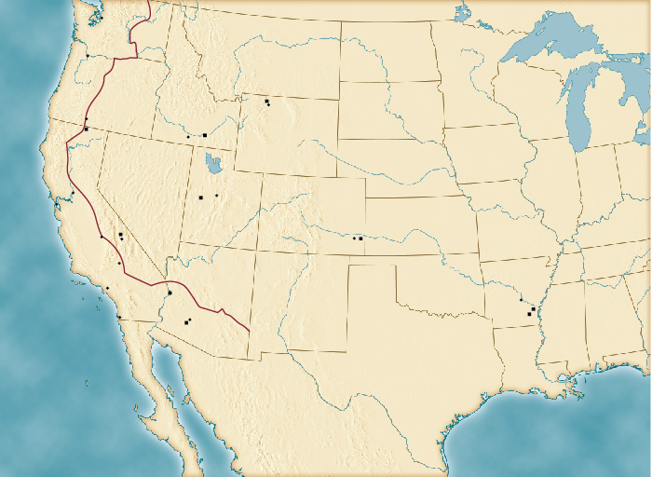

**Japanese-American Internment, 1942-45**

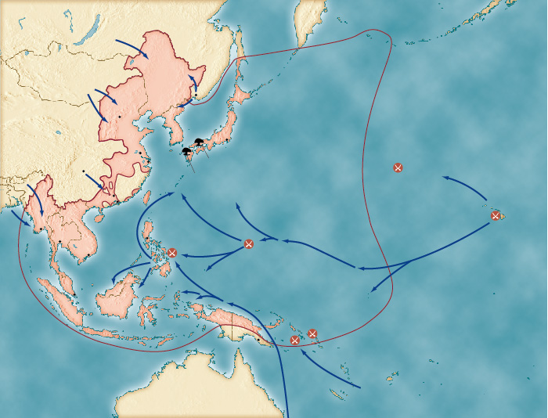

**japan**