Software Requirements
Specification

for

Auction System

Contents:

1 | Introduction
2 | Functional and non functional requirements
6 | Class diagram
7 | Block diagram
8 | Activity diagram
11 | DFD
15 | Sequence Diagram
17 | Use case

1.0 Introduction

- the following section provides an overview of the software requirements specification (SRS) for the Auction System and description of the whole system idea

1.1 Purpose

- The purpose of SRS is to determine the functional and non functional requirements(NFR) of Auction system .also the document provides an overall description about the auction system with UML analysis models and diagrams .

1.2 Scope

-the Auction system is a web Application which enables customers [bidder-product owner] to buy and sell cars by entering in auction .customer can enter auction to buy by bidding on product .the product will be solid to the highest price after a specified duration .in order to customer can add product to sell it on system . Customers can communicate with admin if there is a problem .

1.3 Actors &abbreviation including in the auction system

-

Admin system | Someone who control the whole system.
user | Someone who use application to sell something or buy .can be bidder or product owner

srs | Refers to Software requirements specifications
NFR | Refers to non functional requirements

1.4 Overview

This software will be used by the users to help them to buy or sell cars by entering them in the Auction system . the bidder who announced the highest price for a product after a specified duration will win in this Auction in buying process .the product owner can post any product to start an Auction on it.

1

1.5 General Description

-Functional Requirements

1- Sign_in

-The user and admin fill password and user name in text field and press sign in button get entered to home page by system .

2- Sign_up

- in login page The user fill his data by filling his information in text fields and press sign up to be added to system and waiting for admin confirmation to manage bid and product .

3- Logout

-The user and admin press logout button to exit from his account by system and redirect to login page

4-Add_Product

-in user homepage User can add product by pressing on add product button and he will be turned to form page to fill product information and click submit.

5-Delete_product

-in my products page user can delete any product before auction starts by pressing delete button after opening the product .

6-Bidding

-in user homepage system shows all current Auctions , user can bid by pressing on bid button .user can bid on one product only .

7- Cancel_bid

-in my product page ,user can cancel his bid by pressing cancel bid button //

8-display_products

-in my profile page , user can display all products (products which participated in it – sold product ) by pressing display products button

9-contact_us

-user can complain or asking about something by pressing contact us button in his homepage and he will be directed to page to fill text box and send button
2

10-Edit_Profile

-user can edit his profile information by pressing my profile button form user homepage.
-in admin dashboard , admin can edit his profile information by pressing my profile button.

11-Add_user

- admin can add new user from his dashboard by pressing Add user button which turns him to page to fill user information and click Add button and the added user will be activated automatically

12-delete_user

-in admin dashboard, admin can delete any user by pressing delete user button then will be turned to page to search about user by ID then press Delete button.

13-Activate_user

-in admin dashboard ,admin can show all inactive and new users by pressing activate user button then activate any user by pressing Activate button.

14-Respond_products

-in admin dashboard , admin see all pending products by pressing respond products button then he can accept or refuse if he pressed accept button will specify duration then product will be added and product owner will notified . if he pressed refuse button product will be ignored and product owner will notified.

15- Report

-in admin dashboard , admin can show a full report about all solid products and full profit by pressing report button . Report contains [ product name – id – seller – winner – price – profit ].

16 -Show_user_profile

-in admin dashboard, admin can show any user profile by pressing show user profile button then will be turned to page to search about user by ID then press show button.

- Non Functional Requirements

1- Performance

- performance requirements concerns of the speed of all operations in all software . Processed time of any operation /sec for all user /event .
1-The software should have quick responses to users inputs no more than 1 sec of time to respond
2-The software should be capable of operating with the overloading of the user inputs
3-The software shall be capable of supporting a number of active products/bids .no product /bid should be lost under any circumstance

2-Reliability

-The reliability of this system gives us the right results on different services

1-must-It is expected that more that 97% correct services
2-plan-In our plan it is expected that more than 99% of correct services
3-wish-The wished plan .100% of correct services
4-The Software system will be available 24 hours / dayz
5-Login process will take no more than 10 seconds after writing the correct username and passwords.
6-Generating schedules will take few seconds depending on connection speed.

4

3-Security

- Security requirements are included in system to ensure and manage and secure the process of accessing the system. In order to Security of the communication between the system and database

1-The access permission for system data may only be changed by the system administration .
2- All software data must be bucked up and backup copies stored in a secure location.

3-The system should have a Password authentication . The messages should be encrypted for log-in communications

4-Usability

- The software should have error massages for users and be easy to use

1-must-It is expected that more that 97% error messages .
2-plan-In our plan it is expected that more than 99% of error messages .
3-wish-The wished plan .100% of error massages .

5-Application Compatibility

The System should be compatible with an Internet connection of at least 56K and modern web browser such as Firefox, Internet Explorer, Safari and Google Chrome, regardless of what operating system that users in using.

5

1.6 Class Diagram

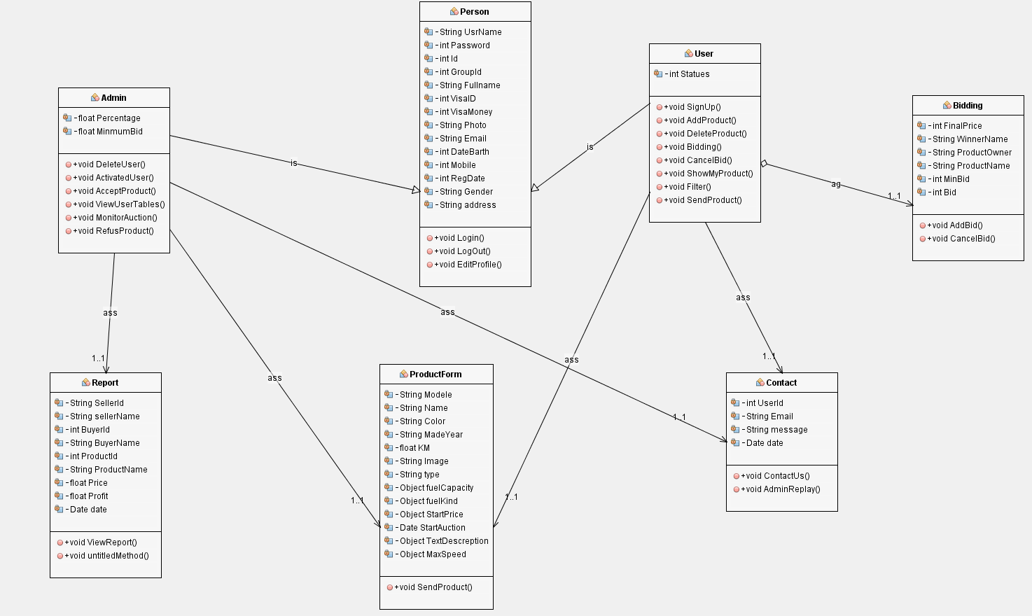

6

1.7 Block and Activity Diagram

- block diagram

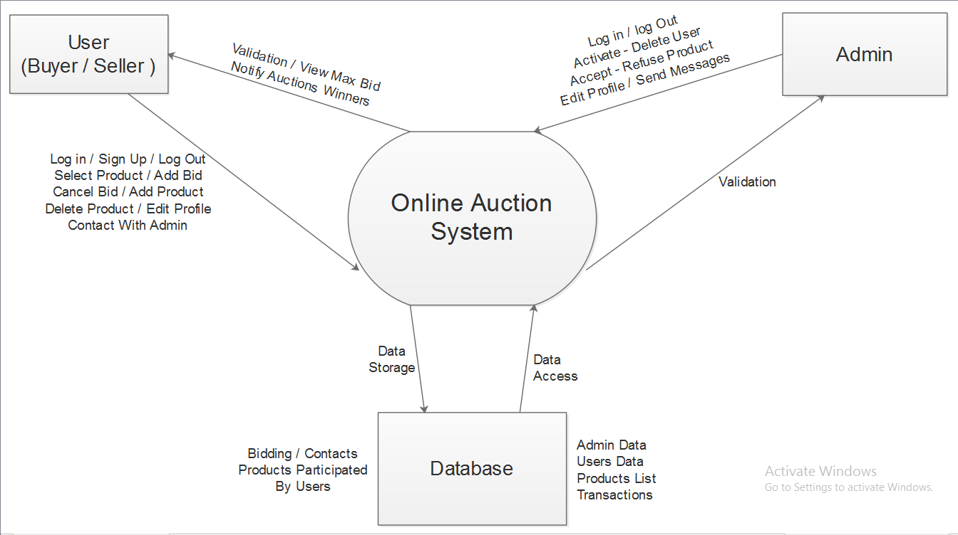

7

- Activity Diagram

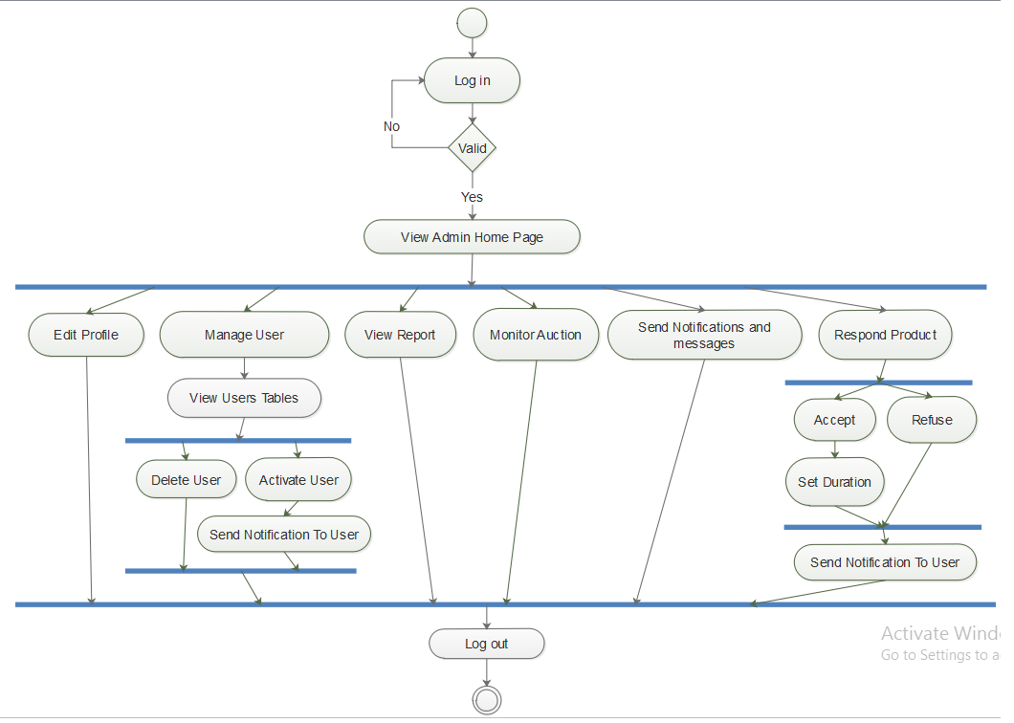

8

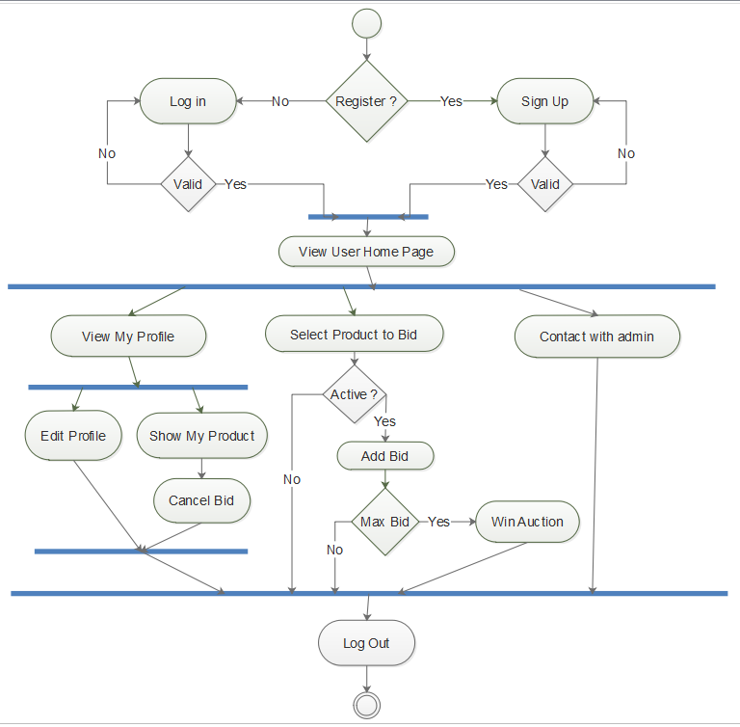

9
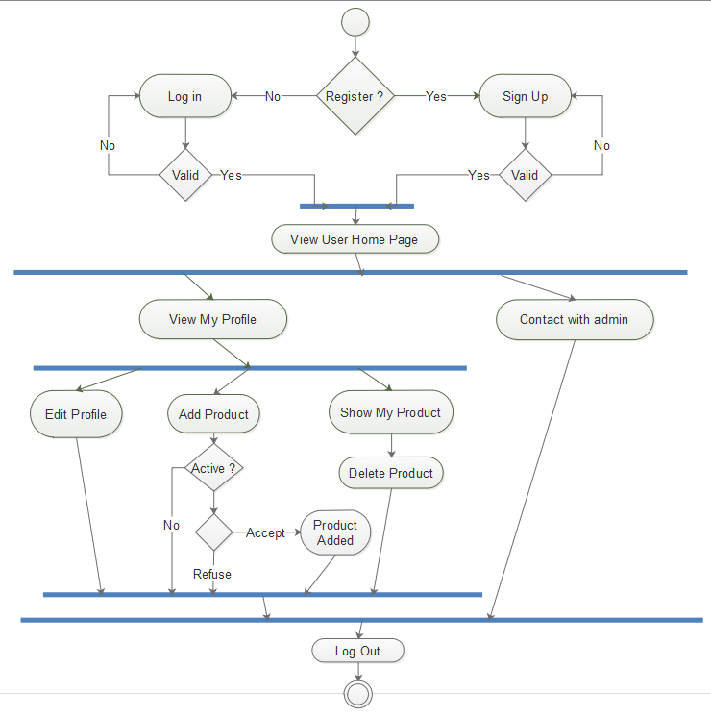

10

1.8 DFD

Table Name : persons
Primary Key : Id
Description : It Store users Detail. Admin & users
 | Column Name | Data Type | Size | Constraint
1 | Id | Int | 11 | Primary key
2 | Username | Varchar | 50 | Not null
3 | Password | Varchar | 100 | Not null
4 | Fullname | Varchar | 100 | Not null
5 | Groupid | Int | 11 | Not null
6 | Visaid | Int | 11 | Not null
7 | Visamoney | Double | 50 | Not null
8 | Photo | Varchar | 100 | Not null
9 | Email | Varchar | 100 | Not null
10 | Dateofbirth | Timestamp |  | Not null
11 | Mobil | Int | 100 | Not null
12 | Regdate | Timestamp |  | Not null
13 | Gender | Int | 11 | Not null

Table Name : users
Foreign key : id
Description : It Store just users Detail .

 | Column Name | Data Type | Size | Constraint
1 | Id | Int | 11 | forignkey
2 | Comment | Text |  | Not null
3 | Status | int | 11 | Not null
4 | Address | varchar | 255 | Not null

Table Name : Admin
Foreign key : id
Description : It Store just Admins Detail

 | Column Name | Data Type | Size | Constraint
1 | id | int | 11 | Forigren key
3 | Feedback | Text |  | Not null
4 | Percentage | double |  | Not null
5 | Profits | double |  | Not null

11
Table Name : products
Primary Key : Id
Foreign key : productownerid , productbidderid
Description : It Store Products Detail
 | Column Name | Data Type | Size | Constraint
1 | Id | int | 11 | Primary key
2 | Name | varchar | 50 | Not null
3 | Module | varchar | 50 | Not null
4 | Type | varchar | 50 | Not null
5 | Color | varchar | 50 | Not null
6 | Year | int | 11 | Not null
7 | Km | int | 11 | Not null
8 | Image | varchar | 200 | Not null
9 | Kindofdriving | int | 11 | Not null
10 | Fuelcapacity | int | 11 | Not null
11 | Fuelkind | int | 11 | Not null
12 | Describition | text |  | Not null
13 | Maxspeed | int | 11 | Not null
14 | Startbid | timestamp |  | Not null
15 | Startprice | double |  | Not null
16 | Duration | int | 11 | Not null
17 | Minbid | double |  | Not null
18 | Dateofend | timestamp |  | Not null
19 | productownerid | int | 11 | Forignkey
20 | Productbidderid | int | 11 | Forignkey
21 | Finalprice | double |  | Not null

Table Name : transaction
Primary Key : Id
Foreign key : sellerid , buyerid , productid , priceofproduct
Description : It Store just transaction Detail( detalies about product after end of auction).
 | Column Name | Data Type | Size | Constraint
1 | Id | int | 11 | primarykey
2 | Sellerid | int | 11 | foriegnkey
3 | Buyerid | int | 11 | foriegnkey
4 | Productid | int | 11 | foriegnkey
5 | Date | Timestamp | 11 | Not null
6 | Priceofproduct | double |  | Not null

Table Name : bidding
Primary Key :
Foreign key : sellerid , biddererid , productid
Description : It Store just current auction Details( detalies about product during of bidding).

 | Column Name | Data Type | Size | Constraint
1 | sellerid | int | 11 | Forgien key
2 | bidderid | int | 11 | Forgien key
3 | bidprice | double |  | Not null
4 | Productid | Int | 11 | Not null

12

Table Name : contacts
Primary Key : id
Foreign key : userid
Description : It Store messages that users sends to system.
 | Column Name | Data Type | Size | Constraint
1 | Id | int | 11 | Primary key
2 | Userid | int | 11 | Primary key
3 | Message | text |  | Not null
4 | Date | Int | 11 | Not null
5 | Email | varchar | 50 | Not null
6 | Replay | text |  | Not null

- Database Specification

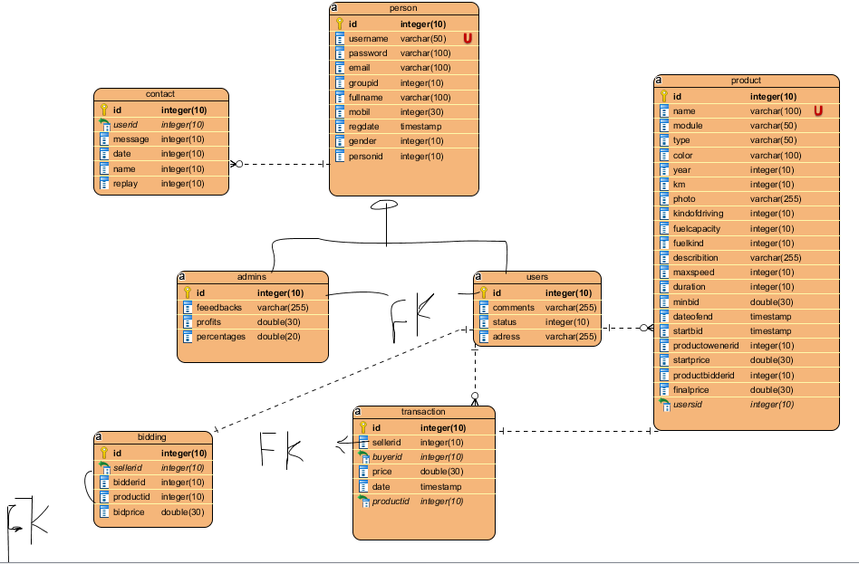

13

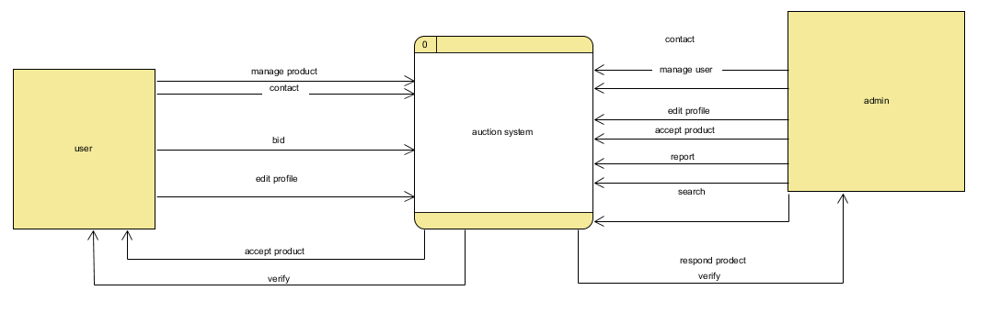
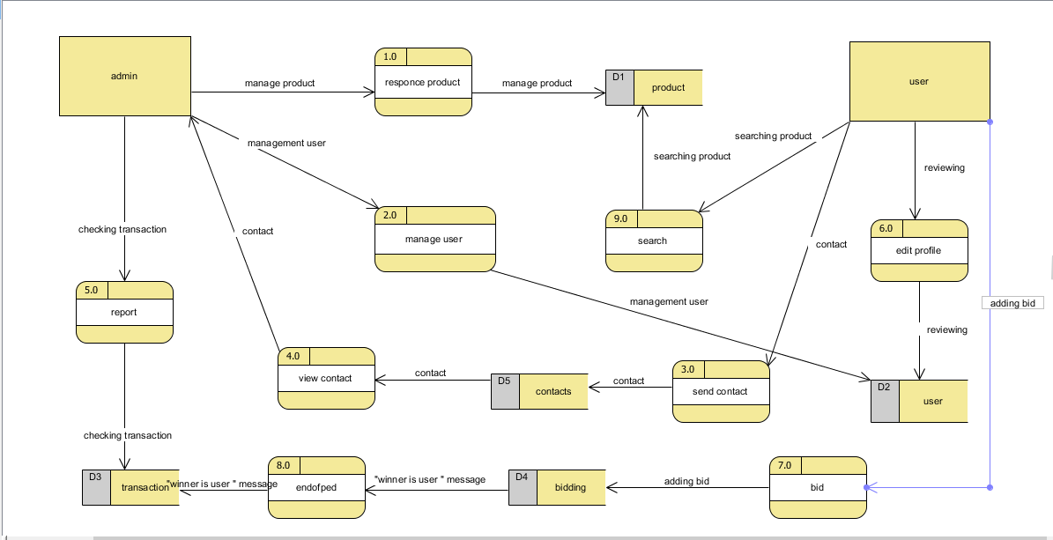

14

1.9 Sequence Diagram

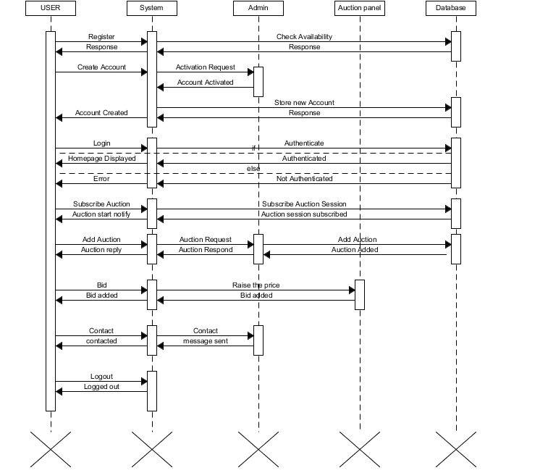

15

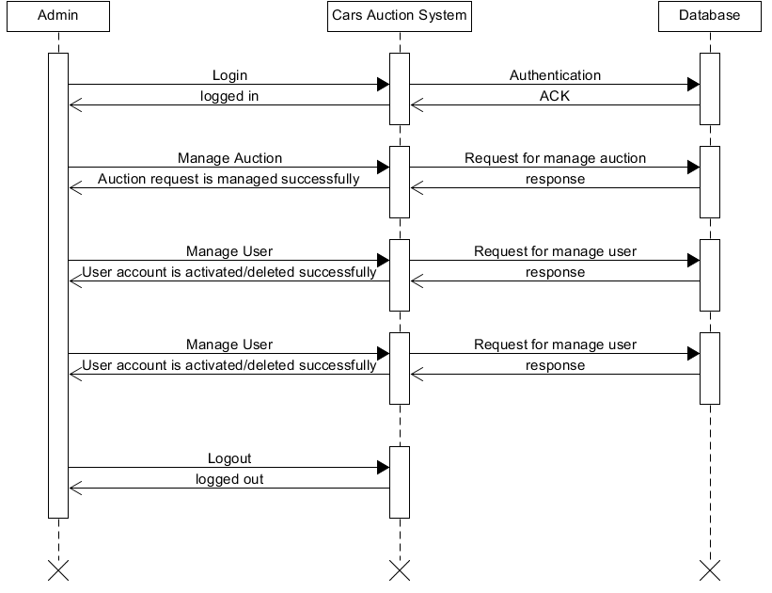

16

2.0 Use Cases Diagram

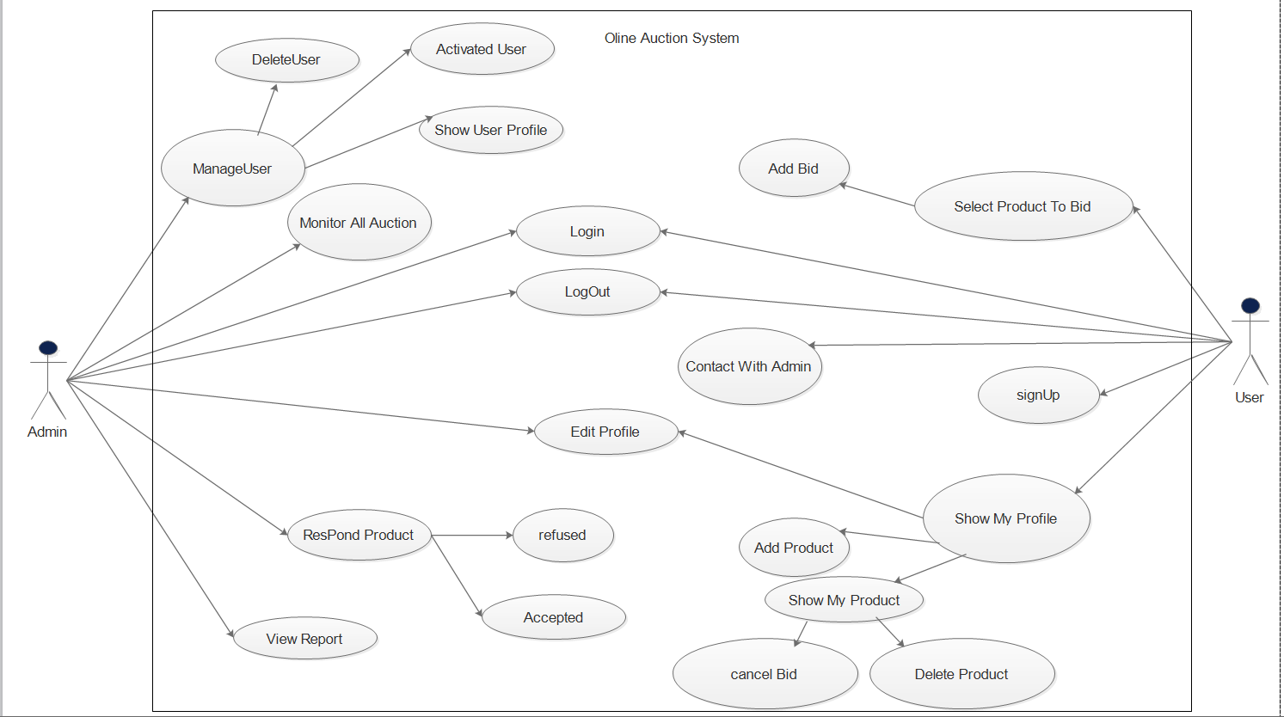
17

2.1 use cases scenario
Registration | name
User | Actors
1-The registration page allows user to provide his/her personal data (Full name, date of birth, email address, address, phone number, user ID, password, Visa ID, Visa Money).  2- The admin will send the user a notify telling him that you have been activated or not on the site.  3- If registration Accepted admin send him/her User ID allow the user to access to his/her Home page to take part to the auction and to post a new auction. | Main Success Scenario
If registration refused The user must contact the administrator | Exception

Login Page | name
User And Admin | Actors
- He/she is asked to provide his/her Username and password These are entered through a registration. If user ID and password are correct, the user is logged in and is no more asked to login throughout the session. | Main Success Scenario
Error message is raised.  - Press logout button.  - The System logs the user out and invalidates the cookie/session.  - The System redirects to the login page. | Exception

18

Logout | name
Admin, User | Actors
1- Press logout button.  2- The system redirects to the login page. | Main Success Scenario

Home page | name
User | Actors
1- Keeps track of all the items the user is presently trying to bid and are bidding in the recent.  2- From this page it is also possible to post a new auction.  3- The user can browse the auctions and selecting just one product To enter the auction.  4- There are a lot of features that will help him like (profile page ,contact us, about , filtration ) | Main Success Scenario
If faced with any problem will communicate with the admin through contact us button. | Exception

about | name
User | Actors
1-Rules must be followed to maintain the account.  2-information about website.  3-help: The system must provide help in order to explain how to perform all possible actions, such as (registering, searching items, posting an auction etc.) | Main Success Scenario

19

Filtration | name
User | Actors
1-The user can search for Product on auction by different criterions:  - Made Date.  Model.-  Kind of car.- | Main Success Scenario

Bid | name
User | Actors
1- No one can enter the bidding process until the account had activated from admin and Bids can only be placed during the auction interval.  2- It shows several features such as the maximum price reached by the auction and the name of the product.  3- System has the right to take a percentage of the total at the end of the auction. | Main Success Scenario

Post an auction | name
User | Actors
1- From his/her personal page, the user can post an auction from a specific form, providing the characteristics of the item he/she is willing to sell then send it to admin . After that he respond whether accepted or refuse.  2- The item is listed in the product list in user profile and in the home page. Other users can place a bid for it.  3- The admin will send the user a notify telling him that you have been accepted or not on the site. | Main Success Scenario

20

Change language | name
User | Actors
-The user can change from every page the language in which he/she wants to read the pages with a combo box (Italian/English). | Main Success Scenario

Contact Us | name
User | Actors
1-The user can send message to website To tell him the problems he is facing.  2- The admin will send the user a notify to answer him. | Main Success Scenario

Administrator Home Page | name
Admin | Actors
1- From the login page, providing his/her username and password, he/she can access.  2- That shows all the administration activities (Manage Auction, manage users, View Report, Monitor All Auction). | Main Success Scenario

Manage Users | name
Admin | Actors
1- The administrator can Show User Profile and show all data about users stored in the database and also delete them and activated user or refused. | Main Success Scenario

21

Manage Auction | name
Admin | Actors
-The administrator can control the new auctions posted by the user and decide whether to accept or to refuse them. | Main Success Scenario

Monitor All Auction | name
Admin | Actors
- Keeps track of all the items the user is presently trying to bid and are bidding in the recent. | Main Success Scenario

Report | Name
Admin | Actors
There is a statistical for all products containing:-  (Product name - ID Product – seller's name - buyer's name - final price – profit). | Main Success Scenario

22

Thank You

