**Exercise: Entity Framework Core**

This document defines the **exercise assignments** for the entity framework core 01.

* **Sales Database**

Create a database for storing data about sales using the Code First approach. The database should look like this:  
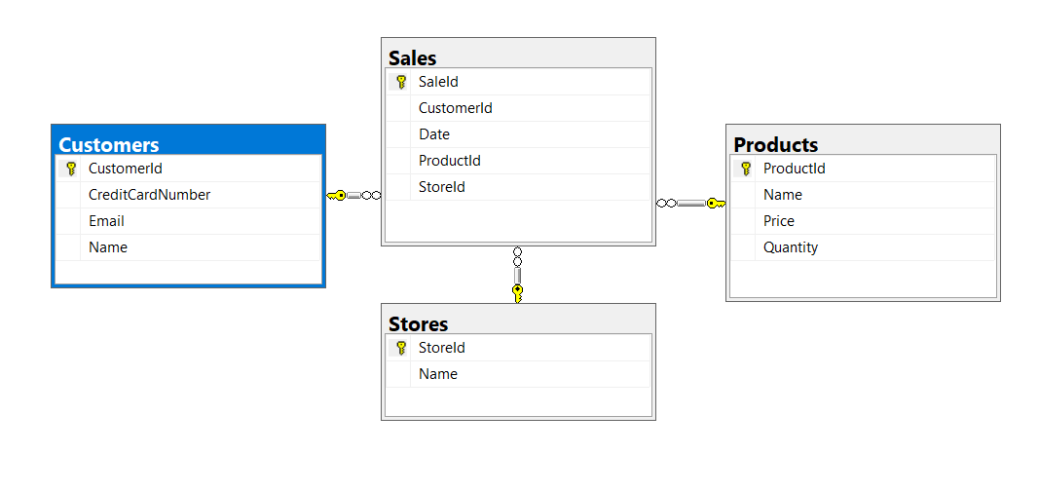  
**Constraints, Using Fluent API**

Your **namespaces** should be:

* **P01_SalesDatabase** – Project Name
* **Data** – (New folder named Data) for your DbContext
* **Models** – (New folder named Models) for your classes

Your **classes** should be:

* **ApplicationDbContext**  – your DbContext
* **Product**:
* ProductId
* Name (up to 50 characters, unicode)
* Quantity (real number)
* Price
* Sales
* **Customer**:
* CustomerId
* Name (up to 100 characters, unicode)
* Email (up to 80 characters, not unicode)
* CreaditCardNumber (string)
* Sales
* **Store**:
* StoreId
* Name (up to 80 characters, unicode)
* Sales
* **Sale**:
* SaleId
* Product
* Customer
* Store
* **Migration**

Add new migration. The migration should be named: **"InitialCreate"** **and** **run** the project.

* **Products Migration**

For table **Products** add string column **Description**, The migration should be named: **"ProductsAddColumnDescription"**.

* **Sales Migration**

For table **Sales** Add **Date** column, Name the migration “**SalesAddDateDefault**”.

* **Upload Projects**

Use GitHub to upload your project.