Create a StatefulSet named web-statefulset with 2 replicas using the nginx image.
The StatefulSet should have a Headless Service named web-service :
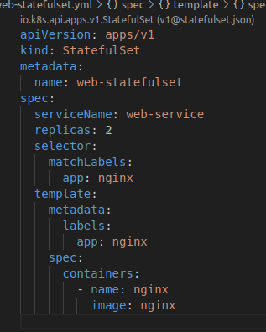

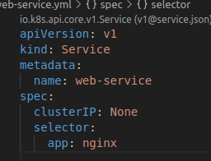

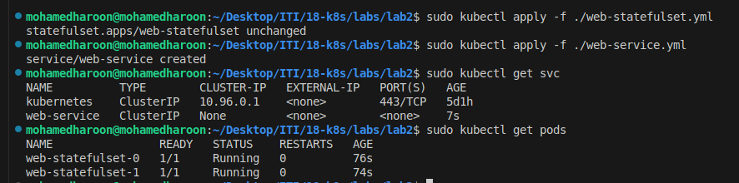
How many DaemonSets are created in the cluster in all namespaces?
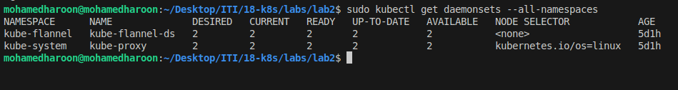
Create a DaemonSet named “nginx” with image “nginx”.
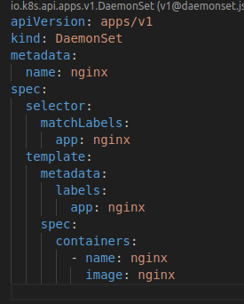

How many pods have been created within the nginx DaemonSet and why?

The number of pods created by a DaemonSet equals the number of nodes in the cluster because a DaemonSet ensures that a copy of a pod runs on each node .

Create a pod named “ingot”
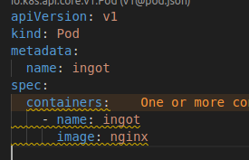

Deploy a DaemonSet for FluentD Logging. Use the given specifications.
➔ Name: elasticsearch
➔ Image: k8s.gcr.io/fluentd-elasticsearch:1.20
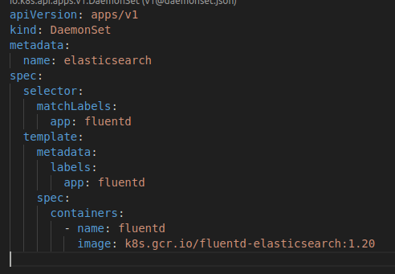

Deploy a pod named nginx-pod using the nginx:alpine image with the labels set to
tier=backend.
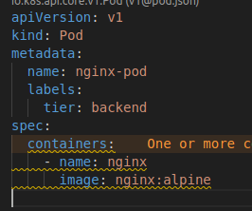

Deploy a test pod using the nginx:alpine image.
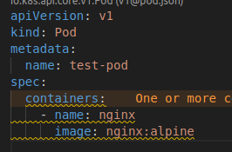

Create a service backend-service to expose the backend application within the cluster
on port 80.
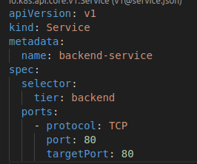

Create a deployment named web-app using the image nginx with 2 replicas What is the response?
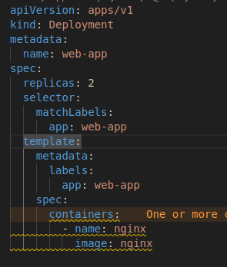

Expose the web-app as service web-app-service application on port 80 and nodeport
30082 on the nodes on the cluster
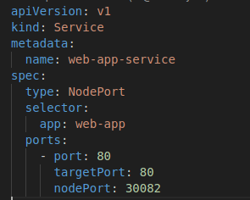

13. Access the web app from the node

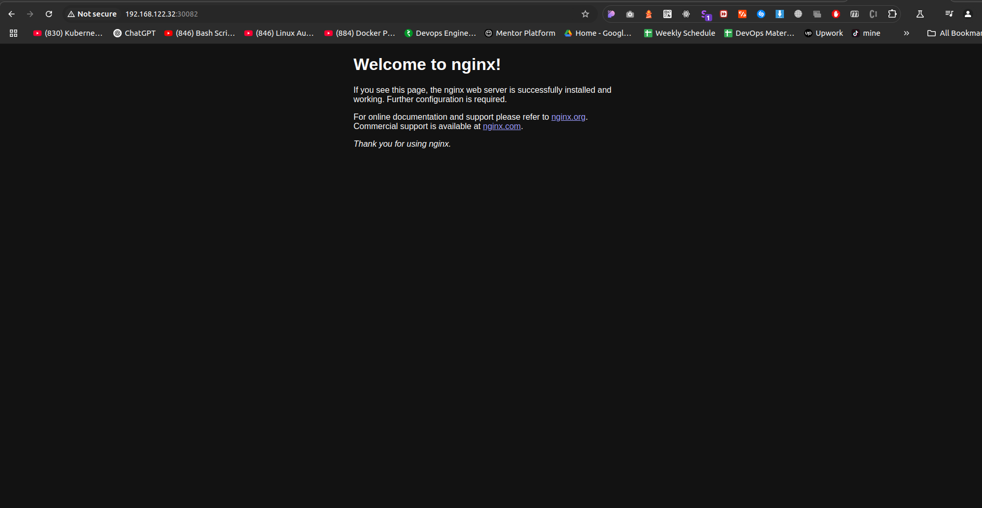

14. Cread a deployment nginx with pod labels
➔ app:nginx
➔ tier:frontend
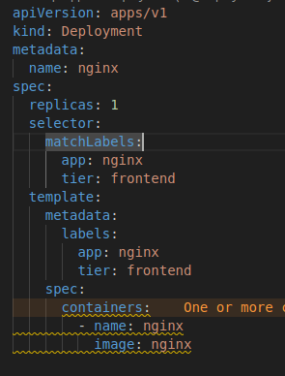

15. When can we use the Loadbalancer service?

A LoadBalancer service can be used when you want to expose your service to external clients. It requires a cloud provider that supports external load balancers .

