1. Where is the default kubeconfig file located in the current environment?
~/.kube/config
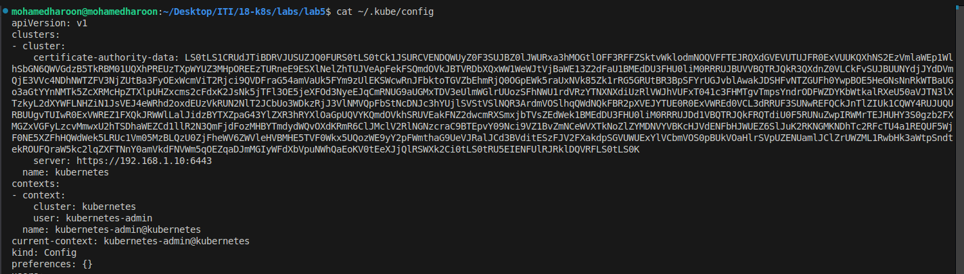

2. How many clusters are defined in the default kubeconfig
one cluster : kuberentes .
3. What is the user configured in the current context?
Kuberentes-admin .
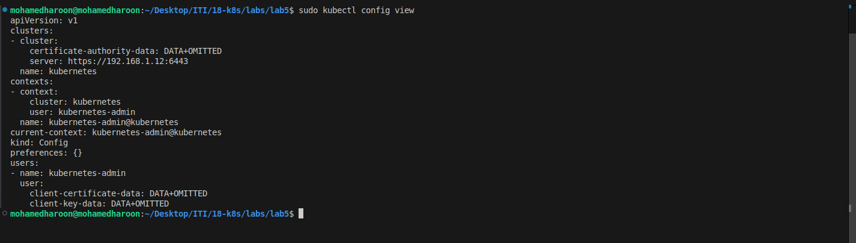
4. Create a Persistent Volume with the given specification. ➔ Volume Name: pv-log ➔
Storage: 100Mi ➔ Access Modes: ReadWriteMany ➔ Host Path: /pv/log
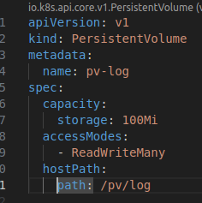

5. Create a Persistent Volume Claim with the given specification. ➔ Volume Name: claim-
log-1 ➔ Storage Request: 50Mi ➔ Access Modes: ReadWriteMany

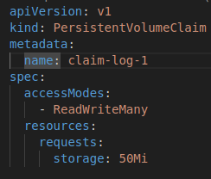

6. Create a webapp pod to use the persistent volume claim as its storage. ➔ Name:
webapp ➔ Image Name: nginx ➔ Volume: PersistentVolumeClaim=claim-log-1 ➔ Volume
Mount: /var/log/nginx
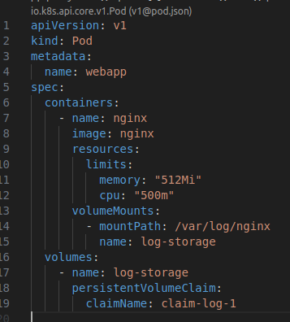

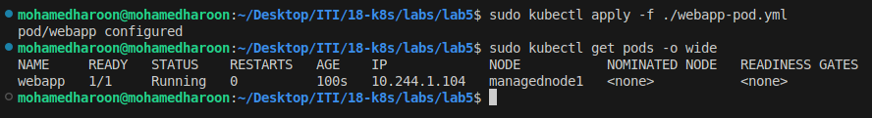

7. volume-share-datacenter pod.
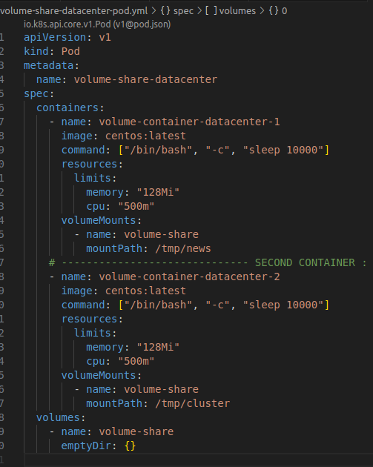

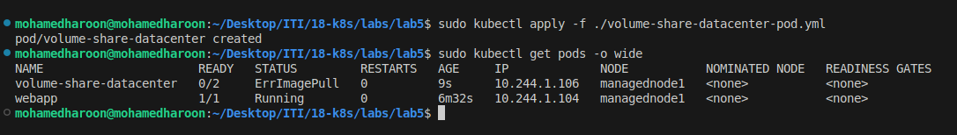

8. webserver pod
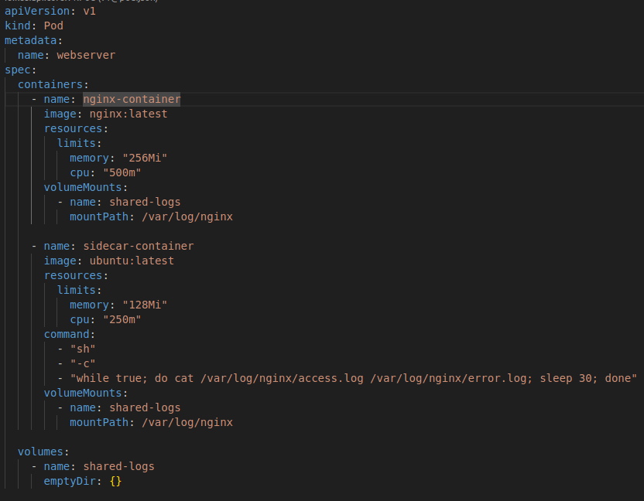

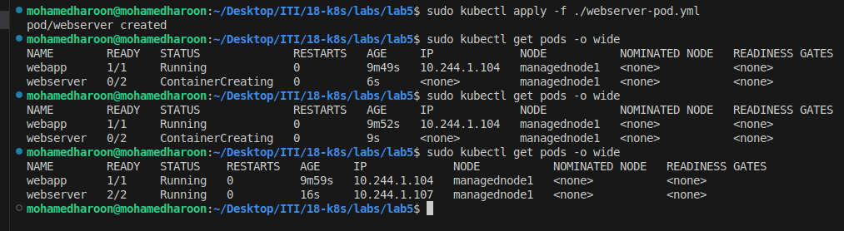

9. Create a new service account with the name pvviewer. Grant this Service account
access to list all PersistentVolumes in the cluster by creating an appropriate cluster role
called pvviewer-role and ClusterRoleBinding called pvviewer-role-binding.
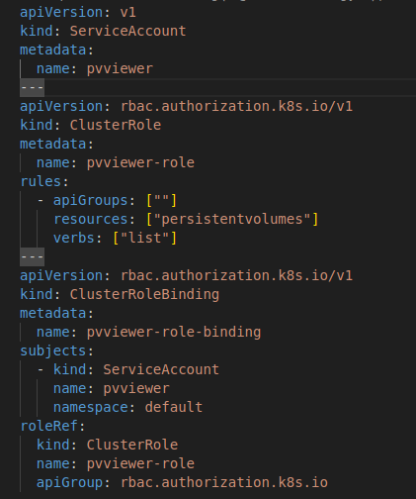

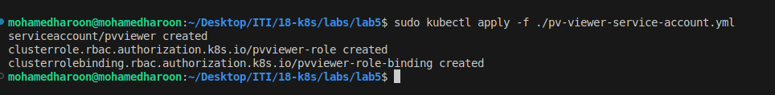
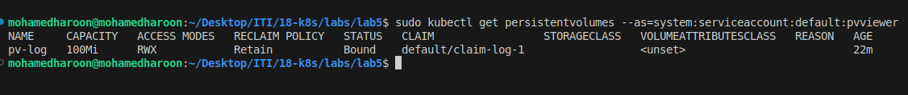

10. Create a ConfigMap named nginx-config
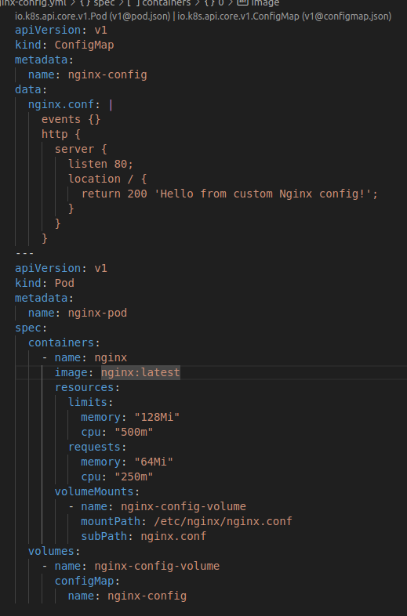

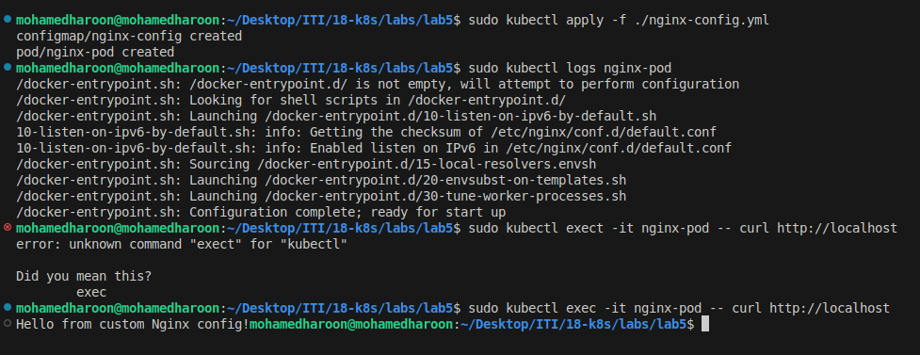

Deploy HaProxy

1- namespace haproxy-controller-devops
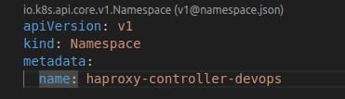

2- ServiceAccount haproxy-service-account-devops

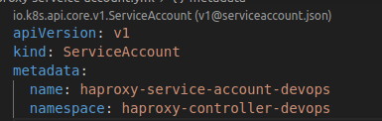

3- ClusterRole haproxy-cluster-role-devops
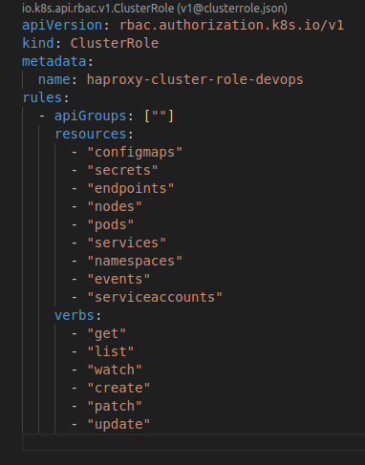

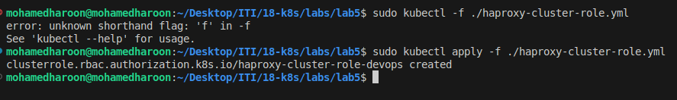
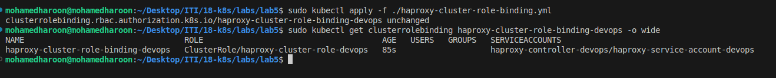

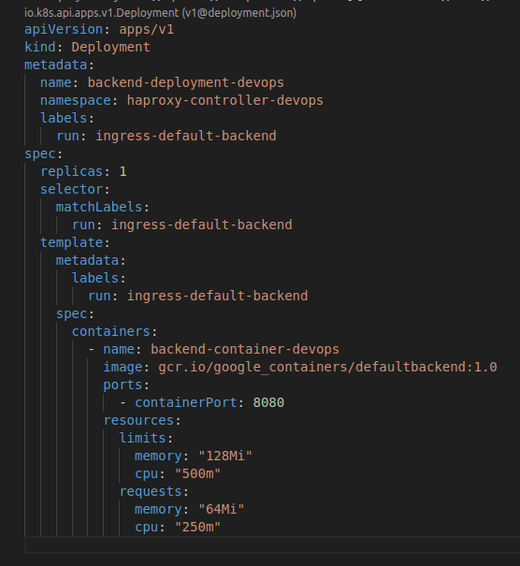
5- backend deployment

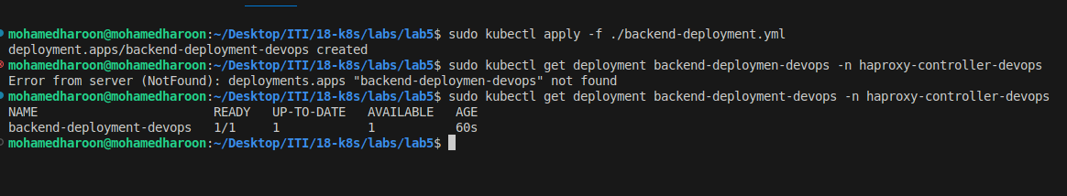

6- service for backend
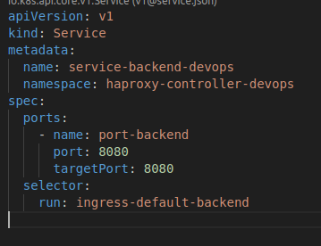

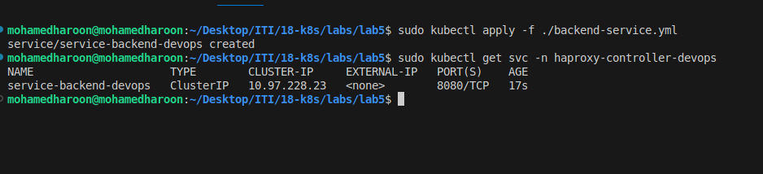

deployment for frontend :
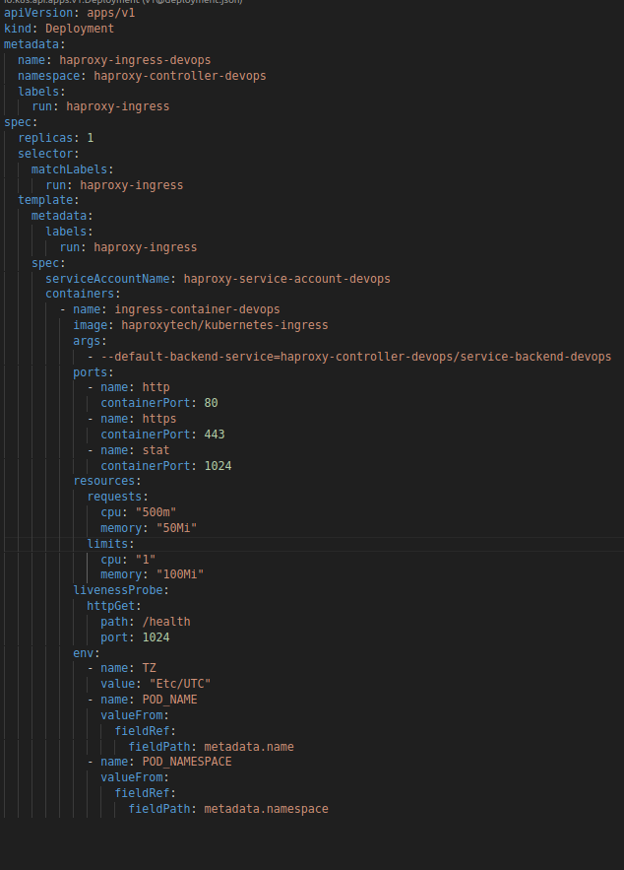

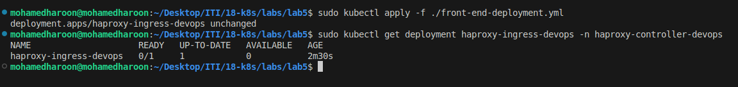

front-end service :

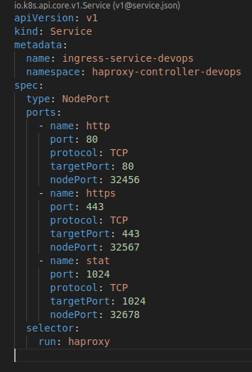

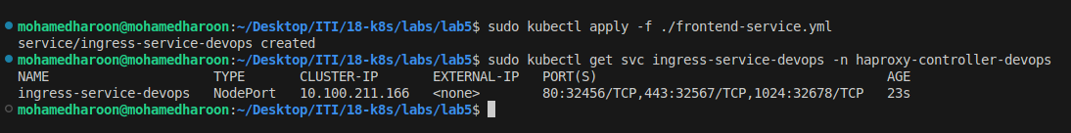

9- Access the proxy states

