1. ٍHow many ConfigMaps exist in the cluster?
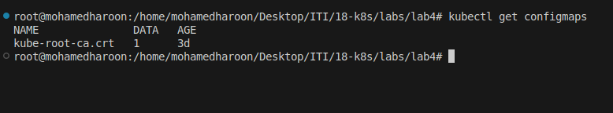

Create a new ConfigMap Use the spec given below.
➔ ConfigName Name: webapp-config-map
➔ Data: APP_COLOR=darkblue
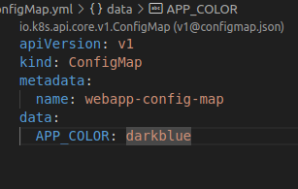

Create a webapp-color POD with nginx image and use the created ConfigMap
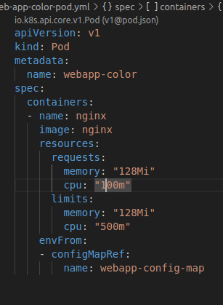

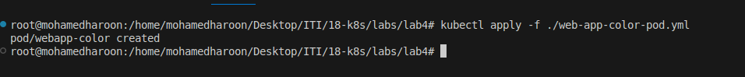

How many Secrets exist in the cluster?
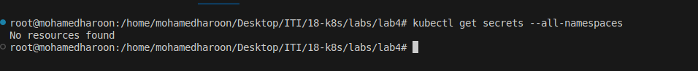

5. How many secrets are defined in the default-token secret?

6. create a POD called db-pod with the image mysql:5.7 then check the POD status :

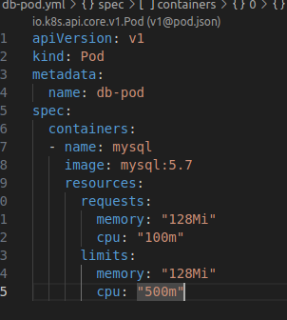

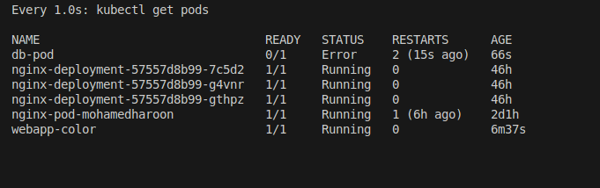
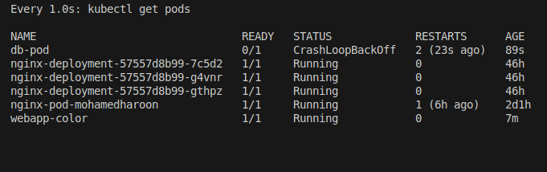

7. why is the db-pod status not ready?

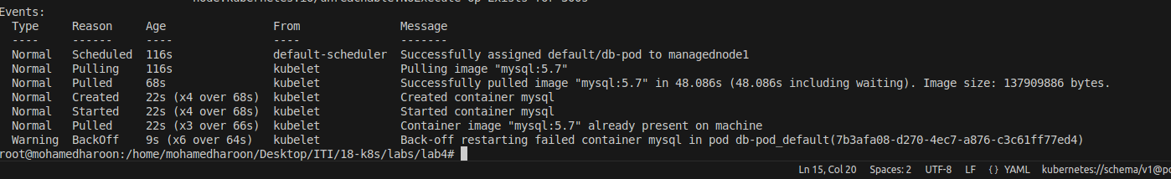
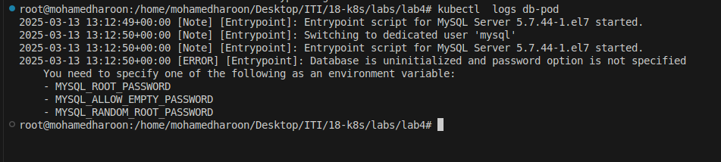

Create a new secret named db-secret with the data given below: ➔ Secret Name: db-secret ➔ Secret 1: MYSQL_DATABASE=sql01 ➔ Secret 2: MYSQL_USER=user1 ➔ Secret 3: MYSQL_PASSWORD=password ➔ Secret 4: MYSQL_ROOT_PASSWORD=password123

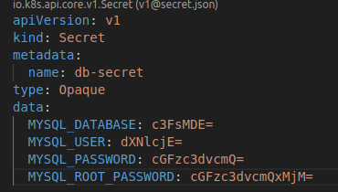

Configure db-pod to load environment variables from the newly created secret. Delete and recreate the pod if required
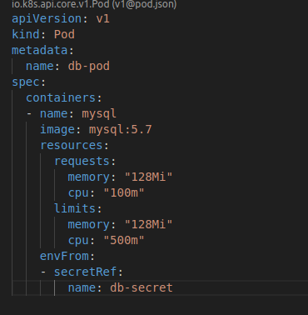

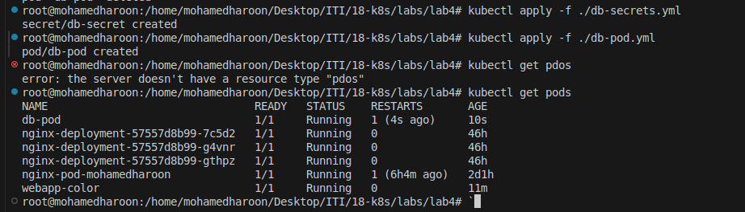
Create a multi-container pod with 2 containers. ➔ Name: yellow ➔ Container 1 Name: lemon ➔ Container 1 Image: busybox ➔ Container 2 Name: gold ➔ Container 2 Image: redis
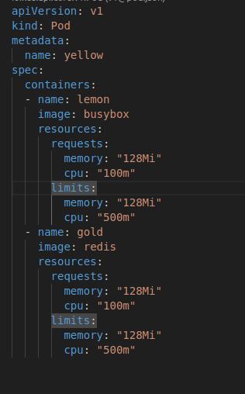

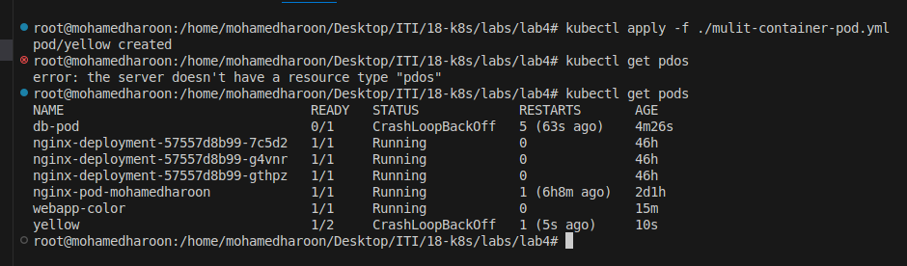

Create a pod red with redis image and use an initContainer that uses the busybox image and sleeps for 20 seconds
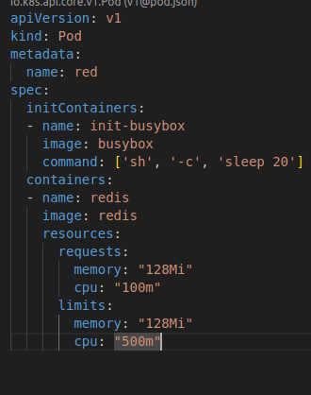

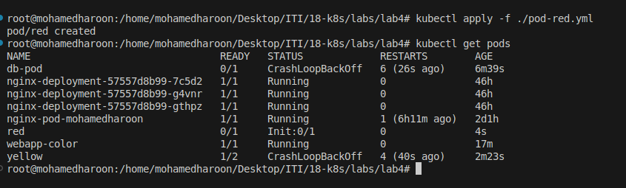

. Create a pod named print-envars-greeting, Configure spec as, the container name should be print-env-container and use bash image, Create three environment variables: ➔ GREETING and its value should be “Welcome to” ➔ COMPANY and its value should be “DevOps” ➔ GROUP and its value should be “Industries”

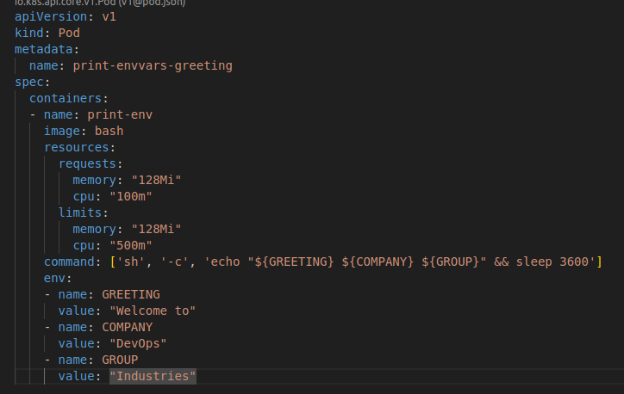
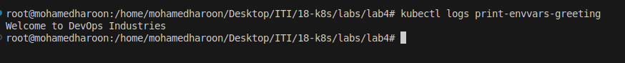

4. Create a pod with a container running the nginx image. ➔ Configure a startupProbe that checks if Nginx is ready using curl. ➔ Set the probe to check every 5 seconds with a failure threshold of 3. ➔ What happens if the container takes longer to start than expected?

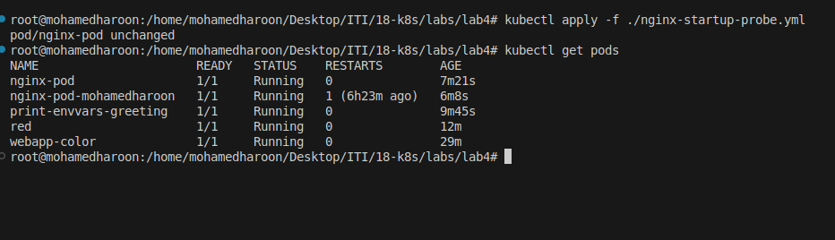

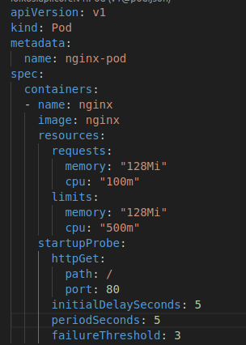

15 . Deploy an Nginx pod with a livenessProbe that checks /

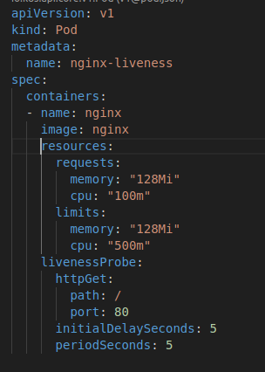

16. What happens to the pod?

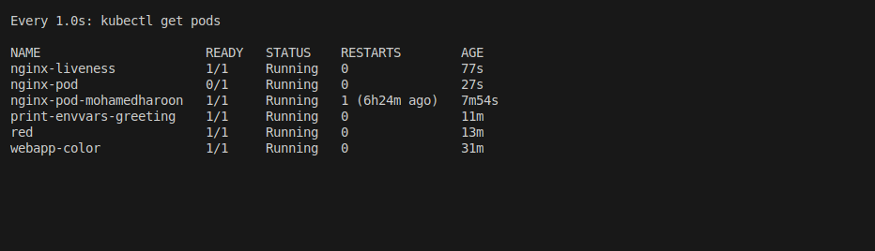

17. Edit the livenessProbe inside the pod to /test.html.
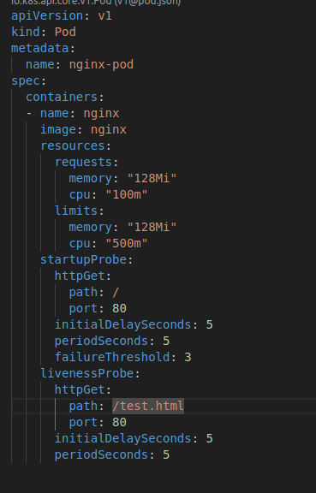

18. What happens to the pod after the edit?
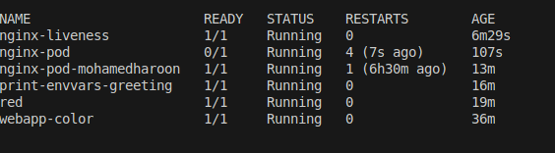

19. Create a pod running a simple Node.js web server.
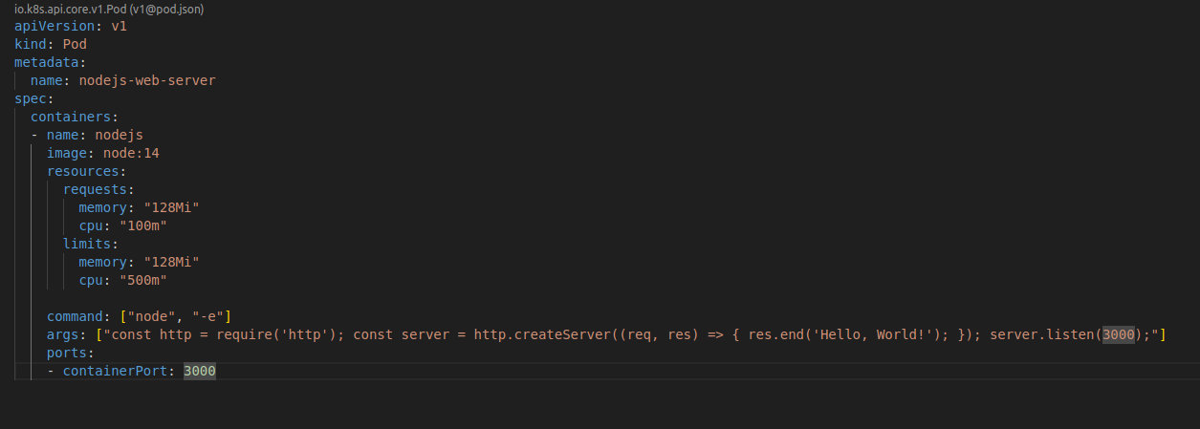

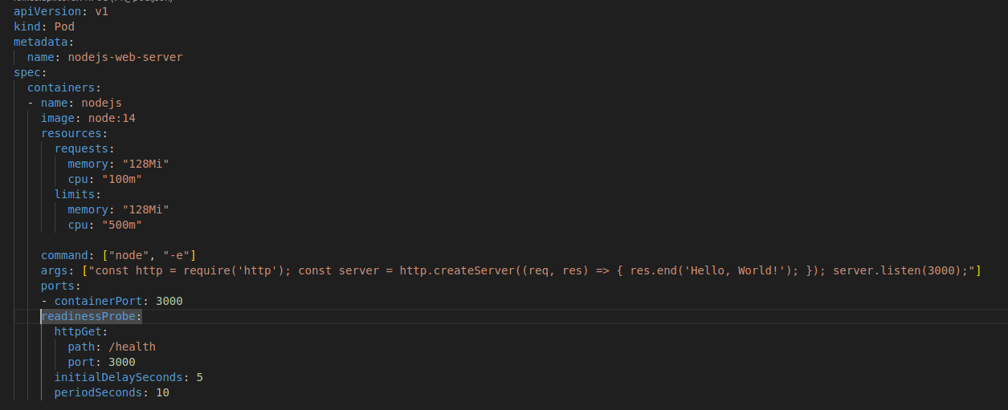
20. Use a readinessProbe to check the HTTP endpoint (/health).

21. Test what happens when the application is not ready.S
k8s will not forward traffic to the pod .

