[Validation] Cancellation and timeouts on WebWorkerClient calls
Validation Task: [Validation] Cancellation and timeouts on WebWorkerClient calls
Configurations tested in:
- Interactive WebAssembly
- Standalone WebAssembly
- Interactive WebAssembly(Published Output)
- Standalone WebAssembly(Published Output)
Environments tested:
- SDK: .NET 11 Preview 7 (11.0.100-preview.7.26381.103)
- OS: Windows 11
- Browser: Chrome(Version: 151.0.7922.174 (Official Build) (64-bit)), Edge(Version: 152.0.4191.53 (Official build) (64-bit))
Sample Location: GitHub - MohamedHasan3644/blazor-webworker-validation
Browser Mapping:
Evidence directory | Configuration | Browser and version | URL
InteractiveWebAssembly | Source Interactive WASM | Chrome 151.0.7922.174 | http://localhost:5002/interactive-wasm
StandaloneWebAssembly | Source Standalone WASM | Chrome 151.0.7922.174 | http://localhost:5093/
PublishedInteractiveWASM | Published Interactive WASM | Chrome 151.0.7922.174 | http://localhost:5003/interactive-wasm
PublishedOutputStandalone | Published Standalone WASM | Chrome 151.0.7922.174 | http://localhost:5094/
Testcases:
Testcase No | Testcase description | Steps to do in the sample | Result | Comments
TC-01 | Verify normal worker creation and a fast invocation before testing failures. | 1. Confirm the page shows Browser runtime.  2. Set creation timeout to 10000.  3. Click Create client.  4. Select Fast and set invocation timeout to 2000.  5. Click Invoke.  6. Click Dispose. | Interactive WebAssembly: Works Properly | Creation and Fast invocation show Returned. Status changes to Client ready, then back to No client. Worker count changes from zero to one and back to zero.
 |  |  | Standalone WebAssembly: Works Properly
 |  |  | Interactive WebAssembly(Published): Works Properly
 |  |  | Standalone WebAssembly(Published): Works Properly
TC-02 | Cover cancellation part way through a slow invocation and recovery using a new client. | 1. Create a client.  2. Select Slow.  3. Set slow duration 4000 and timeout 10000.  4. Click Invoke.  5. After 300–500 ms, click Cancel active.  6. Click New client + fast call. | Interactive WebAssembly: Works Properly | Slow invocation reports Cancelled within one second of cancellation and before 4000 ms. The old client is disposed, a new client is created, and Fast reports Returned.
 |  |  | Standalone WebAssembly: Works Properly
 |  |  | Interactive WebAssembly(Published): Works Properly
 |  |  | Standalone WebAssembly(Published): Works Properly
TC-03 | Verify a slow call fails when its timeout is shorter than its duration and that recovery succeeds. | 1. Create a client.  2. Select Slow.  3. Set slow duration 4000 and timeout 500.  4. Keep Use the timeout field checked.  5. Click Invoke.  6. Click New client + fast call. | Interactive WebAssembly: Works Properly | Slow reports TimedOut near 500 ms and well before 4000 ms. The replacement client’s Fast call reports Returned. The UI never hangs.
 |  |  | Standalone WebAssembly: Works Properly
 |  |  | Interactive WebAssembly(Published): Works Properly
 |  |  | Standalone WebAssembly(Published): Works Properly
TC-04 | Verify a slow method completes when given enough time. | 1. Create a client.  2. Select Slow.  3. Set slow duration 1000 and timeout 5000.  4. Click Invoke. | Interactive WebAssembly: Works Properly | Result is Returned, not TimedOut. Elapsed time is approximately at least the slow duration and below the timeout.
 |  |  | Standalone WebAssembly: Works Properly
 |  |  | Interactive WebAssembly(Published): Works Properly
 |  |  | Standalone WebAssembly(Published): Works Properly
TC-05 | Verify a method that never completes cannot hang the caller when a timeout is supplied. | 1. Create a client.  2. Select Never returns.  3. Set timeout 500 and keep explicit timeout checked.  4. Click Invoke.  5. After timeout, click New client + fast call. | Interactive WebAssembly: Works Properly | Never-returning invocation reports TimedOut near 500 ms. The UI remains responsive and Fast succeeds on the new client.
 |  |  | Standalone WebAssembly: Works Properly
 |  |  | Interactive WebAssembly(Published): Works Properly
 |  |  | Standalone WebAssembly(Published): Works Properly
TC-06 | Exercise the API overload without explicitly supplying the timeout field. | 1. Create a client.  2. Select Never returns.  3. Uncheck Use the timeout field.  4. Click Invoke.  5. After 300–500 ms, click Cancel active.  6. Dispose the client. | Interactive WebAssembly: Works Properly | The call reports Cancelled promptly and does not wait for the API’s default timeout. Disposal removes the worker.
 |  |  | Standalone WebAssembly: Works Properly
 |  |  | Interactive WebAssembly(Published): Works Properly
 |  |  | Standalone WebAssembly(Published): Works Properly
TC-07 | Verify cancelling a token after its operation completed does not alter the completed result. | 1. Create a client if required.  2. Click Cancel completed call. | Interactive WebAssembly: Works Properly | Fast reports Returned. The subsequent token cancellation also reports a successful completed-state check. The original result remains unchanged and no exception appears.
 |  |  | Standalone WebAssembly: Works Properly
 |  |  | Interactive WebAssembly(Published): Works Properly
 |  |  | Standalone WebAssembly(Published): Works Properly
TC-08 | Verify a pre-cancelled token prevents an invocation from waiting or running normally. | 1. Create a client.  2. Set invocation timeout to 10000.  3. Click Pre-cancel call.  4. Select Fast and click Invoke afterward. | Interactive WebAssembly: Works Properly | Pre-cancelled Slow invocation reports Cancelled almost immediately. Fast subsequently reports Returned, showing that the client remains usable.
 |  |  | Standalone WebAssembly: Works Properly
 |  |  | Interactive WebAssembly(Published): Works Properly
 |  |  | Standalone WebAssembly(Published): Works Properly
TC-09 | Verify cancellation applies to client creation, not only invocation. | 1. Create and dispose a client once to load the module.  2. Confirm zero workers.  3. Set creation timeout 10000.  4. Click Create client and immediately click Cancel active.  5. Wait several seconds and inspect workers.  6. Create a client normally, invoke Fast, and dispose it. | Interactive WebAssembly: Works Properly | Creation reports Cancelled promptly, status remains No client, and no abandoned worker remains. A later normal creation and Fast invocation succeed.
 |  |  | Standalone WebAssembly: Works Properly
 |  |  | Interactive WebAssembly(Published): Works Properly
 |  |  | Standalone WebAssembly(Published): Works Properly
TC-10 | Verify cancellation isolation when several invocations are active. | 1. Create a client.  2. Set slow duration to 500.  3. Click Start 3 concurrent calls.  4. Immediately click Cancel active, which targets call B.  5. Wait for all calls to settle. | Interactive WebAssembly: Works Properly | Concurrent B reports Cancelled. Concurrent A and C report Returned. The client remains ready and no unrelated call is cancelled or timed out.
 |  |  | Standalone WebAssembly: Works Properly
 |  |  | Interactive WebAssembly(Published): Works Properly
 |  |  | Standalone WebAssembly(Published): Works Properly
TC-11 | Verify disposal settles an active invocation instead of leaving it hanging. | 1. Create a client  2. Set invocation timeout to 2000.  3. Click Dispose during call.  4. Wait until the action finishes.  5. Inspect the worker list and Console. | Interactive WebAssembly: Works Properly | Disposal completes before the timeout. The pending Never call settles once, normally as Failed with a worker-terminated detail. Status becomes No client, the worker disappears, and the page remains usable.
 |  |  | Standalone WebAssembly: Works Properly
 |  |  | Interactive WebAssembly(Published): Works Properly
 |  |  | Standalone WebAssembly(Published): Works Properly
TC-12 | Verify repeated abandonment does not leak workers or corrupt later clients. | 1. Reload and confirm zero sample workers.  2. Capture the baseline worker view.  3. Click Run 10 cancel/timeout cycles.  4. Wait for Idle.  5. Verify all ten cycle rows and the recovery Fast call  6. Because the action leaves the recovery client active, click Dispose.  7. Wait briefly and inspect workers again. | Interactive WebAssembly: Works Properly | Exactly five cycle calls report Cancelled and five report TimedOut. Recovery Fast reports Returned. One worker is valid while the recovery client is ready; after Dispose, worker count equals the original baseline.
 |  |  | Standalone WebAssembly: Works Properly
 |  |  | Interactive WebAssembly(Published): Works Properly
 |  |  | Standalone WebAssembly(Published): Works Properly
TC-13 | Verify cancellation and timeout are distinguishable from success and ordinary failure. | 1. Create a client and invoke Fast.  2. Invoke Slow with 4000/10000 and cancel it  3. Invoke Slow with 4000/500 and let it time out.  4. Select Ordinary failure and invoke it.  5. Keep all rows in the log. | Interactive WebAssembly: Works Properly | Four distinct classifications appear: Returned, Cancelled, TimedOut, and Failed. The intentional worker exception is Failed, never misclassified as cancellation or timeout.
 |  |  | Standalone WebAssembly: Works Properly
 |  |  | Interactive WebAssembly(Published): Works Properly
 |  |  | Standalone WebAssembly(Published): Works Properly
TC-14 | Verify no cancellation, timeout, or disposal produces an unhandled browser error. | 1. Enable Preserve log and clear the Console.  2. Perform TC-02, TC-03, TC-05, TC-09, TC-10, TC-11, and TC-12.  3. Wait for any late worker responses.  4. Filter the Console to Errors. | Interactive WebAssembly: Works Properly | No unhandled errors appear during cancellation, timeout, late completion, worker creation cancellation, or disposal. Expected exception details appear only in the sample’s operation log.
 |  |  | Standalone WebAssembly: Works Properly
 |  |  | Interactive WebAssembly(Published): Works Properly
 |  |  | Standalone WebAssembly(Published): Works Properly
TC-15 | Test the creation-timeout path independently from invocation timeouts. | 1. Confirm zero workers  2. Set creation timeout to 1 ms.  3. Click Create client.  4. Wait several seconds and inspect workers.  5. Restore 10000, create normally, invoke Fast, and dispose. | Interactive WebAssembly: Works Properly | Initial creation reports TimedOut, leaves No client, and does not leave an abandoned worker. Normal creation afterward succeeds.
 |  |  | Standalone WebAssembly: Works Properly
 |  |  | Interactive WebAssembly(Published): Works Properly
 |  |  | Standalone WebAssembly(Published): Works Properly
TC-16 | Verify creation called with an already-cancelled token exits immediately. | 1. Confirm no active client and zero workers.  2. Click Pre-cancel creation.  3. Create a client normally afterward and invoke Fast. | Interactive WebAssembly: Works Properly | Pre-cancelled creation reports Cancelled almost immediately and creates no worker. Subsequent normal creation and invocation succeed.
 |  |  | Standalone WebAssembly: Works Properly
 |  |  | Interactive WebAssembly(Published): Works Properly
 |  |  | Standalone WebAssembly(Published): Works Properly
TC-17 | Verify a timed-out worker response cannot corrupt later calls on the same client. | 1. Create a client.  2. Set Slow duration 1000 and timeout 100.  3. Invoke Slow and wait for TimedOut.  4. Without replacing the client, select Fast, set timeout 2000, and invoke.  5. Wait beyond 1000 ms for the old Slow work to finish.  6. Invoke Fast again and dispose. | Interactive WebAssembly: Works Properly | Both Fast calls report Returned. The late Slow response creates no extra row, changes no completed result, and produces no Console error.
 |  |  | Standalone WebAssembly: Works Properly
 |  |  | Interactive WebAssembly(Published): Works Properly
 |  |  | Standalone WebAssembly(Published): Works Properly
TC-18 | Verify timing out one concurrent invocation does not lose peer responses. | 1. Create a client.  2. Set slow duration to 500.  3. Click Timeout 1 of 3 calls.  4. Wait for all calls to settle.  5. Invoke Fast afterward. | Interactive WebAssembly: Works Properly | Concurrent timeout B reports TimedOut; A and C report Returned. Fast also returns. Any peer timeout, missing peer result, or hang is a product failure.
 |  |  | Standalone WebAssembly: Works Properly
 |  |  | Interactive WebAssembly(Published): Works Properly
 |  |  | Standalone WebAssembly(Published): Works Properly
TC-19 | Test cancellation arriving near the timeout deadline. | 1. Create a client.  2. Set Slow duration 4000 and timeout 300.  3. Invoke and click Cancel active around 250–300 ms.  4. Repeat at least five times, replacing/disposing the client between attempts.  5. Dispose the final client. | Interactive WebAssembly: Works Properly | Each invocation settles exactly once as either Cancelled or TimedOut. Neither race outcome is inherently wrong, but Failed, duplicate rows, hangs, and unhandled errors are failures.
 |  |  | Standalone WebAssembly: Works Properly
 |  |  | Interactive WebAssembly(Published): Works Properly
 |  |  | Standalone WebAssembly(Published): Works Properly
TC-20 | Verify component teardown cleans up a worker when the user navigates away. | 1. Create a client.  2. Select Never returns and uncheck explicit timeout.  3. Click Invoke.  4. While it is active, click Navigate away.  5. Inspect the URL, workers, and Console. | Interactive WebAssembly: Works Properly | Navigation reaches /counter. Component disposal cancels the active wait and terminates the worker. Worker count returns to baseline and no unhandled error appears.
 |  |  | Standalone WebAssembly: Works Properly
 |  |  | Interactive WebAssembly(Published): Works Properly
 |  |  | Standalone WebAssembly(Published): Works Properly
TC-21 | Exercise the boundary where completion and timeout can race. | 1. Create a client.  2. Set Slow duration and timeout both to 1000.  3. Invoke five times.  4. Invoke Fast afterward and dispose. | Interactive WebAssembly: Works Properly | Each Slow call settles exactly once as either Returned or TimedOut. No call hangs, becomes an unrelated Failed result, or produces duplicate rows. Fast remains usable.
 |  |  | Standalone WebAssembly: Works Properly
 |  |  | Interactive WebAssembly(Published): Works Properly
 |  |  | Standalone WebAssembly(Published): Works Properly
TC-22 | Verify required hosts and build forms have equivalent behavior. | 1. Execute the core tests in all four required passes.  2. Record configuration, build form, SDK, browser, and URL.  3. Compare classifications, recovery, worker cleanup, and Console state. | Interactive WebAssembly(Published): Works Properly | Standalone and Blazor Web App Interactive WebAssembly produce equivalent outcomes. Source and published runs both load worker assets and pass the same behavioral checks.  TC-22 is an aggregate comparison of the configuration-specific recordings and is not a separately executed scenario. Its evidence consists of TC-01 through TC-21 under InteractiveWebAssembly, StandaloneWebAssembly, PublishedInteractiveWASM, and PublishedOutputStandalone.
 |  |  | Standalone WebAssembly(Published): Works Properly

Must Hold Assessment:
Requirement | Result | Evidence
In-flight cancellation returns promptly | Passed | TC-02
Caller does not await worker completion | Passed | TC-02
Calls exceeding timeout fail properly | Passed | TC-03
Never-returning method times out | Passed | TC-05
Cancellation, timeout, and failure are distinguishable | Passed | TC-13
Recovery after cancellation | Passed | TC-02
Recovery after timeout | Passed | TC-03 and TC-05
Concurrent cancellation isolation | Passed | TC-10
No orphan workers after ten cycles | Passed | TC-12 before/after worker-list recording
Worker count returns to baseline | Passed | TC-12
No browser Console errors | Passed | TC-14 and TC-12
Disposal settles pending invocation | Passed | TC-11

Dedicated Worker Cleanup Evidence:
Configuration | Before count | During recovery | After disposal | Evidence
Source Interactive WASM | 0 | 1 | 0 | TC-12
Source Standalone WASM | 0 | 1 | 0 | TC-12
Published Interactive WASM | 0 | 1 | 0 | TC-12
Published Standalone WASM | 0 | 1 | 0 | TC-12

Build Output:
- Interactive WebAssembly:
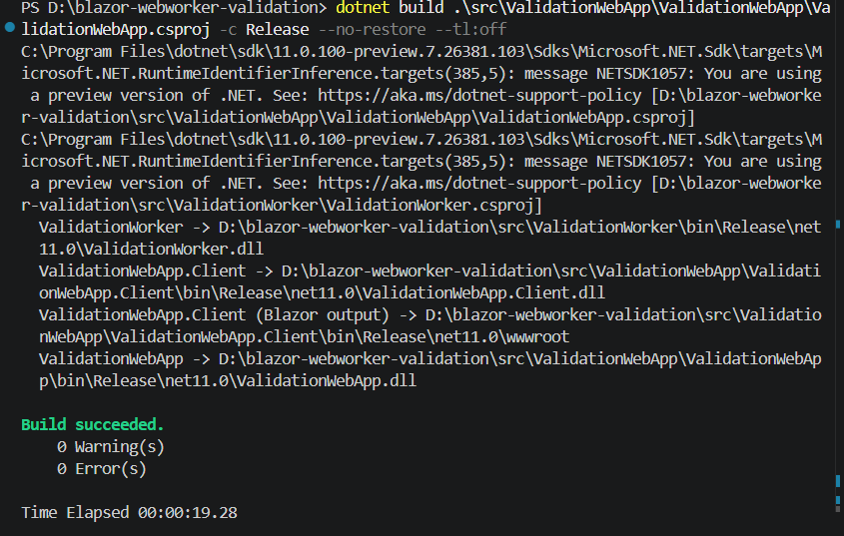
- Standalone WebAssembly:
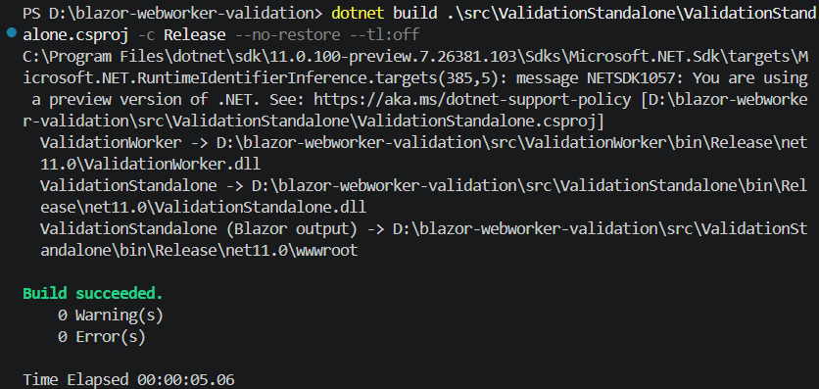
- Interactive WebAssembly(Published):
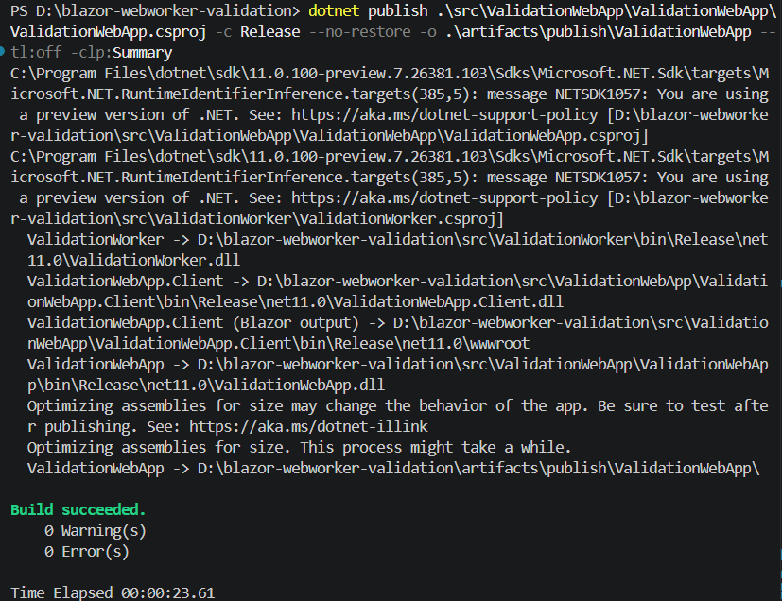

- Standalone WebAssembly(Published)
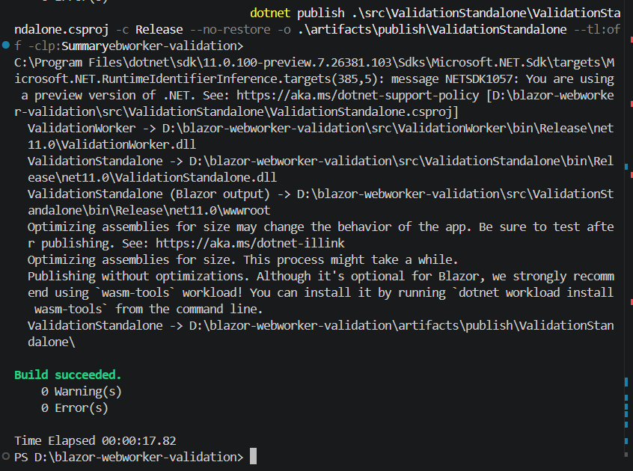

Console Errors:
No Console errors were observed during the validation testing of all the testcases and also captured the console while testing for all the configurations.

