F# Bilingual Dictionary Application

1. Overview
The F# Bilingual Dictionary Application is a modern WPF desktop tool that translates between Arabic and English. The system uses an immutable functional architecture, supports full CRUD operations, searching, and JSON file persistence.

2. Features
• Bilingual Translation (Arabic ↔ English)
• Full CRUD Operations
• Search Engine (case-insensitive & partial matching)
• JSON Save/Load Persistence
• Immutable Functional Architecture
• Modern Dark-Themed WPF UI

3. Project Structure
The project is divided into logical modules ensuring clean separation of concerns, maintainability, and extensibility.
Types.fs
Defines core domain types such as Dictionary, Direction, and internal models.
ErrorHandling.fs
Contains DictionaryError and helper utilities for Result types.
Crud.fs
Implements add, update, delete, and retrieval operations using immutable Maps.
Search.fs
Provides search functionality using case-insensitive partial matching.
FileIO.fs
Handles JSON serialization and deserialization.
MainWindow.xaml / xaml.fs
WPF UI layout and interaction logic.
Program.fs
Application entry point.

4. Architecture
The architecture is functional and immutable, ensuring predictable and testable behavior.
Immutable Maps
All CRUD operations return new Map<string,string> instances.
Result-Based Design
Operations may return errors expressed using Result<T, DictionaryError>.
Functional Separation
Each module is self-contained and pure where possible.
UI State Updates
UI never mutates dictionaries directly; instead, receives new immutable states.

5. Testing Strategy
Testing follows functional principles. Since the majority of the system is pure, unit tests are simple, deterministic, and provide full coverage of logic.

Unit Testing Principles
• Pure functions simplify test scenarios.
• No mutable state — previous results do not affect future tests.
• Result<T, DictionaryError> makes error-path testing straightforward.
• Modules can be tested independently without UI interaction.

CRUD Testing
• Adding words to an empty dictionary.
• Adding duplicates results in WordAlreadyExists.
• Empty inputs trigger ValidationError.
• Updating existing entries updates meaning correctly.
• Updating missing entries results in WordNotFound.
• Deleting existing entries removes them.
• Deleting missing entries returns WordNotFound.
• Ensuring immutability: original dictionary never changes.

Search Testing
• Case-insensitive matching.
• Partial substring matching.
• Direction-aware lookups.
• Empty search returns empty list.
• No-match queries handled gracefully.

File I/O Testing
• Correct JSON serialization.
• Correct deserialization recreating dictionary state.
• Handling invalid JSON with appropriate errors.
• Handling missing file paths safely.

UI Testing
UI testing is optional. Since logic lives in pure modules, UI only forwards events to backend logic. Optional WPF automation tests may validate button interactions, list updates, and bindings.
Block Diagram :
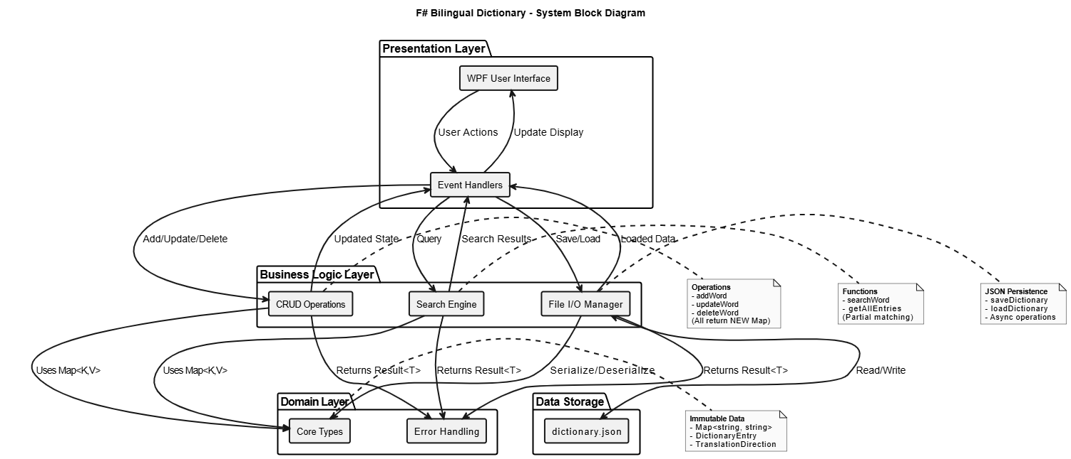
System Architecture :
