Kinematic Chain :
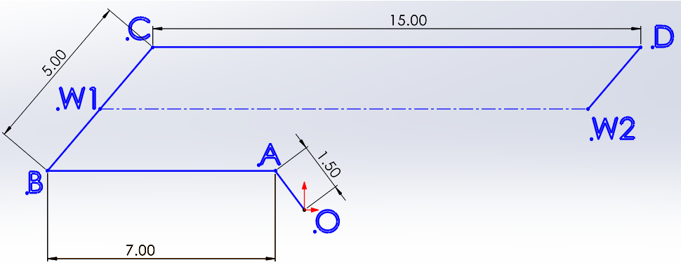

$$OA=link 2, AB=link3, BC=link4, CD=link5, DW_{2}=link6$$
$O=Motor, W_{1}=Wheel 1, W_{2}=Wheel 2, y_{B}=y_{A}, θ_{3}=180°$
Position Analysis :
$$OA=r_{2}e^{iθ_{2}} ⇒ x_{A}=r_{2}cosθ_{2}, y_{A}=r_{2}sinθ_{2}$$
$$OB=OA+AB$$
$$x_{B}+iy_{B}=x_{A}+iy_{A}+r_{3}e^{iθ_{3}}⇒ x_{B}=x_{A}+r_{3}cosθ_{3}, y_{B}=y_{A}+r_{3}sinθ_{3}$$
$$OC=OB+BC$$
$$x_{C}+iy_{C}=x_{B}+iy_{B}+r_{4}e^{iθ_{4}}⇒ x_{C}=x_{B}+r_{4}cosθ_{4}, y_{C}=y_{B}+r_{4}sinθ_{4}$$
$$OW_{1}=OB+BW_{1}$$
$$x_{W_{1}}+iy_{W_{1}}=x_{B}+iy_{B}+BW_{1}e^{iθ_{4}}⇒ x_{W_{1} }=x_{B}+BW_{1}cosθ_{4}, y_{W_{1}}=y_{B}+BW_{1}sinθ_{4}$$
Velocity Analysis :
$$V_{A}=iw_{2}r_{2}$$

