Designing a Model Ship
NORMANDY 2

Presented By:
كريم ايهاب حمادة عبد الرؤوف 21010979
محمد حسني محمد ابراهيم 21011116
كريم السيد محمد محمد سريح 21010978
حنين اسامة محمد احمد 21010480
عبدالرحمن سيد احمد كامل 21010742
احمد رضا بسيوني السيد 19015233
زياد حسام محمد السعيد عثمان 21010567

Presented To:
Dr. Yasser Abuouf

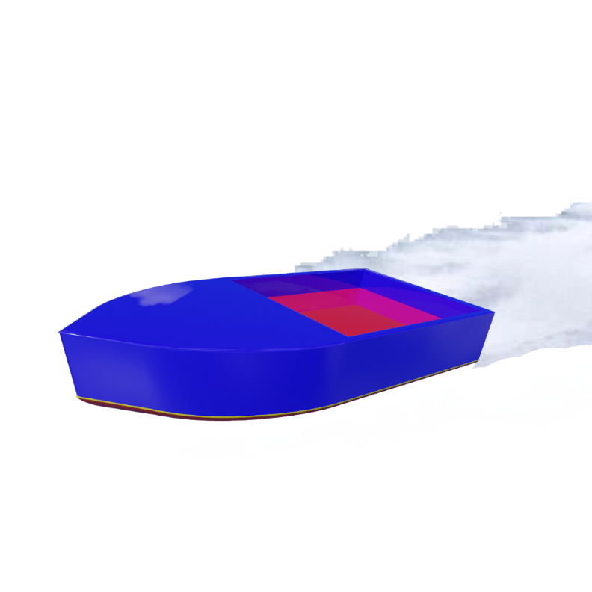
Abstract
As it is required to build a ship with the ability to carry a standard cargo load of 1 can of soft drink (330ml) and must be stable in both cases loaded or unloaded. As a cooperative team, we fulfilled the requirements with an extraordinary outcome “Normandy 2”.

Design Evolution
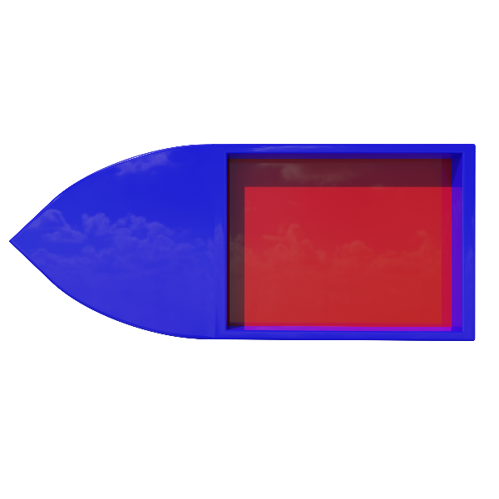
Phases were tackled by the team members to develop a fruitful result beginning with brainstorming and collaboration where we shared our ideas and developed them together followed by the illumination phase where we put the strategy, the costs, material selection, and the timeline to get the work done due to the set deadline. As everything comes to an end, implementation was our last to make ideas real and test the creation.

Frame Design
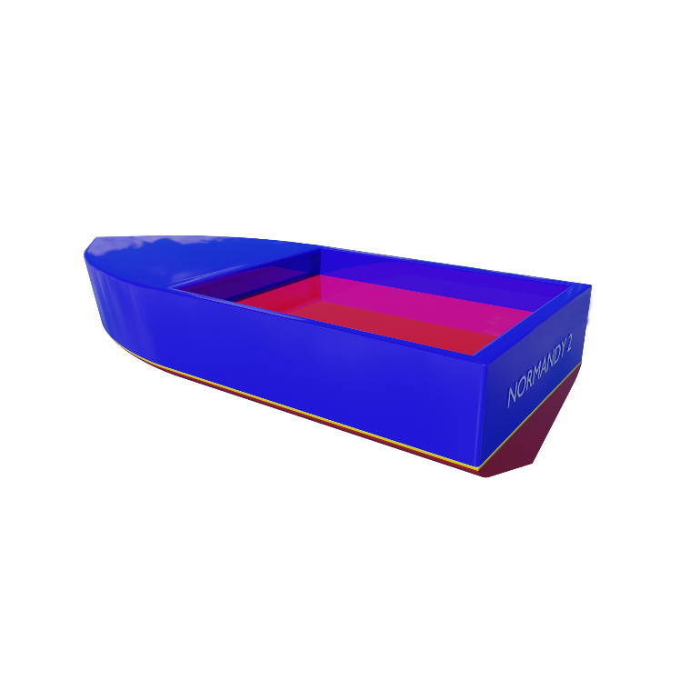
The boat’s frame was carefully designed to be stable loaded and unloaded. For fixations, a squared groove was made to maintain the components. The unloaded boat’s dimensions are 36 cm in length and 20 cm in width, 1598.16883 cm³ in volume, and 3689.3515 cm² in area, where its height from the hull to the waterline is 1.4 cm. These dimensions include the likes of the motor, the propeller, and the battery. When the can is included the height of the water line increases to 2.6 cm.

Material Selection
Foam has proved its ability in compromising strength to hold the load and other components and being stable while loaded and unloaded. Foam appeared to be the most cost-effective compared to other materials such as wood or plastic polymers.

Calculations

Immersed Volume :

Unloaded :
Boat Mass = 470 grams, Seawater Density = 1030 kg/m³, Immersed Height = 1.4 cm

$$Volume_{immersed} × ρ_{fluid}={Volume}_{body} × ρ_{solid}$$
$$V_{imm}=\frac{m_{body}}{ρ_{fluid}}=\frac{0.47}{1030}$$
$$V_{imm}=4.56 × {10}^{-4}{ m}^{3}$$
Loaded :
Boat Mass = 840 grams, Seawater Density = 1030 kg/m³, Immersed Height = 2.6 cm

$$Volume_{immersed} × ρ_{fluid}={Volume}_{body} × ρ_{solid}$$
$$V_{imm}=\frac{m_{body}}{ρ_{fluid}}=\frac{0.84}{1030}$$
$$V_{imm}=8.155 × {10}^{-4}{ m}^{3}$$

Stability Check :

Unloaded :
Boat Mass = 470 grams, Center of Gravity (From Solidworks) = 50 mm
Center of Buoyancy (From Solidworks) = 12.48 mm, Volume _{immersed} = $4.56 x {10}^{-4}{ m}^{3}$
Second moment of area (From Solidworks) = 197200620.36 mm⁴

$$BG=KG-KB=50-12.48$$
$$BG=37.52 mm$$

$$BM=\frac{I}{V_{imm}}=\frac{197200620.36 × {\left({10}^{-3}\right)}^{4}}{4.56 × {10}^{-4}}$$
$$BM=0.432 m=432.46 mm$$

$$BM>BG → ∴Boat is stable$$
Loaded :
Boat Mass = 840 grams, Center of Gravity (From Solidworks) = 50 mm
Center of Buoyancy (From Solidworks) = 22 mm, Volume _{immersed} = $8.16 x {10}^{-4}{ m}^{3}$
Second moment of area (From Solidworks) = 143052480.16 mm⁴

$$BG=KG-KB=50-22$$
$$BG=28 mm$$

$$BM=\frac{I}{V_{imm}}=\frac{143052480.16 × {\left({10}^{-3}\right)}^{4}}{8.16 × {10}^{-4}}$$
$$BM=0.175 m=175.42 mm$$

$$BM>BG → ∴Boat is stable$$
Ship Resistance (Drag Force) :

Unloaded :
Seawater Density = 1030 kg/m³, Velocity (Calculated after trials) = 0.4667609 m/s,
Wetted Area = $0.11401175$ m², Water’s Kinematic Viscosity = 1 mm²/s

$$Re=\frac{Velocity × Length}{Kinematic viscosity}=\frac{0.4667609×0.36}{1 × {10}^{-6}}=168033.924$$

$$Resistance coefficient=\frac{0.075}{{\left(\log_{10}{Re}-2\right)}^{2}}=7.2 × {10}^{-3}$$

$$Resistance=Cf ×\frac{1}{2} × ρ × v^{2} × A_{imm}$$
$$Res=7.2 × {10}^{-3} ×\frac{1}{2} × 1030 × {0.4667609}^{2} ×0.11401175$$
$$Resistance=0.0921 N$$

Loaded :
Seawater Density = 1030 kg/m³, Velocity (Calculated after trials) = 0.37362729 m/s,
Wetted Area = $0.18644327$m², Water’s Kinematic Viscosity = 1 mm²/s
$$Re=\frac{Velocity × Length}{Kinematic viscosity}=\frac{0.37362729×0.36}{1 × {10}^{-6}}=134505.82$$

$$Resistance coefficient=\frac{0.075}{{\left(\log_{10}{Re}-2\right)}^{2}}=7.66 × {10}^{-3}$$

$$Resistance=Cf ×\frac{1}{2} × ρ × v^{2} × A_{imm}$$
$$Res=7.66 x {10}^{-3} ×\frac{1}{2} × 1030 × {0.37362729}^{2} × 0.18644327$$
$$Resistance=0.1027 N$$

Flow Simulation :

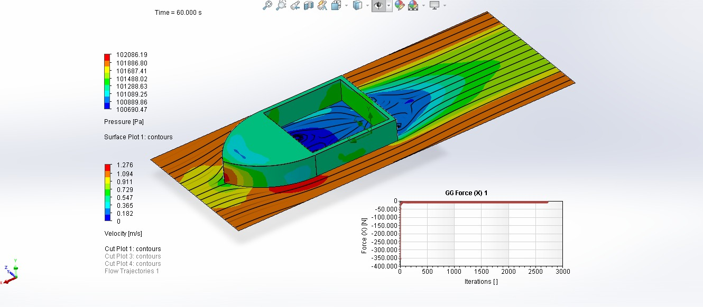

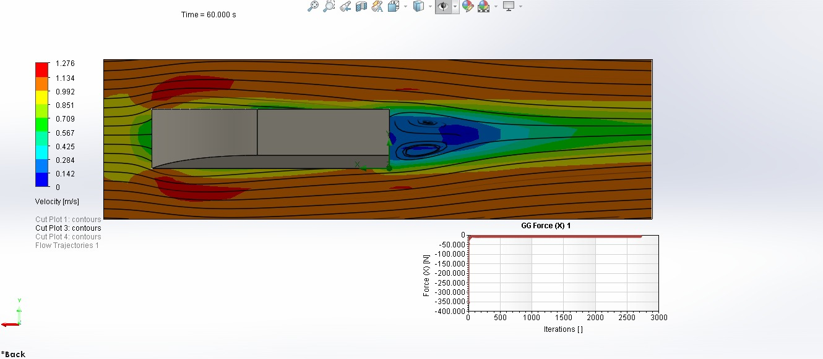

Drag Force = 0.09 Newtons

Cost Analysis

Component | Description | Status | Cost
Foam sheet | 142 gm | New | 300.0
Dc motor | Dc motor with gearbox 9V | New | 140.0
Battery | Camelion battery 9V 6F22 | New | 20.0
Battery cap | Battery cap 9V | New | 2.0
Propeller | Red plastic 4 blades propeller | New | 15.0
Switch | On/off red switch 3 pins 6A 250VAC 15x21mm | New | 2.0
 |  |  | 479.0

