Systolic array

Tiling strategy:
SA usually does not match the size of the matrices to be operated on. Therefore, matrices need to be segmented and computed in sequential batches to obtain the final accumulation results.
The following figure explains how we can multiply two 64x64 matrices with 32*32 SA.
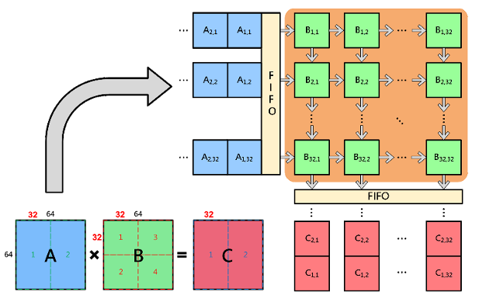
Figure 1: tiling matrices to smaller systolic
Assume this notation C[tile].
C [1] = A [1] * B [1] + A [2] * B [2]. C [2] = A [1] * B [3] + A [2] * B [4].
To get C [1] we first multiply A [1] to B [1] then we load this partial sum from the top of the systolic and the systolic will multiply A [2] * B [2] and accumulate the partial sums entered from above.

Systolic array specifications

Architecture
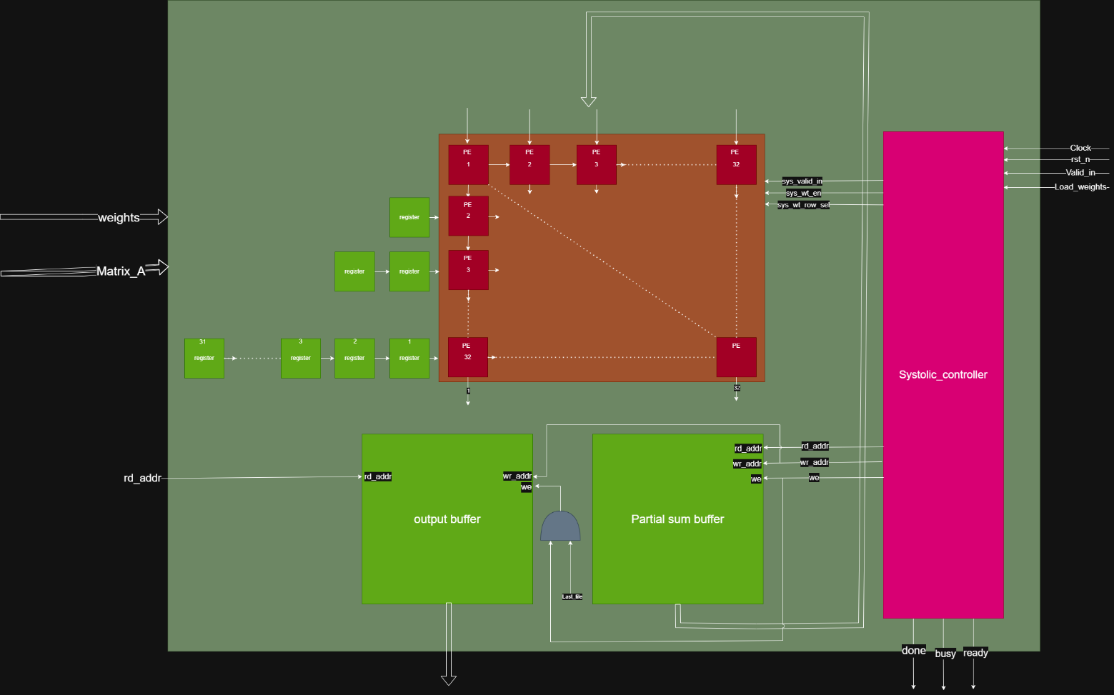
Figure 2: Systolic Architecture

In this design we introduce 32 x 32 weight stationary systolic array with tiling control via systolic controller FSM and partial sums accumulate internally from the partial sum buffer.

PE
The processing element contains an 8-bit register that holds the weight value, it multiplies input data to the weights add the value entered from the top in 32-bit reg and then pass this value to the PE under it, and pass input element to the right PE.
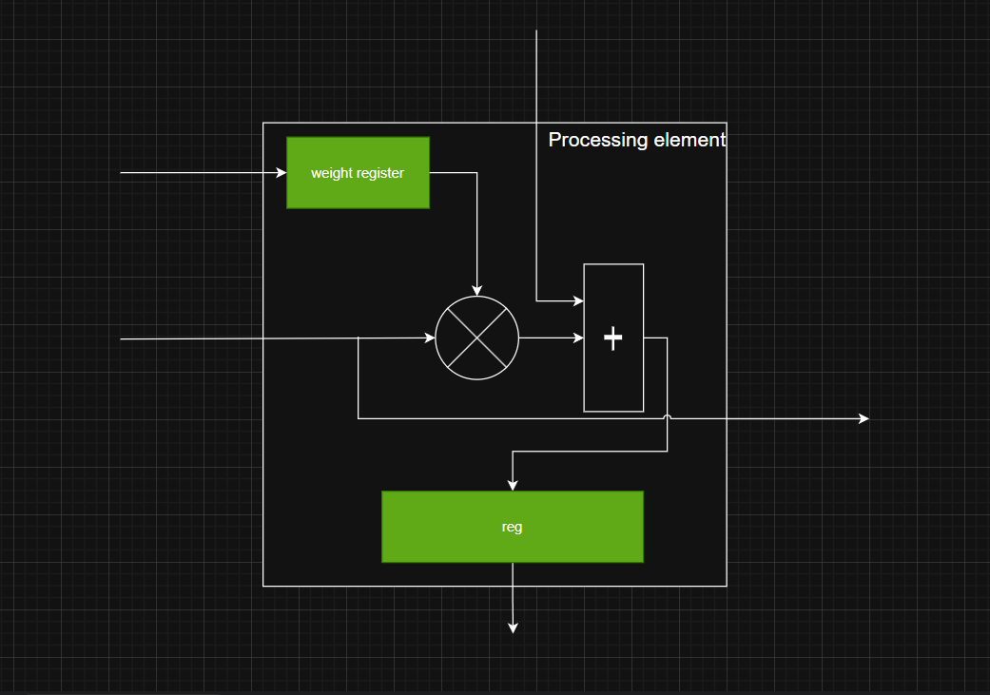
Figure 3: PE

Systolic controller
This module implements a 3 state FSM IDEL, Load weight and compute and based on Load weight signal or the valid input it changes its state.
- The systolic runs in compute mode based on internal counter when it reaches specific value the systolic back to idle state
- The controller generates weight enable, read address, write address and write enable for the partial sum buffer.

Skew buffer:
This module generates a chain of registers that is responsible for generating the skewed input like for the systolic.

Systolic interface signals:
Signal | type | description
weight | Input | This is the weight wire
Matrix_A (In_A) | Input | This is the input port for matrix values
Clk | Input | clock
Rst_n | Input | Active low reset
Valid_in | Input | Indicates whether the input is valid or no it should be high as long as there is a valid data
load_weight | Input | Indicates if there is a valid weights on the bus.
last_tile | input | Indicates if this tile if the last tile which means after this operation a valid tile will be produced (not partial sums)
first_iteration | Input | Indicates if this is the first tile to be processed so that the systolic input 0 at the partial sums
rd_addr_outbuffer | Input | The read address for the output buffer (used when outer block need to read the output tile)
out_data_outbuffer | output | Output data of the buffer
busy | output
Done | output
ready | output

Important notes:
- The weights are loaded on 32 cycles
- Load_weight signal should be high at these 32 cycles
- Afte finishing entering matrix the outer design should keep feed the systolic with zeroes until done signal is high (Valid input also should be high)

