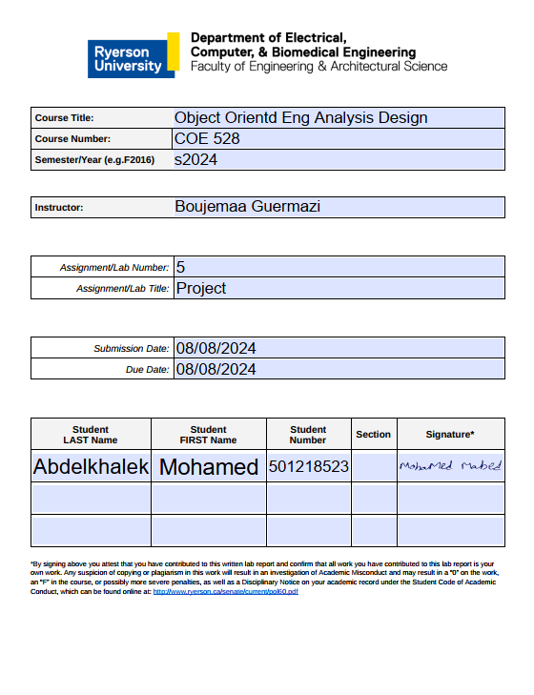

**1. Introduction**

The Bank Management System is a software application developed to manage customer accounts, transactions, and other banking operations. The system is designed with a focus on ease of use and security, providing functionalities for both customers and bank managers. It was developed using Java, with a user interface built using JavaFX.

**2. System Overview**

The Bank Management System consists of several core modules, each responsible for a different aspect of banking operations. These include customer account management, transaction processing, and administrative functionalities for bank managers. The system ensures data integrity and security while offering a user-friendly interface.

**3. Use Case Diagram**

The Bank Management System has been modeled to represent key interactions between different actors and the system. The primary actors identified are the Customer and the Bank Manager, with use cases including login, account management, transaction processing, and manager operations. The system is designed to ensure that all user interactions are secure and efficient.

*Use Case: Customer Login*  
**Actors:** Customer  
**Entry Condition:** The customer has the necessary credentials and opens the login interface.  
**Flow of Events:**

1. The customer enters their username and password.
2. The system validates the credentials.
3. Upon successful validation, access to the customer's account is granted.

**Exit Condition:** The customer is either successfully logged in or prompted to retry.  
**Exceptions:** If the credentials are invalid, the customer will be asked to re-enter their details.  
**Special Requirements:** Secure handling of passwords and user credentials to prevent unauthorized access.

**4. Class Diagram**

The class diagram of the Bank Management System is designed to represent the relationships between different classes such as Customer, Account, Transaction, Manager, and Bank. The Customer class is associated with multiple Account instances, and the Manager class is responsible for the creation and deletion of customer profiles. The Bank class acts as a central point managing collections of customers and their accounts.

**5. Selected Class for Discussion**

The class chosen for detailed discussion is the Customer class. This class encapsulates the customer's information, their associated bank account, and operations such as depositing, withdrawing, and making online purchases.

**6. State Design Pattern**

The State design pattern is implemented within the BankAccount class hierarchy. The BankAccount class has three concrete states: SilverBankAccount, GoldBankAccount, and PlatinumBankAccount. Each of these subclasses represents a different account level, with its specific rules for online purchases. The state of the bank account can change dynamically based on the balance, reflecting the core principle of the State pattern where an object's behavior changes when its state changes.

**7. Conclusion**

The Bank Management System successfully provides a comprehensive platform for managing customer accounts, transactions, and other banking operations. The system is designed with a strong emphasis on security, usability, and efficiency. It offers a robust solution for both customers and bank managers, ensuring smooth and secure banking operations.