Name: Mohamed Ibrahim Abouelmagd Ibrahim
Student id: 37612336
1)Objective: this coursework’s primary objective was to build a fully automated system to track bitcoin prices. Collect data every hour using a script and cron and saving it in a csv file and automatically generates 10 different plots using gnuplot and all of this running on the university server.
2.0)To start with my script called bitcoincollect.sh initialized using command “nano bitcoincolllect.sh”:
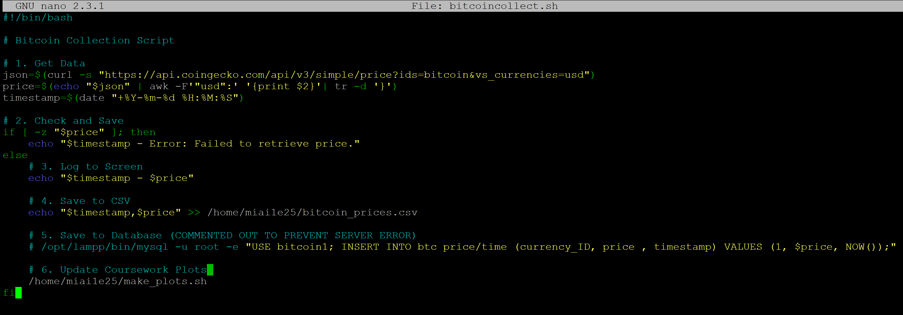
Figure 1: source code of the data collection script.
The first line #!/bin/bash (called shebang) tells the Linux system to interpret it using Bash shell.
Then we used the command “json” to get raw data and ”curl -s” which means silent mode. Then the URL of CoinGecko an accessible public site where there are less restrictions allowing more reliable data retrieval.
“Echo $json” at the start to write the data collected and then be adjusted using “awk -F ‘“usd”:’” makes “usd”: act as a separator and “{print $2}” print everything after the separator and “tr” is a translate command and using flag “-d” is used to delete specific characters so since ’}’ is written so it remove the brackets and just leave us with pure numbers.
“If [ -z “$price”]” checks if the length of the value is zero or not if zero prints time and failed to retrieve price if not it acts normally and print timestamp in years-months-days hours-minutes-second and – between to write price after it .
“Echo timestamp,price >> /home/miai1e25/bitcoin_prices.csv” command : append operators are used , the absolute path is given so cron knows where exactly the file is and new data enter under old data without overwriting it and stored as (timestamp,price).
Path to my sql to use database bitcoin1 and insert into table btc price/time values. However, the university server prevents me from accessing the sql so I made it locally on XAMPP.
“/home/miai1e25/make_plots.sh” to make the file containing commands of plotting to work.
Finally, fi to close the if statement started.

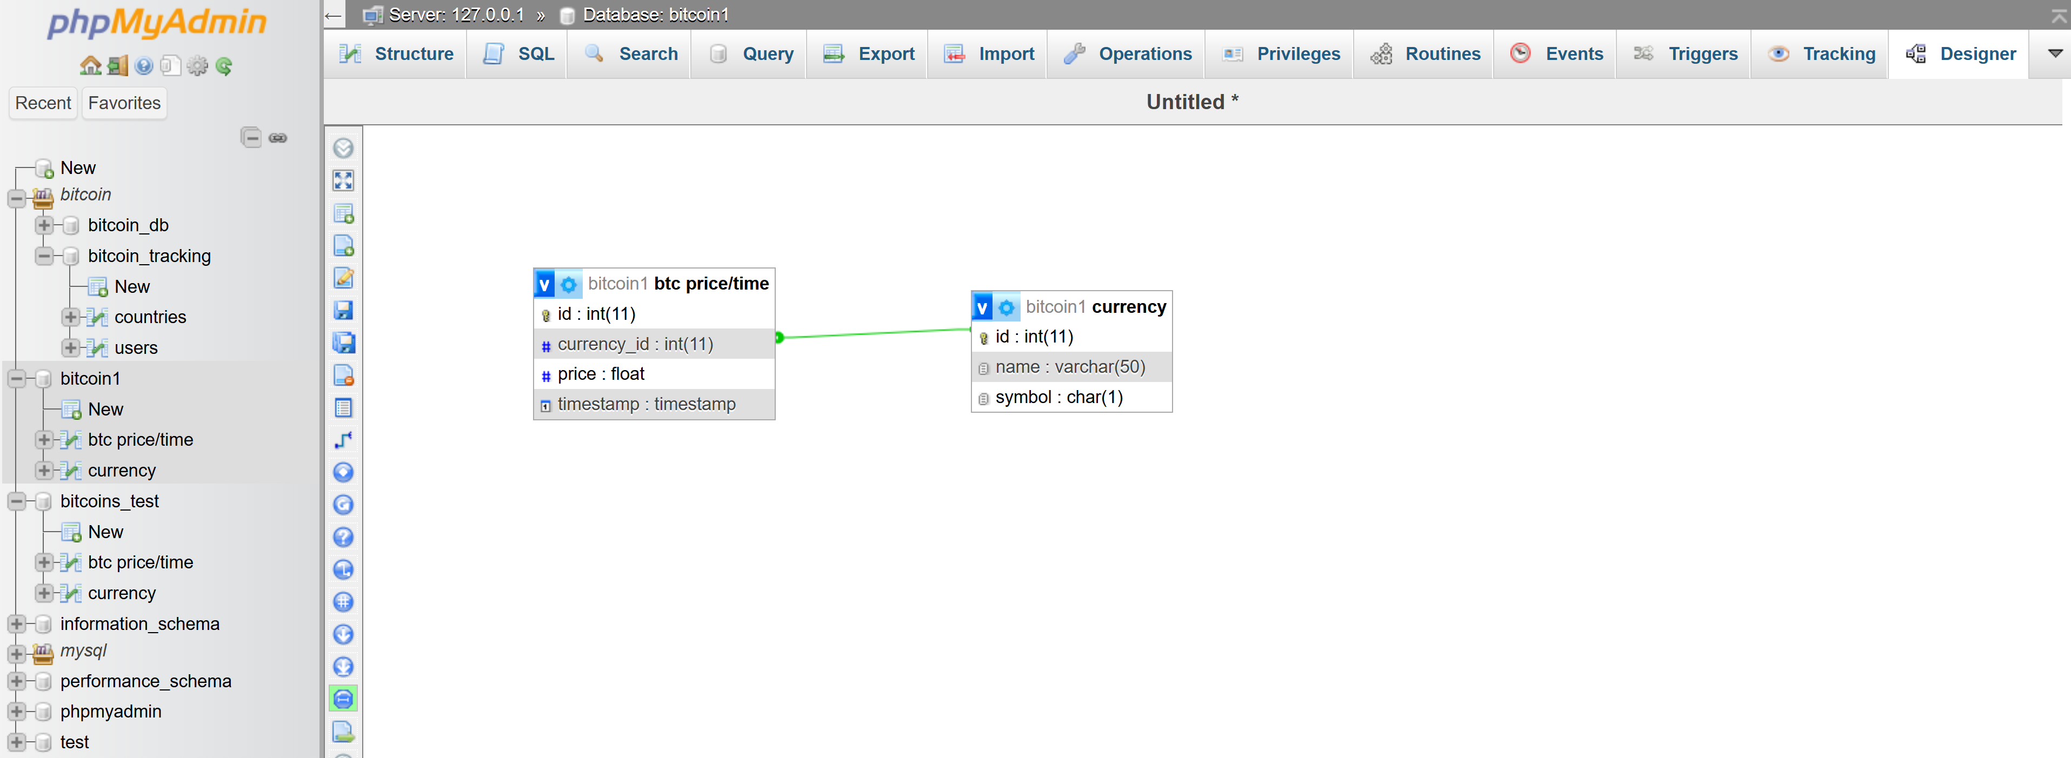
Figure 2: Local MySQL Database Schema (Designed in XAMPP due to server restrictions).

Create database bitcoin1;
Use bitcoin1;
create table currency (id INT AUTO_INCREMENT PRIMARY KEY,
name VARCHAR(50) NOT NULL,
symbol VARCHAR(10) NOT NULL UNIQUE);
CREATE TABLE btc price/time (
id INT AUTO_INCREMENT PRIMARY KEY,
currency_id INT NOT NULL,
price DECIMAL(18,8) NOT NULL,
timestamp TIMESTAMP NOT NULL,

CONSTRAINT fk_btc_currency
FOREIGN KEY (currency_id)
REFERENCES currency(id)
ON DELETE CASCADE
);
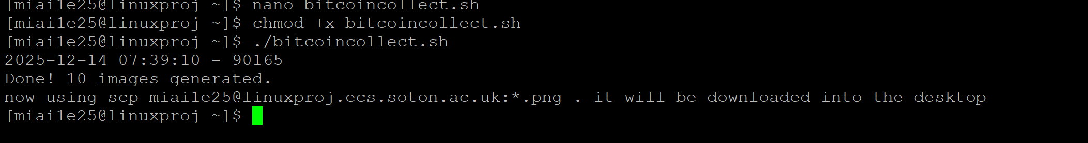
Figure 3: proof of working code.
Chmod +x bitcoincollect.sh to make the file executable.
./bitcoincollect.sh to execute the file.
Then the output we get is in this form.
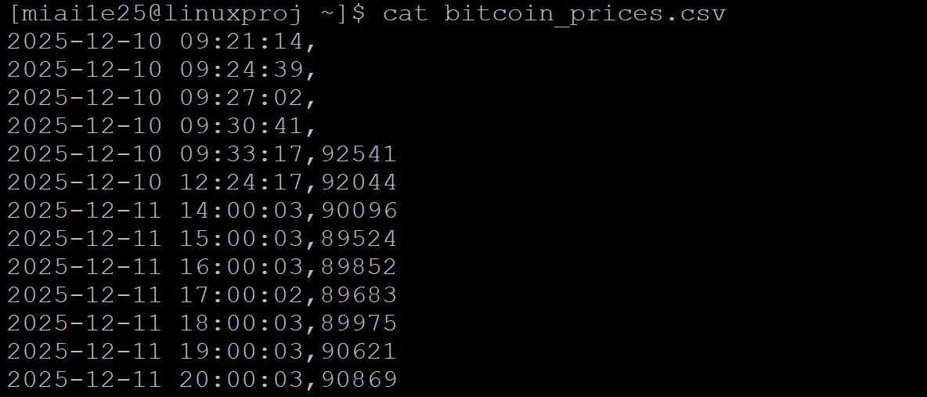
Figure 4: example of the storage bitcoin_prices.csv contents
This figure shows the command cat which sends all the contents of the file out .
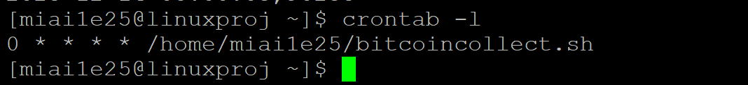
Figure 5: automation configuration using crontab.
The four asterisks (*) represent wildcards for every hour,Day, Month, and Day of Week. Where the minutes is zero data will be collected which means at every start of a new hour data will be collected and the absolute path to make sure the crontab knows where the file is.
2.1)data plotting file is called ”make_plots.sh”(the full code will be on github repo):
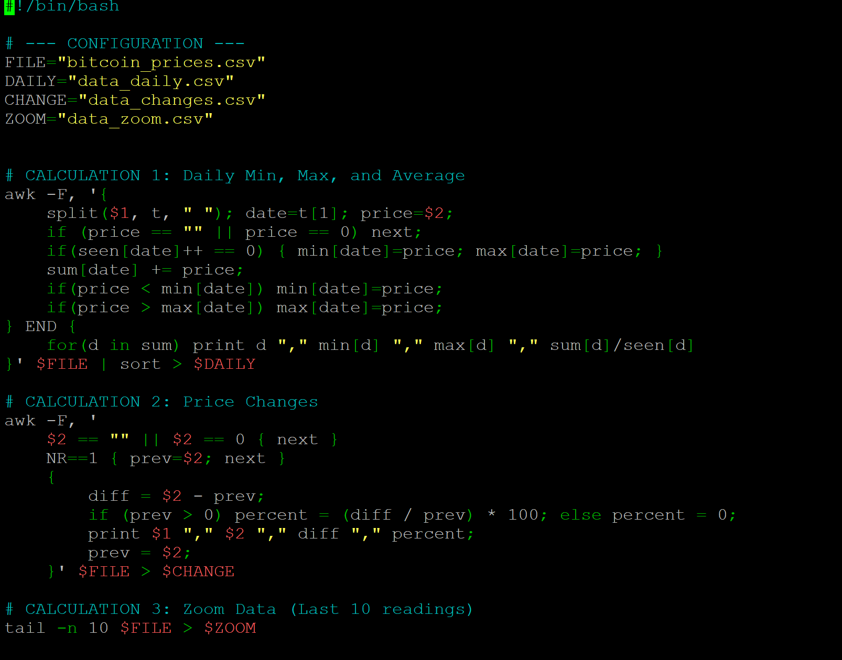
Figure 6: shows the calculations used in the plotting.
The first line #!/bin/bash (called shebang) tells the Linux system to interpret it using Bash shell.
Configuration: it acts like variables so instead of writing bitcoin_prices.csv many times we just write $File.

Calculation 1:
awk -F , means split whenever you see a comma.
it splits the year,month and day from the full time stamp and t array carries the date and insert it into variable date and price $2 just reads the second column from bitcoin_prices.csv file and saves it into variable price.
if (price == "" || price == 0) next; command checks if price is zero or none if it is valid it proceeds normally if not the next command will skip this line.
if(seen[date]++ == 0) { min[date]=price; max[date]=price; } sum[date] += price; command means If it is the first time this date is shown it will be the minimum, the maximum. Crucially, every time it will be added to the sum and increment seen variable by 1.
if(price < min[date]) min[date]=price; command means if the current price is less than the lowest saved if yes it will replace it .
if(price > max[date]) max[date]=price; command means if the current price is more than the highest saved if yes it will replace it .
End block is the final output: for (d in sum) print d ”,” min[d] ”,” max[d] ”,” sum[d]/seen[d].command means in the for loop it goes through every d in the loop and get average then print out min, max & avg It gets data from bitcoin_prices.csv and sends it sorted in order to data_daily.csv.
Calculation 2:
awk -F , means split whenever you see a comma.
$2 == "" || $2 == 0 { next } checks if column 2 is empty or equal to zero in this case next command skip this line.
NR==1 { prev=$2; next } checks if this is the first record if yes in that case it saves it in variable prev and directly next command occurs skipping this line.
diff = $2 - prev; subtracts the value obtained from the second column with the prev data and saves into variable diff.
if (prev > 0) percent = (diff / prev) * 100; else percent = 0; checks if prev is greater than zero because dividing by zero will cause the program to crash so percent variable takes direct zero if it is valid variable percent will get a value using the equation.
print $1 "," $2 "," diff "," percent; means the output will be date, current price, difference and percentage.
prev = $2; prev variable will be modified to a new value at the end.
' $FILE > $CHANGE means data_changes.csv will receive data from bitcoin_prices.csv and changes file will be overwritten everytime.
Calculation 3:
tail -n 10 $FILE > $ZOOM command tail read data from the end of the file flag -n forces it to take the last 10 lines and file data_zoom.csv will receive data from bitcoin_prices.csv and the zoom file will be overwritten every time.
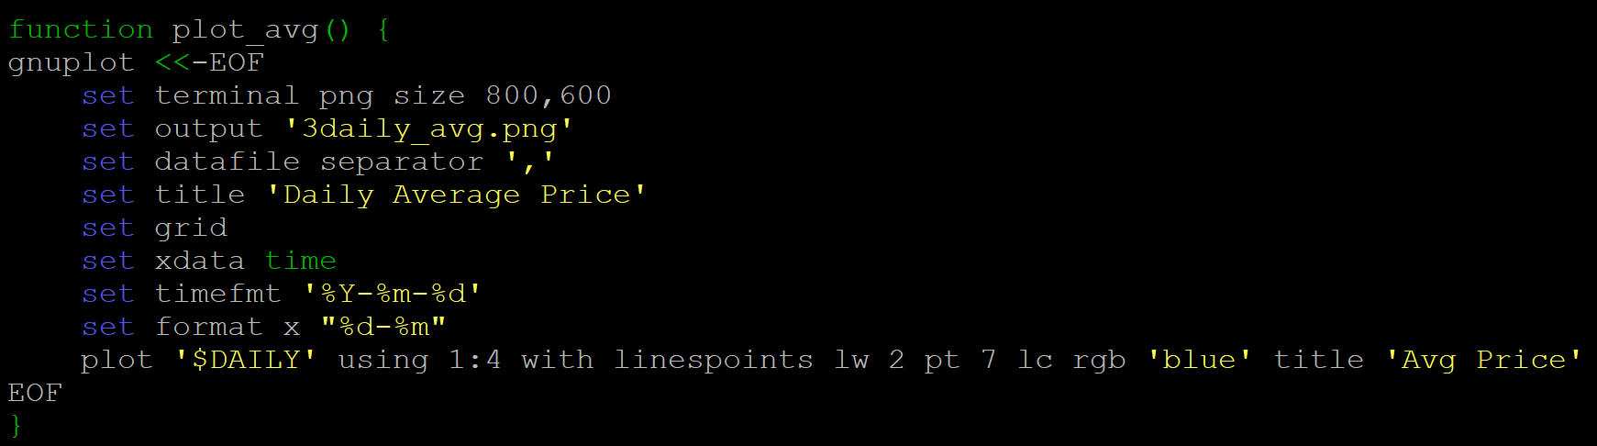
Figure 7: the average function which shows that calculation 1 works:
Gnuplot <<-EOF means insert everything in EOF into gnuplot. set terminal png size 800,600 means ]output will be image in png format 800 pixels width 600 pixels tall. set output '3daily_avg.png' means output will be in file 3daily_avg.png. set datafile separator ',' normally gnuplot uses spaces as separators now it will use commas. set title 'Daily Average Price' means title will be Daily Average Price. set grid means setting grid normally. set xdata time set timefmt '%Y-%m-%d' set format x "%d-%m" means telling gnuplot that these are not just data they are dates and timefmt informs gnuplot how to read the data and format x are their format and how they are expressed in the plot. plot '$DAILY' using 1:4 with linespoints lw 2 pt 7 lc rgb 'blue' title 'Avg Price' reads data from data_daily.csv plot column 1 on x axis and column 4 on y axis then draws dots and connect them to show a trend with line width 2 and point type 7 which is filled circles colour blue and key name Avg Price.
Other functions are the same only difference is in the title, format x and input source file and the column index. 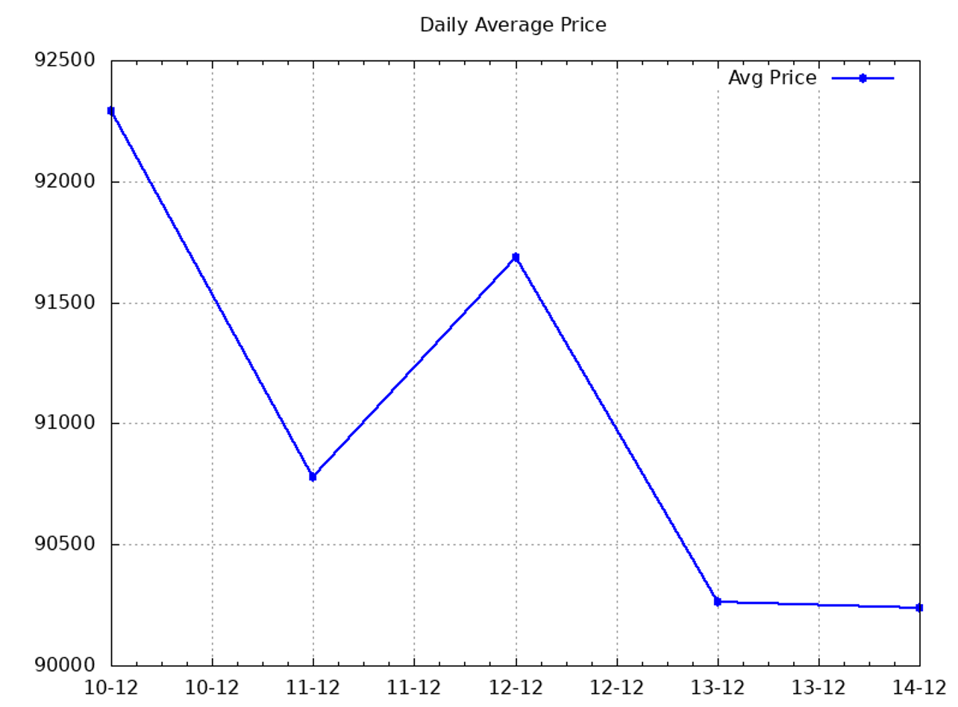
Figure 8: shows the daily Average price plot.
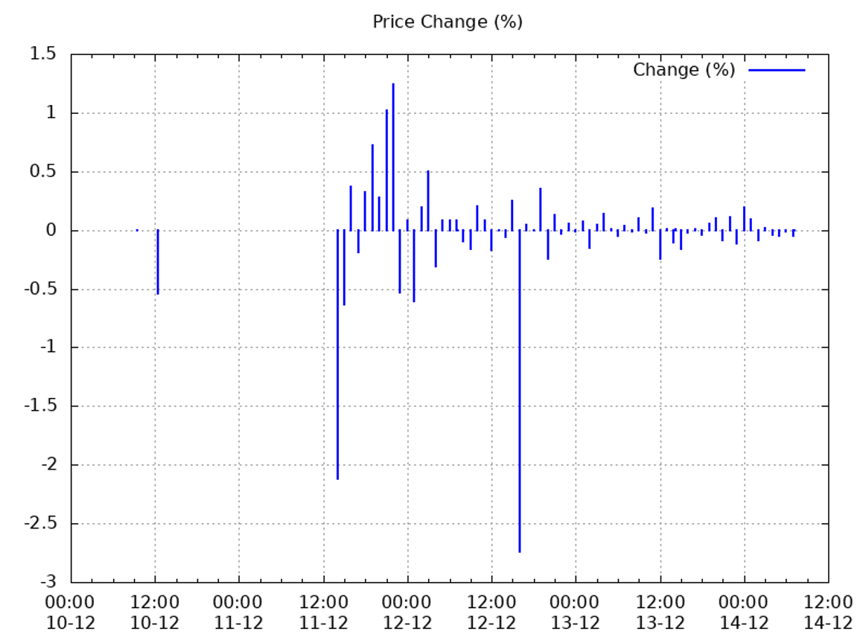
Figure 9: shows the price change % plot.

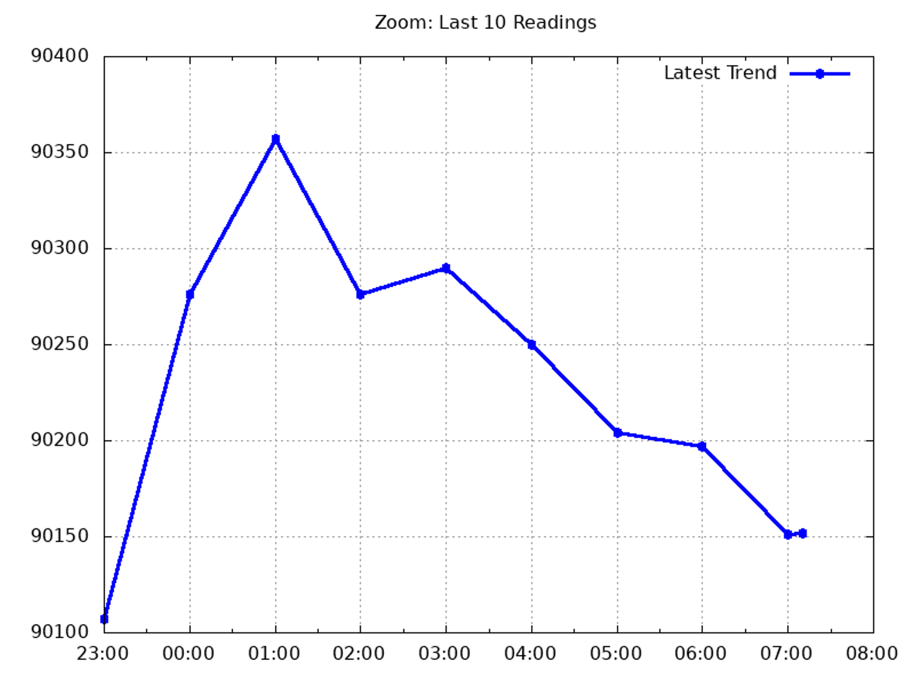
. Figure 10: shows the zoom plot.
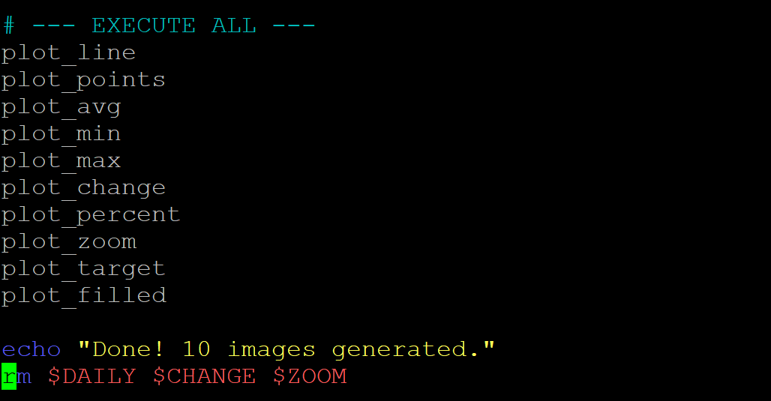
Figure 11: shows that at the end of the code all functions are executed a print message given and remove files data_daily.csv, data_changes.csv and data_zoom.csv.
Git hub repo link: https://github.com/MohamedIbrahim768/Bitcoin-tracker

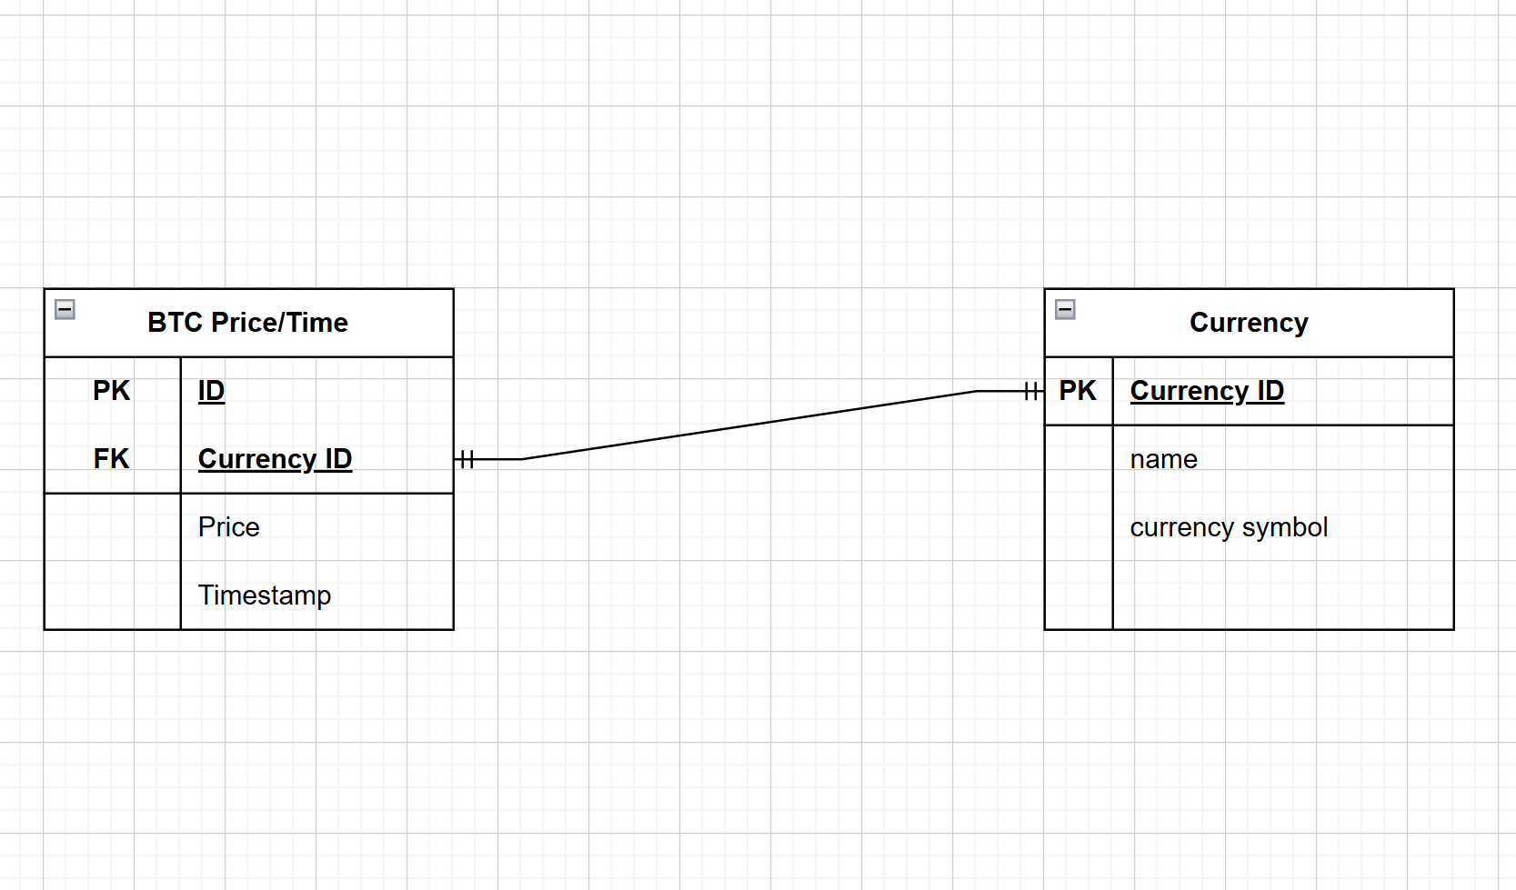
Figure 12: shows the ERD diagram for the cryptocurrency tracker database .

