**Threads**

**Operating system**

**LAB**

**NAME:** Mohamed Ibrahim El-Metwaly

**ID:** 3804

**GROUP:**  4

**Matrix Multiplications:**

-There are three files:

1- main.c

2- interface.h: contains the prototypes of used functions

3- prog.c: contains the implementations of the used functions

Major function:

1. Void readMatrix(char* ptr): take name of file as parameter then read the size of the matrices and fill the two matrices
2. Void multiplyMatrix(int thread_e0_r1): the parameter thread_e0_r1 specifies if the multiplication is done using thread for each element or thread for each row , then create threads and send the coordinates of each elements (thread for element) or coordinates of each row
3. Void thread_element(void* parm): make the multiplication of row by column to get element by element and cast the coordinates parm to be a pointer to struct
4. Void thread_row(void* parm): make the multiplication of row by all columns to get the row by row and cast parm to be a pointer to struct
5. Void writematrix(int** matrix, int row, int column, double timeTaken): write the matrix and time taken in a file called “output.txt”

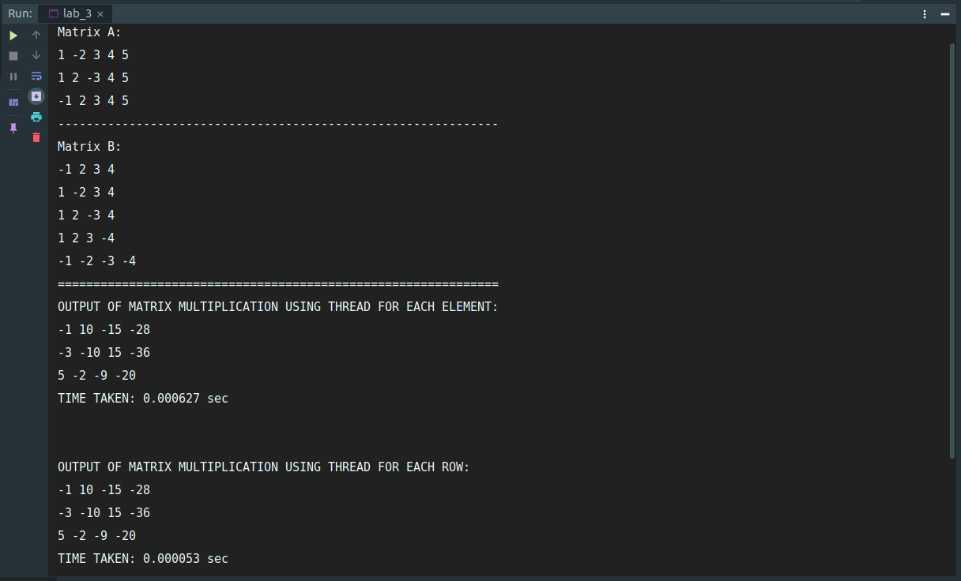

**Merge Sort using Threads:**

-There are three files:

1- main.c

2- interface.h: contains the prototypes of used functions

3- prog.c: contains the implementations of the used functions

**Main Functions:**

**1**-int readArray(char* ptr): read the unsorted array from file which is specified by ptr

**2-**MergeSortByThreads(int size_of_array): make the mainthread that calls function mergeSort function

3-void* mergeSort(void* parm): function that divide the array into subarrays and the division is done each time by creating a thread parm is casted to be pointer to struct that carries the indices

4-void merge(int first_index, int last_index): make the actual merge between the subarrays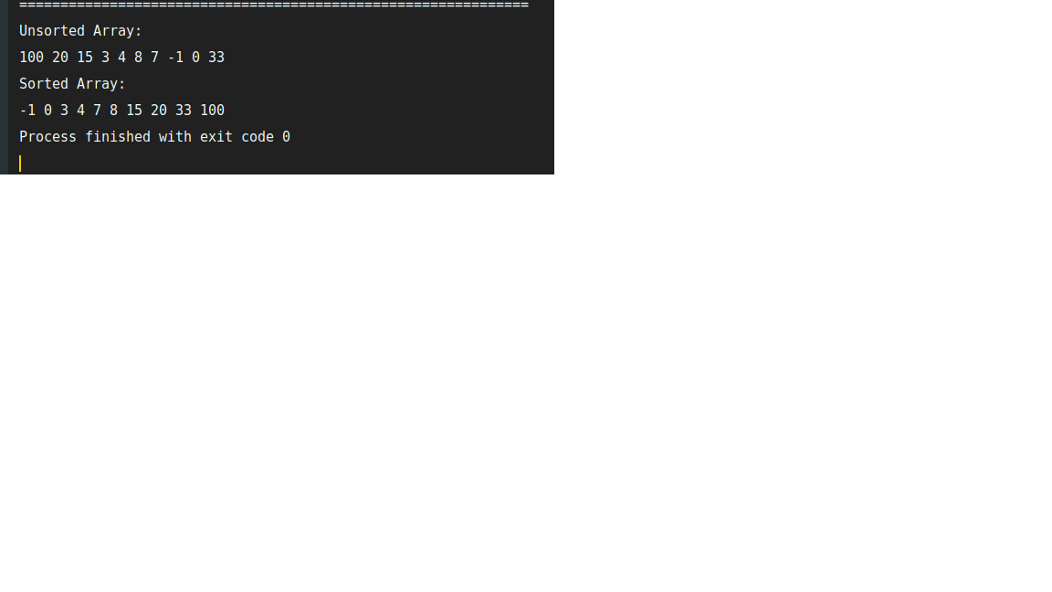

**References:**

-This link helped me to understand the pthread functions:

“https://macboypro.wordpress.com/2009/05/20/matrix-multiplication-in-c-using-pthreads-on-linux/?fbclid=IwAR1Dlr4avE5s4qJv3x68O-i8Mm2kHzBn1R2jk1YMlUTwyX3H0P9W17Z7oIU”