TIC and Technologies Report

Ouweis wail sari-bey

December 29, 2023

**Contents**

1. Introduction 2
2. Google Services 2
3. Microsoft Tools 3

3.1 Microsoft 365 . . . . . . . . . . . . . . . . . . . . . . . . . . . . . . . . . **3**

3.2 Azure . . . . . . . . . . . . . . . . . . . . . . . . . . . . . . . . . . . . . **4**

1. Git and GitHub 5

4.1 Git . . . . . . . . . . . . . . . . . . . . . . . . . . . . . . . . . . . . . . . **5**

4.2 GitHub . . . . . . . . . . . . . . . . . . . . . . . . . . . . . . . . . . . . **5**

1. Conclusion 6

# Introduction

Information and Communication Technologies (TIC) have revolutionized the way we live and work. This report explores key technologies in the TIC domain, with a focus on Google services, Microsoft tools, Git, and GitHub.

# Google Services

Google offers a diverse range of services that have become integral to our digital experi- ence. Table 1 provides an overview of some key Google services.

|  |  |
| --- | --- |
| **Service** | **Description** |
| Gmail | Email service with powerful search capabilities. It pro-  vides features like labels, filters, and integrations with  other Google services. |
| Google Drive | Cloud storage and collaboration platform. It allows  users to store files, share them with others, and col- laborate in real-time on documents, spreadsheets, and  presentations. |
| Google Docs | Online document editing and collaboration. Multiple  users can work on the same document simultaneously,  and changes are saved in real-time. |
| Google Sheets | Online spreadsheet application. Similar to Google Docs,  it supports real-time collaboration and offers powerful  spreadsheet functionalities. |
| Google Slides | Online presentation creation and sharing. Users can col-  laborate on presentations, add comments, and deliver  presentations online. |

Table 1: Key Google Services

# Microsoft Tools

Microsoft provides a suite of tools and services catering to various needs. Figure 1 displays the Microsoft logo.



Figure 1: Microsoft Logo

## Microsoft 365

Microsoft 365 integrates productivity applications with cloud services. Table **??** outlines some components of Microsoft 365.

|  |  |
| --- | --- |
| **Component** | **Description** |
| Word | Word processing application. It offers advanced format-  ting options, collaboration features, and compatibility with various document formats. |
| Excel | Spreadsheet software. Excel provides powerful data  analysis tools, charting, and the ability to create com- plex formulas and macros. |
| PowerPoint | Presentation creation tool. Users can create dynamic  presentations with multimedia content, transitions, and animations. |
| Teams | Collaboration platform for chat, video, and file sharing.  Microsoft Teams facilitates communication and collab-  oration within teams, supporting virtual meetings and shared workspaces. |

## Azure

Microsoft Azure is a comprehensive cloud computing platform offering various services. Figure 2 illustrates the Azure services landscape.



Figure 2: Microsoft Azure Services Microsoft Azure provides a wide range of services, including:

* + - **Virtual Machines (VMs):** Allows users to deploy and manage virtual machines

in the cloud.

* + - **Azure Blob Storage:** Scalable object storage for documents, images, and other unstructured data.
    - **Azure SQL Database:** A fully managed relational database service.
    - **Azure AI Services:** Provides machine learning and AI capabilities for developers.

# Git and GitHub

Git and GitHub are fundamental to modern software development practices.

## Git

Git is a distributed version control system. It allows for efficient tracking of code changes. Table **??** showcases some common Git commands.

|  |  |
| --- | --- |
| **Command** | **Description** |
| git init | Initialize a new Git repository. |
| git add | Add changes to the staging area. |
| git commit | Record changes in the repository. |
| git push | Push changes to a remote repository. |

Git allows for branching, merging, and collaboration among multiple developers. It is widely used in open-source and private software projects.

## GitHub

GitHub enhances collaboration with features like pull requests and issue tracking. Figure 3 illustrates a typical GitHub workflow.

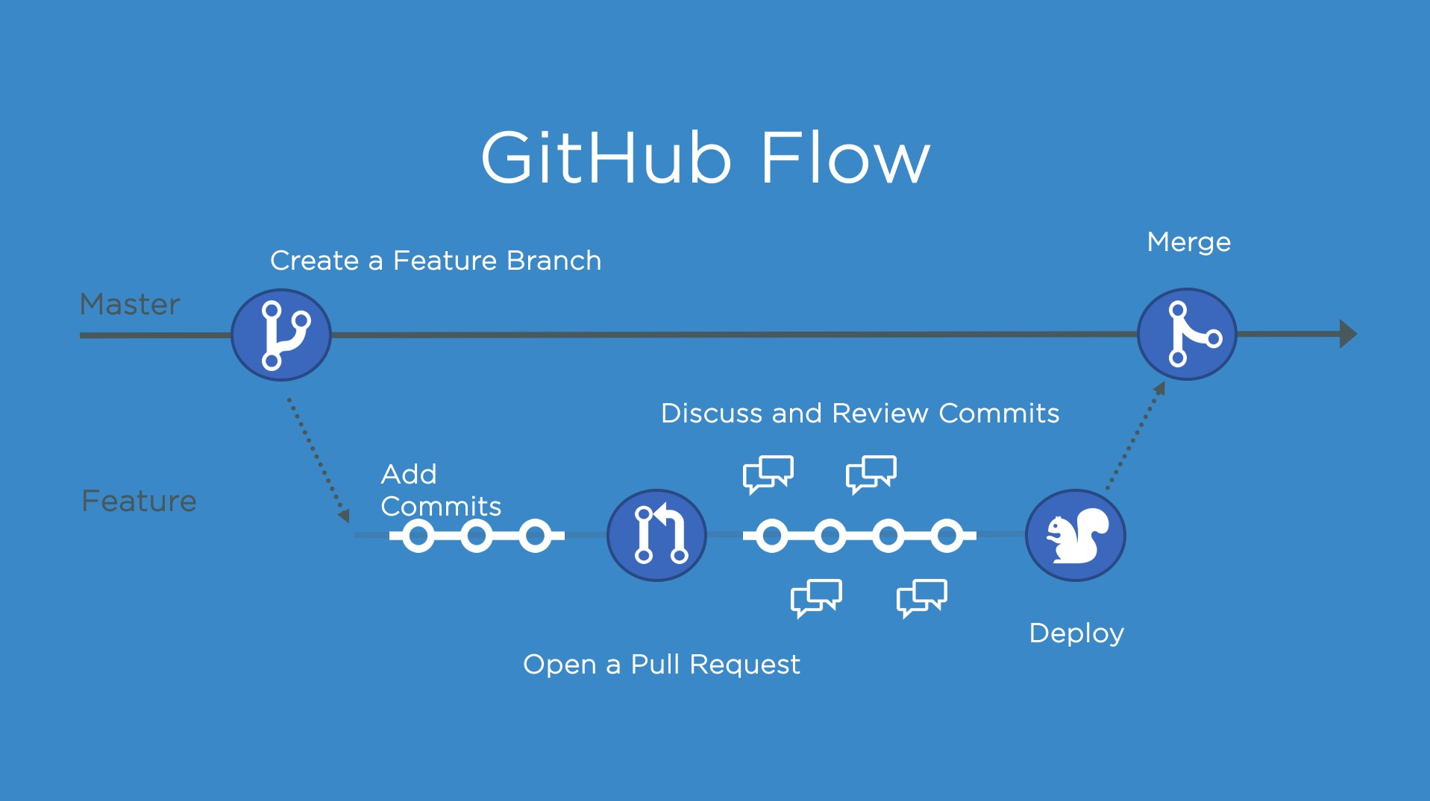

Figure 3: GitHub Workflow

GitHub provides a platform for hosting Git repositories, and it includes features such as:

* **Pull Requests:** Allows developers to propose changes, discuss, and review code before merging.
* **Issues:** Enables tracking and discussion of bugs, enhancements, and other tasks.
* **Actions:** Automates workflows such as building, testing, and deploying code.

# Conclusion

In conclusion, TIC and associated technologies, including Google services, Microsoft tools, Git, and GitHub, play a pivotal role in shaping the digital landscape. Embracing these tools can enhance productivity, collaboration, and software development processes.