TIC and Technologies: A Comprehensive Report

Ouweis Wail Sari-Bey

**Contents**

1. Introduction 2
2. Google Services 2

2.1 Google Drive . . . . . . . . . . . . . . . . . . . . . . . . . . . . . . . . . 2

2.2 Google Workspace . . . . . . . . . . . . . . . . . . . . . . . . . . . . . . 3

1. Microsoft Tools 3

3.1 Microsoft 365 . . . . . . . . . . . . . . . . . . . . . . . . . . . . . . . . . 3

3.1.1 Word . . . . . . . . . . . . . . . . . . . . . . . . . . . . . . . . . . 4

3.1.2 Excel . . . . . . . . . . . . . . . . . . . . . . . . . . . . . . . . . . 4

3.1.3 PowerPoint . . . . . . . . . . . . . . . . . . . . . . . . . . . . . . 4

3.1.4 Outlook . . . . . . . . . . . . . . . . . . . . . . . . . . . . . . . . 4

3.1.5 OneNote . . . . . . . . . . . . . . . . . . . . . . . . . . . . . . . . 4

3.1.6 Teams . . . . . . . . . . . . . . . . . . . . . . . . . . . . . . . . . 4

3.1.7 SharePoint . . . . . . . . . . . . . . . . . . . . . . . . . . . . . . . 4

3.1.8 OneDrive . . . . . . . . . . . . . . . . . . . . . . . . . . . . . . . 4

3.1.9 Planner . . . . . . . . . . . . . . . . . . . . . . . . . . . . . . . . 5

3.1.10 Yammer . . . . . . . . . . . . . . . . . . . . . . . . . . . . . . . . 5

3.1.11 Azure . . . . . . . . . . . . . . . . . . . . . . . . . . . . . . . . . 5

1. Git and GitHub 6

4.1 Git Basics . . . . . . . . . . . . . . . . . . . . . . . . . . . . . . . . . . . 6

4.2 GitHub . . . . . . . . . . . . . . . . . . . . . . . . . . . . . . . . . . . . 6

4.2.1 Git Workflow . . . . . . . . . . . . . . . . . . . . . . . . . . . . . 7

4.2.2 Collaboration on GitHub . . . . . . . . . . . . . . . . . . . . . . . 7

1. Conclusion 8

# Introduction

Information and Communication Technologies (TIC) play a pivotal role in the mod- ern digital landscape, encompassing a wide array of tools and services that facilitate communication, collaboration, and information management. This report explores key technologies related to TIC, including Google services, Microsoft tools, Git, GitHub, and additional tools such as Azure.

# Google Services

Google offers a suite of services that significantly contribute to TIC. Among these, Google Drive stands out as a versatile cloud-based storage and collaboration platform.

## Google Drive

Google Drive provides users with seamless cloud storage, enabling them to store, access, and share files from anywhere with an internet connection. Its collaborative features allow multiple users to work on documents, spreadsheets, and presentations in real-time.

Google Drive Features:

* + - **Cloud Storage:** Google Drive provides scalable cloud storage for various file types.
    - **Collaboration:** Real-time collaboration features enable multiple users to work on documents simultaneously.
    - **Access Anywhere:** Users can access their files from any device with internet connectivity.

Table 1: Google Drive Features

|  |  |
| --- | --- |
| **Feature** | **Description** |
| Cloud Storage | Provides file storage in the cloud |
| Collaboration | Allows real-time collaboration on documents |
| Access Anywhere | Users can access files from any device |



Figure 1: Google Drive Interface

## Google Workspace

Google Workspace, formerly known as G Suite, is a suite of cloud-based productivity and collaboration tools by Google. It includes applications such as Gmail, Google Docs, Google Sheets, Google Slides, and more.

* + - **Gmail:** A popular email service with powerful search capabilities and integrated communication features.
    - **Google Docs:** A collaborative word processing application for creating and editing documents online.
    - **Google Sheets:** A spreadsheet application for analyzing and visualizing data with built-in collaboration features.
    - **Google Slides:** A presentation application for creating and delivering dynamic presentations.

Google Workspace enhances communication and collaboration within organizations.

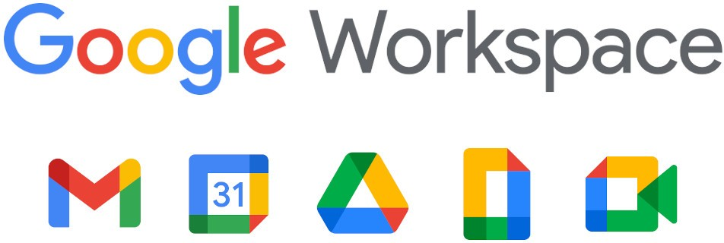

Figure 2: Google Workspace

# Microsoft Tools

Microsoft offers a comprehensive suite of cloud-based productivity tools and services known as Microsoft 365.

## Microsoft 365

Microsoft 365 is a comprehensive suite of cloud-based productivity tools and services designed to empower individuals, organizations, and businesses. It integrates a variety of applications and services to enhance collaboration, communication, and productivity across different devices.

### Word

Microsoft Word is a word processing application that allows users to create, edit, and format documents. It provides a range of features for text formatting, spell checking, and document layout. Word is widely used for creating reports, letters, and other written documents.

### Excel

Microsoft Excel is a powerful spreadsheet application that enables users to create, analyze, and visualize data. It includes features for creating formulas, charts, and graphs, making it an essential tool for tasks such as financial analysis, data tracking, and reporting.

### PowerPoint

Microsoft PowerPoint is a presentation software that allows users to create dynamic and engaging slideshows. It provides features for adding text, images, videos, and animations to convey information effectively. PowerPoint is commonly used for business presenta- tions, educational lectures, and more.

### Outlook

Microsoft Outlook is an email client and personal information manager. It offers email organization, calendaring, task management, and contact management features. Outlook is widely used for professional email communication and managing schedules.

### OneNote

Microsoft OneNote is a digital note-taking application that allows users to create and organize notes, drawings, and multimedia content. It provides a flexible and collaborative platform for capturing and sharing ideas across different devices.

### Teams

Microsoft Teams is a collaboration platform that integrates chat, video conferencing, file sharing, and application integration. It facilitates communication and collaboration within teams, making it a central hub for remote and in-person teamwork.

### SharePoint

Microsoft SharePoint is a web-based collaboration platform that enables organizations to create, manage, and share documents and information. It supports document libraries, version control, and workflow automation, fostering efficient collaboration among team members.

### OneDrive

OneDrive is a cloud storage service provided by Microsoft, integrated into the Microsoft 365 suite. It allows users to store, sync, and share files securely in the cloud. OneDrive ensures that users have access to their files from any device with an internet connection.

### Planner

Microsoft Planner is a task management application that helps teams organize and pri- oritize work. It provides a visual interface for creating, assigning, and tracking tasks, fostering teamwork and project management.

### Yammer

Yammer is an enterprise social networking service that facilitates communication and collaboration across an organization. It enables users to connect, share information, and engage in conversations in a social media-style environment.

### Azure

Microsoft Azure, often referred to simply as Azure, is a comprehensive cloud computing platform that provides a wide range of services, including computing power, storage, databases, machine learning, and more. Azure enables organizations to build, deploy, and manage applications and services through a global network of data centers.

Azure services include:

* + - * **Virtual Machines (VMs):** Allows the deployment of virtualized Windows or Linux servers in the cloud.
      * **Azure Blob Storage:** Provides scalable and secure object storage for large amounts of unstructured data.
      * **Azure SQL Database:** A fully managed relational database service with built-in intelligence.
      * **Azure Kubernetes Service (AKS):** Simplifies the deployment, management, and scaling of containerized applications using Kubernetes.
      * **Azure Cognitive Services:** Offers a set of AI services and APIs for vision, speech, language, and decision capabilities.
      * **Azure DevOps Services:** A set of development tools for planning, tracking, and discussing work across teams.



Figure 3: Microsoft Azure Logo

Microsoft Azure is widely used by businesses for scalable and flexible cloud solutions, allowing them to focus on innovation and growth.

# Git and GitHub

Version control is fundamental to software development, and Git, along with GitHub, has become the de facto standard for source code management.

## Git Basics

Git is a distributed version control system that allows developers to track changes in their codebase efficiently. It provides a decentralized and robust way to manage code, enabling collaboration among developers. Some fundamental Git commands include:

Table 2: Git Commands

|  |  |
| --- | --- |
| **Command** | **Description** |
| git clone | Clone a repository into a new directory |
| git init | Initialize a new Git repository |
| git add | Add changes to the staging area |
| git commit | Record changes to the repository |
| git pull | Fetch from and integrate with another repository or a local branch |
| git push | Update remote repository with local changes |

## GitHub

GitHub is a web-based platform built on top of Git that enhances collaboration and provides additional features for project management. Key features of GitHub include:

* + - **Repository Hosting:** GitHub allows users to host Git repositories online, provid- ing a centralized location for collaboration.
    - **Pull Requests:** Developers can propose changes to a project by submitting pull requests. This facilitates code review and collaboration among team members.
    - **Issues and Projects:** GitHub provides tools for issue tracking and project man- agement, helping teams organize and prioritize work.
    - **Branching and Merging:** GitHub simplifies branching and merging workflows, making it easier for teams to work on different features concurrently.
    - **Collaboration Tools:** GitHub includes features such as wikis, discussions, and actions to enhance collaboration and automation within projects.



Figure 4: GitHub Logo

### Git Workflow

Understanding the Git workflow is crucial for efficient collaboration. Here is a simplified version of a typical Git workflow:

* + - 1. **Clone:** Developers clone a repository to get a local copy of the code on their machine.
      2. **Branch:** Developers create a new branch to work on a specific feature or bug fix, keeping the main codebase clean.
      3. **Commit:** Developers make changes to the code and commit them to their local branch.
      4. **Push:** Changes are pushed to the remote repository, making them available for others to see.
      5. **Pull Request:** Developers create a pull request to propose changes and initiate a code review.
      6. **Review:** Team members review the code, provide feedback, and discuss changes.
      7. **Merge:** Once the changes are approved, the branch is merged into the main code- base.

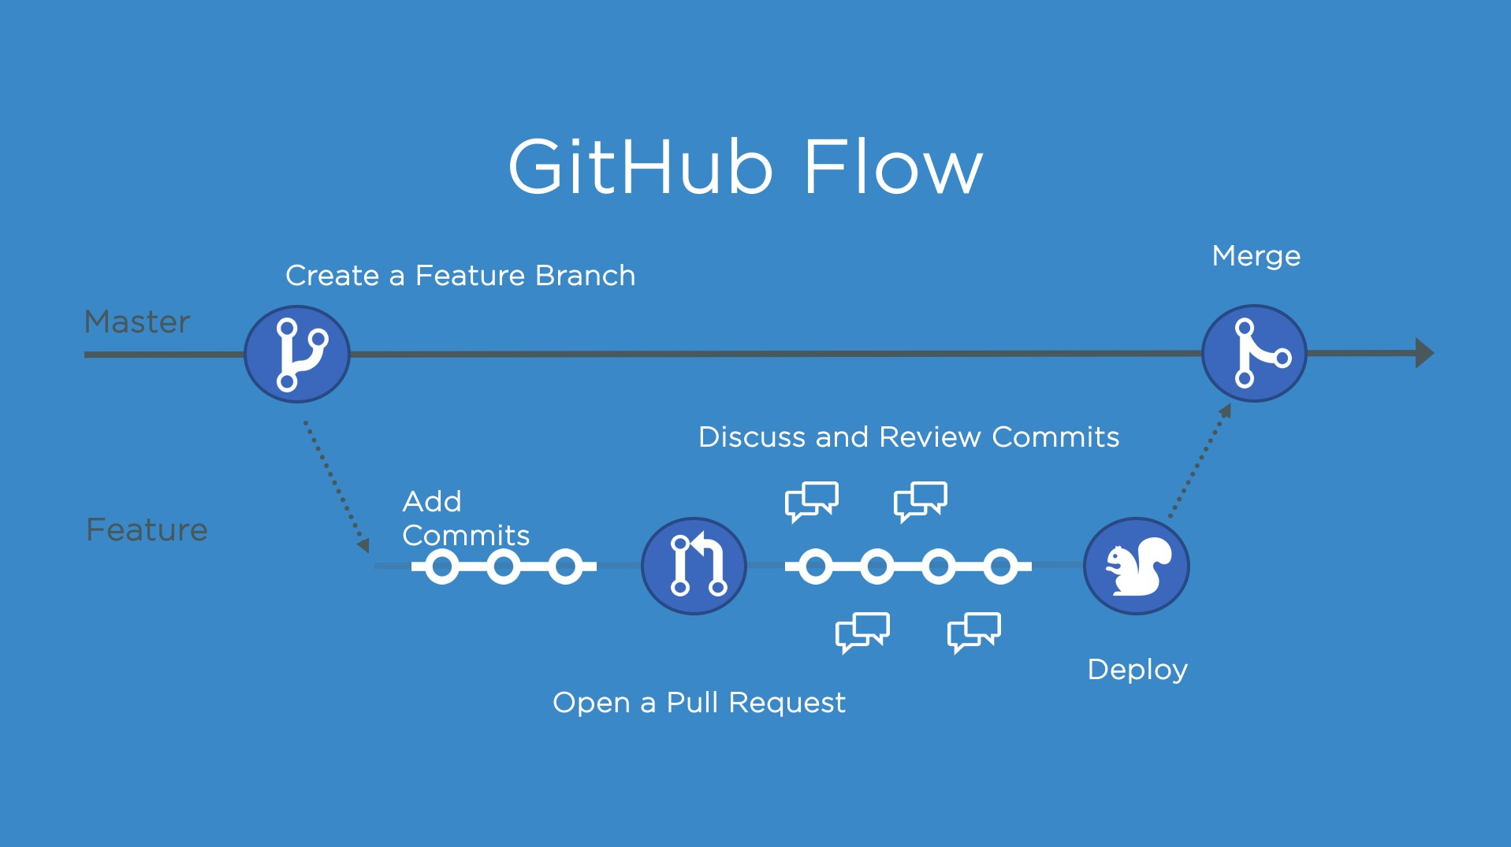

Figure 5: Git Workflow

### Collaboration on GitHub

GitHub provides features that facilitate collaboration among team members:

* **Code Review:** Pull requests enable thorough code review, with discussions and feedback directly within the code.
* **Issues and Labels:** GitHub’s issue tracking system helps manage tasks, bugs, and enhancements. Labels can be used to categorize and prioritize issues.
* **GitHub Actions:** Automated workflows can be set up using GitHub Actions for tasks such as testing, building, and deploying code.

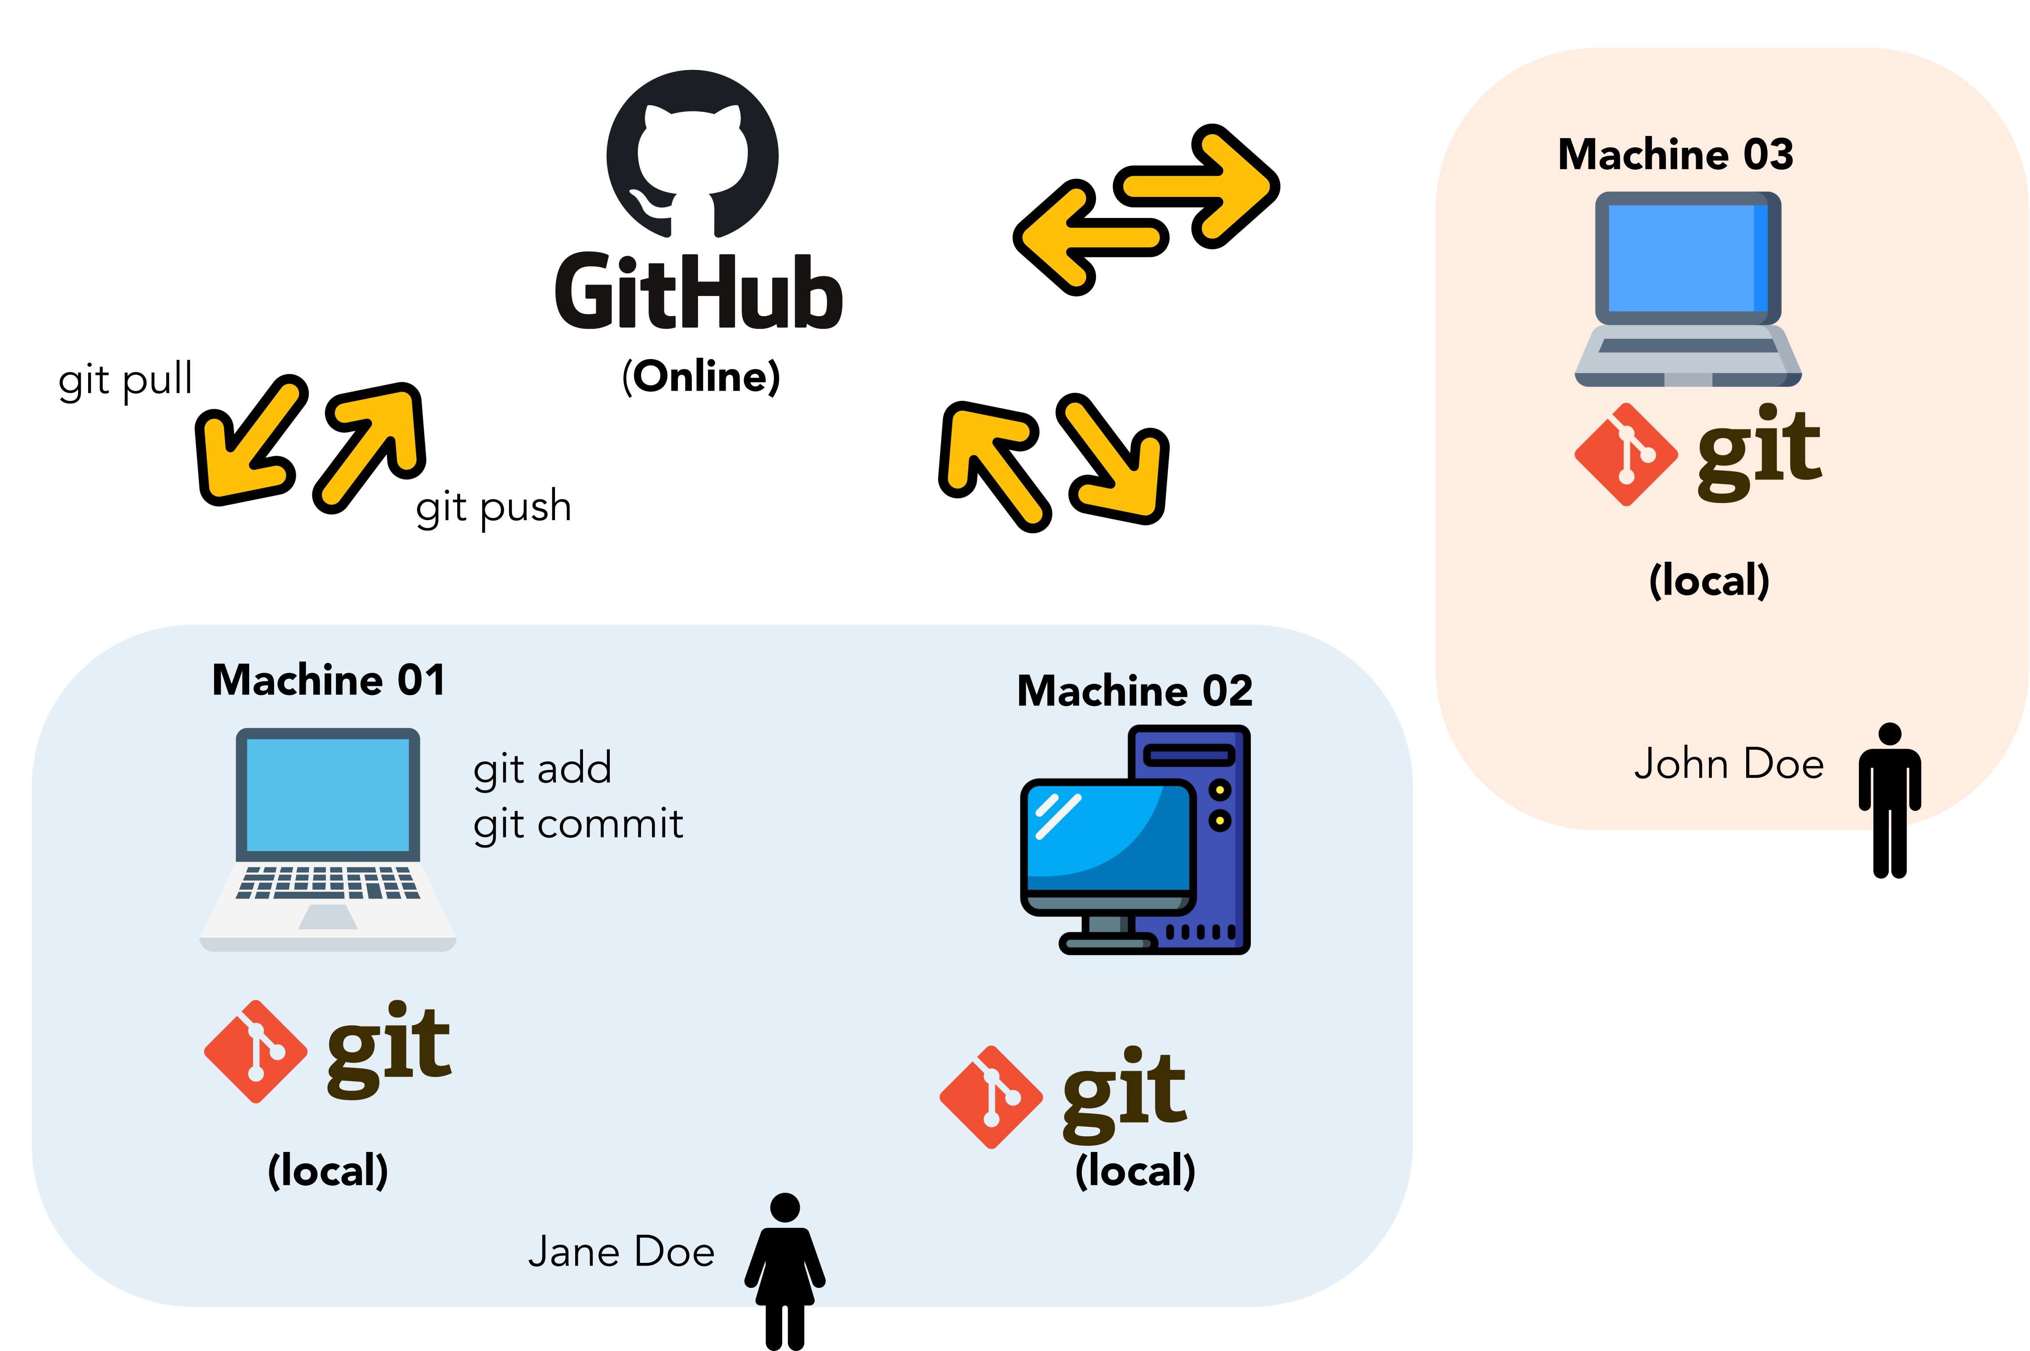

Figure 6: GitHub Collaboration

In summary, Git and GitHub are integral tools for version control and collaborative software development. Git provides the underlying version control system, while GitHub enhances collaboration, project management, and code review processes.

# Conclusion

In conclusion, the technologies discussed in this report represent critical components of the TIC landscape. Google services, Microsoft tools, Git, GitHub, and Azure offer powerful solutions for information management, collaboration, version control, and cloud comput- ing. As the digital realm continues to evolve, staying proficient in these technologies is essential for individuals and organizations alike.