CPE301 – SPRING 2019

Design Assignment 1A

Student Name: Mohamad Jundi

Student #: 8000321867

Student Email: jundi@unlv.nevada.edu

Primary Github address: https://github.com/MohamedJundi1994/Submission_DA.git

Directory: Documents\School\CPE 301\Repository\CPE_301\DesignAssignments\DA1A

1. **COMPONENTS LIST AND CONNECTION BLOCK DIAGRAM w/ PINS**

NONE

1. **INITIAL/MODIFIED/DEVELOPED CODE OF TASK 1/A**

My Code:

;

; Lab1A-F19.asm

;

; Created: 2/9/2019 1:33:16 PM

; Author : Mohamad Jundi

;

LDI R24, 0x04 // Loading 16 bit number to register (multiplicand)

LDI R25, 0xD2 // Loading 16 bit number to register (multiplicand)

LDI R22, 0x0A // Loading 8 bit number to register (mutiplier)

LDI R20, 0 // Reserving register for storing result of 16 bit

LDI R19, 0 // Reserving register for storing result of 16 bit

LDI R18, 0 // Reserving register for storing result of 24 bit

LDI R26, 0 // Reserving register for carry addition

CPSE R22, R26 // Compare registers to make sure it is zero

JMP add_loop // Jump to loop if not zero

LDI R16, 0 // load zero to register as place holder

JMP stop // jump to stop if it is zero

add_loop: // Loop begins for repeated adding

ADD R20, R25 // Adding 16 bit multiplicand, and storing into register

ADC R19, R24 // Carry adding 16 bit multiplicand, and storing into register

ADC R18, R26 // Carry adding 16 bit multiplicand for 24 bit result, and storing into register

DEC R22 // Decrementing multiplier until 0, so loop can stop

BRNE add_loop // Branching, add_loop will repeat until multiplier is 0.

// Verifying answer using MUL

LDI R30, 0 // Reserving register for storing verified result

LDI R29, 0 // Reserving register for storing verified result

LDI R28, 0 // Reserving register for storing verified result

LDI R22, 0x0A // Loading 8 bit number to register (mutiplier)

MUL R22, R25 // Multiply values of registers together and storing high bit in R1 and low bit in R0

ADD R30, R0 // Add low bit value from R0 and store into R30

ADC R29, R1 // Add high bit value from R1 with carry and store into R30

MUL R22, R24 // Multiply values of registers together and storing high bit in R1 and low bit in R0

ADD R29, R0 // Add low bit value from R0 and store into R29

ADC R28, R1 // Add high bit value from R1 and store into R28

stop: // Stop running program

BREAK

1. **DEVELOPED MODIFIED CODE OF TASK 2/A from TASK 1/A**

No modifications, just developed code.

1. **SCHEMATICS**

NONE

1. **SCREENSHOTS OF EACH TASK OUTPUT (ATMEL STUDIO OUTPUT)**

**Different Examples:**

Example 1:

Code:

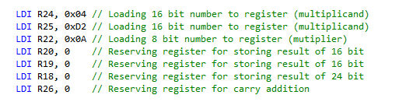

Result:

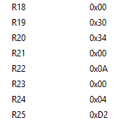

Example 2:

Code:

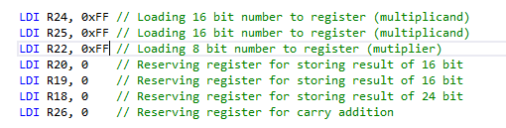

Result:

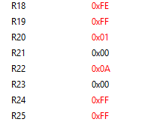

**Verify:**

Code:

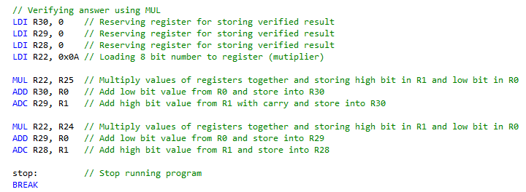

Result:

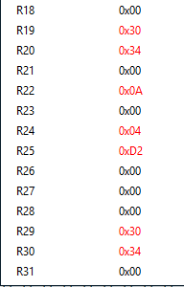

1. **SCREENSHOT OF EACH DEMO (BOARD SETUP)**

NONE

1. **VIDEO LINKS OF EACH DEMO**

NONE

1. **GITHUB LINK OF THIS DA**

Link: https://github.com/MohamedJundi1994/Submission_DA.git

This assignment submission is my own, original work.

MOHAMAD JUNDI