CPE301 – SPRING 2019

Design Assignment 3A

Student Name: Mohamad Jundi

Student #: 8000321867

Student Email: jundi@unlv.nevada.edu

Primary Github address: https://github.com/MohamedJundi1994/Submission_DA.git

Directory: Documents\School\CPE 301\Repository\CPE_301\DesignAssignments\DA3A

1. **COMPONENTS LIST AND CONNECTION BLOCK DIAGRAM w/ PINS**

USB port => Xplained Mini => FTDI => PuTTY

1. **INITIAL/MODIFIED/DEVELOPED CODE OF TASK 1/A**

My Code:

#define *F_CPU* 16000000UL // Run at 16MHz

#include <avr/io.h>

#include <avr/interrupt.h> // Interrupt library included

#include <stdio.h> // Stdio library included

#define BAUDRATE 9600 // Needed for communication with board

#define BAUD_PRESCALLER (((*F_CPU* / (BAUDRATE * 16UL))) - 1) // Needed for communication with board

void USART_init( unsigned int ubrr ); // Used to call function for integer

void USART_tx_string( char *data ); // Used to call function for string

char String[] = "I LOVE PANCAKES"; // "I LOVE PANCAKES" will display and be used to hold string value

char outs[25]; // Display 25 spaces when running

char blank[] = " "; // Used for spacing

int ran_dom; // Used for random number holder

float my_number = 19.94; // Used 19.94 as my float number

int main(void)

{

sei(); // Declare global interrupt

TCCR1A |= (1 << CS12 | (1 << CS10)) ; // Used to set prescaler of 1024

TIMSK1 = (1 << TOIE1); // TOIE1 will be set high and enable overflow

TCNT1 = 49911; // Set to count from 49911 to count up to 65535 to achieve 1 second

USART_init(BAUD_PRESCALLER); // Used to initialize USART BAUD PRESCALLER

USART_tx_string("Connected!\r\n"); // Used to initialize and give heads up for display

USART_tx_string(blank); // Inserted to make a separation

while (1)

{

// loop forever

}

}

ISR (TIMER0_OVF_vect) // Interrupt overflow

{

USART_tx_string(String); // Used to display my string of I LOVE PANCAKES

USART_tx_string(blank); // Used to create space

ran_dom = *rand*(); // Used to generate a random number for display

my_number = 19.94; // Used to display my decimal of choice

*dtostrf*(my_number, 2, 2, outs); // Used to allow for 2 decimal places to left, and right

USART_tx_string(outs); // Used for spacing of string

USART_tx_string(blank); // Used to create more space

*snprintf*(outs, sizeof(outs), "%3d\r\n", ran_dom); // Used to print out

USART_tx_string(outs); // Used for spacing of string

USART_tx_string(blank); // Used to create more space

TCNT1 = 49911; // Reset my TCNT1 value back so it can count to 1 second

}

/* INIT USART (RS-232) */

void USART_init( unsigned int ubrr )

{

UBRR0H = (unsigned char)(ubrr>>8);

UBRR0L = (unsigned char)ubrr;

UCSR0B = (1 << TXEN0)

UCSR0C = (3 << UCSZ00);

}

/* SEND A STRING TO THE RS-232 */

void USART_tx_string( char *data )

{

while ((*data != '\0'))

{

while (!(UCSR0A & (1 <<UDRE0)));

UDR0 = *data;

data++;

}

}

1. **DEVELOPED MODIFIED CODE OF TASK 2/A from TASK 1/A**

All code is in number 2.

NEXT PAGE

1. **SCHEMATICS**

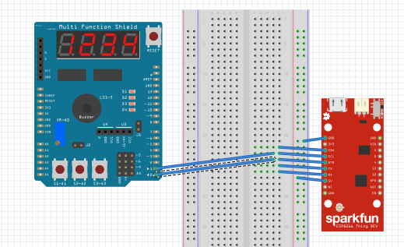

**NOTE:** Used the Shield to represent Xplained MINI

1. **SCREENSHOTS OF EACH TASK OUTPUT (ATMEL STUDIO OUTPUT)**

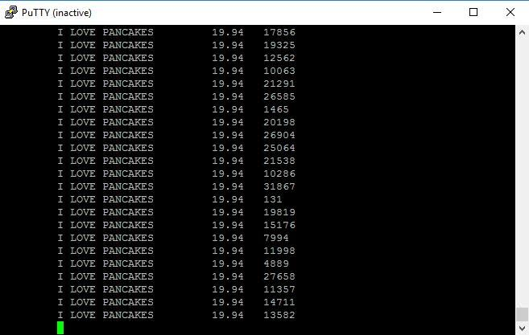

1. **SCREENSHOT OF EACH DEMO (BOARD SETUP)**

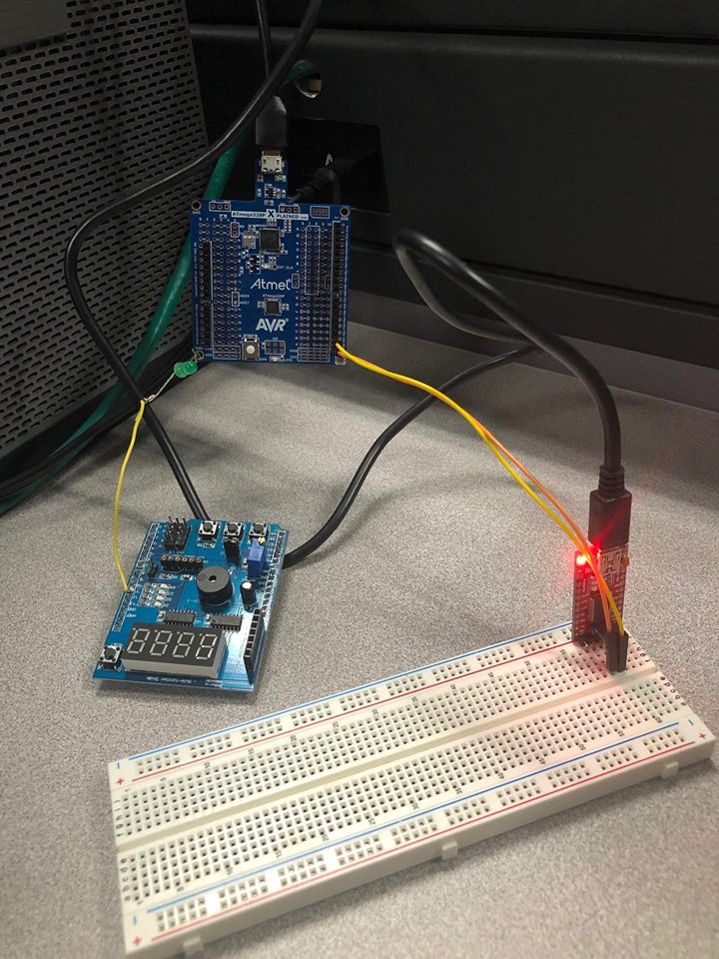

1. **VIDEO LINKS OF EACH DEMO**

<https://www.youtube.com/watch?v=LTUk64KV2Xg&feature=share&fbclid=IwAR2EDv0ZEU36EMwUgBGY4SHzMRZLPocJV3Kk4EWkEPu79NJ0halURaPmrmU>

1. **GITHUB LINK OF THIS DA**

Link: https://github.com/MohamedJundi1994/Submission_DA.git

This assignment submission is my own, original work.

MOHAMAD JUNDI