CPE301 – SPRING 2019

Design Assignment 4A

Student Name: Mohamad Jundi

Student #: 8000321867

Student Email: jundi@unlv.nevada.edu

Primary Github address: https://github.com/MohamedJundi1994/Submission_DA.git

Directory: Documents\School\CPE 301\Repository\CPE_301\DesignAssignments\DA4A

1. **COMPONENTS LIST AND CONNECTION BLOCK DIAGRAM w/ PINS**

USB port => Xplained Mini => PD6 => TB6612FNG (PWMA)

=> TB6612FNG (VCC) => 5V source using lab board

=> TB6612FNG (VMOT) => 5V source using lab board

=> TB6612FNG (GND) => GND of Xplained and board

1. **INITIAL/MODIFIED/DEVELOPED CODE OF TASK 1/A**

My Code:

#define *F_CPU* 16000000UL // Frequency of the board

#include <avr/io.h>

#include <util/delay.h>

#include <avr/interrupt.h>

int adc_value; // Used to hold ADC value

int p_button = 0; // Used to hold button value to control motor ON/OFF

int main()

{

sei(); // Enable global interrupt

DDRC = (1 << PC2); // Used to set PC2 as output

DDRD = (1 << PD6); // Used to set PD6 as output

PORTC |= (1 << PC1); // Used to enabled the pull up resistor

TCCR0A= (1 << COM0A1) | (1 << WGM01) | (1 << WGM00); // Used to set mode to Fast PWM with clear OCR0A on match

TCCR0B= (1 << CS02) | (1 << CS00); // Used to set the prescaler to 1024 for calculations

PCICR = (1 << PCIE1); // PCIE1 is set high, to enable PCMSK1

PCMSK1 = (1 << PCINT9); // PIN change interrupt source 9, so PC1 will serve as external interrupt source

ADMUX = (0<<REFS1); // Selecting voltage reference for ADC

ADCSRA = 0b11100111; // ADC enabled, ADC will start conversion, ADC auto trigger enabled, division factor set to 128

while (1)

{

// Infinite loop, wait

}

}

ISR(PCINT1_vect)

{

if(!(PINC & ( 1 << PC1))) // If PC1 button pressed, enter if statement

{

if(p_button == 1) // If p_button is high, enter if statement

{

while((ADCSRA & (1 << ADIF)) == 0); // ADC conversion completes when high

adc_value = ADC; // The value in ADC placed in variable

OCR0A = adc_value; // Motor will run as value of ADC set to OCR0A

*_delay_ms*(500); // Used to remove denouncing

}

else if (p_button == 0) // If p_button is 0, enter if statement

{

OCR0A = 0; // Motor will stop now

*_delay_ms*(500); // Used to remove denouncing

}

p_button ^= 1; // Reset the value of button to 1

}

}

1. **DEVELOPED MODIFIED CODE OF TASK 2/A from TASK 1/A**

All code is in number 2.

1. **SCHEMATICS (Battery for 5V)**

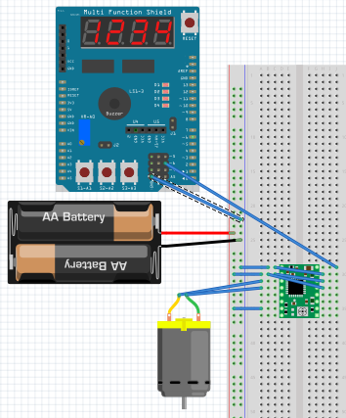

1. **SCREENSHOTS OF EACH TASK OUTPUT (ATMEL STUDIO OUTPUT)**

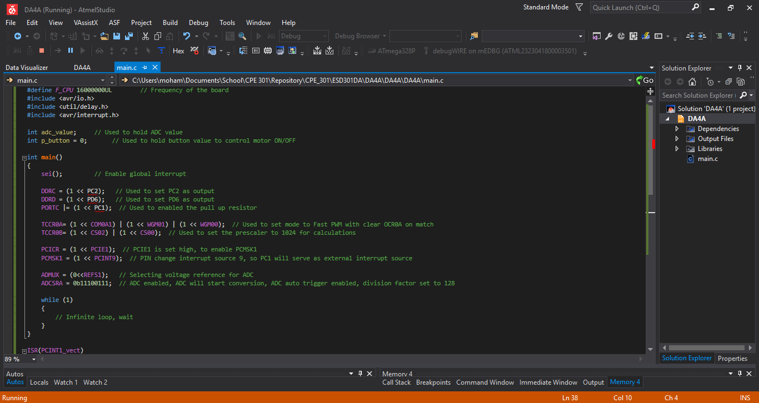

1. **SCREENSHOT OF EACH DEMO (BOARD SETUP)**

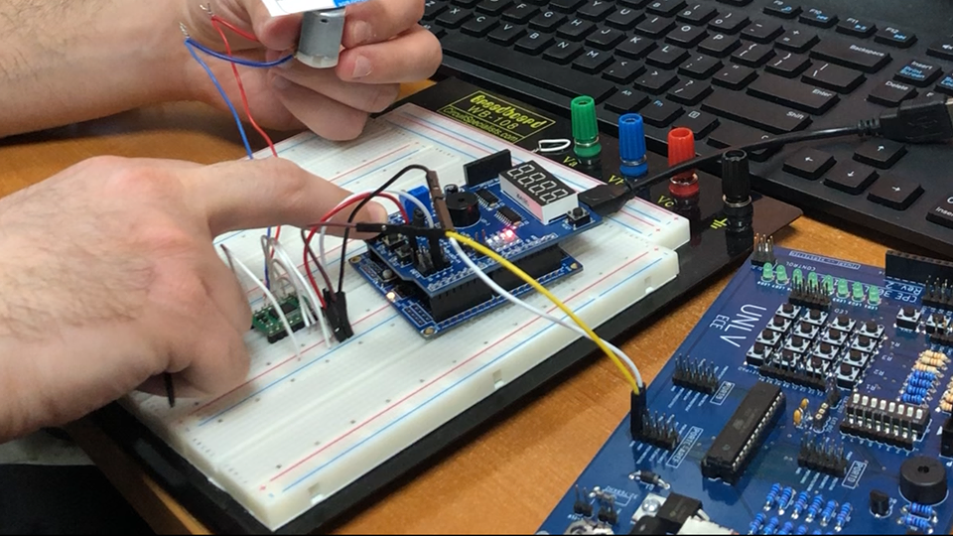

1. **VIDEO LINKS OF EACH DEMO**

Link: <https://www.youtube.com/watch?v=gCwPaDZYeIY&feature=share&fbclid=IwAR0UyIyDhQT_iGsoGexAN0O3lWAILrxfuHiE00n1zO74kOl8nfT3beN-O8A>

1. **GITHUB LINK OF THIS DA**

Link: https://github.com/MohamedJundi1994/Submission_DA.git

This assignment submission is my own, original work.

MOHAMAD JUNDI