BELLABEAT

Smart Device Usage & Growth Opportunities
Google Data Analytics Capstone Case Study
Prepared using the supplied Fitbit Fitness Tracker Data (2016)

Executive takeaway: The dataset suggests an opportunity for Bellabeat to encourage achievable everyday movement, help users understand their personal activity patterns, and make consistent sleep tracking more valuable.

Executive Summary
This case study examines how people used non-Bellabeat fitness trackers and considers how the observed patterns could inform Bellabeat’s wellness app and marketing strategy. The analysis follows the Google Data Analytics process: Ask, Prepare, Process, Analyze, Share, and Act. The supplied Fitbit files were cleaned and analyzed, and the charts below are embedded in this report.
- The cleaned daily-activity dataset contains 1,373 user-date records from 35 distinct users.
- Average daily steps were approximately 7,247; the median was 6,910, showing that a typical recorded day was below 10,000 steps.
- Users recorded an average of about 993 sedentary minutes per day, alongside approximately 185 lightly active minutes.
- The sleep dataset contains 410 unique user-date records from 24 users. Average recorded sleep was about 419 minutes (6 hours 59 minutes).
- Steps and calories were positively associated in this sample (correlation approximately +0.59); this is an association, not proof that steps alone caused the calorie difference.
These results are directional. The data is drawn from Fitbit users rather than Bellabeat customers, so recommendations should be tested using Bellabeat’s own customer data.

1. ASK — Define the Business Task

Business question
How do consumers use smart fitness devices, and how can Bellabeat apply those behavioral patterns to improve product engagement and marketing?

Objectives
- Identify patterns in daily steps, activity intensity, sedentary time, calories, and sleep.
- Translate the patterns into opportunities for Bellabeat’s app and wellness products.
- Recommend measurable marketing and product experiments rather than treating the sample as representative of all consumers.

Stakeholders
- Urška Sršen — Bellabeat co-founder and Chief Creative Officer.
- Sando Mur — Bellabeat co-founder and executive team member.
- Bellabeat marketing analytics team — responsible for turning behavioral evidence into product and campaign decisions.

Product focus
This report focuses primarily on the Bellabeat app experience, with recommendations that could support connected Bellabeat devices. The app is a suitable focus because it can turn tracking data into understandable feedback, reminders, and ongoing engagement.

2. PREPARE — Understand the Data
This analysis uses daily activity and daily sleep data because these files directly support the business questions about movement, activity, and rest.

Data source and coverage
- Source: Fitbit Fitness Tracker Data, shared publicly by the dataset publisher Möbius and commonly used for analytics practice.
- Daily activity period: 12 March 2016 to 12 May 2016.
- Sleep period: 12 April 2016 to 12 May 2016.
- The source files contain user IDs, dates, steps, distance, activity-minute categories, estimated calories, and sleep duration/time in bed.

Data quality considerations
- The data is from 2016 and should not be treated as a current picture of wearable-device behavior.
- The participants are a small convenience sample; selection method and representativeness are limited.
- The dataset does not establish that participants are Bellabeat customers or that their demographics match Bellabeat’s target audience.
- Not every participant logged sleep, and a missing sleep record does not necessarily mean the person did not sleep.
- Calories and activity values are device estimates and may differ by device and user.

ROCCC assessment
Criterion | Assessment
Reliable | Useful for exploratory analysis, but small sample and device-derived measures limit generalization.
Original | Third-party data rather than Bellabeat’s first-party customer data.
Comprehensive | Contains multiple activity fields and some sleep records, but coverage varies by user and date.
Current | No; records are from 2016.
Cited | Dataset provenance is commonly documented, but the original data documentation should be retained with any public submission.

3. PROCESS — Clean and Prepare the Data
The raw daily-activity data was combined across two exports. Dates were parsed using the month/day/year format, and records were keyed by user ID and activity date. Sleep records were similarly keyed by user ID and sleep date.

Cleaning steps
- Combined the two daily activity CSV exports into one analysis table.
- Standardized date fields and created day-of-week and weekday/weekend categories.
- Checked required user ID and date fields for missing values.
- Flagged repeated user-date keys and retained the first record for each user-date combination to prevent duplicate days from being counted twice.
- Applied the same duplicate-key handling to sleep records.
- Matched sleep records to activity by user ID and calendar date for comparisons involving both datasets.

Cleaning summary
- Daily activity rows across source files: 1397
- Daily activity rows after duplicate-key handling: 1373
- Daily activity distinct users: 35
- Daily activity duplicate user-date rows flagged: 48
- Daily activity rows missing required ID/date: 0
- Sleep rows across source files: 413
- Sleep rows after duplicate-key handling: 410
- Sleep distinct users: 24
- Sleep duplicate user-date rows flagged: 6
- Sleep rows missing required ID/date: 0
- Matched activity-sleep user-date records: 410
Important cleaning note: duplicate handling is a documented analytical choice. Retaining the first record is reasonable for a simple user-date daily summary, but repeated records should be reviewed against source definitions if this analysis is extended.

4. ANALYZE — Findings and Visualizations

Finding 1: Average daily steps are below 10,000
Across 1,373 cleaned user-date records, average daily steps were 7,247 and the median was 6,910. The mean being higher than the median suggests some high-step days pull the average upward. A marketing strategy should not assume every user is ready for a 10,000-step target; flexible personal goals may be more approachable.
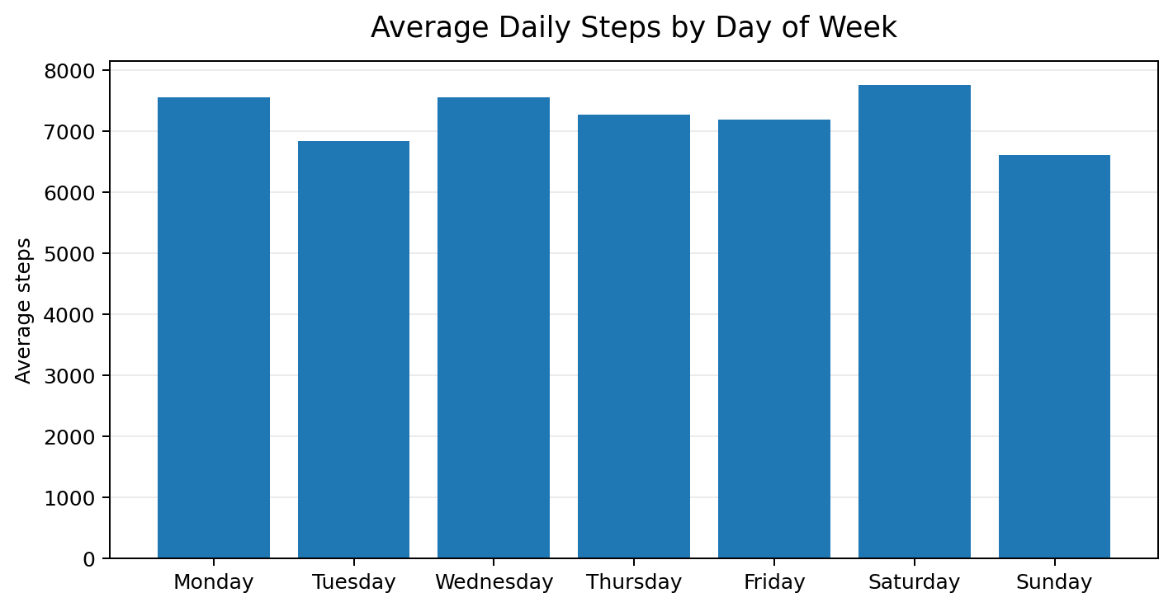
Figure 1. Average recorded steps by day of week. Saturday had the highest mean; Sunday had the lowest.

Finding 2: Weekend steps are slightly lower overall
Average steps were approximately 7,271 on weekdays and 7,188 on weekends. The difference in means is small, while the weekend median (6,112) was lower than the weekday median (7,225). This suggests the average alone may hide a more varied weekend pattern. Bellabeat could test optional weekend-specific prompts rather than assuming everyone is less active on weekends.
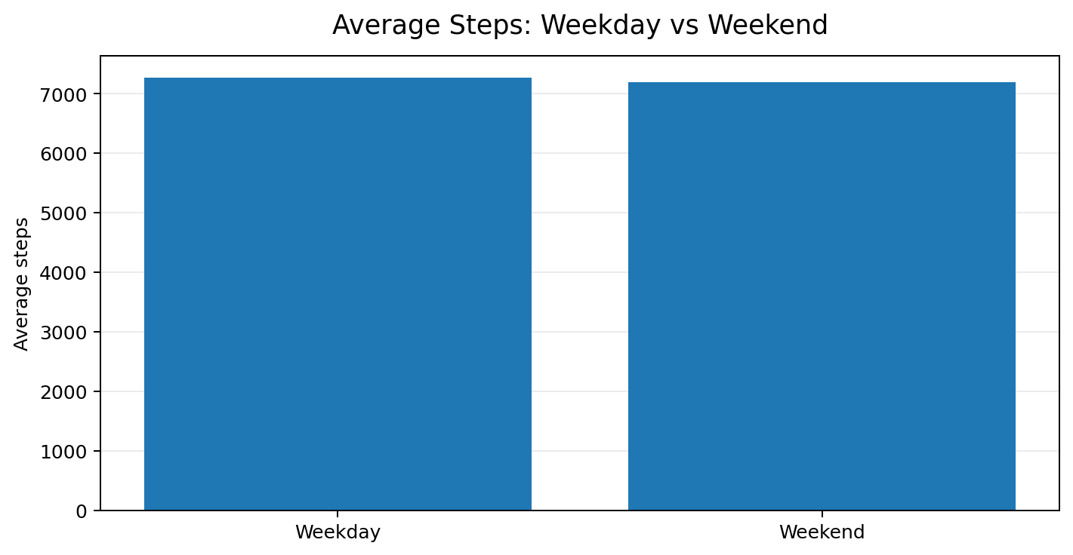
Figure 2. Average steps on weekdays compared with weekends.

Finding 3: Recorded time is dominated by sedentary and light activity
The mean daily record includes about 993 sedentary minutes, 185 lightly active minutes, 14 fairly active minutes, and 20 very active minutes. The high sedentary total includes all sedentary time captured in a day and should not be interpreted as uninterrupted sitting. Still, the pattern supports testing small movement breaks and attainable activity goals.
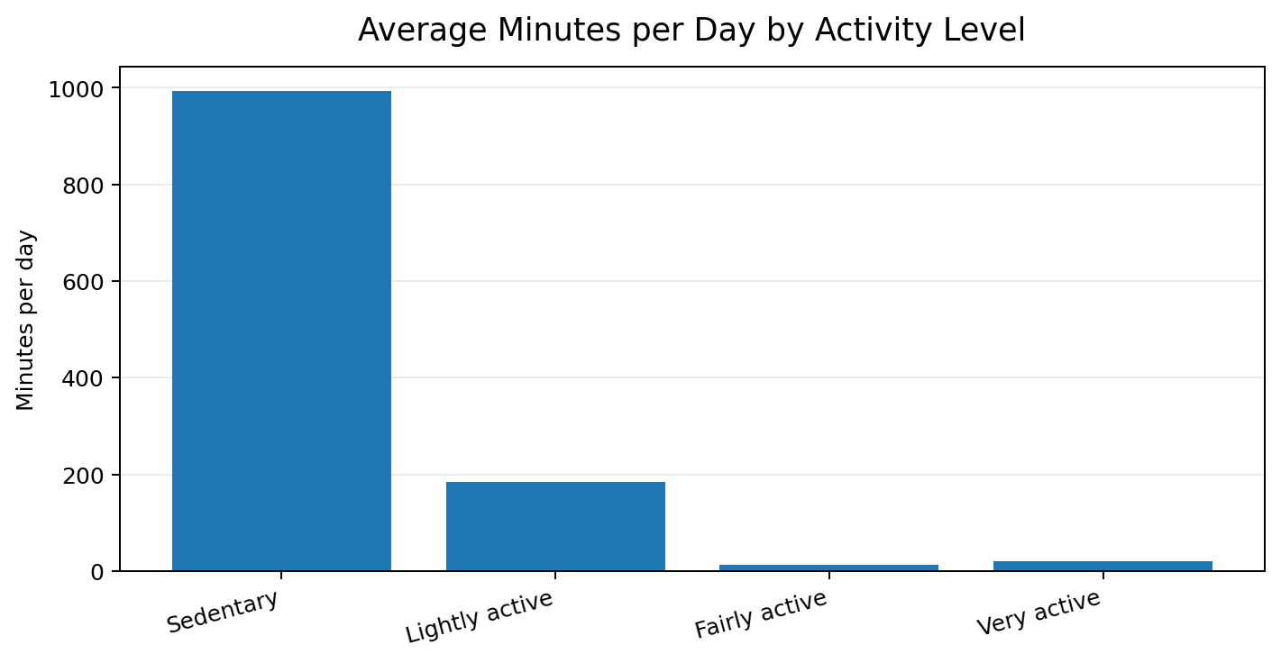
Figure 3. Average minutes recorded in each activity category per day.

Finding 4: Average recorded sleep is about seven hours
Among sleep records, mean time asleep was 419 minutes (approximately 6 hours 59 minutes), compared with 458 minutes in bed (approximately 7 hours 38 minutes). The gap between time in bed and time asleep is around 39 minutes on average. Sleep was logged by 24 users, fewer than the 35 users in the activity dataset, so sleep findings apply only to the available sleep records.
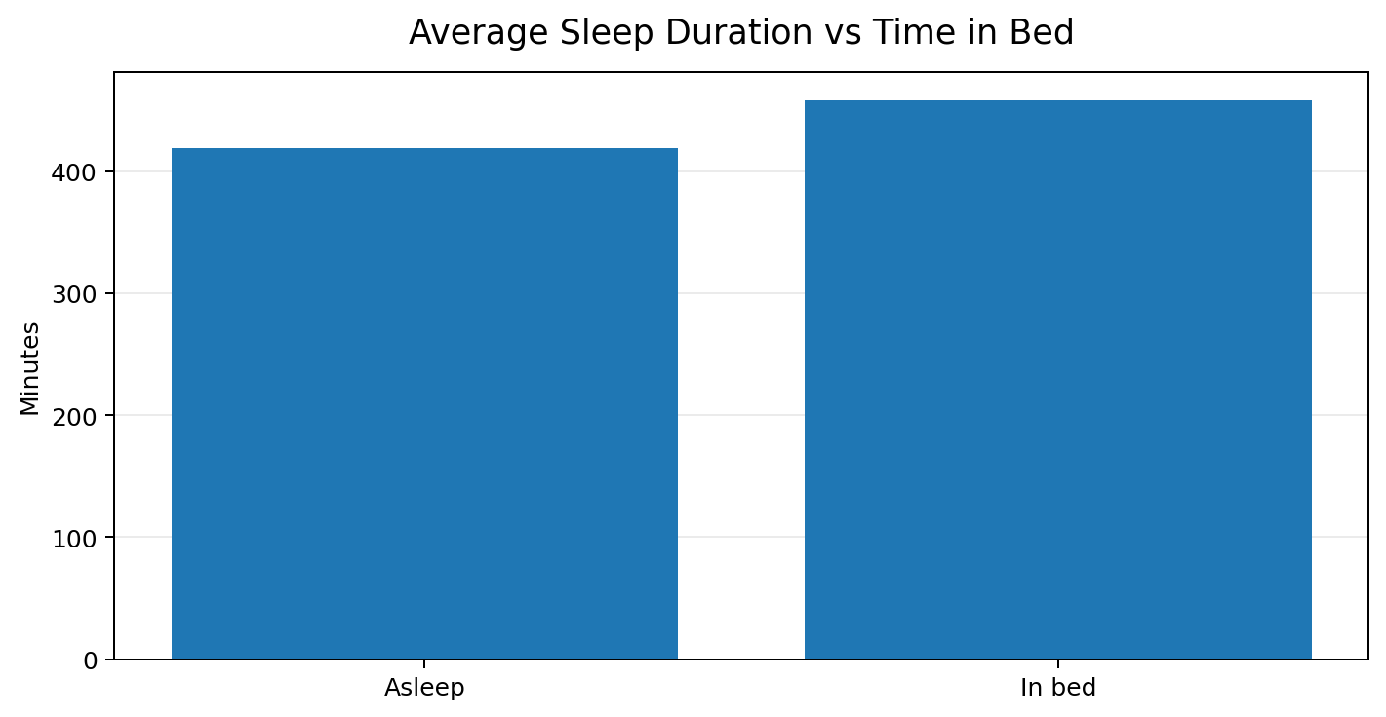
Figure 4. Mean recorded sleep duration and time in bed.

Finding 5: Steps and estimated calories are positively associated
The correlation between daily steps and recorded calories was approximately +0.59, a moderate positive relationship in this dataset. Higher-step days tended to coincide with higher calorie estimates. This relationship is not causal evidence: total daily energy expenditure is affected by body characteristics, other movement, and the tracker’s estimation method.
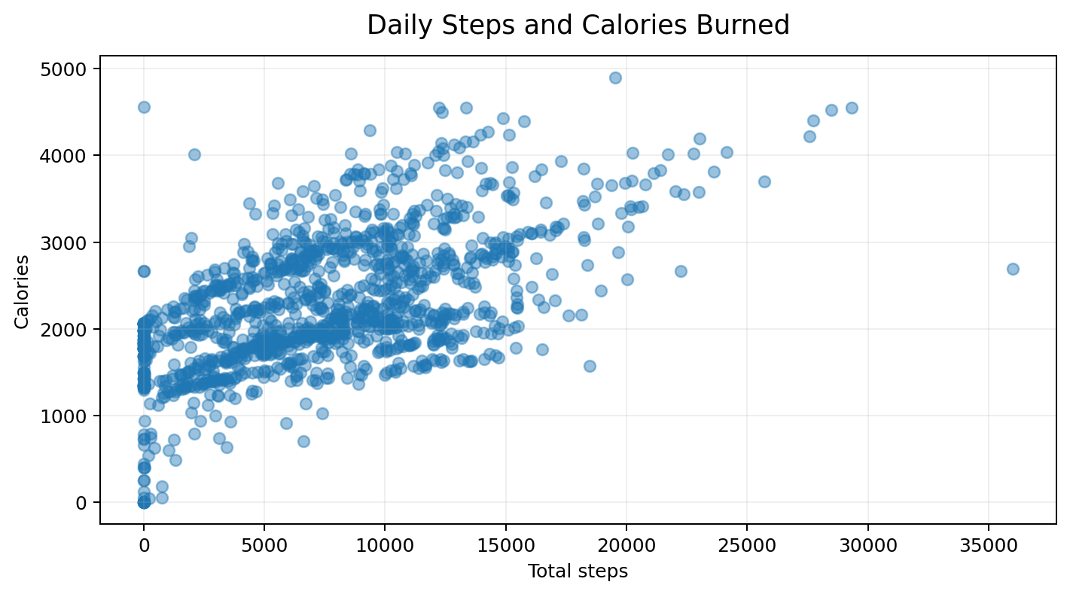
Figure 5. Daily steps versus calories recorded by the tracker.

Finding 6: Steps and sleep are not strongly positively related in these records
For user-date records where activity and sleep could be matched, the steps–sleep correlation was approximately −0.18, a weak negative association. This does not support claiming that more steps produce longer sleep. Bellabeat should present activity and sleep as complementary wellness signals and validate any combined recommendations with a larger dataset.

5. SHARE — Key Takeaways
Evidence | Interpretation | Business implication
Mean 7,247 steps; median 6,910 | A typical recorded day was below 10,000 steps. | Offer flexible, progressive personal goals.
~993 sedentary minutes and ~185 light-active minutes/day | Recorded behavior is weighted toward sedentary and light activity. | Promote short, achievable movement breaks.
Saturday mean 7,752; Sunday mean 6,607 steps | Activity varies by day, with Sunday lowest in this sample. | Test day-aware reminders and compare engagement.
Mean sleep 419 minutes; 24 sleep users | Sleep tracking is available for fewer users than activity tracking. | Make sleep logging easier and show users the value of consistency.
Steps/calories correlation ~+0.59 | Higher-step records coincide with higher estimated calories. | Use personalized feedback without implying causation.

6. ACT — Recommendations

Recommendation 1: Make movement feel achievable
Introduce personalized step goals based on a user’s recent baseline, with gradual increases and positive reinforcement for improvement. Avoid presenting 10,000 steps as the only meaningful success metric.
Example campaign: “Small moves, real momentum.”

Recommendation 2: Test context-aware movement reminders
Allow users to choose reminder windows and test prompts at times when they are likely to be receptive. Use weekday and weekend behavior as hypotheses to test—not universal rules—and let users pause or personalize notifications.
Example prompts: “Take a short movement break” or “A few extra minutes of walking can move you toward your personal goal.”

Recommendation 3: Make sleep tracking useful and easy
Reduce friction in sleep logging and provide simple weekly summaries that connect sleep consistency with a broader wellness routine. Avoid claiming that step counts predict sleep duration based on this sample.

Recommendation 4: Run measurable experiments
Test these recommendations with Bellabeat’s own customers using an A/B test or staged rollout. Define success metrics before launch.
- Activation: proportion of users who set a personal movement goal.
- Engagement: weekly active days and completion of optional movement prompts.
- Retention: week-4 and week-8 retention compared with a control group.
- Sleep tracking: number of nights logged per week and the proportion of users logging consistently.
- Guardrails: notification opt-outs, negative feedback, and user-reported pressure or annoyance.

Suggested implementation sequence
- Weeks 1–2: validate the ideas with Bellabeat customer analytics and user research.
- Weeks 3–4: pilot personalized goals and opt-in movement reminders with a small user segment.
- Weeks 5–8: evaluate engagement, retention, sleep logging, and notification opt-outs against a control group.
- After the pilot: scale only the interventions that show a meaningful improvement without harming user experience.

7. Limitations and Further Analysis
- The sample is small and may not represent the broader wearable market or Bellabeat’s customers.
- The data is historical (2016); current user behavior and device features may be different.
- The dataset does not establish participant gender, motivations, or product preferences.
- Some records may reflect incomplete device wear or inconsistent logging.
- Daily aggregates hide within-day timing; hourly data would be needed to identify the best prompt windows reliably.
- The duplicate-key rule retains the first record, which may not be the best resolution if source duplicates have different meanings.
Next steps should include current Bellabeat app analytics, opt-in user research, richer hourly activity data, and controlled tests of reminder timing and personalized goals.

Conclusion
The supplied Fitbit data points to a practical engagement opportunity: support everyday movement, avoid one-size-fits-all targets, and make sleep tracking more useful. The analysis does not prove what Bellabeat customers will do, but it provides clear hypotheses to test with Bellabeat’s own data. A supportive, personalized app experience—measured through activation, engagement, retention, and opt-out rates—is a defensible next step.

Sources
- Supplied Fitbit Fitness Tracker Data archive (daily activity and sleep CSV exports; records dated 2016).
- Google’s case study framework: Ask, Prepare, Process, Analyze, Share, Act.
- Note: This report builds the charts and numerical findings from the user-supplied Fitbit data.

