**Task 1:**

**Task 2:**

Design the Relational Database Schema

Create an ER diagram to visualize your schema

**Task 3:**

Connect Python to SQLite

**Task 4:**

Title: Implement CRUD Operations on SQLite via Python

**Task 5:**

 Develop RESTful APIs with Python

**Task 6:** Test APIs Using Postman

**1. Add a New Book (POST /books)**

**2. Retrieve the List of Books (GET /books)**

**3. Update a Book’s Details (PUT /books/<id>)**

**4. Delete a Book (DELETE /books/<id>)**

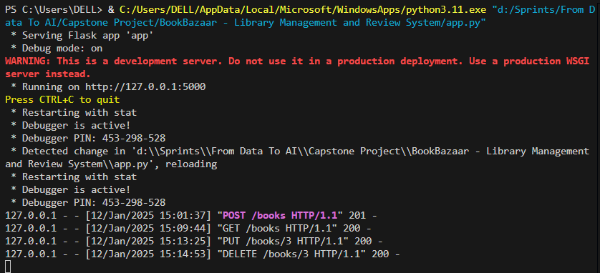

**Task 7:**

**Access Your API**:

Host APIs on Apache Web Server : http://localhost:5000

Ensure that when you access your server’s URL in a browser : http://localhost/books

Troubleshoot any server configuration issues (e.g., permission issues, missing modules).

* Error log: "C:\Apache24\logs\bookbazaar-error.log"
* Access log: "C:\Apache24\logs\bookbazaar-access.log"

**Task 8, 9:**

Title: Set Up the Non-Relational Database with MongoDB

Connect Python to MongoDB Using PyMongo

**Task 10:**

Implement CRUD Operations on MongoDB via Python

**Task 11:**

Integrate MongoDB Operations into the APIs



