# Crosswords of Architecture

# The intersection of goals and achievements in our lives builds us a bridge of hope over a river of despair

# 

**1- Introduction**

**1-A definition:**

A crossword is a word puzzle that usually takes the form of a square or a rectangular grid of white-and black-shaded squares. The game's goal is to fill the white squares with letters, forming words or phrases, by solving clues, which lead to the answers. In languages that are written left-to-right, the answer words and phrases are placed in the grid from left to right and from top to bottom. The shaded squares are used to separate the words or phrases.[1]

**1-B Background:**

**Science Explains Why Crossword Puzzles Are Good For Your Mental Health:**

Plenty of researchers have discovered the positive effects that crossword puzzles can have on one’s brain if played regularly. Regularly doesn’t necessarily mean every day — once a week is fine. Among these researchers is Ann Lukits, who wrote “Puzzles Boost Verbal Skills, Cut Dementia Risk” for the Wall Street Journal. She firmly believes that solving crosswords on a regular basis can “improve memory and brain function in older adults.” Such activities can also “improve mental functions in patients with brain damage or early dementia.”[2]

**1-C Motivation:**

solving interactive Crosswords puzzle are more interesting then writing because it has more features than normal way with pencil and paper.

# 2- Crosswords Puzzle

# 2-1 preparing words and Defintions:

|  | **Word** | **definitions** |
| --- | --- | --- |
| 1 | Cement | A binder, a substance used for construction that sets, hardens, and adheres to other materials to bind them together. |
| 2 | Mineral | It is, broadly speaking, a solid chemical compound that occurs naturally in pure form |
| 3 | Concrete | A composite material composed of fine and coarse aggregate bonded together with a fluid cement (cement paste) that hardens over time |
| 4 | Rebar | A steel bar or mesh of steel wires used as a tension device in reinforced concrete and reinforced masonry structures to strengthen |
| 5 | Brick | A building material used to make walls, pavements and other elements in masonry construction. |
| 6 | Moisture | It is the presence of a liquid, especially water, often in trace amounts. |
| 7 | Dam | A barrier that stops or restricts the A composite materialflow of water or underground streams. |
| 8 | Fiberglass | A common type of fiber-reinforced plastic . The fibers may be randomly arranged, flattened into a sheet (called a chopped strand mat), or woven into a fabric. |
| 9 | Area | It is the quantity that expresses the extent of a two-dimensional figure or shape, or planar lamina, in the plane. |
| 10 | Chemical | A form of matter having constant chemical composition and characteristic properties |
| 11 | Weather | It is the state of the atmosphere, describing for example the degree to which it is hot or cold, wet or dry, calm or stormy, clear or cloudy |
| 12 | Mixture | It is a material made up of two or more different substances which are physically combined |
| 13 | Hardness | It is a measure of the resistance to localized plastic deformation induced by either mechanical indentation or abrasion. Some materials (e.g. metals) are harder than others (e.g. plastics, wood) |
| 14 | Schema | It comes from a Greek word which means shape, or more generally, plan. |
| 15 | Force | In physics, it is any interaction that, when unopposed, will change the motion of an object. it can cause an object with mass to change its velocity |
| 16 | Designer | It is a person who makes designs for objects. A fashion designer designs clothing, a web designer designs web pages. |
| 17 | Tensile | In physics, tension may be described as the pulling force transmitted axially by the means of a string, cable, chain, or similar one-dimensional continuous object. |
| 18 | Steel | It is an alloy of iron and carbon, and sometimes other elements. Because of its high tensile strength and low cost, it is a major component used in buildings, infrastructure, tools, ships, automobiles, machines, appliances, and weapons. |
| 19 | Waterproof | It is the process of making an object or structure waterproof or water-resistant so that it remains relatively unaffected by water or resisting the ingress of water under specified conditions |
| 20 | Inspection | It is, most an organized examination or formal evaluation exercise. In engineering activities inspection involves the measurements, tests, and gauges applied to certain characteristics in regard to an object or activity. |
| 21 | Performance | It is completion of a task with application of knowledge, skills and abilities |
| 22 | Bond | It means of protection against the non-performance of the contractor. They are an undertaking by a bondsman or surety to make a payment to the client in the event of non-performance of the contractor. |
| 23 | Terrace | A raised flat platform |
| 24 | Beam | A structural elements that resists loads applied laterally to their axis. [3] |
| 25 | Load | A force which apply to a structure |
| 26 | Plan | It is typically any diagram or list of steps with details of timing and resources, used to achieve an objective to do something. |
| 27 | Plot | An architecture, engineering, and/or landscape architecture plan drawing that shows the buildings, utility runs, and equipment layout of a project as well as the positions of roads and other constructions |
| 28 | Gap | A low point or opening between hills or mountains or in a ridge or mountain range |
| 29 | Roof | It is the top covering of a building, including all materials and constructions necessary to support it on the walls of the building or on uprights |
| 30 | Sample | It might include simple items such as paint, tiles, bricks, or carpets. Mock-ups are scaled-down or full-size assemblies, such as sections of cladding, window assemblies or masonry. |
| 31 | Scale | In very general this term refers to an object’s size in relationship to another object. For example, the components of a building may be designed so they are at a human scale, ie they are comfortable to use, are functional and anthropometric. |
| 32 | Flat | An apartment in the United Kingdom, Australia and other Commonwealth countries |
| 33 | Ground | typically refers to the solid surface of the Earth or an area that is used for a specified purpose. |
| 34 | Measurement | It is the assignment of a number to a characteristic of an object or event, which can be compared with other objects or events |
| 35 | Feasibility study | it aims to objectively and rationally uncover the strengths and weaknesses of an existing business or proposed venture, opportunities and threats present in the natural environment, the resources required to carry through, and ultimately the prospects for success |
| 36 | Construction | It is the process of constructing a building or infrastructure |
| 37 | Structure | is an arrangement and organization of interrelated elements in a material object |
| 38 | Architect | An architect is a person who plans, designs and reviews the construction of buildings. |

[1] [3]

**2-2 Creating and development:**

using Java script and html and Dreamweaver to build a web interactive applications Fig1, 2

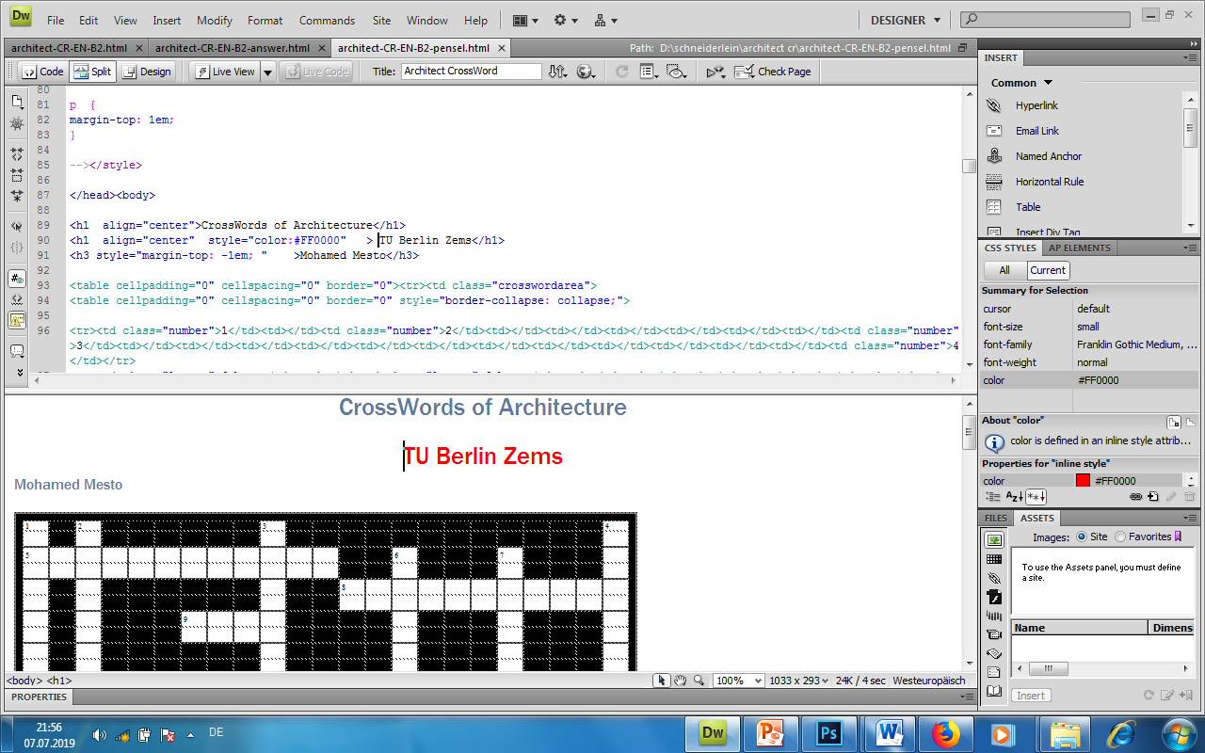

Fig.

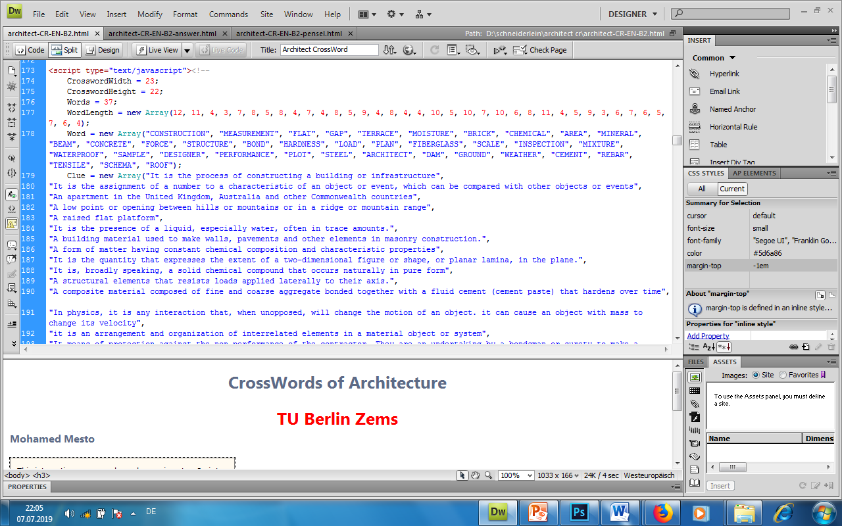

Fig.

**2-3: Stages of the puzzle**

**2-3-1: normal solving with pencil and a printed copy of the puzzle: Fig.3**

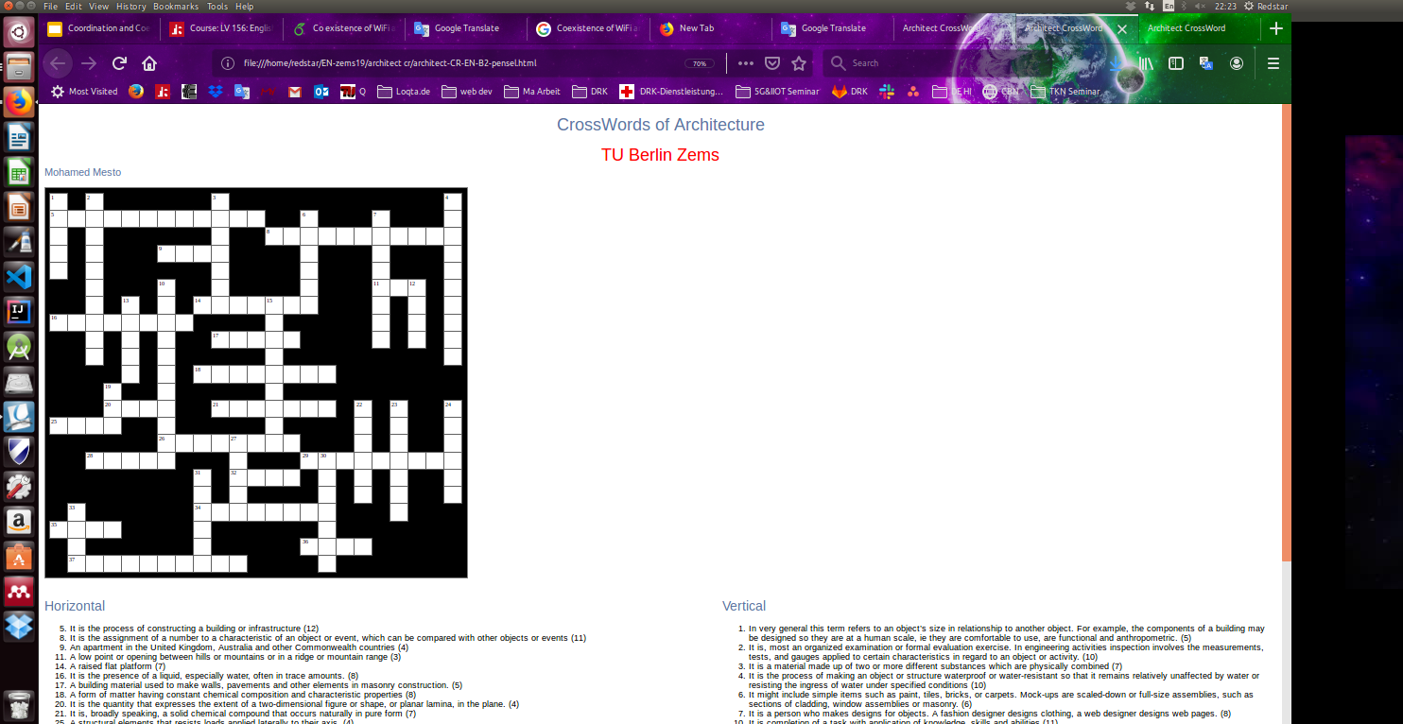

Fig.

**2-3-2:Keywords or answer words: Fig.4**

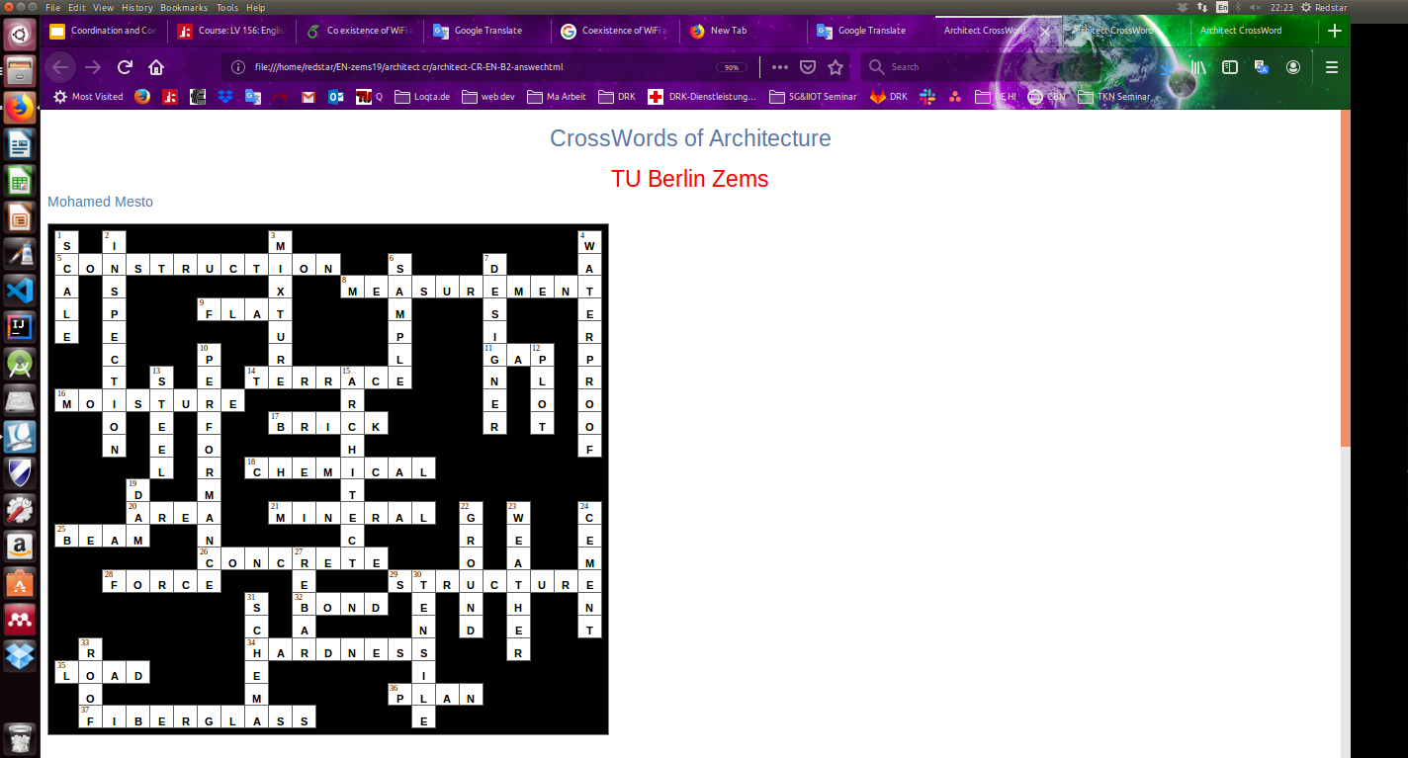

Fig.

**2-3-3: solving the puzzle through the interactive User interface: Fig.5**

Startup the puzzle like a web app in any browser within an interactive environment

by running the file architect-CR-EN-B2.html which shown in Fig.5.

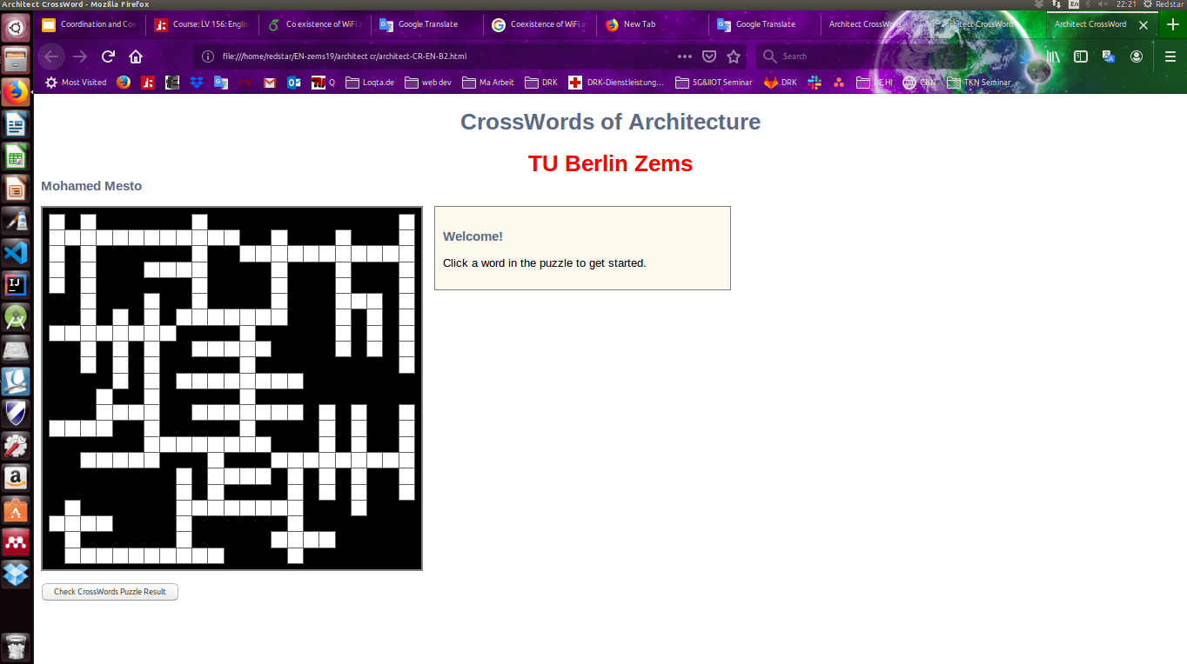

Fig.

After clicking on any word it shows definition window and solving button and checking the puzzle result Fig. 6,7

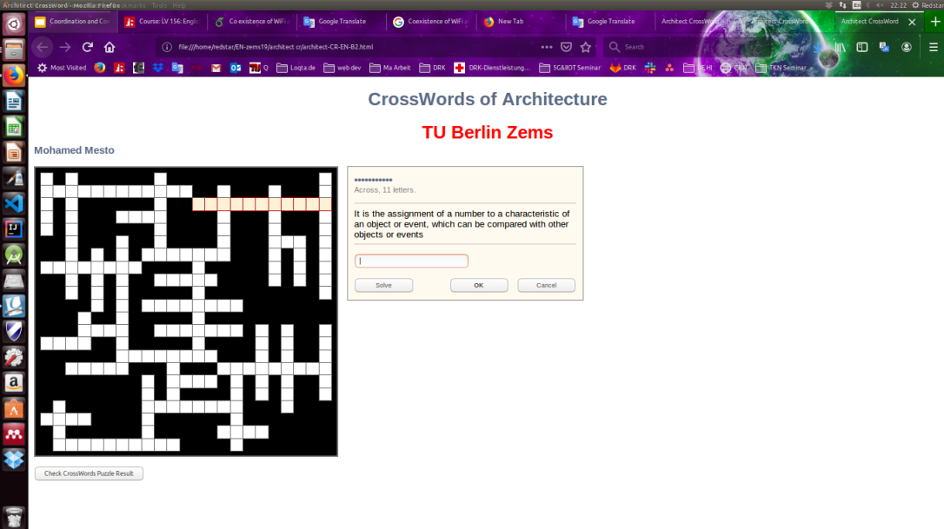

Fig.

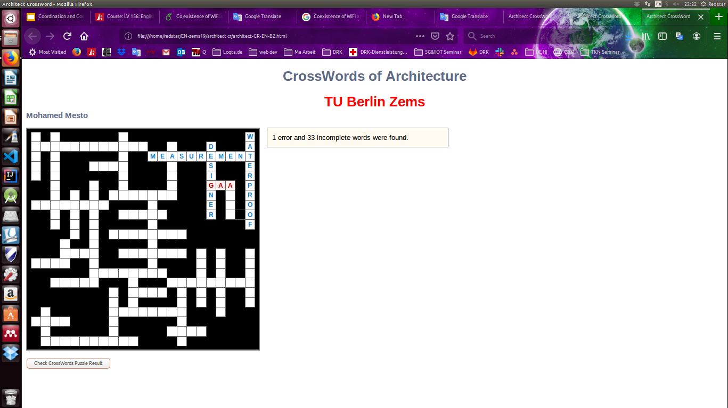

Fig.

**3- Conclusion:**

# Crosswords of architecture

* Solving crossword puzzles alone is beneficial, but working in a group adds a bigger advantage to one’s brain function.
* One important factor of collaborative is the ability to think creatively in a more strategic fashion.
* The other factors are fairly easy to capture. Involving yourself in such a brain-consuming activity helps you vastly by improving your verbal skills, making you solve problems, and causing you to think deeply.

**My opinion:**

I agree with solving as much as possible crosswords and puzzle which by time improve you knowledge and experience for solving life problems and impact positively your brain to deep thinking

so have a break please with a cup of coffee to enjoy solving Crosswords and

Unleash your thoughts

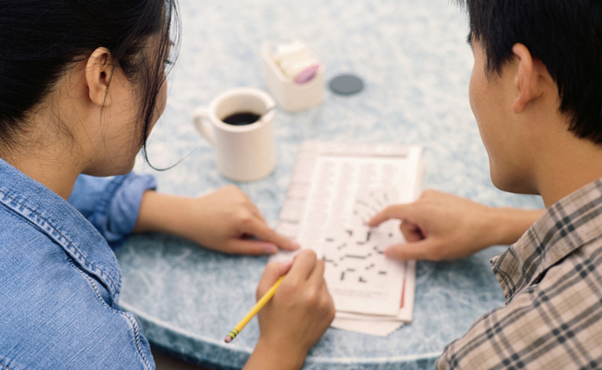

**References:**

1. <https://en.wikipedia.org/wiki/>
2. <https://www.lifehack.org/374975/science-explains-why-crossword-puzzles-are-good-for-your-mental-health>
3. <https://www.designingbuildings.co.uk/wiki/Types_of_beam>