# Technical Report: Abstract Factory Pattern Implementation

## 1. Overview

The Abstract Factory pattern implementation addresses two core system requirements:

1. Dynamic UI component generation
2. Flexible payment processing

## 2. View Layer Factory

### 2.1 Architecture

* **Abstract Factory**: ViewFactory
* **Products**:
  + Dashboard
  + Form
  + NotificationPanel
* **Factories**:
  + PatientViewFactory
  + ProviderViewFactory
  + RegulatorViewFactory

### 2.2 Objectives

* Role-based UI generation
* Consistent component rendering
* Modular interface management

## 3. Payment Processing Factory

### 3.1 Architecture

* **Abstract Factory**: PaymentProcessingFactory
* **Products**:
  + PaymentValidator
  + TransactionHandler
  + ReceiptGenerator
* **Factories**:
  + CreditCardPaymentFactory
  + BankTransferPaymentFactory

### 3.2 Objectives

* Multi-method payment handling
* Standardized transaction processing
* Secure payment validation

## 4. UML Diagrams

### 4.1 View Layer Factory

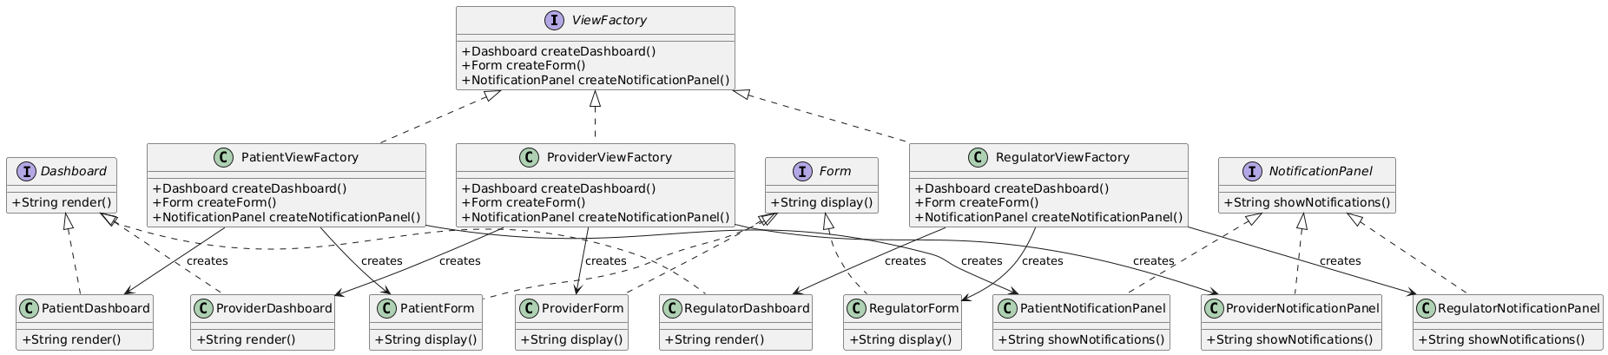

View Layer Factory UML

* Abstract factory-product relationships
* Component hierarchy
* Factory method implementation

### 4.2 Payment Processing Factory

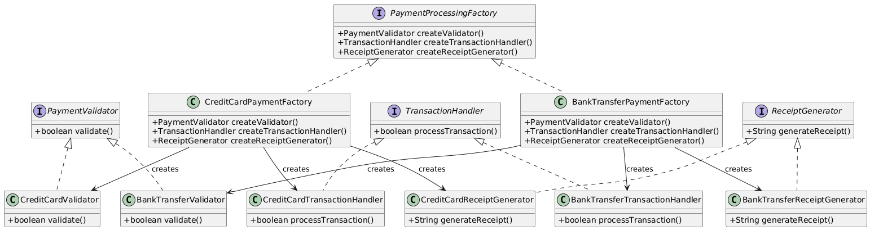

Payment Processing Factory UML

* Payment processing structure
* Component relationships
* Factory method implementation

## 5. Implementation Benefits

### 5.1 Flexibility

* Extensible role management
* Modular payment integration
* Maintainable architecture

### 5.2 Consistency

* Standardized component creation
* Uniform payment processing
* Predictable user experience

### 5.3 Scalability

* Modular expansion support
* Clear component boundaries
* Reusable architecture

## 6. Design Principles

1. **Interface Segregation**
   * Focused component interfaces
   * Clear responsibility boundaries
2. **Single Responsibility**
   * Dedicated factory roles
   * Focused component functionality
3. **Open/Closed Principle**
   * Extensible architecture
   * Minimal modification requirements

## 7. Future Development

1. **View Layer**
   * Enhanced component library
   * Extended role support
   * Advanced customization
2. **Payment Processing**
   * Additional payment methods
   * Enhanced validation
   * Comprehensive logging

## 8. Conclusion

The Abstract Factory implementation establishes a robust foundation for:

* Dynamic UI management
* Flexible payment processing
* Scalable system architecture

This implementation exemplifies modern software engineering principles and provides a solid framework for system evolution.