POINT OF INTEREST SURVEY REPORT
Facility Name: | {{FACILITY_NAME}} |  |  |  |  | Report #: | {{REPORT_NO}}
Location: | {{LOCATION}} |  | Category: | {{CATEGORY}} |  | Type: | {{TYPE_ASBUILT}} As-Build {{TYPE_NEW}} New
Client’s Details: | Name: | {{CLIENT_NAME}} |  |  | Mobile #: | {{CLIENT_MOBILE}}
Client’s Details: | Designation: | {{CLIENT_DESIGNATION}} |  |  | Email: | {{CLIENT_EMAIL}}
Contractor: | {{CONTRACTOR}}
Contractor’s Details: | Name: | {{CONTRACTOR_NAME}} |  |  | Mobile #: | {{CONTRACTOR_MOBILE}}
Contractor’s Details: | Designation: | {{CONTRACTOR_DESIGNATION}} |  |  | Email: | {{CONTRACTOR_EMAIL}}
Design  Verified By: | Certified Engineer: | {{CERTIFIED_ENGINEER}} |  |  | Certified Technician: | {{CERTIFIED_TECHNICIAN}}
Installation and Configuration Guide:
- Use the JSVG Lens Calculator to evaluate the setup https://www.jvsg.com/calculators/cctv-lens calculator/.
- The cameras must be installed strictly as per measurements mentioned in the report and after cameras are installed, perform the focus calibration at the best level and zoom to the target area mentioned in the report.
Ensure to configure and set the values of each parameter for the camera as per below:
Encoding Compression: {{ENCODING}}  Resolution: {{RESOLUTION}}  FPS: {{FPS}} | Bit Rate: {{BITRATE_KBPS}} kbps  WDR Settings: Day – {{WDR_DAY}}  Night – {{WDR_NIGHT}}

- Configure and add the cameras on the POI NVR and follow camera convention as below.

[Facility_Name].MOI-[Location]-[Area]-[Camera Number]-[Camera-IP]
1 2 3 4 5
E.g.: ABC MALL.MOI-AL-SAAD-GF-MAIN-ENTRANCE CAM-1-192.168.1.1
Note:
- The lighting conditions across all areas must meet the recommended illumination level of 250 lux.
- The POI system must be installed and reported to the Ministry of Interior within 60 days from the date of this report. Non-compliance will result in regulatory action.
- All outdoor camera installations must include appropriate outdoor housing and brackets.
- The CCTV contractor is responsible for maintaining the system with zero downtime. Any system faults or malfunctions will result in regulatory action.
- Upon readiness for integration with MOI, the contractor must provide comprehensive system details, including camera specifications and GPS coordinates for all installed cameras.
- For any support or additional details required during or after project implementation, the POI team at MOI must be contacted immediately.
01: Camera Details:
SN | Location Name | Height (m) | Distance (m) | Target Area | Camera Model | Lens Model | Installation Type | Installation Environment
 |  |  |  | (m)
{{SN}} | {{LOCATION_NAME}} | {{HEIGHT}} | {{DISTANCE}} | {{TARGET_AREA}} | {{CAMERA_MODEL}} | {{LENS_MODEL}} | {{INSTALL_TYPE}} | {{INSTALL_ENV}}
 | Total Cameras |  |  |  | {{TOTAL_CAMERAS}} | Camera Vendor | {{CAMERA_VENDOR}}

02: NVR Details:
SN | Device Type | Model # | Description | Qty
{{SN}} | {{DEVICE_TYPE}} | {{MODEL}} | {{DESCRIPTION}} | {{QTY}}

STORAGE CALCULATION - (40s Recording (20s Pre & 20s Post) + Image Events for 90 Days & Continuous Record 120 Days
Description | POI System (90 Days Event Record)
Encoding Mode | {{STG_ENCODING}}
Bitrate Type | {{STG_BITRATE_TYPE}}
Recording Resolution | {{STG_RESOLUTION}}
Frame Rate(fps) | {{STG_FPS}}
Bitrate (Mbps) | {{STG_BITRATE_MBPS}}
No. of Cameras | {{STG_CAMERAS}}
120 days Estimate storage per Camera (TB) | {{STG_120D_PER_CAM_TB}}
Per 40 Seconds event recording per camera Estimate storage (MB) | {{STG_EVENT_MB}}
Number of Events per Day per Camera | {{STG_EVENTS_PER_DAY}}
Per Day Event Recording per camera Estimate storage (GB) | {{STG_DAY_EVENT_GB}}
90 Days event recording total camera Estimate storage (TB) | {{STG_90D_EVENT_TB}}
1 Event Image size (MB) | {{STG_IMG_MB}}
Image storage per day (GB) | {{STG_IMG_GB_DAY}}
90 Days Image Storage (GB) | {{STG_90D_IMG_GB}}
Total Required Storage (TB) | {{STG_TOTAL_TB}}
Total Required Storage with {{STG_EXTRA_PCT}}% Extra (TB) | {{STG_TOTAL_EXTRA_TB}}
Note :- POI storage calculations are project-dependent and the final confirmation will be provided by the MOI POI Team.

03: Verification Report by Dahua
SN | Verified Category | Verified | Stamp & Verification ID
1 | Camera Installation Height vs Distance to Target |  | 
2 | Camera Model & Lens Model (Per Target Distance)
3 | Storage Calculation (Per Camera Qty & Project Type)
4 | IVSS / IVD Model & HDD Qty
5 | Installation Type (wall/Ceiling/Pendant) and Installation Environment (Indoor/Outdoor) |  | To Be Verified by System Integrator
6 | Site POI Drawing |  | To Be Verified by System Integrator
Important Note: The system integrator is responsible for ensuring compliance by verifying that all entrances are equipped with POI cameras

Note: -
Responsibilities of the System Integrator:
- Verify Installation Type and Environment:
  - Verify whether the installation type is Wall, Ceiling, or Pendant.
  - Confirm the installation environment, whether indoor or outdoor.
  - If the environment is outdoor, ensure to consider Outdoor Housing for proper weather protection.
- Prepare Site POI (Point of Interest) Drawing:
  - Provide a POI Drawing with camera positions, including:
    - Height and Distance from the target.
    - Camera angles and coverage zones.
04: Floor Key plan (To Identify the location of K-POI Cameras)
{{FLOOR_PLAN}}
{{#CAMERA_PAGES}}
{{SEC_PREFIX}}Location Image Reference: {{LOCATION_NAME}}
Target Area:
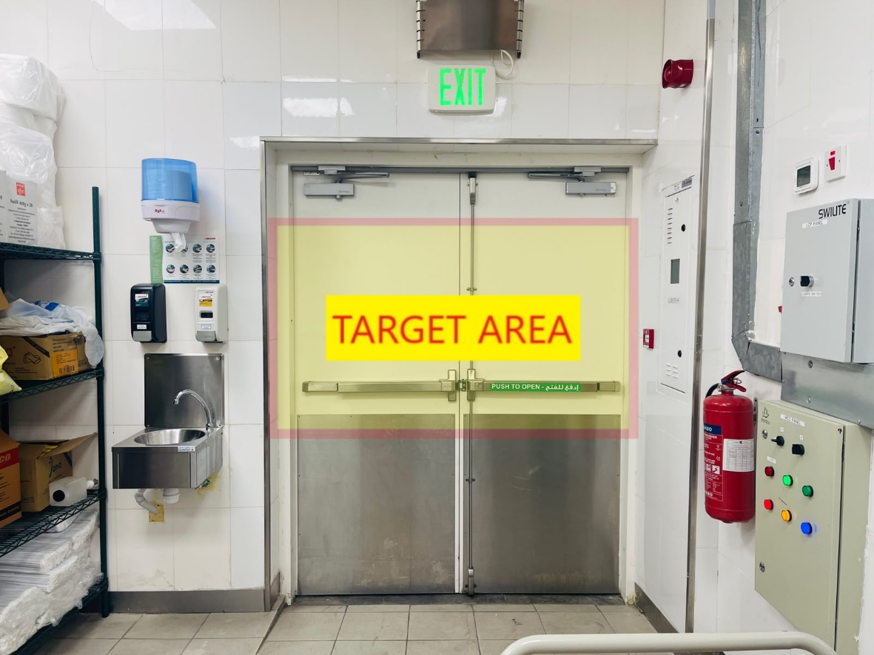
Location: {{LOCATION_NAME}}

Camera Location:
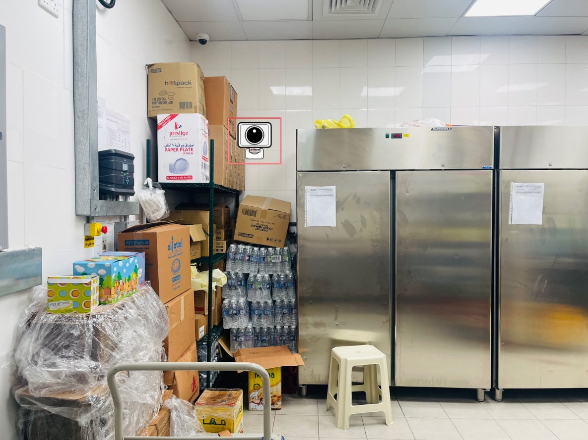
Camera Location
Height: {{HEIGHT}} M
Distance: {{DISTANCE}} M
{{INSTALL_TYPE}}
Location: {{LOCATION_NAME}}

{{/CAMERA_PAGES}}
06: POI Camera Installation Table (Reference)
Used to determine the recommended installation height and lens model for each camera from its distance to the target.
{{POI_TABLE}}

