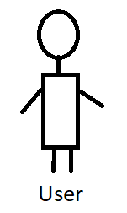

* User recites a sentence
* MemorEase transcribes user input and claculates similarity(actual sentence, user’s sentence)
* If similarity >80%, we move to the next sentence
* Else, we increment error by 1 and gives user up to 2 retrials, if all 3 trials are incorrect, the program stops and a message “You’d better re-review your text before proceeding.”
* If the user tends to complete up to the last sentence, a message with the number of errors he has committed will be shown along with a score out of 20.

1. Presses start button
2. Begins reciting Sentence by Sentence
3. Saves it
4. Performs sentence tokenization
5. Waits for the user to start
6. Inputs text to memorize