Software Requirements Specification
for
ELearn
Prepared by:
- Mohamed Osama
- Aya Abdelkhalk
- Doha Ahmed
- Sama Mohamed
- Marwan Sayed
- Jamila Ahmed
- Shimaa Mohamed
Table of Contents
Table of Contents ii
1. Introduction 1
1.1 Purpose 1
1.2 Document Conventions 1
1.3 Intended Audience and Reading Suggestions 1
1.4 Project Scope 1
1.5 References 1
2. Overall Description 2
2.1 Product Perspective 2
2.2 Product Features 2
2.3 User Classes and Characteristics 2
2.4 Operating Environment 2
2.5 Design and Implementation Constraints 2
2.6 User Documentation 2
2.7 Assumptions and Dependencies 3
3. System Features 3
3.1 System Feature 1 3
3.2 System Feature 2 (and so on) 4
4. External Interface Requirements 4
4.1 User Interfaces 4
4.2 Hardware Interfaces 4
4.3 Software Interfaces 4
4.4 Communications Interfaces 4
5. Other Nonfunctional Requirements 5
5.1 Performance Requirements 5
5.2 Safety Requirements 5
5.3 Security Requirements 5
5.4 Software Quality Attributes 5
6. Other Requirements 5
Appendix A: Glossary 5
Appendix B: Analysis Models 6
Appendix C: Issues List 6

Introduction

Purpose
This document provides an in-depth description of the Online Learning
Management System and illustrates, in clear terms, the system’s primary uses and required functionality.
Developers should rely solely on this document and subsequent revisions for project requirements. Any requirement statements, whether verbal or written, must first appear in this document before they are taken into consideration.

Document Conventions
Web-based application: an application that runs on the Internet.
MS-SQL: Microsoft structured query language to interrogate the system
GUI: Graphical User Interface
SRS: Software Requirements Specification document.
Stakeholder: any person who is directly or indirectly involve and have interest in this project.
Database: Collection of all the information monitored by this system.
User: any authorized user who has an account.
Admin: website owners and developers.
Customer: person who needs and consumes services.
Logon ID - a user identification number to enter the system
Password - a word that enables one to gain admission into the system

Intended Audience and Reading Suggestions
The document is intended for the people of following profession: -
• Project managers- are those who supervise the entire project.
• Implementers or coding expertise- This category of professionals implement the design stated by the developers using programming languages. They are responsible for all the application modules and graphical user interfaces.
• Tester- This class of people test the developed system with the help of certain test cases and determine the efficiency and estimates the performance of the system.
• Documentation writers- Documentation writers prepare the user manuals and other necessary documents for proper setting of the system in a certain operating environment.
• System Users- The people who wants the system in their Educational Institutes. They are responsible for quality of software requirement specification document through their valuable comments on the initial requirement documents.

Reading Suggestions: The intended audience can benefit from reading the following documents:
- User documentation to understand how to use the system.
- Developer documentation to understand the design and technical implementation of the system.
- Testing documentation to understand how to test and evaluate the system.
- Software requirements documentation to understand the core requirements of the system.
It is recommended that the intended audience reads these documents to gain a comprehensive understanding of the system and effectively achieve its objectives.

Project Scope
an educational platform that helps students succeed in their studies by providing various features such as supplying educational materials, completing educational tasks, and submitting task-related work. It also assists instructors in delivering courses and exams. Users are registered in the official system as either students or responsible teachers.

In this educational platform, a range of tools and resources are provided to aid students in achieving success in their studies.

The platform also offers educational materials that students require for their studies. These materials may include texts, books, audio clips, videos, and other educational resources.

Moreover, students can complete assigned educational tasks and submit their work for those tasks. Student progress and performance are tracked and evaluated through this platform.

Additionally, the platform contributes to assisting doctors or instructors in delivering courses and exams. Doctors or instructors can utilize the system for organizing and delivering educational content and assessing students.

Users are registered in the system as students or responsible teachers, granting them access to appropriate features and functions according to their role in the educational process.

Course Management: The LMS allows administrators and instructors to create, manage, and organize online courses. This includes adding course materials, creating assignments and assessments, and monitoring student progress.
User Management: The LMS provides user management capabilities, allowing administrators to create and manage user accounts for students, instructors, and other personnel. It may include features such as user registration, authentication, and permissions management.
Content Management: The LMS enables the storage, organization, and delivery of educational content. This can include multimedia files, documents, presentations, and interactive learning materials.

Communication and Collaboration: The LMS facilitates communication and collaboration among users. It may include features such as discussion forums, messaging systems.

Assessment and Grading: The LMS provides tools for administering assessments, quizzes, and exams. It may also include features for automated grading, providing feedback to students.

Integration and Compatibility: The LMS may integrate with other systems and tools, such as learning content repositories, student information systems, and external learning platforms. This allows for seamless data exchange and interoperability.

Administration and Analytics: The LMS includes administrative tools for managing system settings, user roles, and permissions. It may also provide analytics and reporting features for administrators to monitor system usage, track learner engagement, and make data-driven decisions.
The scope of an Online Learning Management System can vary depending on the specific platform or software being used, as well as the needs and requirements of the educational institution or organization implementing it.

References
Users: Student, Staff, Admin
Admin: Application administrator responsible for application, manage the entire working of Virtual Classroom.
Staffs: Registered teachers of VCS to teach the students studying in VCS.
Students: Registered users of VCS as the students of the classroom.
Lecture: A Video/PowerPoint Presentation/Notes on any subject/topic related to any course.
Assignment:
Two types of assignments:
Self-Practice --> The one's those are not to be submitted and will just work as practice exercises.
Submission Assignments -->These are to be submitted within a given a deadline.
Examination:
Test conducted to evaluate the performance of a student in a particular subject/course.

• Acronyms and Abbreviations:
VCS: Virtual Classroom System
HTML: Hypertext Markup Language
HTTP: Hypertext Transfer Protocol
HTTPS: Secure Hypertext Transfer Protocol
SRS: System Requirement Specification
WWW: World Wide Web
SMS: Student Management System
RDBMS: Relational Database Management System

Overview
The Learning Management System aims to:
Facilitate seamless communication, resource sharing, and interaction among students and professors.
Provide a centralized platform for efficient course-related discussions, material sharing, assessments, and community engagement.
Enhance the educational experience by tailoring features to the specific needs of the college community.
OR
The Software Requirements Specification is designed to document and describe the agreement between the customer and the developer regarding the specification of the software product requested. Its primary purpose is to provide a clear and descriptive "statement of user requirements" that can be used as a reference in the further development of the software system.
This document is broken into a number of sections used to logically separate the software requirements into easily referenced parts. This Software Requirements Specification aims to describe the functionality, external interfaces, attributes, and design constraints imposed on the implementation of the software system described throughout the rest of the document.
Throughout the description of the software system, the language and terminology used are unambiguous and consistent throughout the document.

Overall Description

Product Perspective
This product is designed to offer a platform for educators to create, manage, and deliver online courses and quizzes to students. It also allows them to create a voting & survey to gather students' opinions on a specific topic.
Additionally, it provides a community for students to communicate with each other.
The system is intended to enable flexible and convenient access to educational content.

Product Features
The system functions can be described as follows:
- User: Admin
- Add, Delete staff Member
- Manage user accounts and permissions, including creating new accounts, editing profiles, and removing accounts
- In general, can maintain and update the whole system

- User: Staff
- Log in and out
- Create, Delete and Manage Courses
- Create Voting & Survey
- Create, Manage Quizzes & Tasks
- Make an announcement
- Staff Member can add student as a leader to manage his Courses
-Chat with other students or with Staff

- User: Student
- Log in and out
- Create Voting & Survey
- Make an announcement
-Can participate in Quizzes & Voting & Survey
- Upload tasks’ solutions
- Can post in community
- Make comments & reacts on posts
-Chat with other students or with Staff

User Classes and Characteristics
- User: Staff
- Are expected to have a basic to intermediate level of technical proficiency.
- Should be familiar with common web browsers, online communication tools, and document management systems.
- Should be adaptable to changes and updates in the platform's features and functionalities. This includes embracing new tools and improvements designed to enhance the overall educational experience.
- User: Student
- Undergraduate Students (Freshman, Sophomore, Junior, Senior)
- No need for technical expertise
- Familiarity with similar systems
- Has good skills in the language of the system

- User: Admin
- Technical Proficiency: Administrators possess advanced technical skills to manage server infrastructure, databases, and resolve technical issues.
- Security Awareness: Administrators are vigilant about platform security, implementing measures to protect user data and prevent unauthorized access.
- Monitoring and Analytics: Administrators utilize monitoring tools and analytics to assess platform performance.
- User Management: Administrators have tools for managing user accounts, access permissions, and resolving user-related issues.
System Configuration: Administrators may need access to configuration settings to customize the platform according to organizational needs.

General Constraints
-The system must be secure, with appropriate measures in place to protect user data and prevent unauthorized access.
-The backup ability shall be available to avoid data loss.
- The system must be scalable, responsive, and reliable to handle a large number of users simultaneously.
- The user interface of the website should be simple and user-friendly

Assumptions and Dependencies
User Internet Access:
It is assumed that educators and students possess consistent and reliable internet access to ensure a seamless interaction with the platform.

Basic User Competence:
Users are presumed to have fundamental computer literacy and internet navigation skills, contributing to optimal Participation with the educational platform.

Browser Compatibility:
The platform presupposes compatibility with major web browsers (e.g., Chrome, Firefox, Safari, Edge) to deliver an optimum user experience.

Content Ownership:
Educators are expected to possess the requisite rights and permissions for the educational content they upload.

User Participation:
The effectiveness of the community features, including voting and surveys, hinges on active Participation from both educators and students.

System Features

Log in
3.1.1 Description and Priority
It is for certificated users to login into the system
It has high priority.
3.1.2 Stimulus/Response Sequences
- The user chooses its role (student, staff or admin)
- User enters their username.
- The system checks if it is a valid username.
- User enters their password
- System checks if it is a valid password.
- Open home page for further actions.
3.1.3 Functional Requirements
Login:

Input: the user chooses a role and enters a username and password.

Output: in the case of valid credentials, a new window corresponding to the profile of the user opens up with options available for further actions.

Error condition:
- If the user enters an incorrect username or password, the system displays an error message indicating which field is incorrect and asks the user to re-enter the required data.

- If the user enters an incorrect role, the system displays an error message indicating that the role is invalid.

- If the user leaves a field empty, the system displays an error message indicating that the field is required.

Create group

Description and Priority
It is for staff to create groups that under their supervision.
It has high priority.

Stimulus/Response Sequences
- Staff login into the system
- Staff input the required data
- Now the group is visible for the rest of users

Functional Requirements
Create group:

Input: the staff enter the required data.

Output: a new group is created.

Error condition:

- If the staff leaves a field empty, the system displays an error message indicating that the field is required.

Join group

Description and Priority
It is for the students to join their groups.
It has a high priority

Stimulus/Response Sequences
- student login into the system
- student input the group code or the invitation link
- Now the student is a member in the group

Functional Requirements
Join group:

Input: the student entre the group code or the invitation link.
Output: in the case of valid code, the student become a member in the group and the group would be visible in his home page.

Error condition:

- If the user enters an incorrect code, the system displays an error message indicating that the code is invalid.

- If the user leaves a field empty, the system displays an error message indicating that the field is required.

Make announcement

Description and Priority
It is for staff, admin and some authorized students to enable them to make announcements that appears in the announcements section.
It has medium priority.

Stimulus/Response Sequences
- The authorized user login into the system
- Enter the content of the announcement
- Specify the target groups he want to announce in

Functional Requirements
Make announcement:

Input: The authorized user input the content and the target groups.

Output: A new announcement appears in the announcement section for every targeted student.

Error condition:

- If the user leaves a field empty, the system displays an error message indicating that the field is required.

Make survey

Description and Priority
It is for staff and admin to enable them to make a survey.
It has medium priority.

Stimulus/Response Sequences
- The user login into the system
- Enter his questions and their types
- Specify the target groups he want to publish the survey in

Functional Requirements
Make survey:

Input: the user input the questions, their types and the target groups.

Output: A new survey appears in the survey section for every targeted student.

Error condition:

- If the user leaves a field empty, the system displays an error message indicating that the field is required.

Join survey

Description and Priority
It is for targeted users to enable them to answer surveys
It has medium priority.

Stimulus/Response Sequences
- User login into the system
- Enter the survey section
- Press join button
- Answer the questions
- Press submit button

Functional Requirements
Join survey:

Input: pressing join button and answering the questions.

Output: your answers will be submitted to the survey creator.

Error condition:

- If the user leaves a required question empty, the system displays an error message indicating that the question is required.

Make voting

Description and Priority
It is for staff and admin to enable them to make a voting.
It has medium priority.

Stimulus/Response Sequences
- The user login into the system
- Enter his question and the options
- Specify the target groups he want to publish the voting in

Functional Requirements
Make survey:

Input: the user input the question, its options and the target groups.

Output: A new voting appears in the voting section for every targeted student.

Error condition:

- If the user leaves a field empty, the system displays an error message indicating that the field is required.

Vote

Description and Priority
It is for targeted users to enable them to vote.
It has medium priority.

Stimulus/Response Sequences
- User login into the system
- Enter the voting section
- Press join button on the wanted voting
- vote
- Press submit button

Functional Requirements
Vote:

Input: pressing join button and select the wanted option.

Output: your vote will be submitted to the voting creator.

Error condition:

- If the user leaves a required question empty, the system displays an error message indicating that the vote is required.

Chatting

Description and Priority
It is for every user in the system, enable them to send and receive messages from other users with some restrictions.
It has medium priority.

Stimulus/Response Sequences
- The user login into the system
- Choose the chatting room you want to chat in
- Send/receive messages

Functional Requirements
Chatting:

Input: the user chooses the chatting room he wants, and entre the message he wants to send.

Output: a new message is sent from one user to the rest of users in the chatting room.

Error condition:

- If the user leaves a field empty, the system displays an error message indicating that the field is required.

Add staff / admin

Description and Priority
It is for admin if he wants to add new staff or new admin
It has high priority

Stimulus/Response Sequences
- Admin login into the system
- Enter the required info about the new admin or staff

Functional Requirements
Add staff / admin:

Input: the admin entre the new staff or admin info.

Output: in the case of valid credentials, a new staff/admin is added to the system database.

Error condition:
- If the admin enters an incorrect info, the system displays an error message indicating which field is incorrect and asks the user to re-enter the required data.

- If the user leaves a field empty, the system displays an error message indicating that the field is required.

Group management

Upload material

Description and Priority
It is for staff to enable them to upload the material in their group

Stimulus/Response Sequences
- The staff login into the system
- Entre the group
- Upload the material he wants

Functional Requirements
Upload material:

Input: the user uploads the material.

Output: a new material is uploaded in the group.

Error condition:

- If the user leaves a field empty, the system displays an error message indicating that the field is required.

Make quiz

Description and Priority
It is for staff to enable him to make a quiz.
It has medium priority.

Stimulus/Response Sequences
- The user login into the system
- Enter his questions and their types and their right answers

Functional Requirements
Make quiz:

Input: the user input the questions, their types and their types and their right answers

Output: A new quiz appears in the quiz section for every targeted student in the group.

Error condition:

- If the user leaves a field empty, the system displays an error message indicating that the field is required.

Join quiz

Description and Priority

Stimulus/Response Sequences

Functional Requirements
Login:

Input: the user chooses a role and enters a username and password.

Output: in the case of valid credentials, a new window corresponding to the profile of the user opens up with options available for further actions.

Error condition:
- If the user enters an incorrect username or password, the system displays an error message indicating which field is incorrect and asks the user to re-enter the required data.

- If the user enters an incorrect role, the system displays an error message indicating that the role is invalid.

- If the user leaves a field empty, the system displays an error message indicating that the field is required.

Upload task

Description and Priority
It is for group supervisor enable him to upload and assign task to group members (students).
It has medium priority

Stimulus/Response Sequences
- Staff login into the system
- Entre the group
- Upload the task

Functional Requirements
Upload task:

Input: the staff uploads the task content and related media.

Output: a new task appears in tasks section in the group.

Error condition:

- If the user leaves a field empty, the system displays an error message indicating that the field is required.

Create subgroup

Description and Priority
It is for group supervisor enable him to create a group for each group project team
It has low priority

Stimulus/Response Sequences
- Staff login into the system
- Staff entre their group
- Staff input the required data
- Now the group is visible for its members

Functional Requirements
Create subgroup:

Input: the staff enter the required data.

Output: a new group is created.

Error condition:

- If the staff leaves a field empty, the system displays an error message indicating that the field is required.

Join subgroup

Description and Priority
It is for students in groups that has project enable them to join team group which is a sub group from the main group
It has low priority

Stimulus/Response Sequences
- student login into the system
- student input the group code or the invitation link
- Now the student is a member in the group

Functional Requirements
Join sub group:

Input: the student entre the group code or the invitation link.
Output: in the case of valid code, the student become a member in the group and the group would be visible in his home page.

Error condition:

- If the user enters an incorrect code, the system displays an error message indicating that the code is invalid.

If the user leaves a field empty, the system displays an error message indicating that the field is required.

External Interface Requirements

User Interfaces

Login page:

Asks for email address, password, and role

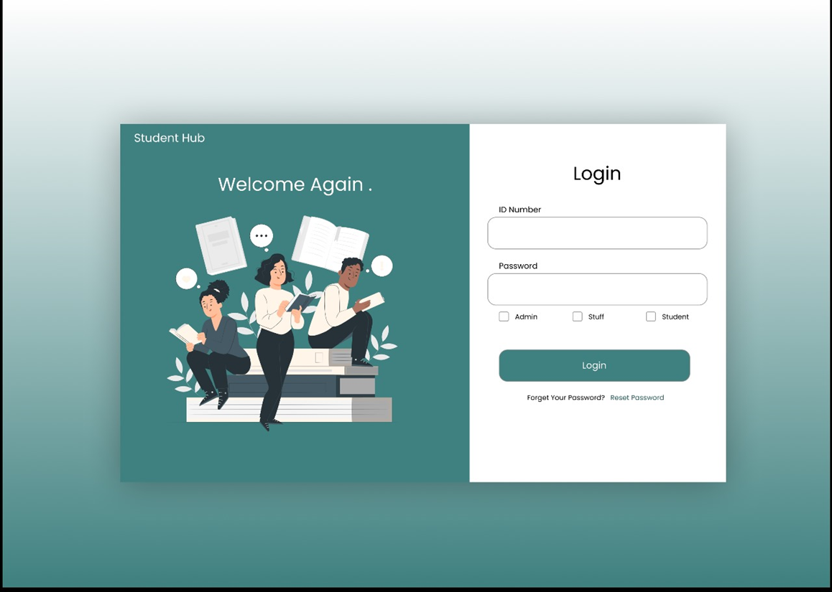

Home page:

Showing your groups and other sections you can access on the left menu.

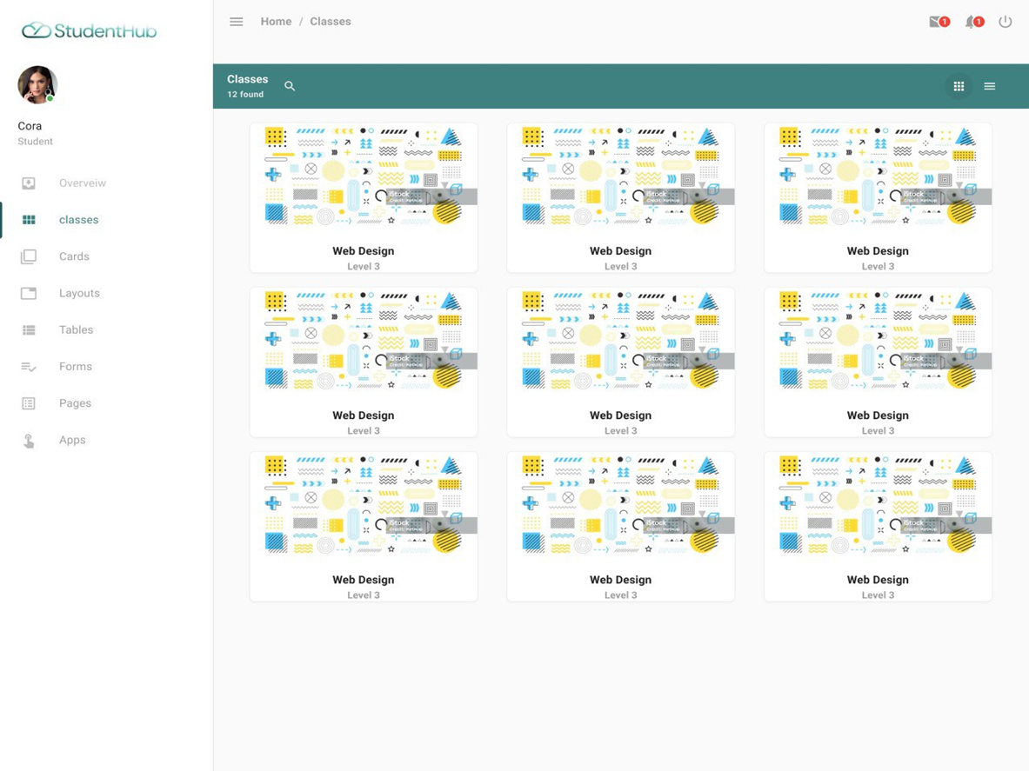

Group page:

Showing all the functions you can do in the group

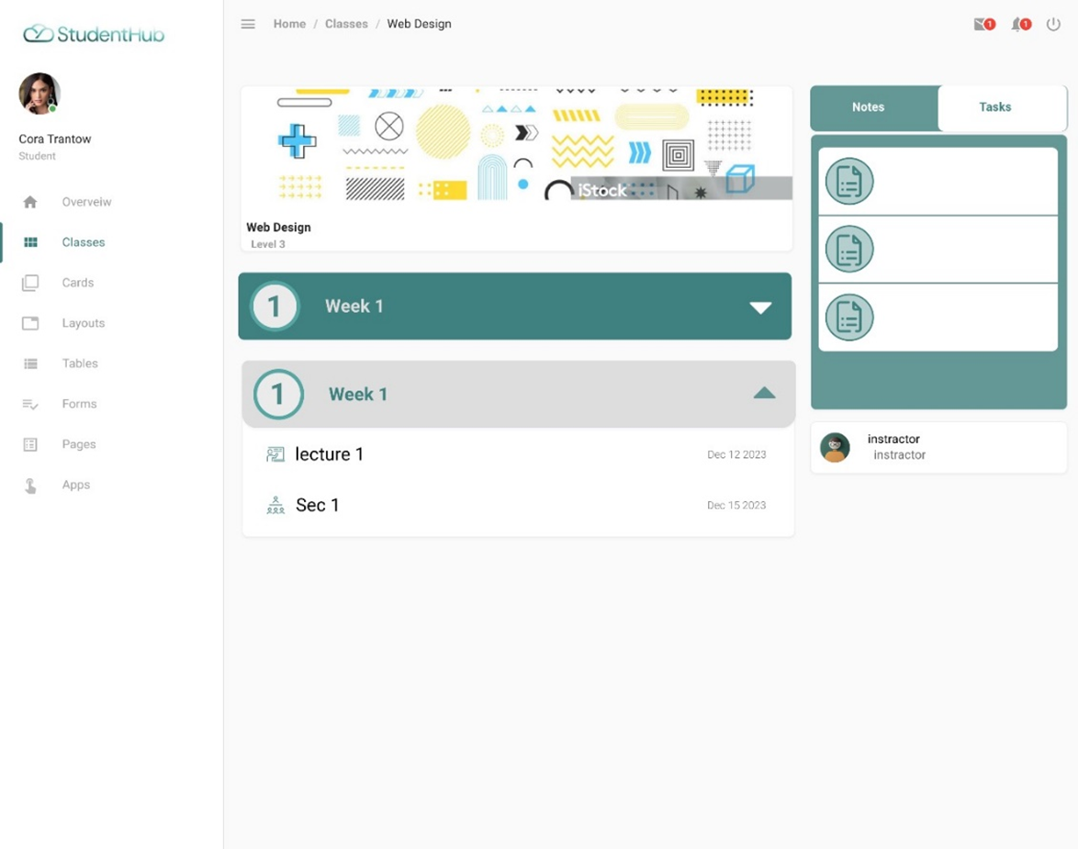

Other Nonfunctional Requirements
Here are some key non-functional requirements (NFRs) for a student management system, typically included in a Software Requirements Specification (SRS):

Performance Requirements
- Response time: Specify acceptable time frames for various operations (e.g., loading student records, generating reports, processing grades). Aim for 2-3 seconds or less for most interactions.
- Concurrent users: Indicate the maximum number of users the system should support simultaneously without performance degradation.
- Data processing capacity: Define the volume of data the system should handle efficiently (e.g., number of students, courses, grades).
- Scalability: Ensure the system can accommodate future growth in student population and data volume without major architectural changes.

Security Requirements
- Authentication: Implement robust mechanisms to verify user identities (e.g., strong passwords, two-factor authentication).
- Authorization: Define access control rules to restrict user actions based on roles and permissions (e.g., students, teachers, administrators).
- Data encryption: Protect sensitive student information (e.g., grades, personal details) using encryption techniques.
- Audit trails: Track user activities and system events for security monitoring and compliance purposes.
- Vulnerability management: Regularly scan for and address security vulnerabilities.

Usability Requirements
- Intuitive interface: Design a user-friendly interface that is easy to navigate and understand for users with varying technical expertise.
- Clear navigation: Provide clear menus, labels, and instructions to guide users through tasks efficiently.
- Accessibility: Ensure the system is accessible to users with disabilities (e.g., visual impairments, motor limitations).
- Error handling: Provide informative error messages and guidance to help users recover from mistakes.
- Help and documentation: Offer comprehensive help resources and documentation to assist users.

Reliability Requirements
- Uptime: Set a target for the percentage of time the system should be available (e.g., 99.9% uptime).
- Data integrity: Ensure the accuracy and consistency of student data throughout its lifecycle.
- Fault tolerance: Implement mechanisms to handle hardware or software failures gracefully, minimizing downtime.
- Backup and recovery: Establish regular data backups and recovery procedures to restore the system in case of major failures.

Maintainability Requirements
- Modular design: Structure the system into well-defined modules to facilitate updates and bug fixes.
- Code readability: Write clear, well-commented code to ease understanding and modification.
- Documentation: Provide comprehensive documentation for system architecture, code, and user guides.
- Testing: Implement thorough testing procedures to ensure system quality and reliability.

Additional NFRs to consider
- Scalability: Ability to handle increasing numbers of students and data without performance degradation.
- Compatibility: Operate seamlessly across different web browsers, devices, and operating systems.
- Localization: Support multiple languages and cultural conventions for global usage.
- Regulatory compliance: Adhere to relevant data privacy and security regulations (e.g., GDPR, FERPA).

