Cairo University  
Faculty of Computers and Information



**CS251**

**Software Engineering I**

CleverZone

Software Design

M & N

December 2016

Contents

Team 3

Document Purpose and Audience 3

System Models 3

I. Class diagrams 3

Important Algorithm 5

II. Sequence diagrams 5

Class - Sequence Usage Table 11

Policy Regarding Plagiarism: 12

References 12

Authors 13

# Team

|  |  |  |  |
| --- | --- | --- | --- |
| **ID** | **Name** | **Email** | **Mobile** |
| 20140291 | Nour Ahmed Abbas | nourahmed@stud.fci-cu.edu.eg | 01211196825 |
| 20140245 | Mahmoud Ahmed Mahmoud | [ouka.ahmed2@gmail.com](mailto:ouka.ahmed2@gmail.com) | 01025517515 |
| 20140225 | Mohamed Ragab Mohamed | mohamed225.mr@gmail.com | 01096023385 |
| 20140211 | Mazen Mohamed Sayed | mazen.mohamed.967@gmail.com | 01009066848 |

# Document Purpose and Audience

* This is a Software Design Specification Document. The document completely describes the class diagram and sequence diagram for the three use case (AddGame , PlayGame ,Register ) .
* The audience for this document include the users (Teacher, Student), client, the system developers, Project management team and the system designers.

# System Models

## Class diagrams

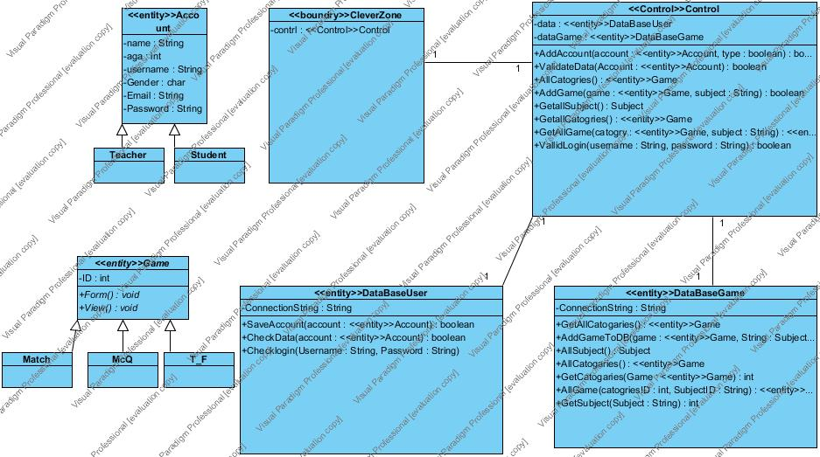

**List down your classes and describe them**

| **Class ID** | **Class Name** | **Description & Responsibility** |
| --- | --- | --- |
| 1 | Account | Generalization of roles of users in the system. |
| 2 | CleverZone | Works as interface between the user and the system (GUI). |
| 3 | Control | Works as intermediate class between GUI and DataBase. |
| 4 | Teacher | Describes one type of user. |
| 5 | Student | Describes one type of user. |
| 6 | Game | Interface class for three classes (match , MCQ , T_F ). |
| 7 | DataBaseUser | Control DataBase of user. |
| 8 | DataBaseGame | Control DataBase of game. |
| 9 | Match | It have all the methods for the game. |
| 10 | MCQ | It have all the methods for the game. |
| 11 | T_F | It have all the methods for the game. |

### Important Algorithm

## II. Sequence diagrams

1. **Register.**

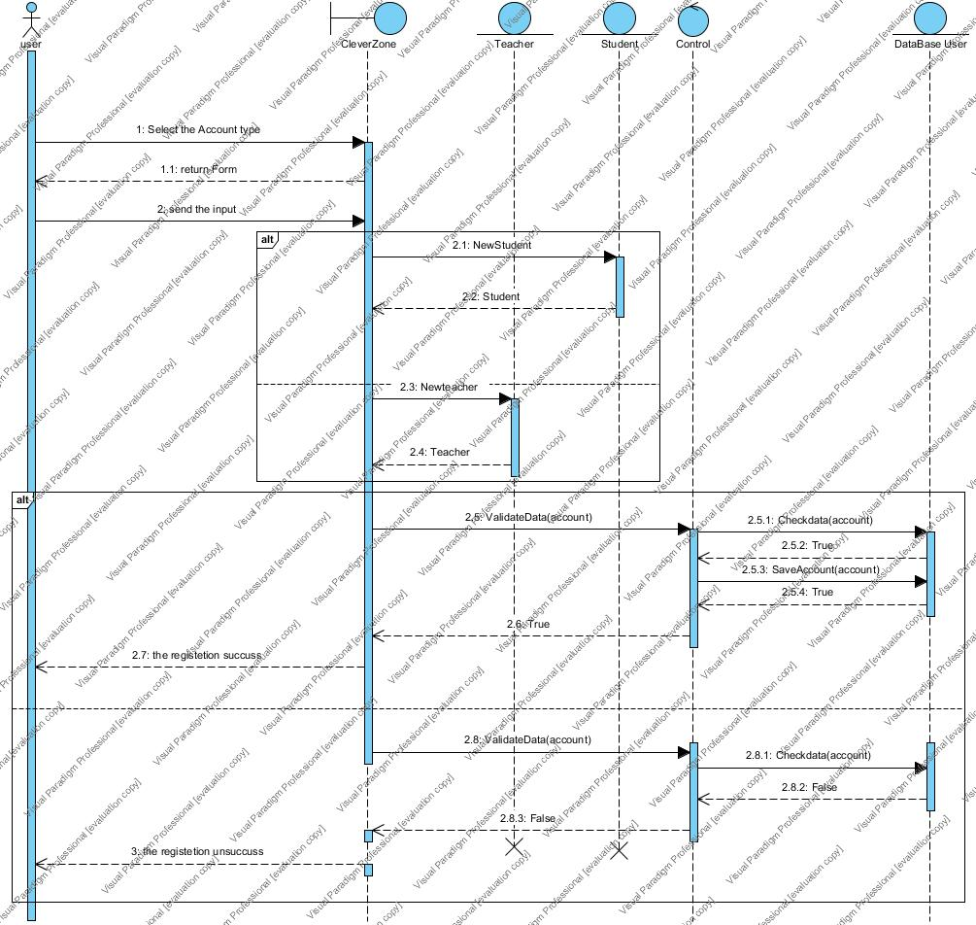

1. **AddGame.**

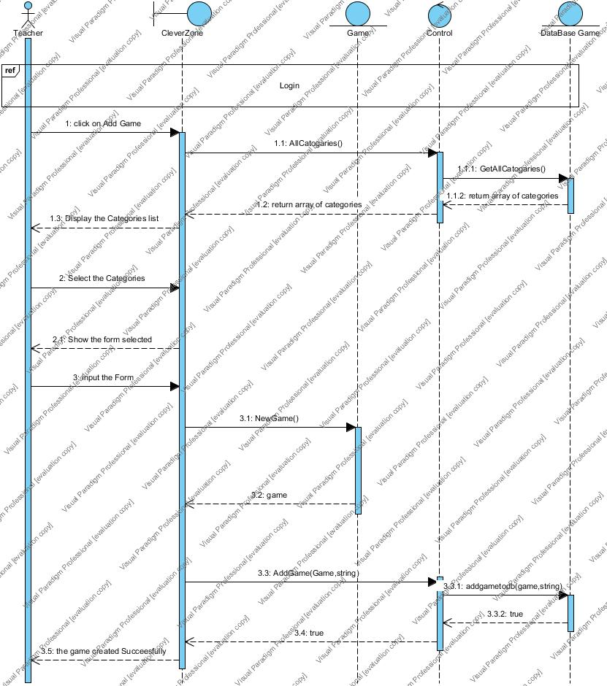

1. **PlayGame.**

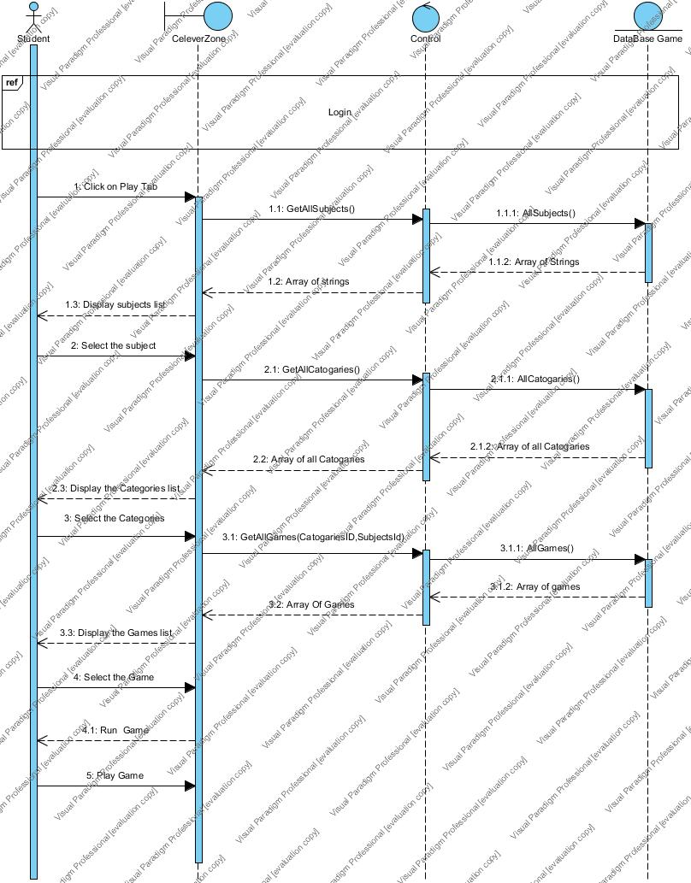

1. **Login.**

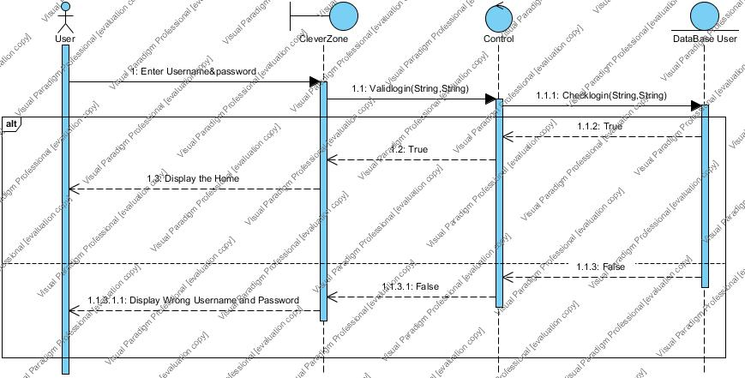

### Class - Sequence Usage Table

| **Class Name** | **Sequence Diagrams** | **Overall used methods** |
| --- | --- | --- |
| CleverZone | 1, 2, 3, 4 |  |
| Teacher | 4, 2 |  |
| Student | 4, 3 |  |
| Account | 1 |  |
| Control | 1, 2, 3, 4 | AddAccount  ValidateData  AllCatogries  AddGame  GetallSubject  GetallCatogries  GetAllGame  VallidLogin |
| DataBaseUser | 1, 4 | SaveAccount  CheckData  Checklogin |
| DataBaseGame | 2, 3 | GetAllCatogaries  AddGameToDB  AllSubject  AllCatogaries  GetCatogaries  AllGame  GetSubject |
| Game | 2, 3 | Form  View |

* Ownership Report

|  |  |
| --- | --- |
| **Item** | **Owners** |
| Login and register | *Nour ahmed abbas* |
| Class diagram | *Mahmoud ahmed Mahmoud ali* |
| Play Game | *Mazen mohamed sayed* |
| Add Game | *Mohamed ragab mohamed* |

# Policy Regarding Plagiarism:

# Github

https://github.com/supernour09/CleverZone.git