Deep Learning

Introduction:

* Deep learning is an artificial intelligence (AI) function that simulates the function that the human brain working with it , these functions like processing data for use in object discovery, speech recognition, language translation and decision-making.
* Deep learning also able to learn without human supervision or direct human control all the time, also drawing from data that is both unstructured and unlabeled.
* Deep learning, a form of machine learning, can be used to help detect fraud or money laundering, among other functions.

How Deep Learning Works

Deep learning has developed very significantly in parallel with the digital age, which has led to the emergence of data in all its forms and from every region of the world in a rush. This data, currently simply known as big data, is taken from sources like social media like Facebook, internet search engines like Google, e-commerce platforms, online cinemas, and more. We can quickly access this huge amount of data easily and can also share it through fintech applications such as cloud computing.

However, the data, which is usually untidy, is organized, so huge that humans may take a very large time, perhaps a decade or centuries, to comprehend it and extract relevant information. Companies are realizing the huge potential that can result from unbundling this wealth of information and are increasingly adapting AI systems to gain automated support.

## Deep Learning vs. Machine Learning

## 

## 

## 

## 

## Figure(1)

Machine learning is one of the most popular artificial intelligence techniques used in processing very big data, and it is a self-adaptive algorithm that gets increasingly better analysis and patterns with experience or with newly added data.

If a digital payment company wants to detect the occurrence or potential for fraud in its system, it can use machine learning tools for this. The computational algorithm built into the computer model will process all transactions occurring on the digital platform, find patterns in the data set, and indicate any anomalies detected by the pattern.

## Deep learning is a subset of machine learning, which uses the classification level of artificial

## neural networks to implement the machine learning process. The structure of the artificial

## neural network is like the human brain, and the neural nodes are connected to each other like

## the Internet. Although traditional software uses data for linear analysis, the organization of

## deep learning systems allows machines to use non-linear methods to process data.

**Special Considerations**

Traditional methods of detecting fraud or money laundering can depend on the number of customers, while the in-depth learning process can include time, geographic location, IP address, type of vendor, and other objects that can indicate a fish. The first layer of the neural network processes the transmission of raw data, such as the number of customers, and sends it to the next layer as a product. The second layer processes the first layer information including additional information, such as the user's IP address, and the delivery of the result.

The next level takes information for the second level and includes raw data such as geographic location and makes the machine’s pattern even better. This continues at all levels of the neural network.

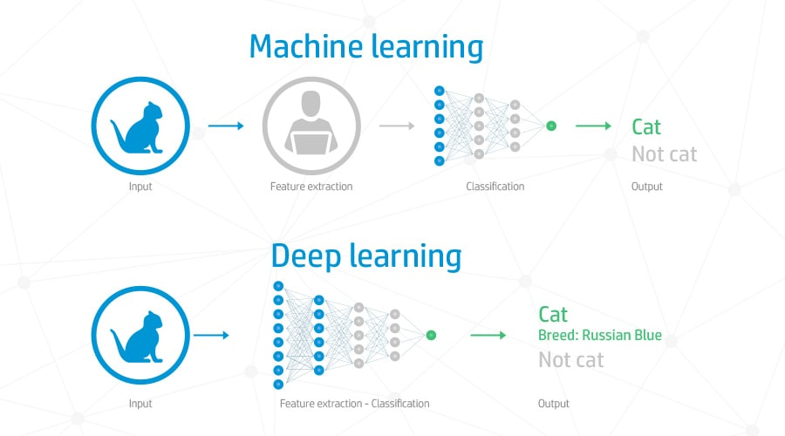

Figure(2)

## A Deep Learning Example

Using the above-mentioned fraud detection and machine learning system, examples of detailed learning can be created. If the machine learning system builds a model with parameters generated based on the amount of dollars sent or received by the user, the background learning method can begin to develop the machine learning results provided.

Each layer of your neural network is based on the previous layer with additional data such as retailers, senders, users, social media events, credit scores, IP addresses, and various other functions that require the connection to process people for years. Background learning algorithms are not only trained to produce patterns in all transactions, but also to know when a pattern indicates the need for inaccurate research.

In-depth learning, which is used in all industries to perform tasks. Commercial systems that use image recognition, open source platforms with consumer recommendations, and medical research tools that test the feasibility of drug use in the disease are just examples of learning. Deep.

