Use Case : Register – Login

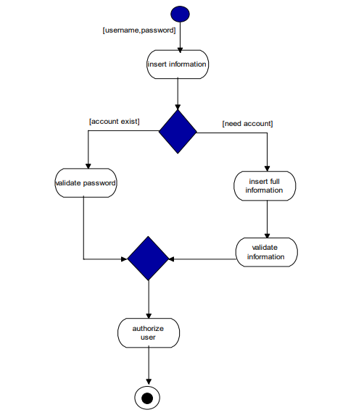

Use Case : Reservation Locker



Use Case : staff



Use case : Admin

