|  |  |  |
| --- | --- | --- |
| **شعار جامعة بنها الجديد**f |  | **logo.jpg** |
| Benha University |  | Faculty of Computers & Informatics |

**Food Lovers**

A summer training project submitted is a website page that provide you a looks to see all types of foods and enjoy the happiness of looking at foods

**2nd Year Students Summer Training**

*Project Team*

1. Mohamed Sabry
2. Abdelrhman Osman
3. Megdy Mohamed
4. Heba Ragab
5. Hanem Elsayed

Benha, August 2017

We hereby certify that this project, submitted by the project teamwork, conforms to acceptable standards and is fully adequate in scope and quality to fulfill the seminar requirements for the degree of Bachelor of Computers and Informatics.

**Abstract**

**Food Lovers** is a website page that provide you a

looks to see all types of foods and enjoy the happiness of

looking at foods.

This is website containt of different types of food like

1-Breakfast.

2-Entrée.

3-Salads.

4-Rice.

5-Pasta.

6-Pizza.

7-Desserts.

8-Drinks.

First type of this menu is the Breakfast that user can

choose anything that he love.

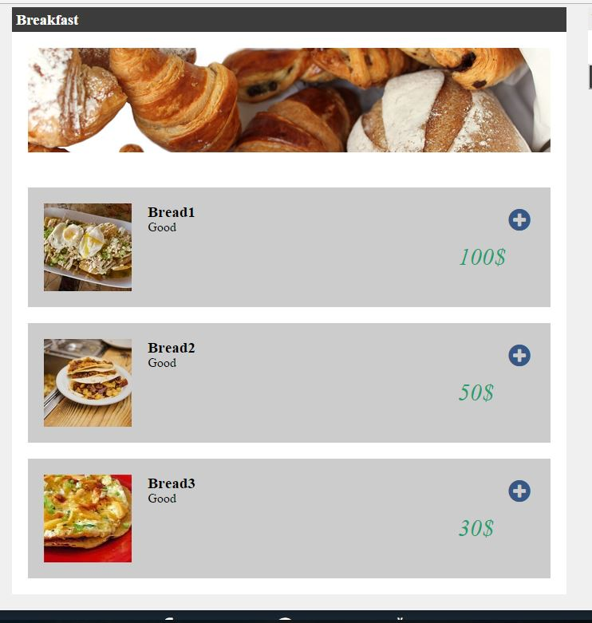

Another types shows the same purpose of the Breakfast show to user.

Food Lovers is a website that consist of many frame

Such:

1-Home.

2-Login.

3-About Restaurant.

4- Team.

5-Contact.

**Home** is the first frame that consider the interface of this website that shows to the user this Website cosists .

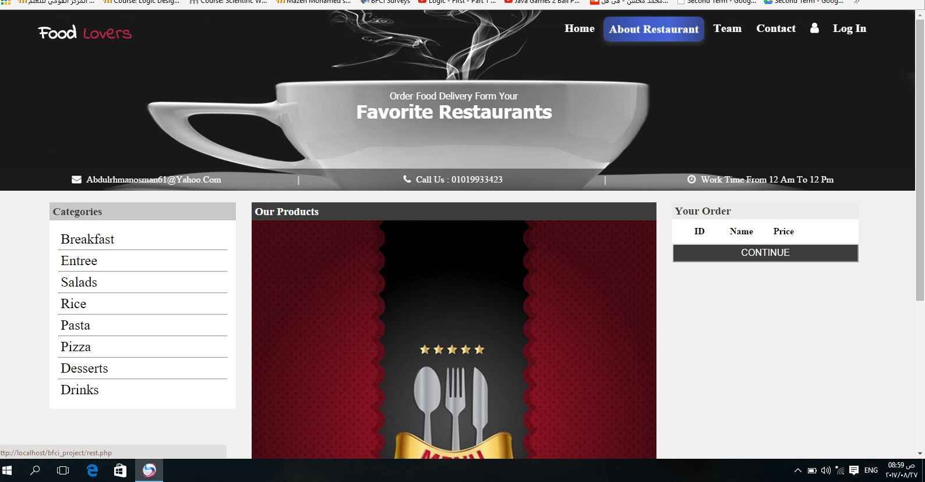

**Login**:

This frame allowed to user to sign up inside this website to see orders and get them.

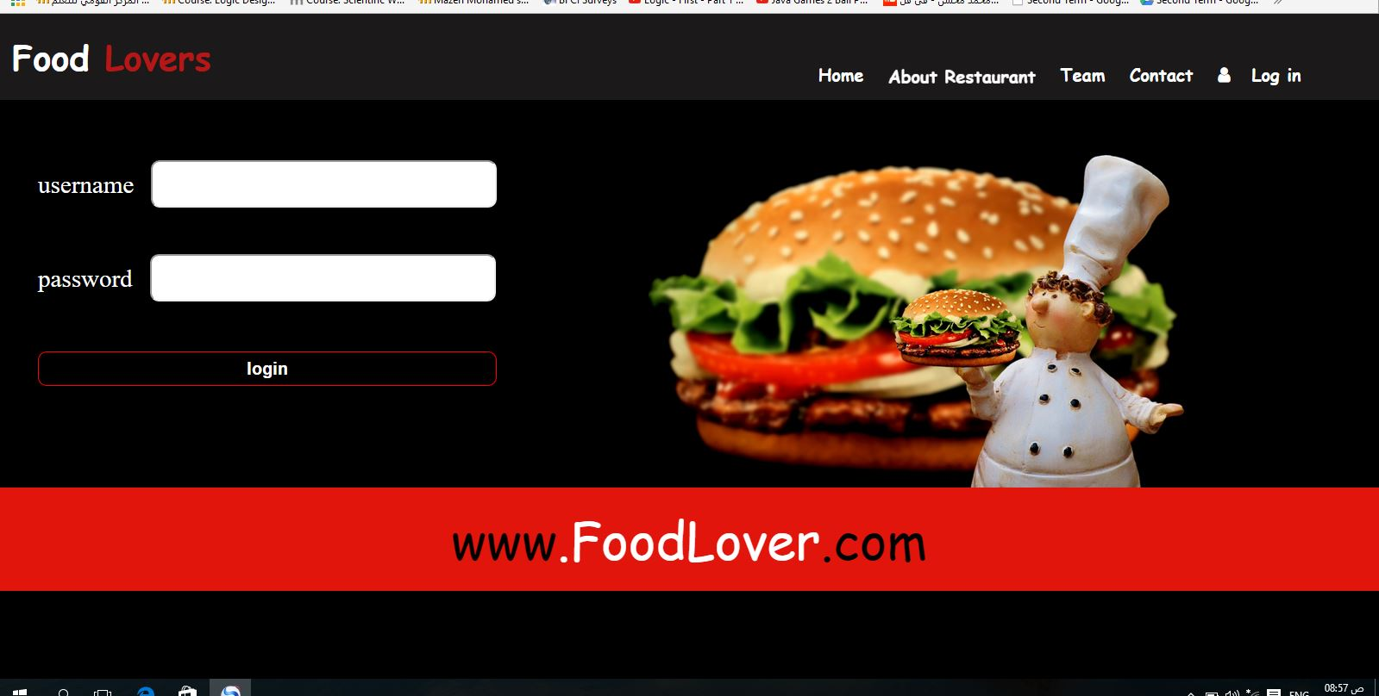

**About Restaurant:**

**This filed show to user anything want to know about this restaurant who establishe it and who cook the food.**

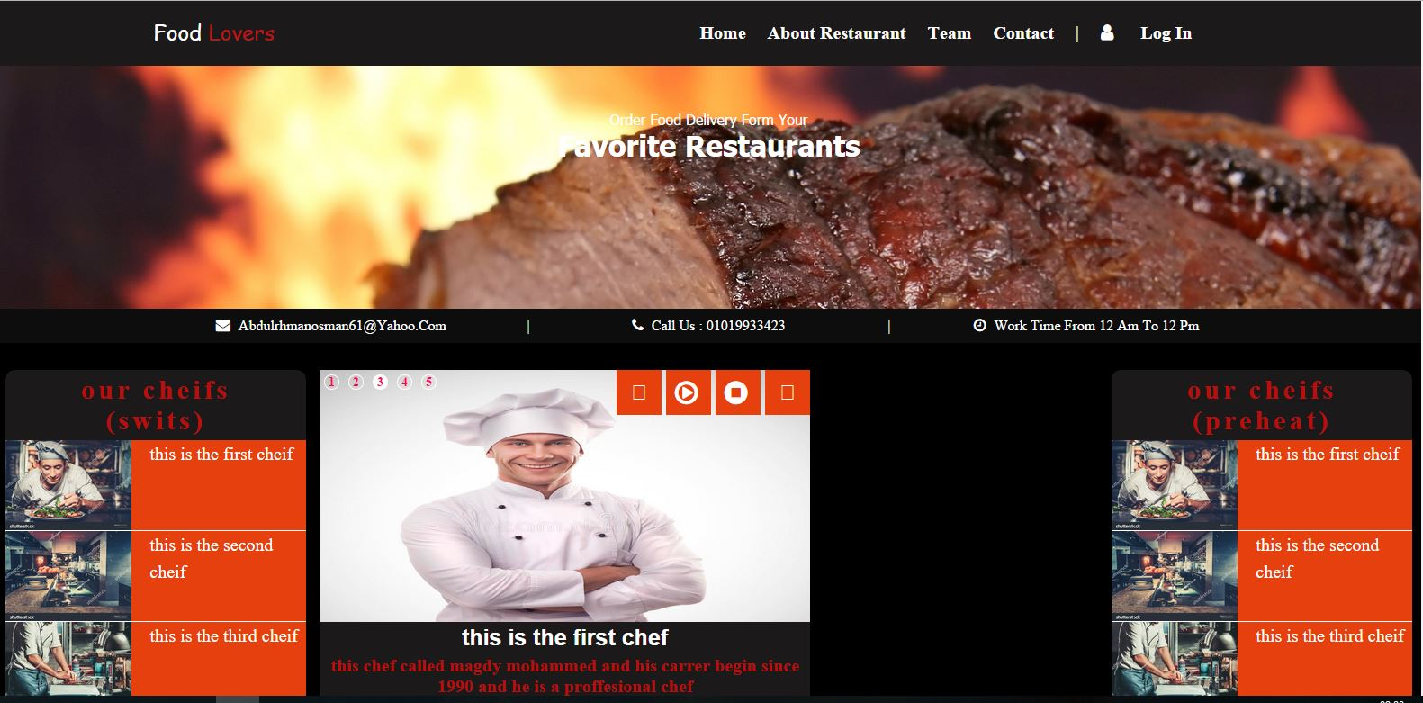

**Contact:**

**This form show to user that he can contact easy to this website and take his order very easy.**

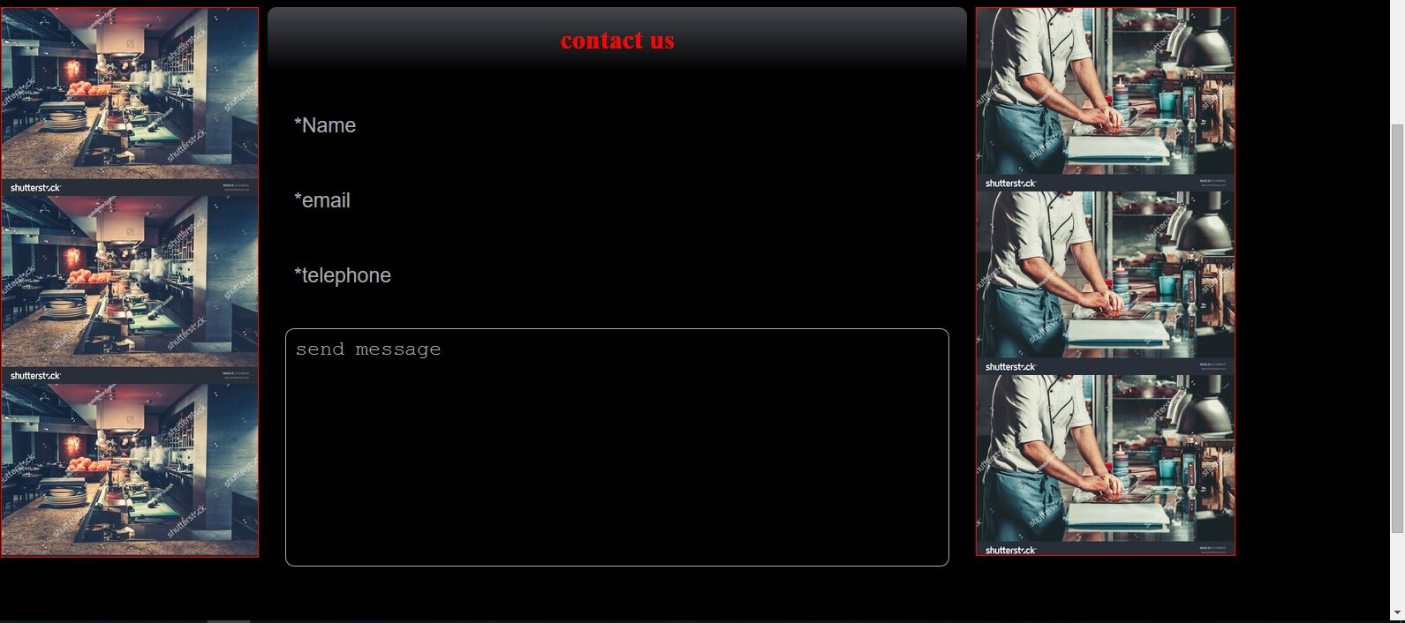

**Introduction**

**Food Lovers**

a website page that provide you a looks to see all types of foods and enjoy the happiness of looking at foods.

This website provide to see any food to choose the food that he want to eat and he can also show the price of them and ordered.

This restaurant has owner this owner may have more restaurant .

This website invide as more page like:

Home ,About Restaurant, Team,Contact.

Every page do something such user can contact on this order and make her order,can show the contain of this website and show the price of his order .

**Program Interface**



**Program Structure**

**Fisrt Index Code:**

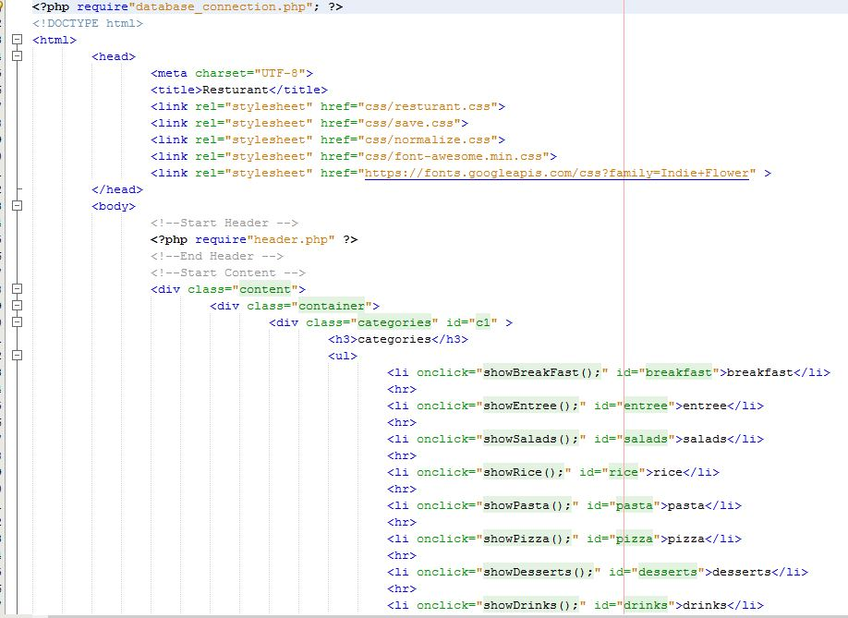

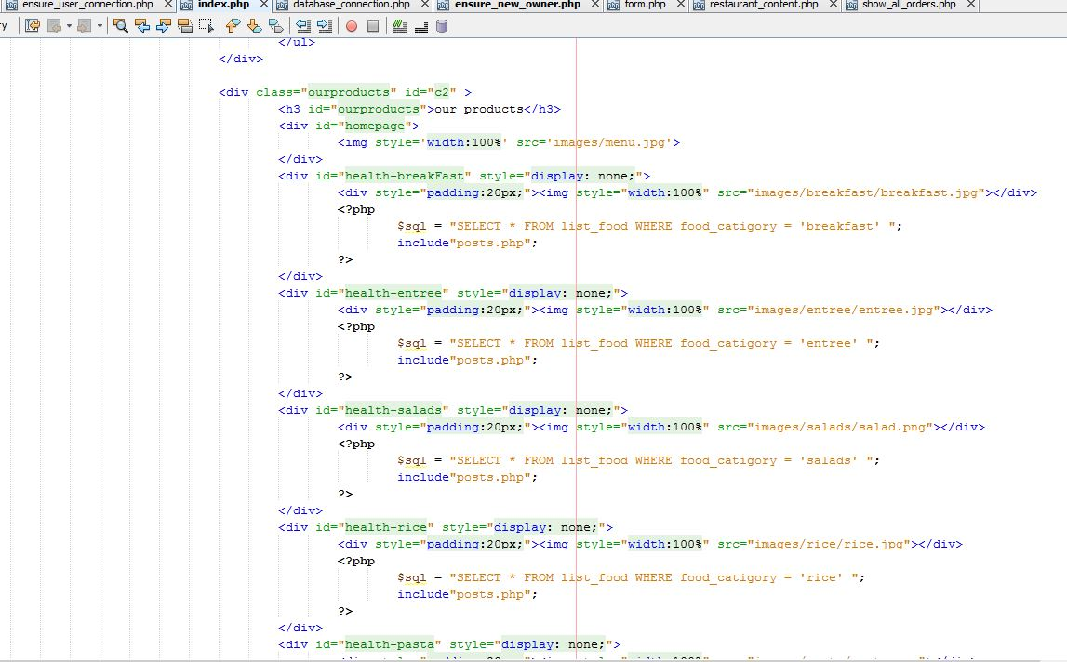

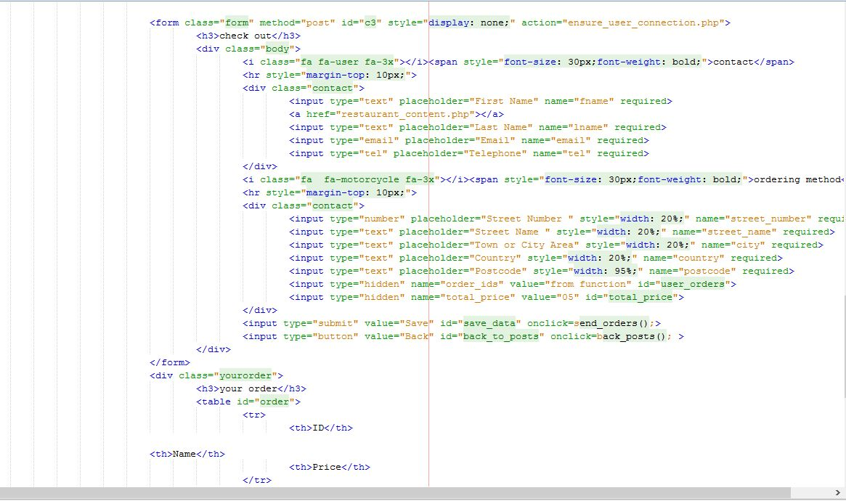

**En_Sure_User_Connection**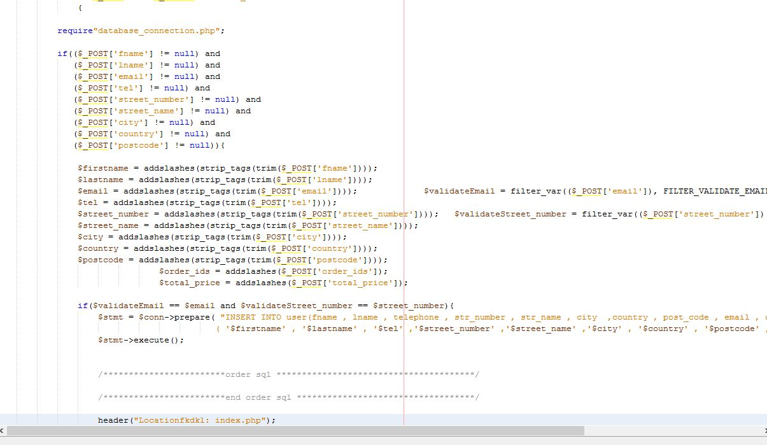

**DataBase_Connection**

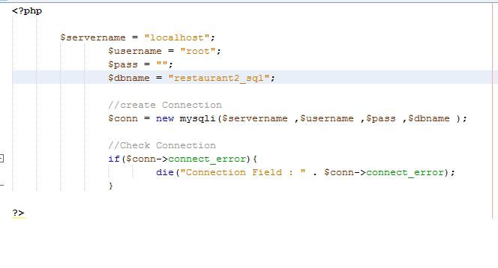

**En_Sure_New_Owner**

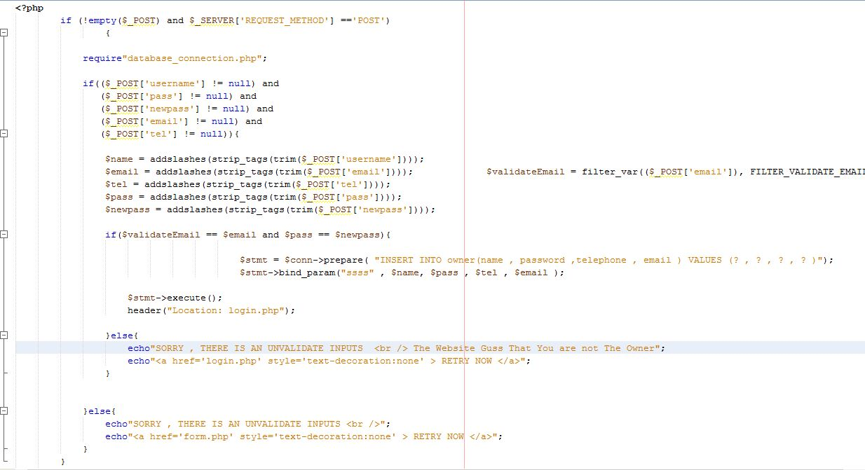

**Form**

