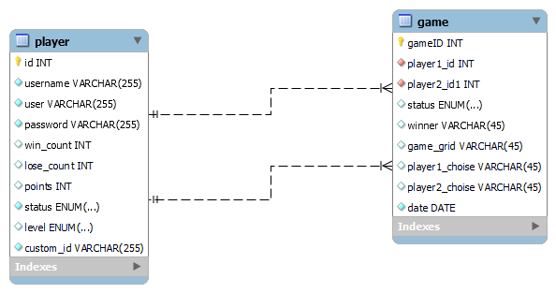

This is our ERD:

We have 2 tables; one for player and one for game

**Player**

Each player have 10 attributes(

**id ,** (the primary key of the table),

**user-name** (which is used to register and sign in),

**user**(which represents his name during the game) ,

**password**(to log in to his account),

**win_count**(represents how many times the player won the game),

**lose_count** (represents how many time the player lost the game),

**points** (represents count of points he collected from the pravious games which will be used to sort the players),

**status** (represents wether the user is online or offline ) to make it easy for a player to now who is online to envite him to play),

**level** (repsents whether the user is just beginner , intermediate or excellent player),

**custom_id**(represents the name used for each user to be envited with).

**Game**

Each gane is represented by 9 attributes :

**game_id**(which is a primary key representing the number of the game between two players),

**player1_id , player2_id**(both of them are foreign keys from the player table representing the id’s af the two players participating in the game),

**status**(represents the status of the game (finished , paused or resumed)),

**winner** (holds the name of the winner player or none if no one won),

**game_grid**(holds the result of the game as a string if the players paused the game to view it as it is and complete the game the next time ),

**player1_choice , player2_choice** (represent the choice of each player whether to blay as “X” or as “O”),

**game_date**(represents the time at which the players started their game).