* Some of the obstacles facing us as developers that our site is renewable and developed for several reasons: -

1. Possibility of developing a short video for the publicity and advertising of the film
2. Set an evening and morning schedule to view the movie
3. Set a price list for each ticket
4. Make a special part for users to write their own opinion in the film story
5. Know the movie revenue every week
6. Make Facebook page
7. And put more cinemas in many cities
8. And the possibility of using the sit on all systems such as Apple or Android
9. The possibility of downloading the SAT from the Apple Astor or Google Play
10. Making a map will set you the shortest way to reach your chosen destination to the cinema

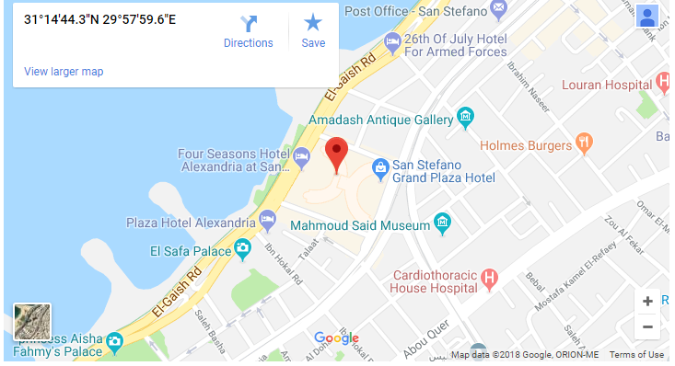

Scenario for project

Our project is about a movie site due to the reception of many customers who request a cinema site in order to know the available films and their availability in cinemas. So we held the developers meeting with customers to see what the problems are facing the answer was as follows:

He needs a movie site because he faces a lot of difficulties to see what movies are in theaters . The biggest problems he faces is that he does not know the place of the cinema contains the films he wants to see. It takes time to visit movie theaters in order to search for a specific film. He also finds it difficult to book tickets because of their speed finish . So we did a movie site to help the client to know the films available and to know their places