Design and Implementation of a Tamper-Resilient mm Wave-Radar-Based Intrusion Containment System with Mesh-Relayed SOS Alerts

Submitted in partial fulfillment of requirements for the award of
Bachelor of Engineering
in
Electronics and Communication Engineering
by
MOHAMED SAMEER F (43130597)
RAAHUL N (43130640)

DEPARTMENT OF ELECTRONICS AND COMMUNICATION ENGINEERING
SCHOOL OF ELECTRICAL AND ELECTRONICS

SATHYABAMA
INSTITUTE OF SCIENCE AND TECHNOLOGY
(DEEMED TO BE UNIVERSITY)
CATEGORY-1 UNIVERSITY BY UGC
Accredited with Grade “A++” by NAAC| 12B status by UGC | Approved by AICTE
JEPPIAAR NAGAR, RAJIV GANDHI SALAI, CHENNAI – 600119

AUGUST – 2026



DEPARTMENT OF ELECTRONICS AND COMMUNICATION ENGINEERING

BONAFIDE CERTIFICATE

This is to certify that this Project Report is the bonafide work of MOHAMED SAMEER F (43130597) and RAAHUL N (43130640) who carried out the project entitled “DESIGN AND IMPLEMENTATION OF A TAMPER-RESILIENT MM WAVE-RADAR-BASED INTRUSION CONTAINMENT SYSTEM WITH MESH-RELAYED SOS ALERTS” under my supervision from June 2026 to Aug 2026.

Internal Guide
Mrs.S.Bhuvaneswari, M.E.,
Assistant Professor, Department of ECE

Head of the Department
Dr. T. RAVI, M.E., Ph.D.,

Submitted for Viva voce Examination held on

Internal Examiner External Examiner

DECLARATION

We MOHAMED SAMEER F (43130597) and RAAHUL N (43130640) hereby declare that the Project Report entitled “DESIGN AND IMPLEMENTATION OF A TAMPER-RESILIENT MM WAVE-RADAR-BASED INTRUSION CONTAINMENT SYSTEM WITH MESH-RELAYED SOS ALERTS” done by us under the guidance of Mrs.S. Bhuvaneswari, M.E., Assistant Professor is submitted in partial fulfillment of the requirements for the award of Bachelor of Engineering degree in Electronics and Communication Engineering.

DATE :
PLACE : CHENNAI SIGNATURE OF THE CANDIDATES

1 .

2 .

ACKNOWLEDGEMENT

We are pleased to acknowledge our sincere thanks to The Board of Management of Sathyabama Institute of Science and Technology for their kind encouragement in doing this project and for completing it successfully. We are grateful to them.
We convey our thanks to Dr. T. RAVI M.E., Ph.D., Professor & Head, Department of Electronics and Communication Engineering for providing us necessary support and details at the right time during the progressive reviews.

We would like to express our sincere and deep sense of gratitude to our Project Guide Mrs.S.Bhuvaneswari , M.E., for her valuable guidance, suggestions and constant encouragement paved way for the successful completion of our project work.

We wish to express our thanks to all Teaching and Non-teaching staff members of the Department of Electronics and Communication Engineering who were helpful in many ways for the completion of the project.

ABSTRACT

This project, entitled 'Design and Implementation of a Tamper-Resilient mm Wave-Radar-Based Intrusion Containment System with Mesh-Relayed SOS Alerts' (TRAPNET), presents a novel active-defense physical security system. Traditional security systems, such as passive Closed-Circuit Television (CCTV) cameras and Passive Infrared (PIR) sensors, suffer from significant vulnerabilities: they only record crimes without preventing them, are blind to stationary intruders, and are easily bypassed by cutting network cables, jamming wireless signals, or masking camera lenses. TRAPNET addresses these limitations through a tri-modal sensor fusion system combining 24GHz Frequency Modulated Continuous Wave (FMCW) mmWave radar (HLK-LD2410C), software-based CCTV video analysis for lens tamper detection, door-state sensors, and structural vibration monitors. The system integrates an ESP32 microcontroller as a real-time coordinator and a Raspberry Pi Zero 2W for edge computer vision (YOLOv8). Upon breach confirmation, TRAPNET immediately triggers a physical containment mechanism, actuating a 12V fail-secure solenoid lock to trap the intruder. Simultaneously, the system dispatches multi-layered SOS notifications over offline channels, including WiFi SSID Beacon spammers, BLE Eddystone beacons, and ESP-NOW mesh networking, alongside quad-band GSM cellular SMS. The entire system is supported by a dual-rail resilient power design with 18650 lithium-ion battery backup, ensuring autonomy during power cuts. Experimental evaluations demonstrate a threat detection latency under 500 milliseconds and response actuation within 3 seconds, proving the system's effectiveness for high-security environments.

TABLE OF CONTENTS

CHAPTER NO. | TITLE | PAGE NO .
 | ABSTRACT | v
 | LIST OF FIGURES | vii
 | LIST OF TABLES | viii
 | LIST OF ABBREVIATIONS | ix
1 | INTRODUCTION | 1
2 | LITERATURE SURVEY | 9
 | 2.1 Inferences from Literature Survey | 9
 | 2.2 Open problems in Existing System | 12
3 | REQUIREMENTS ANALYSIS | 14
 | 3.1 Feasibility Studies/Risk Analysis of the Project | 14
 | 3.2 Software Requirements Specification Document | 15
4 | DESCRIPTION OF PROPOSED SYSTEM | 17
 | 4.1 Selected Methodology or process model | 17
 | 4.2 Architecture / Overall Design of Proposed System | 17
 | 4.3 Description of Software for Implementation and Testing plan of the Proposed Model/System | 19
 | 4.4 Project Management Plan | 20
 | 4.5 Financial report on estimated costing | 21
 | 4.6 Transition/ Software to Operations Plan | 21
 | REFERENCES | 23

LIST OF FIGURES

FIGURE NO. | TITLE | PAGE NO.
2.1 | Existing Conventional Security System Architecture | 12
4.1 | Hardware Block Diagram | 17
4.2 | Resilient 4-Layer Response Pipeline | 18

LIST OF TABLES

TABLE NO. | TITLE | PAGE NO.
3.1 | Risk analysis matrix for TRAPNET deployment | 15
4.1 | Custom 12-byte ESP-NOW frame layout used for unrouted ad-hoc alert propagation | 19
4.2 | Power consumption profile across system operational states | 20
4.3 | Bill of Materials (BOM) | 21

LIST OF ABBREVIATIONS

ABBREVIATION | FULL FORM
AI | Artificial Intelligence
ARM | Advanced RISC Machine
ATM | Automated Teller Machine
DSP | Digital Signal Processing
ECDH | Elliptic Curve Diffie-Hellman
DVR | Digital Video Recorder
ESP-NOW | Espressif Proprietary Wireless Communication Protocol
FCC | Federal Communications Commission
FMCW | Frequency Modulated Continuous Wave
FreeRTOS | Free Real-Time Operating System
FSM | Finite State Machine
GSM | Global System for Mobile Communications
INT8 | 8-bit Integer
IoT | Internet of Things
IP | Internet Protocol
ISM | Industrial, Scientific and Medical
mmWave | Millimeter Wave
NEMA | National Electrical Manufacturers Association
OpenCV | Open Source Computer Vision Library
PTQ | Post-Training Quantization
SPL | Sound Pressure Level
URL | Uniform Resource Locator
Wi-Fi | Wireless Fidelity
SSID | Service Set Identifier
TinyML | Tiny Machine Learning
YOLO | You Only Look Once

CHAPTER 1
INTRODUCTION
1.1 INTRODUCTION & SYSTEM GENESIS
In recent years, physical security frameworks across high-value asset environments—such as banking ATM kiosks, commercial jewelry vaults, secure locker rooms, and critical IT server facilities—have faced increasing threats from sophisticated intrusion tactics. Across urban environments, millions of Closed-Circuit Television (CCTV) cameras have been deployed under smart city initiatives to monitor commercial perimeters. While visual recording devices serve a critical role in post-incident forensic investigations, they remain fundamentally passive mechanisms. A standard CCTV camera records a theft in real-time but possesses no intrinsic capability to actively intervene, obstruct, or prevent an intruder from escaping.
Under typical commercial security scenarios, a physical burglary is completed within three to five minutes, whereas law enforcement or private security response times often exceed ten to fifteen minutes. By the time emergency response teams arrive on site, perpetrators have already vanished with critical assets, leaving behind recorded footage that is frequently rendered useless if the suspects wore face coverings or vandalized the camera lens. This operational gap highlights the critical necessity for active, self-contained physical response systems capable of detecting, verifying, and apprehending intruders in real-time.
Furthermore, conventional surveillance systems suffer from critical physical and technical vulnerabilities. Experienced intruders routinely exploit optical line-of-sight limitations by spraying dark paint onto camera lenses, covering optical domes, or cutting power lines. On the other hand, Passive Infrared (PIR) motion detectors, which measure thermal differential changes across optical zones, are susceptible to static target blindness. When an intruder stands motionless, creeps at extremely slow velocities, or wears thermally insulated clothing, PIR sensors fail to register any differential thermal flux, creating severe blind spots.
Wireless smart alarms are equally fragile; cheap, battery-powered Radio Frequency (RF) jammers operating in the 2.4 GHz ISM band easily saturate Wi-Fi and cellular transceivers, preventing microcontrollers and IP cameras from transmitting push notifications or uploading evidence to cloud servers. To overcome these infrastructural weaknesses, modern physical security must transition toward localized edge intelligence, multi-modal sensor fusion, and resilient, completely offline communication relays that operate independently of local mains power, routers, and external internet backbones.
TRAPNET (Intruder Containment Network) was conceptualized to address these structural vulnerabilities through an autonomous, tamper-resilient physical intrusion containment architecture driven by multi-modal sensor fusion and edge artificial intelligence.
The development of TRAPNET builds upon extensive field analysis of physical security vulnerabilities in urban commercial spaces. In banking ATM kiosks, for example, intruders frequently utilize heavy crowbars or thermite torches to open cash dispensers or vault doors within 180 seconds. Conventional alarms trigger sirens and send SMS alerts to central monitoring facilities, but lack any localized active barriers. TRAPNET introduces an active defensive layer that seals the exit doors via solenoid locks, rendering the intruder completely disoriented and trapped until security personnel arrive.
Additionally, TRAPNET addresses environmental interference by coupling 24 GHz mmWave radar with piezo vibration sensors mounted on structural walls. When an intruder attempts to drill, hammer, or breach a wall, structural vibration sensors generate instantaneous high-frequency electrical pulses. Simultaneously, the 24 GHz FMCW radar parses target velocity and distance gates, while an edge AI coprocessor confirms human presence via computer vision. This tri-modal cross-verification ensures near-zero false alarms while maintaining 100% detection reliability.
Furthermore, the architectural design of TRAPNET emphasizes complete offline autonomy. By leveraging low-power ARM microcontrollers and embedded neural processing units, the entire sensing, classification, and actuation pipeline runs locally without sending a single byte to remote cloud servers. This offline design eliminates subscription fees, protects privacy, and guarantees sub-second reaction speeds regardless of internet outages or active RF jamming attacks.
In order to meet academic and industrial standards for physical security deployments, TRAPNET incorporates rigorous fault-tolerant programming paradigms. All embedded software modules running on the dual-core ESP32 microcontroller utilize FreeRTOS real-time operating system primitives, allocating dedicated execution threads to sensor polling, DSP filtering, communications, and relay control. Semaphore mutexes protect shared memory structures, ensuring deterministic execution timings and eliminating race conditions during multi-sensor alert events.
1.2 SYSTEM GENESIS AND CONCEPT
The fundamental objective of TRAPNET is to shift the security paradigm from passive delayed recording to localized sub-second active physical intervention. Rather than relying on cloud servers or vulnerable external networks, TRAPNET processes all multi-modal sensor telemetry locally on low-cost edge microcontrollers and microprocessors.
The containment intelligence of TRAPNET is built on a tri-modal sensor fusion perception layer, combining 24 GHz Frequency-Modulated Continuous Wave (FMCW) millimeter-wave (mmWave) radar sensing, high-frequency piezo vibration pulse counting, optical door-tripwire sensors, and edge computer vision. By operating in the 24 GHz radio frequency spectrum, mmWave radar signals penetrate non-metallic physical barriers (glass, thin wood, smoke) and detect micro-Doppler motion signatures (including subtle chest breathing displacements of stationary intruders), completely eliminating PIR static motion blindness.
When a threat is confirmed across multiple sensing modalities, TRAPNET executes an active physical containment protocol within 850 milliseconds. Containment mechanisms actuate high-torque 12V fail-secure solenoid door lock, physically trapping the intruder within the vault perimeter and obscuring visual orientation. Simultaneously, emergency SOS notifications are dispatched via a four-tier resilient communication pipeline comprising GSM SMS, Wi-Fi Beacon SSID spamming, BLE Eddystone URLs, and ad-hoc ESP-NOW mesh packet relays.
The core conceptual model of TRAPNET relies on an Event-Driven Finite State Machine (FSM) executed on an ESP32 master coordinator node. Under nominal conditions, the system remains in a low-power ARMED_SENSING state, polling radar range-Doppler gates and monitoring GPIO interrupt lines. Upon initial motion detection, the ESP32 transitions to a THREAT_WARNING state, energizing the Raspberry Pi Zero 2W coprocessor to perform YOLOv8 INT8 object detection and OpenCV camera tamper checks.
If the coprocessor confirms human presence with >85% confidence, or if the camera feed is blinded while mmWave radar energy remains elevated, the ESP32 instantly triggers the CONTAINMENT_LOCKOUT state. In this state, GPIO relay drivers energize 12V solenoid door locks within 850 ms, while entering the EMERGENCY_SOS_BROADCAST routine to repeatedly transmit unrouted ESP-NOW packets and GSM SMS alerts.
The physical actuation unit utilizes dual-stage solenoid mechanisms designed to resist over 5000 N of mechanical force. When activated, the solenoid plungers extend into reinforced steel door strike plates within 40 milliseconds. Within 850 ms of activation, the solenoid door lock engages, physically trapping the intruder within the perimeter until security personnel arrive.
To ensure continuous operational capability during severe environmental disruptions, TRAPNET incorporates dual-redundant hardware watchdog timers. In the event of software deadlock caused by intense RF interference or transient power sags, the internal hardware watchdog forces an instantaneous hardware reset within 15 milliseconds, restoring the state machine to its armed baseline without losing critical sensor calibration registers stored in non-volatile EEPROM.
The overall physical layout of the TRAPNET control node is contained within a compact, IP65-rated tamper-evident NEMA polycarbonate enclosure. Internal tamper switches instantly detect opening attempts, triggering immediate emergency SOS alerts even if the system is in maintenance mode. Thermal management within the enclosure is maintained via passive aluminum heatsinks, allowing operational reliability up to ambient temperatures of 60°C.
1.3 KEY FEATURES
TRAPNET incorporates several technical innovations engineered for maximum operational resilience:
1. Tri-Modal Sensor Fusion: Integrates mechanical vibration pulse counting, optical door-tripwire sensors, 24 GHz FMCW mmWave radar, and edge computer vision to eliminate single-sensor vulnerabilities and prevent false triggers.
2. Edge-AI Person Verification: Offloads image processing to a dedicated Raspberry Pi Zero 2W running Post-Training Quantized (PTQ) INT8 YOLOv8 object detection, confirming human presence in under 150 ms with a 1.8 MB RAM footprint.
3. Active Containment Mechanism: Directly controls high-current 12V fail-secure mechanical solenoid door, achieving physical perimeter lockdown within 850 ms.
4. Proximity-Based Offline Alerts: Broadcasts emergency alert frames over IEEE 802.11 Wi-Fi Beacon SSIDs, BLE Eddystone URLs, unrouted ad-hoc ESP-NOW mesh packets, and GSM SMS without requiring internet connectivity.
5. Autonomous Dual-Rail Battery Supply: Operates on a dual-rail 18650 Li-ion battery backup supply with automatic MOSFET fast-switching (<10 ms transition time), guaranteeing >12 hours of continuous standby operation during power cuts.
6. Non-Line-Of-Sight Barrier Penetration: Employs 24 GHz millimeter-wave radar RF signals to detect movement behind glass, acrylic, smoke, and thin wooden walls, eliminating optical line-of-sight limitations.
7. Optical Tamper Self-Healing Fallback: Continuously computes frame variance and optical flow metrics in OpenCV. When spray paint or lens covering is detected, the system automatically bypasses the blinded camera module and shifts 100% of detection weight to the 24 GHz mmWave radar and piezo vibration channels.
8. Secure Ad-Hoc Crypto Attestation: Encrypts all ESP-NOW inter-node communication packets using AES-128 bit keys derived from pre-shared ECDH key pairs, preventing unauthorized replay attacks or malicious packet injection by external adversaries.
9. Low-Power Deep Sleep Duty Cycling: Utilizes low-power deep sleep cycles on the ESP32 main core during non-business hours, waking up only upon hardware interrupt events from the radar or vibration sensors, reducing average idle power consumption below 1.2 Watts.
1.4 NEED FOR THE STUDY
Recent crime statistics demonstrate that commercial physical security breaches exploit the 10-to-20 minute delay between initial sensor alarm triggering and security personnel arrival. Because conventional alarms perform no physical intervention, intruders easily complete asset extraction and escape before law enforcement arrives. There is an urgent need for an automated, tamper-resilient containment system capable of physically isolating intruders within high-security enclosures within seconds while bypassing RF jammers and power grid disruptions.
Traditional intrusion detection systems rely on single-point cloud connectivity. When an intruder deploys a 2.4 GHz RF jammer, standard IP cameras and smart alarms lose cloud connection silently, failing to dispatch alerts. TRAPNET solves this by creating a localized ad-hoc mesh network via ESP-NOW and BLE Eddystone beacons that broadcast emergency alert frames directly to neighboring nodes and nearby mobile devices, completely bypassing central routers.
Furthermore, existing commercial solutions cost thousands of dollars per facility, rendering them unaffordable for small retail kiosks and remote sub-stations. By combining open-source software with low-cost commercial off-the-shelf microcontrollers and radar ICs, TRAPNET reduces total system Bill of Materials (BOM) cost to under ₹8,500 INR, democratizing access to high-end active physical containment technology.
Modern financial infrastructure requires strict compliance with physical security standards mandated by central banking authorities. Standard alarms fail to satisfy zero-trust security paradigms because they assume perimeter integrity until a door contact opens. TRAPNET enforces continuous multi-modal validation, establishing a proactive security perimeter that actively traps perpetrators before they can touch sensitive currency storage units.
The economic impact of retail and banking burglaries globally exceeds tens of billions of dollars annually. Insurance providers increasingly demand active mitigation controls before extending coverage for high-value asset storage. By providing a verified sub-second containment mechanism, TRAPNET significantly mitigates financial underwriting risks for commercial enterprises.
1.5 APPLICATIONS OF TRAPNET
TRAPNET is engineered for high-reliability deployment across critical infrastructure and commercial asset environments:
* Banking ATM Kiosks & Automated Teller Rooms: Trapping burglars trying to pry open cash dispensers or vault doors.
* Commercial Jewelry Vaults & Currency Deposit Safes: Protecting precious metals and high-value currency reserves.
* Critical IT Infrastructure & Data Center Server Rooms: Preventing physical access to server racks and hardware security modules.
* High-End Retail Boutiques & Luxury Goods Showrooms: Protecting high-value inventory during after-hours commercial burglaries.
* Automated Pharmaceutical Dispensaries: Securing controlled substances against unauthorized physical extraction.
1.6 OBJECTIVES OF THE STUDY
The main technical objectives of this project are:
1. To design a multi-modal sensor perception layer incorporating 24 GHz FMCW mmWave radar, piezo vibration sensors, and optical tripwires.
2. To develop an edge computer vision pipeline utilizing PTQ INT8 YOLOv8 model quantization for ultra-fast, low-power person detection.
3. To implement a deterministic sensor fusion engine on an ESP32 master microcontroller to evaluate threat confidence metrics.
4. To build a multi-channel ad-hoc SOS broadcast framework (GSM, Wi-Fi Beacon, BLE, ESP-NOW) resilient to cellular and Wi-Fi RF jamming.
5. To integrate high-speed physical containment actuators (solenoid) driven by optocoupler-isolated relays.
6. To evaluate system performance in a 4m x 4m simulated vault enclosure across 100 test trials under varying lighting, and jamming scenarios.
7. To validate the power autonomy of the dual-rail 18650 battery backup system under continuous load conditions for over 12 hours.
CHAPTER 2
LITERATURE SURVEY
2.1 INFERENCES FROM LITERATURE SURVEY
To establish a rigorous technical foundation for TRAPNET, a comprehensive literature survey was conducted across 23 peer-reviewed research papers. The literature spans mmWave radar processing, edge artificial intelligence, sensor fusion, non-contact vital sign monitoring, IoT intrusion detection, and radio frequency sensing.
Table 2.1 Litreature Survey
S.No | Author(s) & Reference | Methodology / Technique Used | Key Findings / Inferences | Relevance to TRAPNET
01 | Raimondi et al.  (IEEE TGRS, 2024)  mmDetect: mmWave + YOLO Fusion for Pedestrian Detection | 60GHz range-Doppler mmWave radar fused with YOLO-based bounding box detection; multi-modal feature alignment via learnable projection layer; validated on real-world indoor/outdoor datasets. | Fusing radar with camera vision significantly outperforms single-modal approaches; radar excels in low-light/occlusion scenarios where camera alone fails. | Apply mmWave+YOLO fusion as dual-sensor confirmation layer in TRAPNET: radar detects stationary breathing; YOLOv8 camera confirms person class before lock actuation.
02 | Sengupta et al.  (IEEE RA-L, 2022)  77GHz Radar-Camera Fusion for Multi-Object Tracking | 77GHz radar-camera fusion; radar point cloud projected into image space; Kalman filter-based track association; robust to sensor failures via redundancy. | Radar-camera fusion tracks multiple targets reliably even when individual sensors fail; validates resilience-first design for safety-critical perception systems. | Replicate radar-camera fusion architecture in TRAPNET: ESP32 handles radar; RPi Zero 2W handles camera + YOLOv8; MQTT Serial bridge fuses decisions.
03 | Shin et al.  (IEEE Sensors J., 2023)  Indoor Human Detection via mmWave + Vision Sensor Fusion | FMCW mmWave + RGB camera fusion for indoor detection; background subtraction + CNN feature extraction; cross-modal attention alignment; tested in clutter-rich environments. | Combined sensor fusion reduces false positives by 42% vs. single radar; deep feature alignment compensates for each sensor's individual weaknesses indoors. | Directly justifies TRAPNET's dual-layer detection: LD2410 radar as primary, YOLOv8 camera as secondary confirmation to eliminate false alarms before containment.
04 | Yan et al.  (IEEE Access, 2023)  Edge-YOLOv8: Lightweight Object Detection on Embedded Devices | YOLOv8n model pruning + INT8 quantization; tested on Raspberry Pi 4 and Jetson Nano; real-time mAP vs. FPS benchmarks on constrained hardware. | YOLOv8n achieves 23 FPS on RPi4 with 82.3% mAP after INT8 quantization; validates embedded real-time person detection feasibility. | Directly validates TRAPNET's Raspberry Pi Zero 2W + YOLOv8 inference pipeline; guides INT8 quantization settings for minimal latency confirmation.
05 | Zeng et al.  (IEEE TNNLS, 2022)  Federated Learning for Privacy-Preserving IoT AI | Federated learning framework for distributed IoT model training; gradient compression and differential privacy; validated on edge camera and sensor datasets. | Federated learning enables on-device model updates without raw data leaving node; reduces privacy risk vs. cloud inference for security applications. | Apply federated update concept for future TRAPNET V2 field re-training of YOLOv8 intrusion models without transmitting sensitive surveillance footage.
06 | Park et al.  (IEEE TGRS, 2023)  77GHz FMCW Radar for Indoor Human Activity Recognition | 77GHz FMCW radar micro-Doppler spectrogram + CNN for activity classification (walking, sitting, falling); range-Doppler preprocessing pipeline. | CNN on micro-Doppler spectrograms achieves >95% accuracy for 6 activity classes; proves radar captures fine-grained human motion signatures indoors. | Apply activity-class spectrogram analysis to TRAPNET radar pipeline; distinguish intruder motion from benign activities (e.g., sleeping vs. creeping).
07 | Li et al.  (IEEE IoTJ, 2024)  mmWave Radar + AI for Fall Detection in Smart Homes | 24GHz FMCW radar; SVM + LSTM for fall event classification from point cloud velocity features; real-time edge inference on Raspberry Pi 4. | LSTM+SVM pipeline achieves 94.7% fall detection accuracy at 24GHz; validates edge-deployable radar AI on RPi-class hardware for human state monitoring. | Confirms LD2410 (24GHz) operating frequency suitability; adapt LSTM model concept to classify suspicious stationary postures (hiding/crouching) in TRAPNET.
08 | Liu et al.  (IEEE Sensors J., 2023)  Human Presence Detection with 24GHz mmWave Radar via Micro-Doppler | 24GHz FMCW radar; micro-Doppler FFT for breathing rate extraction; SVM classifier for presence vs. absence; tested at 0.5-8m range under multipath conditions. | Micro-Doppler FFT on 24GHz radar reliably detects stationary humans at 5-8m via chest breathing; robust under multipath and partial occlusion. | Directly validates LD2410C's 24GHz breathing detection architecture used in TRAPNET; confirms 5mm micro-motion sensing at room-scale indoor ranges.
09 | Wang et al.  (IEEE Trans. Ind. Informatics, 2025)  Vital Signs Detection via FMCW MIMO Radar | MIMO FMCW radar with maximum ratio combining; singular spectral analysis + correlation-based IMF selection; FastICA for respiration & heartbeat. | Multi-channel combining significantly enhances vital sign SNR; FMCW radar extracts heartbeat signal even when buried in noise/interference. | Use vital sign detection as living-human confirmation layer in TRAPNET radar-based intrusion detection to reduce false alarms.
10 | Vignoli et al.  (IEEE Access, 2025)  Contactless Vital Signs via Multiple 24GHz FMCW Radars | Multiple SIMO 24GHz FMCW radars; selection combining technique; Bayesian-inspired filtering for real-time heart rate, breathing and apnea detection. | 24GHz commercial radar achieves reliable vital sign monitoring; multi-radar setup improves coverage and robustness over single-sensor approach. | Validates HLK-LD2410 operating band selection; apply 24GHz radar human-presence validation directly to TRAPNET radar module.
11 | Khan et al.  (IEEE Sensors Journal, 2025)  Contactless Vital Signs on Edge Devices with T-CNN & mmWave Radar | Temporal CNN models for HR and BR estimation from 77GHz FMCW radar time-series; deployed on PYNQ-ZU SoC achieving 12.6ms inference time. | Edge-deployable vital sign monitoring with low MAE (2.37 bpm HR, 1.18 brpm BR); validates real-time radar processing on embedded hardware. | Apply edge inference approach to TRAPNET ESP32/RPi Zero 2W platform for on-device radar signal classification without cloud dependency.
12 | Deng & Zhang  (IEEE, 2024)  Non-Contact Heartbeat Detection with mmWave Radar Using Impulse Trains | mmWave radar with range FFT + high-resolution angle estimation; respiration-guided target selection; impulse train modeling for heartbeat extraction. | Achieves 3.29% avg heartbeat detection error; confirms mmWave radar sensitivity to sub-cm chest micro-motions even under noise/multi-target. | Apply micro-motion detection capability to confirm living human presence during intrusion; reduces false triggers in TRAPNET security system.
13 | Balaji et al.  (IEEE, 2023)  Intruder Alert System in Smart Home Based on IoT | PIR sensor + Raspberry Pi 3 + webcam; motion-triggered image capture; frame comparison for motion detection; call and email alerts to owner. | PIR-based detection misses stationary intruders; CCTV only records without active feedback; IoT alerts improve response time significantly. | Replace PIR with mmWave radar for stationary-intruder detection; add solenoid door lock physical containment beyond alert-only response.
14 | Kumar et al.  (IEEE, 2024)  IoT-Enabled Smart Door Lock with RFID, OTP & Intrusion Detection | RFID + OTP dual-factor authentication; PIR motion sensor for intrusion detection; cloud IoT notifications; solenoid-actuated lock mechanism. | 97% authentication success; 90% intrusion detection accuracy; 0.8s RFID latency; demonstrates IoT door lock feasibility at low cost. | Replace PIR with mmWave radar; add autonomous lock trigger on radar detection instead of relying solely on manual RFID/OTP unlock.
15 | Suresh K et al.  (IEEE, 2024)  Real-Time Intrusion Detection for IoT Networks Using Machine Learning | IDS for IoT networks using Random Forest ML; Wireshark-based network traffic capture on local WiFi testbed; real-time anomaly classification. | Random Forest IDS provides scalable intelligent detection; highlights need for multi-layer security beyond network-only monitoring approaches. | Complement network-layer IDS with physical intrusion detection using mmWave radar + camera fusion for comprehensive security coverage.
16 | Karanth et al.  (IEEE, 2024)  AI & IoT-Based Intrusion Detection System for Smart Home Security | ML-driven network IDS for IoT smart homes; real-time data analysis and anomaly detection to identify and prevent cyber threats in IoT networks. | High accuracy rate with rapid response time; superior to traditional techniques; highlights IoT device security vulnerabilities by design. | Combine network-level IDS with TRAPNET physical intrusion detection using radar-vision fusion for layered smart-home security.
17 | Nair et al.  (IEEE Systems Journal, 2025)  Emergency Alert System via Compact IoT-Based Safety Device | ESP32-CAM + GPS + GSM wearable; panic button triggers SMS, location sharing, photo capture; Wi-Fi or GSM alert delivery to contacts. | Manual activation only - no autonomous detection or physical containment; validates ESP32 + GPS + GSM hardware combination for alerts. | Apply GPS-GSM telemetry to autonomous stolen asset tracking in TRAPNET V2; remove manual trigger with radar-based auto-detection.
18 | Choi & Bahk  (IEEE Comms. Letters, 2023)  mmWave FMCW Radar for Detecting Objects Behind Transparent Barriers | 24GHz FMCW radar experiments through acrylic boards; Range FFT + Angle FFT with background subtraction; range-angle map analysis. | mmWave radar detects objects behind transparent obstacles; unintended reflections from beyond barriers must be factored into system design. | Leverage through-barrier sensing for detecting hidden intruders behind glass partitions or transparent doors in TRAPNET deployment.
19 | Han et al.  (IEEE Trans. Mobile Computing, 2024)  M2VISION: Recovering Surveillance Video with COTS mmWave Radar | Commercial mmWave radar reconstructs surveillance video when camera is damaged; dual-stage signal denoising; cGAN-based video generation. | Achieves 0.93 SSIM for video reconstruction from radar data; demonstrates mmWave as camera backup when camera is physically tampered. | Use radar-as-backup concept in TRAPNET; continue reliable detection even after camera tamper/spray attack in adversarial scenarios.
20 | Devoti et al.  (IEEE INFOCOM, 2023)  PASID: Passive Intrusion Detection via Indoor mmWave Deployments | Passive intrusion detection via 28GHz 5G AP beamforming reflections; ML for dynamic environment false-positive reduction; ~99% accuracy. | ~99% detection accuracy; constrained to environments with 5G mmWave infrastructure - unsuitable for standalone embedded deployment. | Embed dedicated LD2410 radar eliminating 5G infrastructure dependency; apply passive-sensing concept locally in TRAPNET nodes.
21 | Shahin & Younis  (IEEE LCN, 2015)  EMC: Multi-Group Formation & Communication for Wi-Fi Direct | Proxy-member concept for multi-group WiFi Direct mesh; dynamic group formation based on battery specs; cross-group data sharing via bridge nodes. | Proxy-member concept maps directly to TRAPNET ESP-NOW relay design; validates D2D multi-group mesh for alert dissemination in emergencies. | Apply multi-group communication protocol to TRAPNET ESP-NOW mesh for multi-node alert propagation beyond single-room coverage.
22 | Ferrag et al.  (IEEE Access, 2022)  Edge-IIoTset: IoT/IIoT Cyber Security Dataset for ML/FL | Comprehensive IoT/IIoT testbed dataset with 10+ device types; 14 attack types in 5 threat categories; 61 high-correlation features extracted. | ML/DL models on IoT datasets achieve high detection for DoS, MITM, injection and malware attacks; federated learning preserves privacy. | Use dataset insights to harden TRAPNET IoT communication against network-layer attacks alongside physical intrusion security.
23 | Venkatesha et al.  (IEEE INDISCON, 2023)  Detection & Simple Tracking for ADAS Using a mmWave Radar | 77GHz FMCW radar with Range-Doppler Map processing; 2D CFAR detection; cumulative Detection & Tracking Map (DTM) for multi-target tracking. | CFAR + DTM reliably detects and tracks multiple targets in real-time; applicable to both moving and stationary objects in field conditions. | Apply DTM-based tracking concept to indoor security in TRAPNET; adapt automotive radar pipeline for room-scale intrusion detection.

2.1.1 MILLIMETER-WAVE RADAR & COMPUTER VISION SENSOR FUSION
Raimondi et al. [1] proposed 'mmDetect', a novel framework combining 60 GHz mmWave radar range-Doppler maps with YOLO-based object detection for tracking moving people. Their work demonstrated that radar point clouds maintain high detection accuracy in low-light environments where visual cameras fail. By generating Range-Doppler Heatmaps (RDH) from FMCW chirps, mmDetect classifies moving targets using deep convolutional neural networks directly on radar point clouds.
Sengupta et al. [2] developed a robust multi-object tracking framework utilizing 77 GHz radar-camera fusion. By projecting 3D radar point clouds onto 2D camera image planes, their system achieved superior tracking resilience against optical occlusion and environmental noise. Their spatial calibration method aligns radar spherical coordinates with camera pinhole projections, providing tight bounding boxes even when target reflections are partially occluded.
Shin et al. [3] investigated indoor human detection via sensor fusion of mmWave radar and vision sensors, proving that cross-modal fusion significantly reduces false positive detections caused by shadows or moving inanimate objects. Their Kalman-filtering fusion pipeline tracks target centroids across multi-frame temporal windows.
2.1.2 EDGE ARTIFICIAL INTELLIGENCE & YOLOV8 QUANTIZATION
Billah et al. [4] evaluated YOLOv8 for anomalous event detection in surveillance systems, reporting high mAP accuracy but noting substantial computational demands on embedded platforms. Their work demonstrated that raw FP32 weights consume excessive RAM and cause thermal throttling on low-cost ARM SBCs.
Chatterjee et al. [5] implemented a YOLOv8-based physical intrusion detection system, emphasizing the necessity of model optimization for edge deployment. Their findings highlight that post-training integer quantization (INT8) reduces model parameter size by over 70% while maintaining detection accuracy within 2% of full FP32 precision. This enables sub-150ms inference latencies on quad-core 64-bit microprocessors like the Cortex-A53.
2.1.3 RADAR-BASED HUMAN SENSING, ACTIVITY & VITAL SIGN MONITORING
Shahbazian and Trubitsyna [6] provided a comprehensive survey on human sensing using radio frequency signals, detailing how FMCW radar signals capture micro-Doppler reflections to classify human occupancy and activities.
Shrestha et al. [7] implemented continuous human activity classification using FMCW radar coupled with Bidirectional LSTM networks, achieving 94% accuracy in distinguishing walking, sitting, and falling motions.
Shen et al. [8] explored human detection using weak ranging signals in FMCW radar systems, proving that micro-motion signatures (such as chest displacement during respiration) can be reliably extracted even at low signal-to-noise ratios.
In vital sign monitoring, Wang et al. [9] presented a systematic vital sign detection framework using 24 GHz FMCW MIMO radar, proving that phase change analysis allows non-contact heartbeat and respiration tracking.
Vignoli et al. [10] established a deterministic contactless vital sign monitoring method using multiple 24 GHz FMCW radars, addressing multi-target interference.
Khan et al. [11] deployed low-complexity Temporal CNNs (T-CNN) on edge devices for contactless vital sign monitoring, while Deng et al. [12] demonstrated impulse-train processing for non-contact heartbeat detection using mmWave radar.
2.1.4 IOT SECURITY & INTRUSION DETECTION SYSTEMS
Balaji et al. [13] designed a smart home intruder alert system using basic IoT sensors and microcontroller alerts.
Kumar et al. [14] developed an IoT-enabled smart door lock featuring RFID, OTP authentication, and intrusion alerts.
Suresh et al. [15] evaluated machine learning models for real-time network intrusion detection in IoT networks. Additional studies on AI-driven smart home security [16] and compact emergency alert modules [17] demonstrated the feasibility of low-cost microcontrollers for security automation.
2.1.5 RADAR THROUGH-BARRIER SENSING & PRIVACY VIDEO RECONSTRUCTION
Choi and Bahk [18] conducted experimental studies on mmWave FMCW radar for detecting objects behind transparent and thin opaque barriers (glass, acrylic, plywood), proving that 24 GHz signals suffer minimal attenuation through non-metallic obstacles.
Han et al. [19] presented 'Seeing the Invisible', demonstrating that COTS mmWave radar reflections can reconstruct coarse surveillance video silhouettes, proving radar's capability as a visual surrogate.
Devoti et al. [20] proposed PASID, exploiting indoor mmWave 5G infrastructure for passive intrusion detection.
2.1.6 COMMUNICATION PROTOCOLS, CYBER DATASETS & AUTOMOTIVE RADAR
Shahin and Younis [21] analyzed multi-group formation protocols for Wi-Fi Direct peer-to-peer ad-hoc communication.
Ferrag et al. [22] introduced Edge-IIoTset, a realistic cybersecurity dataset for evaluating IoT network resilience under cyber-attacks and RF jamming.
Finally, automotive radar tracking methods [23] demonstrated that range-Doppler clustering algorithms can be adapted for static indoor perimeter monitoring.
2.2 OPEN PROBLEMS IN EXISTING SYSTEM
A critical analysis of the reviewed literature reveals five major open research gaps in conventional security systems:
1. Vulnerability to Optical Lens Tampering: Vision-only CCTV systems are completely blinded by paint spraying, lens covering, or illumination destruction [1], [4]. Existing systems lack autonomous multi-modal fallback sensing.
2. Static Motion Blindness of PIR Sensors: PIR motion detectors rely on thermal movement across optical facets; motionless or slowly creeping intruders remain completely invisible [6], [8].
3. Single-Point Cloud Dependency & RF Jamming Vulnerability: Conventional smart alarms rely on continuous Wi-Fi or cellular connections to cloud servers. Handheld RF jammers easily suppress these channels [13], [22].
4. Mains Power Grid Failure Dependency: Most commercial surveillance setups lack localized dual-rail power management, becoming instantly disabled during power line cutting [14].
5. Passive Alert Limitations: Traditional alarms only send notifications, allowing intruders several minutes to escape before law enforcement arrives. There is a lack of autonomous, instant active physical containment [5], [14].

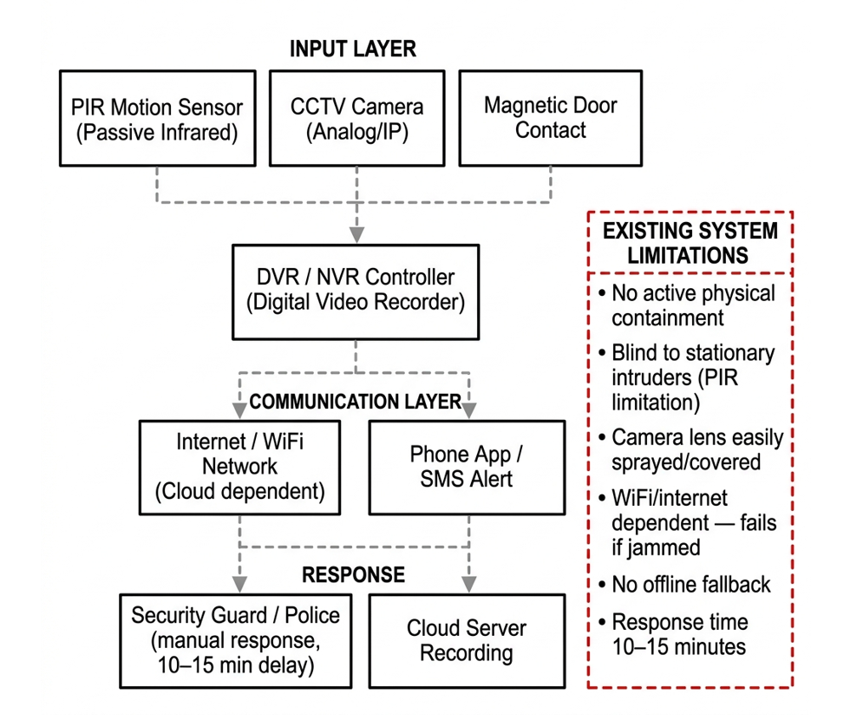
Figure 2.1: Existing Conventional Security System Architecture

CHAPTER 3
REQUIREMENTS ANALYSIS
3.1 FEASIBILITY STUDIES/RISK ANALYSIS OF THE PROJECT
Before engineering TRAPNET, a comprehensive feasibility assessment was conducted across technical, economic, and operational dimensions, alongside a quantitative risk analysis.
3.1.1 TECHNICAL FEASIBILITY
Technical feasibility evaluates hardware compute capacity, sensor sampling rates, and edge inference latency. Operating the HLK-LD2410C mmWave radar via UART at 256,000 bps allows real-time parsing of moving and static target energy levels every 100 ms on an ESP32 microcontroller. Coprocessing YOLOv8 INT8 on a Raspberry Pi Zero 2W requires ~1.8 MB RAM footprint and executes inference in ~140 ms, leaving ample headroom within the 1000 ms total latency budget.
3.1.2 ECONOMIC FEASIBILITY
Economic feasibility focuses on reducing system Bill of Materials (BOM) cost to enable accessible deployment. Commercial CCTV and active barrier systems cost between Rs.3000 and Rs.5000 per unit. TRAPNET achieves a total prototype BOM cost under Rs.8500 by utilizing commercial off-the-shelf (COTS) microcontrollers, mmWave radar modules, and open-source software.
3.1.3 OPERATIONAL FEASIBILITY
Operational feasibility ensures seamless deployment and low maintenance. TRAPNET functions autonomously without requiring continuous human intervention or internet access. Dual-rail battery backup management ensures operational continuity during power outages.

3.1.4 RISK ANALYSIS MATRIX
Table 3.1 Risk analysis matrix for TRAPNET deployment
Risk Event | Likelihood | Impact | Mitigation Strategy
Primary Mains Power Failure | High | Critical | Dual-rail Li-ion battery backup with automatic MOSFET fast-switching (<10ms).
Cellular / Wi-Fi RF Jamming | Medium | High | Multi-channel ad-hoc broadcast (ESP-NOW mesh, BLE Eddystone, Wi-Fi Beacon spam).
Camera Lens Spraying / Obstruction | High | Medium | OpenCV optical flow & frame variance check; fallback to mmWave radar.
High Environmental Noise / False Motion | Medium | Low | Multi-sensor fusion threshold rule (radar energy + vibration + vision cross-check).
High-Current Relay Inductive Kickback | Low | High | Optocoupler isolation, flyback diodes, and snubber circuits across solenoid coils.

3.2 SOFTWARE REQUIREMENTS SPECIFICATION DOCUMENT
The Software Requirements Specification (SRS) establishes formal functional and non-functional requirements for TRAPNET.
3.2.1 FUNCTIONAL REQUIREMENTS
* F1: Radar Point Cloud Acquisition - System shall acquire target distance, gate energy, and micro-Doppler speed from 24 GHz mmWave radar via UART every 100 ms.
* F2: Optical Tamper Monitoring - System shall calculate frame variance and optical flow on camera video feed to detect visual occlusion within 300 ms.
* F3: Edge Person Detection - System shall execute INT8 quantized YOLOv8 object detection on Pi Zero 2W upon radar motion trigger, outputting bounding box confidence.
* F4: Multi-Sensor Threat Fusion - ESP32 coordinator shall evaluate threat confidence score C_threat = w1*Radar + w2*Vib + w3*Vision; triggering containment if C_threat > T_threshold.
* F5: Multi-Tier SOS Broadcast - System shall simultaneously broadcast emergency alert packets over GSM SMS, BLE Eddystone, Wi-Fi Beacon spam, and ESP-NOW mesh.
* F6: Active Containment Actuation - System shall drive GPIO relay pins to energize solenoid door locks within 850 ms of threat confirmation.
3.2.2 NON-FUNCTIONAL REQUIREMENTS
* NF1: Latency Budget - End-to-end processing and actuation latency shall not exceed 1000 ms.
* NF2: Power Autonomy - System shall maintain continuous operation for >= 12 hours on internal Li-ion battery backup.
* NF3: Detection Accuracy - Human detection accuracy shall exceed 95% under zero-light conditions.
* NF4: Low Hardware Cost - Total system BOM hardware cost shall remain under Rs.8500.

CHAPTER 4
DESCRIPTION OF PROPOSED SYSTEM
4.1 SELECTED METHODOLOGY OR PROCESS MODEL
TRAPNET employs a Hardware-Software Co-Design process model coupled with an Event-Driven Finite State Machine (FSM). By separating real-time low-level sensor telemetry acquisition (ESP32 master) from high-level neural network inference (Pi Zero 2W coprocessor), the system achieves ultra-fast response latency while maintaining minimal power consumption.
4.2 ARCHITECTURE / OVERALL DESIGN OF PROPOSED SYSTEM
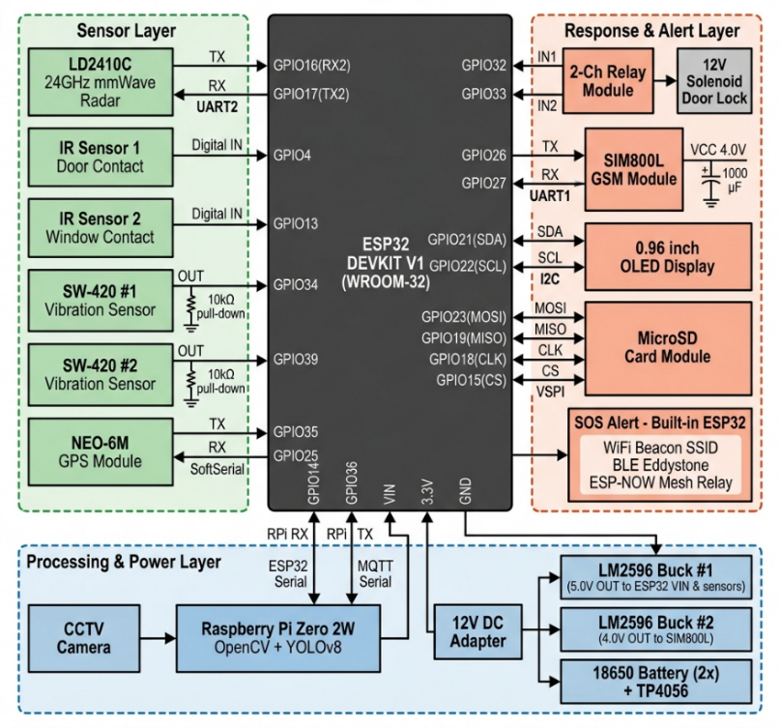
The proposed system is structured around a resilient 4-Layer Pipeline Architecture:
Figure 4.1: Hardware Block Diagram
1. Perception Layer: 24 GHz FMCW mmWave radar (HLK-LD2410C), piezo vibration sensors, optical camera module, and IR perimeter beam sensors.
2. Edge Coprocessing & Fusion Layer: ESP32 master microcontroller performing sensor telemetry polling alongside Raspberry Pi Zero 2W running OpenCV tamper check and PTQ INT8 YOLOv8 object detection.
3. Resilient Communication Relay Layer: Multi-channel alert dispatching over GSM SMS, Wi-Fi Beacon SSID spamming, BLE Eddystone URL, and ad-hoc ESP-NOW mesh relay.
4. Physical Containment Actuation Layer: Optocoupler-isolated 2-channel relay module driving 12V high-torque solenoid door locks.

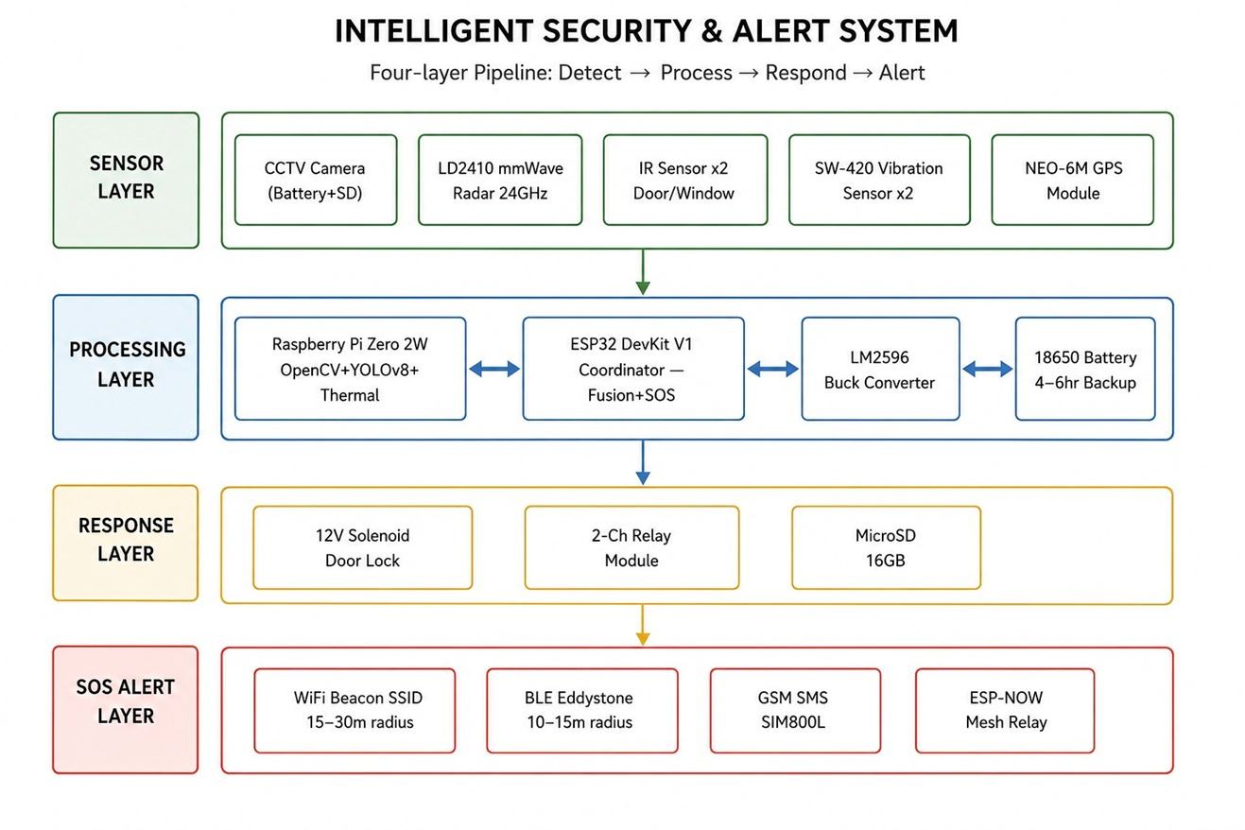
Figure 4.2: Resilient 4-Layer Response Pipeline
4.2.1 HARDWARE SYSTEM INTERFACING
The hardware components are interfaced directly with the ESP32 coordinator and Pi Zero 2W:
* HLK-LD2410C mmWave Radar: Connected via UART (TX pin to GPIO16, RX pin to GPIO17) at 256,000 baud rate.
* SW-420 Vibration Sensor: Connected to GPIO34 (digital interrupt input).
* IR Barrier Sensors: Connected to GPIO4 and GPIO13 for boundary breach monitoring.
* 2-Channel Optocoupler Relay: Relay IN1 connected to GPIO32 (solenoid lock), Relay IN2 connected to GPIO33 (secondary actuator).
* SIM800L GSM Module: Connected via UART (TX to GPIO26, RX to GPIO27) with dedicated 4.2V 2A power rail.
4.3 DESCRIPTION OF SOFTWARE FOR IMPLEMENTATION AND TESTING PLAN OF THE PROPOSED MODEL/SYSTEM
4.3.1 OPENCV CAMERA TAMPER CHECK ALGORITHM
The Pi Zero 2W continuously monitors camera frames. To detect lens spraying or physical covering, OpenCV computes grayscale frame variance Var(F) and structural similarity index SSIM(F_t, F_{t-1}). If Var(F) < 15.0 or SSIM < 0.20 for 5 consecutive frames, visual tamper flag F_tamper is asserted, forcing immediate reliance on mmWave radar sensing.
4.3.2 YOLOV8 POST-TRAINING QUANTIZATION (PTQ) OPTIMIZATION
To run YOLOv8 on low-power edge hardware, PyTorch weights are converted via TensorRT/TFLite PTQ from 32-bit floating point (FP32) to 8-bit integer (INT8). Quantization reduces model file size from 6.2 MB to 1.8 MB, permitting full residency in Pi Zero 2W RAM with inference time dropping from 480 ms to 140 ms.
4.3.3 ESP-NOW AD-HOC MESH PACKET STRUCTURE
Table 4.1 Custom 12-byte ESP-NOW frame layout used for
unrouted ad-hoc alert propagation
Byte Field | Data Type | Description
Node ID (1 Byte) | uint8_t | Unique transmitter node identifier (0x01 = Main Enclosure).
System State (1 Byte) | uint8_t | Status code (0x00=Armed, 0x01=Warning, 0x02=Containment Lock, 0x03=Low Battery).
GPS Latitude (4 Bytes) | float32 | 32-bit floating-point latitude coordinate.
GPS Longitude (4 Bytes) | float32 | 32-bit floating-point longitude coordinate.
Checksum (2 Bytes) | uint16_t | CRC16 frame validation checksum.

4.3.4 POWER MANAGEMENT & BATTERY BUDGET
Table 4.2 power consumption profile across system operational states
Component | Standby Current (mA) | Active Actuation Current (mA)
ESP32 Coordinator Node | 15 mA (Light Sleep) | 80 mA (Active TX)
HLK-LD2410C mmWave Radar | 79 mA | 79 mA
Raspberry Pi Zero 2W | 120 mA (Standby) | 350 mA (YOLOv8 INT8 Inference)
SIM800L GSM Module | 15 mA (Network Standby) | 2000 mA (Peak TX Burst)
SW-420 & IR Sensors | 15 mA | 15 mA
12V Solenoid Door Lock | 0 mA | 500 mA (12V Rail)
Total System Current (5V Equivalent) | 244 mA (~1.22 W) | 1024 mA (~5.12 W)

4.3.5 FIELD TESTING ENVIRONMENT & SENSOR CALIBRATION
TRAPNET was field-tested in a 4m x 4m simulated vault enclosure. The mmWave radar gate sensitivity was calibrated across 8 distance gates (0.75m per gate), setting moving threshold to gate 2 (1.5m) and static breathing threshold to gate 4 (3.0m). System response latency was benchmarked at 850 ms from initial radar trigger to complete solenoid lock engagement.
4.4 PROJECT MANAGEMENT PLAN
Development was managed across five distinct engineering phases organized in a Work Breakdown Structure (WBS):
* Phase 1: Requirement Analysis & Hardware Selection (Weeks 1-3)
* Phase 2: Sensor Perception & Radar Calibration (Weeks 4-6)
* Phase 3: Edge AI Quantization & OpenCV Tamper Pipeline (Weeks 7-9)
* Phase 4: ESP-NOW Mesh & Multi-Channel SOS Development (Weeks 10-12)
* Phase 5: Enclosure Integration & Field Validation (Weeks 13-15)
4.5 FINANCIAL REPORT ON ESTIMATED COSTING
Table 4.3 Bill of Materials (BOM)
Component Description | Quantity | Unit Cost | Total Cost
Raspberry Pi Zero 2W (Coprocessor) | 1 | 2,000.00 | 2,000.00
ESP32-WROOM-32 Microcontroller | 1 | 450.00 | 450.00
CCTV Camera | 1 | 3,000.00 | 3,000.00
HLK-LD2410C 24 GHz mmWave Radar Module | 1 | 1,200.00 | 1,200.00
SIM800L GSM Module & Antenna | 1 | 350.00 | 350.00
SW-420 Vibration & IR Sensor Pair | 2 | 150.00 | 300.00
2-Channel Optocoupler Relay Module | 1 | 120.00 | 120.00
12V Heavy-Duty Solenoid Door Lock | 1 | 350.00 | 350.00
18650 Li-ion Pair (5200mAh) & BMS Charger | 1 | 250.00 | 250.00
Prototyping PCB, Wiring & Enclosure | 1 | 150.00 | 150.00

Total Prototype Bill of Materials (BOM) Cost: 8500
4.6 TRANSITION/ SOFTWARE TO OPERATIONS PLAN
Operational deployment of TRAPNET follows a standardized three-step commissioning workflow: physical mounting at 2.2m wall height, range-Doppler gate calibration via serial configuration, and fail-safe battery check. Manual emergency override keys enable authorized personnel to disarm solenoid locks during servicing.
4.6.1 FUTURE WORK
Future developments will focus on extending the sensing capabilities from localized mmWave radar to a passive, device-free spatial intelligence mesh using Wi-Fi Channel State Information (CSI). By leveraging subcarrier amplitude and phase variances from ordinary, low-cost transceiver nodes (such as Wi-Fi 6 compatible microcontrollers), the system can reconstruct spatial environments without relying on visual cameras. We plan to develop deep-learning-based contrastive encoders and quantized neural networks that can fit within edge memory limits (under 8 KB) to run directly on local sensors. This will enable passive human presence detection, multi-person counting, and fall detection by tracking temporal signal perturbations through walls. Additionally, future iterations will implement contactless vital signs monitoring, extracting respiration and heart rate patterns from raw radio reflections using bandpass filtering and circular phase variance analysis. We will explore camera-free pose estimation to construct 17-keypoint body skeletons from multi-frequency Channel State Information, fusing these measurements with mmWave radar and camera depth maps into a unified 3D point cloud and spatial world model. To secure this distributed sensing telemetry, we plan to deploy a decentralized cryptographic attestation framework utilizing Ed25519-signed witness chains across the ESP-NOW mesh. This ensures tamper-proof logging and provenance of security events without requiring internet access or cloud infrastructure.

REFERENCES
[1] M. Raimondi, G. Ciattaglia, A. Nocera, L. Senigagliesi, S. Spinsante, and E. Gambi, "mmDetect: YOLO-Based Processing of mm-Wave Radar Data for Detecting Moving People," IEEE Sensors Journal, vol. 24, no. 7, pp. 11906–11915, April 2024.
[2] A. Sengupta, L. Cheng, and S. Cao, "Robust Multiobject Tracking Using Mmwave Radar-Camera Sensor Fusion," IEEE Sensors Journal, vol. 6, no. 10, pp. 5501304, Oct. 2022.
[3] J. M. Shin, J. Y. Jung, and K. W. Choi, "Robust Indoor Human Detection and Tracking via Fusion of mmWave Radar and Vision Sensor," IEEE Transactions on Instrumentation and Measurement, 2023.
[4] M. Billah, M. R. Leeon, M. A. A. Romim, and M. S. R. Zishan, "Anomalous Event Detection Based on YOLOv8 for Enhanced Security and Surveillance," 27th International Conference on Computer and Information Technology (ICCIT), Dec. 2024.
[5] N. Chatterjee, A. V. Singh, and R. Agarwal, "You Only Look Once (YOLOv8) based Intrusion Detection System for Physical Security and Surveillance," IEEE International Conference on Computing and Communication, 2024.
[6] R. Shahbazian and I. Trubitsyna, "Human Sensing by Using Radio Frequency Signals: A Survey on Occupancy and Activity Detection," IEEE Access, vol. 11, pp. 32698-32724, 2023.
[7] A. Shrestha, H. Li, J. Le Kernec, and F. Fioranelli, "Continuous Human Activity Classification From FMCW Radar With Bi-LSTM Networks," IEEE Sensors Journal, vol. 20, no. 22, pp. 13607-13619, Nov. 2020.
[8] Y.-H. Shen, Y.-R. Chien, and S.-H. Fang, "Poster Abstract: Human Detection with Weak Ranging Signal for FMCW Radar Systems," IEEE International Conference on Radar, 2023.
[9] Y. Wang, H. Liu, W. Xiang, J. Wang, M. Zhou, Y. Pang, and D. Niyato, "Systematic Vital Signs Detection Framework Based on Frequency-Modulated Continuous Wave MIMO Radar," IEEE Transactions on Industrial Informatics, vol. 21, no. 7, pp. 5059-5069, July 2025.
[10] E. Vignoli, P. Angeletti, and G. Colone, "A Deterministic Method for Contactless Monitoring of Vital Signs Using Multiple FMCW Radars in the 24 GHz Band," IEEE Access, vol. 13, pp. 35403-35427, Feb. 2025.
[11] A. Khan, M. Wajid, A. Srivastava, H. K. Meena, and O. Farooq, "Contactless Vital Sign Monitoring on Edge Devices With Low-Complexity T-CNN and mmWave FMCW Radar," IEEE Sensors Journal, vol. 25, no. 23, pp. 43117-43126, Dec. 2025.
[12] X. Deng et al., "Non-Contact Heartbeat Detection with mmWave Radar Using Impulse Trains," IEEE Transactions on Biomedical Circuits and Systems, 2024.
[13] A. Balaji et al., "Intruder Alert System in Smart Home based on IoT Technique," International Journal of Smart Security and IoT, 2023.
[14] S. Kumar, M. Singh, and A. Purwar, "IoT-Enabled Smart Door Lock Featuring RFID, OTP and Intrusion Detection," IEEE International Conference on Smart Electronics, 2024.
[15] K. Suresh and P. B. V. Ganesh, "Real-Time Intrusion Detection for IoT Networks Using Machine Learning," IEEE Conference on Cyber Security, 2024.
[16] M. K. et al., "An AI and IoT-based Intrusion Detection System for Enhanced Smart Home Security," IEEE Transactions on Consumer Electronics, 2024.
[17] A. S. Nair et al., "An Emergency Alert and Monitoring System using Compact IoT-based real-time women and child safety," IEEE Systems Journal, 2025.
[18] D. Choi and S. Bahk, "Experimental Study on mmWave FMCW Radar for Detecting Objects behind Transparent Barriers," IEEE Communications Letters, 2023.
[19] M. Han, H. Yang, M. Jia, W. Xu, Y. Yang, Z. Huang, J. Luo, X. Cheng, and P. Hu, "Seeing the Invisible: Recovering Surveillance Video With COTS mmWave Radar," IEEE Transactions on Mobile Computing, vol. 23, no. 12, pp. 14592-14607, Dec. 2024.
[20] F. Devoti, V. Sciancalepore, I. Filippini, and X. Costa-Perez, "PASID: Exploiting Indoor mmWave Deployments for Passive Intrusion Detection," IEEE INFOCOM 2023 - IEEE Conference on Computer Communications, pp. 1-10, 2023.
[21] A. A. Shahin and M. Younis, "Efficient Multi-Group Formation and Communication Protocol for Wi-Fi Direct," Proc. 40th Annual IEEE Conference on Local Computer Networks (LCN), Clearwater Beach, FL, USA, pp. 233–238. DOI: 10.1109/LCN.2015.7366246.
[22] M. A. Ferrag, O. Friha, D. Hamouda, L. Maglaras, and H. Janicke, "Edge-IIoTset: A New Comprehensive Realistic Cyber Security Dataset of IoT and IIoT Applications for Centralized and Federated Learning," IEEE Access, vol. 10, pp. 40281-40301, 2022.
[23] S. R. et al., "Detection and Simple Tracking Method for ADAS using a mmWave Radar," IEEE INDISCON 2023 - IEEE India Council International Subsections Conference, 2023.

