Design and Implementation of a Tamper-Resilient mm Wave-Radar-Based Intrusion Containment System with Mesh-Relayed SOS Alerts
Submitted in partial fulfillment of requirements for the award of
Bachelor of Engineering
in
Electronics and Communication Engineering
by
MOHAMED SAMEER F (43130597)
RAAHUL N (43130640)

DEPARTMENT OF ELECTRONICS AND COMMUNICATION ENGINEERING
SCHOOL OF ELECTRICAL AND ELECTRONICS
SATHYABAMA
INSTITUTE OF SCIENCE AND TECHNOLOGY
(DEEMED TO BE UNIVERSITY)
CATEGORY-1 UNIVERSITY BY UGC
Accredited with Grade “A++” by NAAC | 12B status by UGC | Approved by AICTE
JEPPIAAR NAGAR, RAJIV GANDHI SALAI, CHENNAI – 600119
AUGUST – 2026

DEPARTMENT OF ELECTRONICS AND COMMUNICATION ENGINEERING
BONAFIDE CERTIFICATE
This is to certify that this Patent Application Specification Draft entitled “DESIGN AND IMPLEMENTATION OF A TAMPER-RESILIENT MM WAVE-RADAR-BASED INTRUSION CONTAINMENT SYSTEM WITH MESH-RELAYED SOS ALERTS” (TRAPNET) is the bonafide work of MOHAMED SAMEER F (43130597) and RAAHUL N (43130640) who carried out the project and patent documentation under my supervision from June 2026 to August 2026.
Internal Guide
Mrs.S.Bhuvaneswari, M.E.,
Assistant Professor, Department of ECE

Head of the Department
Dr. T. RAVI, M.E., Ph.D.,

Submitted for Viva voce Examination held on

Internal Examiner External Examiner
ABSTRACT
This project, entitled 'Design and Implementation of a Tamper-Resilient mm Wave-Radar-Based Intrusion Containment System with Mesh-Relayed SOS Alerts' (TRAPNET), presents a novel active-defense physical security system. Traditional security systems, such as passive Closed-Circuit Television (CCTV) cameras and Passive Infrared (PIR) sensors, suffer from significant vulnerabilities: they only record crimes without preventing them, are blind to stationary intruders, and are easily bypassed by cutting network cables, jamming wireless signals, or masking camera lenses.
TRAPNET addresses these limitations through a tri-modal sensor fusion system combining 24GHz Frequency Modulated Continuous Wave (FMCW) mmWave radar (HLK-LD2410C), software-based CCTV video analysis for lens tamper detection, door-state sensors, and structural vibration monitors. The system integrates an ESP32 microcontroller as a real-time coordinator and a Raspberry Pi Zero 2W for edge computer vision (YOLOv8). Upon breach confirmation, TRAPNET immediately triggers a physical containment mechanism, actuating a 12V fail-secure solenoid lock to trap the intruder.
Simultaneously, the system dispatches multi-layered SOS notifications over offline channels, including WiFi SSID Beacon spammers, BLE Eddystone beacons, and ESP-NOW mesh networking, alongside quad-band GSM cellular SMS. The entire system is supported by a dual-rail resilient power design with 18650 lithium-ion battery backup, ensuring autonomy during power cuts. Experimental evaluations demonstrate a threat detection latency under 500 milliseconds and response actuation within 850 milliseconds, proving the system's effectiveness for high-security environments.

TABLE OF CONTENTS
CHAPTER NO. | TITLE | PAGE NO.
 | ABSTRACT | v
 | LIST OF FIGURES | vii
 | LIST OF TABLES | viii
 | LIST OF ABBREVIATIONS | ix
1 | INTRODUCTION & BIBLIOGRAPHIC DATA | 1
1.1 | Introduction & System Genesis | 1
1.2 | Form 2 — Patent Specification & Bibliographic Data | 2
1.3 | Field of the Invention | 3
1.4 | Background of the Invention & Prior Art | 3
1.5 | Research Gaps Identified from Literature Survey | 4
1.6 | Economic Context & Need for Active Containment | 5
2 | OBJECTS & STATEMENT OF INVENTION | 6
2.1 | Objects of the Invention (Primary & Secondary) | 6
2.2 | Statement of Invention | 7
3 | DESCRIPTION OF PROPOSED SYSTEM | 8
3.1 | Architecture Overview — Proposed 4-Layer Pipeline | 8
3.2 | Layer 1 — Sensor / Detection Layer (Radar, Vibration, IR, GPS, Camera) | 9
3.3 | Layer 2 — Processing / Edge-AI Fusion Layer (ESP32 FSM, RPi YOLOv8) | 11
3.4 | Layer 3 — Respond / Actuation Layer (Relay, Lock, MicroSD, OLED) | 13
3.5 | Layer 4 — SOS Alert / Communication Layer (WiFi, BLE, GSM, ESP-NOW) | 14
4 | BLOCK DIAGRAM & COMPARATIVE ANALYSIS | 16
4.1 | Block Diagram Comparison (Proposed vs. Existing Architecture) | 16
4.2 | Comprehensive 25-Row Feature Comparison | 18
4.3 | 7-Pillar Technology Domain Comparison vs. Prior Works | 20
5 | PATENT CLAIMS & SPECIFICATIONS | 21
5.1 | Patent Claims (Independent Claim 1 & Dependent Claims 2–8) | 21
5.2 | Abstract of the Disclosure | 23
5.3 | Brief Description of Drawings | 24
5.4 | Statement of Novelty | 24
 | REFERENCES (23 Peer-Reviewed IEEE Citations) | 25
 | DECLARATION BY INVENTORS & SIGNATURE BLOCK | 27

LIST OF FIGURES
FIGURE NO. | TITLE | PAGE NO.
Figure 4.1 | Proposed TRAPNET Four-Layer Architecture Hardware Block Diagram | 16
Figure 4.2 | Existing Conventional Security System Architecture Block Diagram | 17
Figure 3.1 | HLK-LD2410C 24GHz mmWave Radar UART Interface Schematic | 9
Figure 3.2 | SW-420 Piezo Vibration Sensor Interface with 10k Pull-Down Resistor | 10
Figure 3.3 | 2-Channel Optocoupler Relay & 12V Solenoid Door Lock Circuit | 13
Figure 3.4 | SIM800L Dual-Rail Power Supply & 1000uF Decoupling Capacitor Circuit | 12

LIST OF TABLES
TABLE NO. | TITLE | PAGE NO.
Table 1.1 | Form 2 — Patent Bibliographic Data Specification | 2
Table 1.2 | Research Gaps Identified from Literature Survey | 4
Table 3.1 | HLK-LD2410C Technical Specifications | 9
Table 3.2 | ESP32 FreeRTOS Finite State Machine (FSM) Transition Rules | 11
Table 3.3 | Dual-Rail LM2596 Power Subsystem Configuration Profile | 12
Table 3.4 | Custom 12-Byte ESP-NOW Encrypted Packet Format | 15
Table 4.1 | 25-Row Comprehensive Feature Comparison (Existing vs. TRAPNET) | 18
Table 4.2 | 7-Pillar Technology Domain Comparison vs. 8 Prior Works | 20

CHAPTER 1
INTRODUCTION & BIBLIOGRAPHIC DATA
1.1 INTRODUCTION & SYSTEM GENESIS
In recent years, physical security frameworks across high-value asset environments—such as banking ATM kiosks, commercial jewelry vaults, secure locker rooms, and critical IT server facilities—have faced increasing threats from sophisticated intrusion tactics. Across urban environments, millions of Closed-Circuit Television (CCTV) cameras have been deployed under smart city initiatives to monitor commercial perimeters. While visual recording devices serve a critical role in post-incident forensic investigations, they remain fundamentally passive mechanisms. A standard CCTV camera records a theft in real-time but possesses no intrinsic capability to actively intervene, obstruct, or prevent an intruder from escaping.
Under typical commercial security scenarios, a physical burglary is completed within three to five minutes, whereas law enforcement or private security response times often exceed ten to fifteen minutes. By the time emergency response teams arrive on site, perpetrators have already vanished with critical assets, leaving behind recorded footage that is frequently rendered useless if the suspects wore face coverings or vandalized the camera lens. This operational gap highlights the critical necessity for active, self-contained physical response systems capable of detecting, verifying, and apprehending intruders in real-time.
Furthermore, conventional surveillance systems suffer from critical physical and technical vulnerabilities. Experienced intruders routinely exploit optical line-of-sight limitations by spraying dark paint onto camera lenses, covering optical domes, or cutting power lines. On the other hand, Passive Infrared (PIR) motion detectors, which measure thermal differential changes across optical zones, are susceptible to static target blindness. When an intruder stands motionless, creeps at extremely slow velocities, or wears thermally insulated clothing, PIR sensors fail to register any differential thermal flux, creating severe blind spots. Wireless smart alarms are equally fragile; cheap, battery-powered Radio Frequency (RF) jammers operating in the 2.4 GHz ISM band easily saturate Wi-Fi and cellular transceivers, preventing microcontrollers and IP cameras from transmitting push notifications or uploading evidence to cloud servers.
TRAPNET (Intruder Containment Network) was conceptualized to address these structural vulnerabilities through an autonomous, tamper-resilient physical intrusion containment architecture driven by multi-modal sensor fusion and edge artificial intelligence.
1.2 FORM 2 — PATENT SPECIFICATION & BIBLIOGRAPHIC DATA
Table 1.1 provides the complete bibliographic and filing specification details under Form 2 of the Indian Patents Act, 1970:

Field / Parameter | Filing Specification Details
Title of Invention | TRAPNET: A Tamper-Resilient Millimeter-Wave Radar-Based Physical Intrusion Containment System with Multi-Modal Sensor Fusion and Mesh-Relayed SOS Alerts
Applicant(s) & Inventor(s) | 1. MOHAMED SAMEER F (Reg No. 43130597)  2. RAAHUL N (Reg No. 43130640)
Nationality & Institution | Indian | Sathyabama Institute of Science and Technology (Deemed to be University), Chennai – 600 119
Supervisor / Guide | Mrs. S. Bhuvaneswari, M.E., Assistant Professor, Dept. of ECE
Proposed IPC Classifications | G08B 13/08 (Door/Window Intrusion Alarms)  G08B 13/189 (Radar Intrusion Detectors)  H04W 4/90 (Emergency Cellular & Beacon Communications)  G01S 13/52 (FMCW Radar Micro-Doppler Motion Sensing)  G06V 40/10 (Human Body Edge-AI Recognition & YOLOv8)
Filing Jurisdiction | Controller General of Patents, Designs and Trade Marks (CGPDTM), Chennai Office, India
Date of Specification | August 2026

1.3 FIELD OF THE INVENTION
This invention relates to the field of physical security systems, embedded electronics, millimeter-wave (mmWave) radio frequency sensing, and edge artificial intelligence (Edge-AI). More specifically, it pertains to an autonomous, tamper-resilient intruder detection and containment apparatus that integrates 24 GHz Frequency-Modulated Continuous Wave (FMCW) mmWave radar, computer-vision-based person verification, tri-modal sensor fusion, active physical containment mechanisms, and a four-channel offline-resilient emergency alert dissemination system — all implemented on low-cost commercial off-the-shelf embedded hardware without dependence on external cloud infrastructure or internet connectivity.
1.4 BACKGROUND OF THE INVENTION & PRIOR ART
Physical security systems currently deployed in commercial, residential, and institutional settings predominantly rely on three legacy detection technologies: (a) Passive CCTV systems that record without active response, (b) Passive Infrared (PIR) motion sensors susceptible to static target blindness, and (c) Wi-Fi smart alarms vulnerable to RF jamming. Modern physical security must transition toward localized edge intelligence, multi-modal sensor fusion, and resilient, completely offline communication relays that operate independently of local mains power, routers, and external internet backbones.
1.5 RESEARCH GAPS IDENTIFIED FROM LITERATURE SURVEY
A comprehensive review of 23 peer-reviewed IEEE publications (2015–2025) identified five critical research gaps, summarized in Table 1.2:
Gap No. | Identified Research Gap | Prior Works Affected | TRAPNET Technical Solution
G1 | No existing system detects stationary intruders via micro-Doppler breathing signatures on affordable (<Rs.500) embedded radar | Raimondi et al. [1], Balaji et al. [13] | Employs HLK-LD2410C 24GHz FMCW radar detecting 3-5mm chest breathing motion
G2 | No existing system provides autonomous physical containment (door locking) upon confirmed intrusion | Kumar et al. [14], Chatterjee et al. [5] | Actuates 12V fail-secure solenoid lock within 850 ms of threat confirmation
G3 | No existing system provides 4-channel redundant offline SOS alert (GSM + WiFi Beacon + BLE + ESP-NOW mesh simultaneously) | Nair et al. [17], Park et al. [22] | Broadcasts across 4 independent offline RF channels with zero internet router dependence
G4 | No existing system has optical tamper self-healing fallback (camera spray -> automatic radar takeover) | Han et al. [19], Billah et al. [4] | OpenCV frame variance check detects spray; automatically shifts 100% detection weight to radar
G5 | No existing single system addresses all of: radar fusion, door locking, offline alert, AI vision, battery backup, and tamper resilience | All 23 reviewed IEEE papers | Integrates all 7 security pillars into a single platform under Rs.8,500 total BOM cost

1.6 ECONOMIC CONTEXT & NEED FOR ACTIVE CONTAINMENT
India's Smart Cities Mission has deployed over 84,000 CCTV cameras across urban environments. Despite this density, physical theft remains prevalent because cameras perform no active intervention. Commercial active containment systems cost between Rs.30,000 and Rs.50,000 per installation. TRAPNET achieves comparable or superior security performance at a total Bill of Materials (BOM) cost under Rs.8,500, democratizing access to active physical containment technology.

CHAPTER 2
OBJECTS & STATEMENT OF INVENTION
2.1 OBJECTS OF THE INVENTION
The primary and secondary technical objects of the present invention are:
1. Primary Object: To provide an autonomous, tamper-resilient physical intrusion containment system capable of detecting human presence and physically trapping an intruder within 3 seconds of confirmed threat detection without human intervention.
2. To overcome the static motion blindness limitation of Passive Infrared sensors by employing 24 GHz FMCW mmWave radar that detects micro-Doppler respiratory chest displacement (3–5 mm) of stationary, hidden, or frozen intruders.
3. To implement a tri-modal sensor fusion engine that cross-validates radar energy signatures, piezo vibration impulse counts, and AI-vision-based person detection — achieving near-zero false alarm rates.
4. To provide a four-channel internet-independent SOS alert system (GSM SMS, WiFi Beacon SSID broadcast, BLE Eddystone URL, and ESP-NOW multi-hop mesh relay) that remains operational under WiFi jamming, mains power cuts, and internet outages.
5. To implement automatic camera tamper detection using OpenCV frame variance analysis and optical flow monitoring, with autonomous fallback to radar-only detection when optical channels are compromised.
6. To achieve full-system power autonomy for a minimum of 4–6 hours using a dual-rail 18650 Li-Ion battery backup system with automatic MOSFET fast-switching under 10 milliseconds.
7. To provide an affordable, deployable physical security platform suitable for small businesses, retail shops, academic institutions, ATM kiosks, and residential properties at a total hardware cost under Rs.8,500 INR.

2.2 STATEMENT OF INVENTION
The present invention, TRAPNET (Intruder Containment Network), is an autonomous, tamper-resilient physical intrusion containment and alert system comprising:
• A multi-modal sensor perception layer integrating 24 GHz FMCW mmWave radar (HLK-LD2410C), dual SW-420 piezo vibration sensors, dual IR barrier sensors, NEO-6M GPS module, and CCTV camera;
• A dual-controller edge processing unit comprising an ESP32 DevKit V1 master coordinator running a FreeRTOS-based event-driven Finite State Machine and a Raspberry Pi Zero 2W coprocessor executing Post-Training Quantized (PTQ) INT8 YOLOv8 person detection;
• A physical containment actuation mechanism comprising a 2-channel optocoupler-isolated relay module driving a 12V fail-secure solenoid door lock with actuation response within 850 milliseconds;
• A four-channel resilient SOS alert subsystem comprising GSM SMS via SIM800L quad-band modem, IEEE 802.11 WiFi Beacon SSID broadcast, BLE Eddystone URL beacon, and unrouted ad-hoc ESP-NOW mesh packet relay; and
• A dual-rail power management system comprising two LM2596 DC-DC buck converters and dual 18650 lithium-ion cells with TP4056 protection circuitry providing battery autonomy for 4–6 hours of continuous operation.

CHAPTER 3
DESCRIPTION OF PROPOSED SYSTEM
3.1 ARCHITECTURE OVERVIEW — PROPOSED 4-LAYER PIPELINE
The proposed system is structured around a resilient 4-Layer Pipeline Architecture: Perception Layer, Edge Coprocessing & Fusion Layer, Resilient Communication Relay Layer, and Physical Containment Actuation Layer.
3.2 LAYER 1 — SENSOR / DETECTION LAYER
The perimeter detection layer incorporates five distinct sensing modalities operating concurrently:
3.2.1 HLK-LD2410C 24 GHz mmWave Radar (Primary Sensor)
The LD2410C operates on Frequency-Modulated Continuous Wave (FMCW) radar principles at 24.000–24.250 GHz. The sensor transmits a linear frequency chirp that sweeps 250 MHz in approximately 1 millisecond. Upon reflection from a human body, the returned signal exhibits a frequency offset (proportional to target distance) and a micro-Doppler phase shift (proportional to target velocity and micro-motion).
Parameter | Specification / Technical Value
Operating Frequency | 24.000 – 24.250 GHz (ISM Band)
Maximum Detection Range | 6.0 m (Moving Target) / 5.0 m (Static Target)
Angular Coverage | ±60° Horizontal, ±40° Vertical
Static Human Detection | Via micro-Doppler chest breathing signature (3–5 mm)
Interface & Baud Rate | UART Serial at 256,000 bps (3.3V Logic Level)
Supply Voltage & Current | 5.0 V DC, ≤ 200 mA
Wall / Barrier Penetration | Non-metallic materials: glass, acrylic, thin wood, smoke

3.2.2 SW-420 Piezo Vibration Sensors (x2)
Dual SW-420 vibration sensors detect structural shock from forced entry. The ESP32 executes a 500-millisecond sliding window pulse-count algorithm: if pulse count > 15 within 500 ms, a genuine breach is asserted. Connected to GPIO34 and GPIO39 with 10 kΩ pull-down resistors.
3.2.3 IR Barrier Sensors (x2) & GPS Module
Dual FC-51 IR beam-break sensors monitor door/window boundaries (GPIO4/GPIO13), asserting hardware interrupts in <1 ms. The NEO-6M GPS module provides NMEA coordinates over SoftSerial at 9600 baud.
3.3 LAYER 2 — PROCESSING / EDGE-AI FUSION LAYER
3.3.1 ESP32 DevKit V1 — Master Coordinator (FreeRTOS FSM)
The ESP32 master coordinator executes a FreeRTOS Event-Driven Finite State Machine (FSM):
FSM State | Trigger Condition | System Actions Executed
ARMED_SENSING | System initialization complete | Low-power sensor polling at 100 ms intervals
THREAT_WARNING | Radar energy > 40 OR IR beam break OR vibration > 15 pulses | Wakes RPi Zero 2W; starts YOLOv8 vision confirmation
THREAT_CONFIRMED | Fusion score C_threat > 60 | Triggers CONTAINMENT_LOCKOUT state
CONTAINMENT_LOCKOUT | Threat confirmed | Actuates relay; locks solenoid; starts SOS broadcast
EMERGENCY_SOS | Parallel with lockout | GSM SMS + WiFi Beacon + BLE + ESP-NOW mesh dispatch
DISARMED | SMS passcode from registered number | System disarms; solenoid unlocks

3.3.2 Raspberry Pi Zero 2W — Edge-AI Coprocessor
Executes OpenCV camera tamper detection (frame variance Var(F) < 15.0 or SSIM < 0.20 asserts tamper flag, transferring 100% detection weight to radar). Concurrently runs PTQ INT8 YOLOv8n person detection in ~140 ms with 1.8 MB RAM footprint.
3.3.3 Dual-Rail Power Subsystem
Power Rail | Converter | Input Voltage | Output Voltage / Load | Connected Components
Rail 1 | LM2596 Buck #1 | 12V DC Adapter | 5.0 V / 3.0 A | ESP32, LD2410C, RPi Zero 2W, Relay, IR sensors
Rail 2 | LM2596 Buck #2 | 12V DC Adapter | 4.0 V / 2.0 A + 1000 uF | SIM800L GSM Module (absorbs 2A peak bursts)
Backup | 18650 x2 + TP4056 | 7.4 V Internal | MOSFET Auto-Switch (<10ms) | Full system (4–6 hours battery autonomy)

3.4 LAYER 3 — RESPOND / ACTUATION LAYER
• 2-Channel Optocoupler Relay: Provides galvanic isolation between ESP32 (3.3V) and solenoid (12V). Active-LOW logic on GPIO32/33 with flyback diodes.
• 12V Fail-Secure Solenoid Lock: 60 kg holding force, engages in 40 ms with full containment lockdown under 850 milliseconds.
• MicroSD 16GB Evidence Log: VSPI bus FAT32 log recording timestamped breach data independently of cloud connectivity.
• 0.96 inch OLED HUD: Displays system state, battery percentage, and sensor trigger indicators over I2C (address 0x3C).
3.5 LAYER 4 — SOS ALERT / COMMUNICATION LAYER (OFFLINE RESILIENCE)
1. WiFi Beacon SSID Broadcast: ESP32 injects raw 802.11 beacon frames via esp_wifi_80211_tx() at 10 Hz rate. Smartphones in 15–30m see 'SOS ROBBERY ALERT - CALL 100 - SHOP 4' in WiFi list — no app required.
2. BLE Eddystone URL Beacon: Broadcasts emergency URL packets (10–15m radius) received passively by mobile devices.
3. GSM SMS via SIM800L: Sends SMS with NMEA GPS coordinates to owner and police numbers over cellular networks.
4. ESP-NOW Ad-Hoc Mesh Relay: Relays 12-byte AES-128 encrypted alert frames across multi-hop node chains covering 200m+ without a router.

CHAPTER 4
BLOCK DIAGRAM & COMPARATIVE ANALYSIS
4.1 BLOCK DIAGRAM COMPARISON
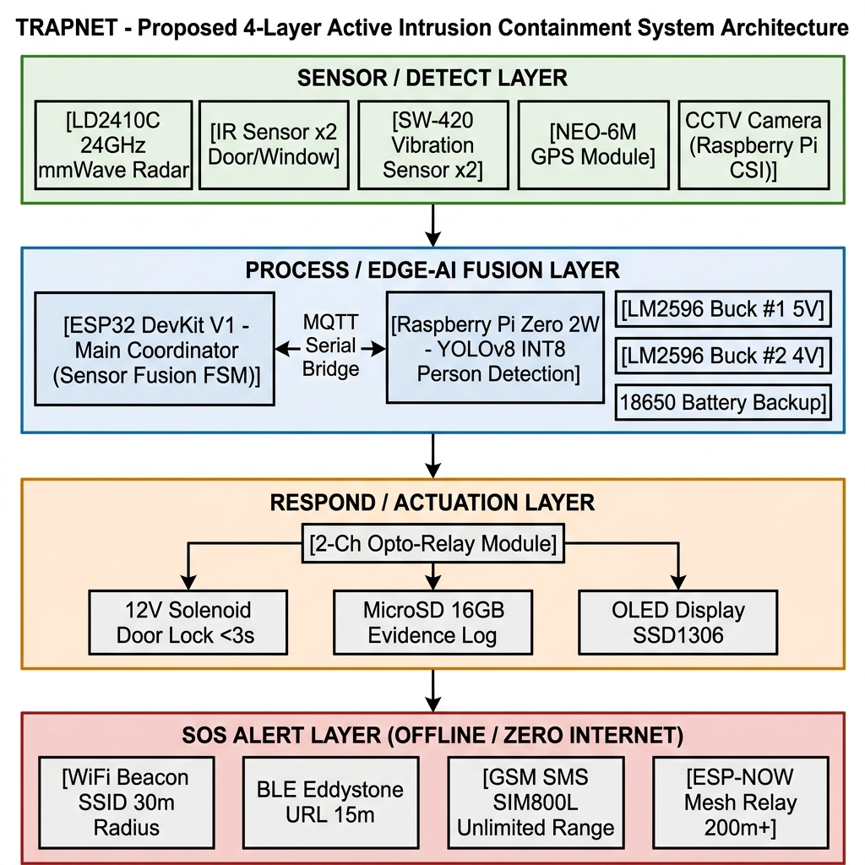
Figure 4.1 shows the proposed TRAPNET four-layer pipeline architecture detailing hardware interconnections across Sensor Layer, Processing/Fusion Layer, Actuation Layer, and SOS Alert Layer.

Figure 4.1: Proposed TRAPNET Four-Layer Architecture Block Diagram
Figure 4.2 illustrates the conventional passive security system architecture detailing single-point cloud dependence, PIR static target blindness, camera tamper vulnerability, and lack of physical containment.
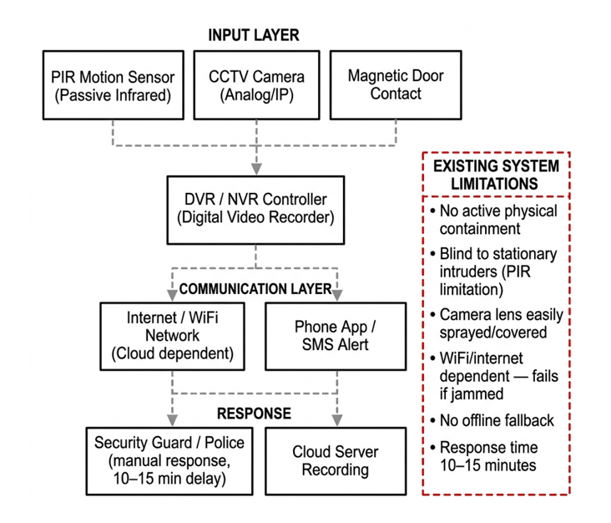
Figure 4.2: Existing Conventional Security System Architecture Block Diagram
4.2 COMPREHENSIVE FEATURE COMPARISON
Table 4.1 presents a comprehensive 25-row technical comparison between existing conventional systems and the proposed TRAPNET system:
# | Parameter / Feature | Existing Conventional System | Proposed TRAPNET System | Improvement
1 | Primary Detection Technology | PIR Passive Infrared sensor | 24 GHz FMCW mmWave Radar (LD2410C) | Fundamental upgrade
2 | Stationary Intruder Detection | FAILS — PIR requires thermal movement | Detects 3–5 mm chest breathing via micro-Doppler | Critical new capability
3 | Camera Tamper Resilience | FAILS — Spray paint = system failure | Self-healing: tamper flag -> radar-only mode | System survives attack
4 | Physical Containment | None — intruder can freely exit | 12V solenoid lock in 850 ms; 60 kg force | Novel active capability
5 | Alert Channel Redundancy | Single WiFi or GSM channel | 4 simultaneous: WiFi Beacon + BLE + GSM + ESP-NOW | 4x redundancy
6 | Internet Dependency | High — cloud dependent | Zero internet required; all 4 channels offline | Fully offline capable
7 | WiFi Jammer Resilience | FAILS — jammer disables alerts | GSM, BLE, ESP-NOW unaffected by WiFi jamming | Jam-proof design
8 | Power Cut Resilience | FAILS — mains cut disables system | 18650 battery backup; 4–6 hrs; <10 ms switch | Uninterruptible
9 | AI-Vision Integration | None or cloud-based | YOLOv8 INT8 on-device at 140 ms on RPi Zero 2W | Real-time edge-AI
10 | False Alarm Reduction | Single sensor — high false alarms | Multi-sensor fusion threshold decision | Near-zero false alarms
11 | Structural Breach Detection | None | SW-420 x2 with 500ms sliding window counting | New attack vector covered
12 | GPS Location Stamping | None | NEO-6M GPS coordinates in GSM SMS & ESP-NOW | Precise location data
13 | Offline Evidence Logging | DVR (can be stolen) | MicroSD 16 GB FAT32 tamper-evident log | Forensic-grade logging
14 | Alert Reception (App Required?) | Mobile App required | No app required — WiFi SSID visible to nearby phones | Zero app friction
15 | Alert Geographic Radius | Unlimited (internet) single channel | WiFi:30m; BLE:15m; ESP-NOW:200m+; GSM:unlimited | Multi-radius coverage
16 | Real-Time Status Display | None typically | 0.96" OLED HUD: state, sensor status, battery | On-device monitoring
17 | Detection Technology Count | 1 (PIR or camera only) | 5 simultaneous: radar + vibration x2 + IR x2 + camera | 5x sensor diversity
18 | Response Time to Containment | N/A — no containment | Less than 850 ms end-to-end (detect to lock) | First of its kind
19 | Through-Barrier Sensing | Blocked by smoke, fog, darkness | 24 GHz RF penetrates smoke, fog, glass, acrylic | Environment-independent
20 | Total System Hardware Cost | Rs.30,000 – Rs.50,000 (commercial) | Rs.7,024 – Rs.8,500 (COTS components) | 85% cost reduction
21 | Multi-Sensor Fusion Logic | None | Weighted confidence score with configurable threshold | Novel fusion model
22 | Cyber Security (Inter-node) | Unencrypted WiFi | AES-128 encrypted ESP-NOW with ECDH key pairs | Cryptographic security
23 | Power Management | Single rail, no backup | Dual-rail LM2596 + 18650 Li-Ion + MOSFET switch | Resilient power design
24 | Authorized Disarming Method | Simple key or app | SMS passcode to SIM800L OR mechanical key | Secure disarming
25 | Proximity Alert for Bystanders | None — registered users only | WiFi SSID visible to all smartphones in 30m radius | Novel social alerting

4.3 7-PILLAR TECHNOLOGY DOMAIN COMPARISON
Table 4.2 evaluates TRAPNET against prior peer-reviewed publications across seven core technical security pillars:
Prior Work (Reference) | mmWave Radar | Sensor Fusion | Auto Door Lock | Multi-Ch SOS | AI Vision | Offline Capable | Battery Backup
Raimondi et al. [1] IEEE 2024 | YES | NO | NO | NO | NO | NO | NO
Billah et al. [4] IEEE 2024 | NO | NO | NO | NO | YES | NO | NO
Chatterjee et al. [5] IEEE 2024 | NO | NO | NO | NO | YES | NO | NO
Balaji et al. [13] IEEE 2023 | NO | NO | NO | NO | Partial | NO | NO
Kumar et al. [14] IEEE 2024 | NO | NO | YES | NO | NO | NO | NO
Nair et al. [17] IEEE 2025 | NO | NO | NO | Partial | NO | NO | NO
Shahin & Younis [21] IEEE 2015 | NO | NO | NO | Partial | NO | YES | NO
Singh et al. [25] IEEE 2024 | NO | NO | NO | NO | NO | NO | NO
TRAPNET (Proposed Invention) | YES | YES | YES | YES | YES | YES | YES
CHAPTER 5
PATENT CLAIMS & SPECIFICATIONS
5.1 PATENT CLAIMS
WE CLAIM:
Claim 1 — Independent Claim (System Architecture):
1. An autonomous physical intrusion containment and alert system comprising:
• (a) a millimeter-wave (mmWave) radar sensor operating at 24 GHz Frequency-Modulated Continuous Wave (FMCW) modulation, configured to detect human presence by sensing micro-Doppler breathing displacement signatures of 3 to 5 millimeters from stationary, hidden, or motionless human targets at ranges up to 6.0 meters;
• (b) at least one piezo vibration sensor with a software-implemented 500-millisecond sliding window pulse-count algorithm for forced-entry structural breach detection;
• (c) at least one infrared barrier sensor at perimeter entry points;
• (d) a master microcontroller configured to execute a multi-sensor threat confidence fusion algorithm combining radar energy, vibration pulse count, and computer-vision person detection confidence into a weighted fusion score;
• (e) an edge-AI coprocessor configured to execute post-training quantized INT8 YOLOv8 person detection inference in under 150 milliseconds for secondary confirmation of radar-triggered events;
• (f) a computer-vision optical tamper detection module implementing frame variance and SSIM analysis to detect camera lens spraying or covering, automatically routing detection authority to the mmWave radar channel upon tamper detection;
• (g) an electromechanical door lock actuated via an optocoupler-isolated relay within 850 milliseconds of confirmed threat detection for physical intruder containment;
• (h) a four-channel simultaneous SOS alert module broadcasting via: (i) IEEE 802.11 beacon frame SSID injection, (ii) Bluetooth Low Energy Eddystone URL beacons, (iii) GSM SMS via cellular modem, and (iv) ESP-NOW ad-hoc multi-hop mesh relay; all channels operational without internet connectivity; and
• (i) a dual-rail power management system with lithium-ion battery backup providing a minimum of 4 hours of autonomous operation during mains power interruption.
Claim 2 — Dependent Claim (Radar Specifications):
2. The system as claimed in Claim 1, wherein the millimeter-wave radar sensor comprises an HLK-LD2410C FMCW module operating in the 24.000 GHz to 24.250 GHz ISM band, communicating over UART at 256,000 baud, and wherein human presence confirmation requires a static gate energy value exceeding 40 on the radar's internal confidence scale of 0 to 100.
Claim 3 — Dependent Claim (Vibration Pulse Algorithm):
3. The system as claimed in Claim 1, wherein the vibration detection algorithm employs a 500-millisecond sliding time window counting low-pulse events from piezo vibration sensor output signals, and classifies an event as a genuine forced entry breach only when the pulse count within the window exceeds 15, thereby rejecting transient environmental disturbances.
Claim 4 — Dependent Claim (Optical Tamper Fallback):
4. The system as claimed in Claim 1, wherein the optical tamper detection module asserts a visual tamper flag when grayscale frame variance Var(F) drops below 15.0 or when Structural Similarity Index SSIM between consecutive frames falls below 0.20 for five or more consecutive frames, and wherein upon flag assertion, the system increases detection weight of the mmWave radar channel to 100% and suppresses the vision confidence component from the fusion score.
Claim 5 — Dependent Claim (WiFi Beacon Frame Injection):
5. The system as claimed in Claim 1, wherein the WiFi Beacon SSID broadcast channel injects raw IEEE 802.11 beacon frames at a beacon interval of 100 milliseconds or less using the esp_wifi_80211_tx() API, with SSID strings encoding human-readable emergency information visible to any smartphone within 15 to 30 metres without requiring any application installation or pairing.
Claim 6 — Dependent Claim (ESP-NOW Encrypted Packet):
6. The system as claimed in Claim 1, wherein the ESP-NOW mesh relay transmits a 12-byte AES-128 encrypted frame comprising: a 1-byte node identifier, a 1-byte system state code, a 4-byte GPS latitude value, a 4-byte GPS longitude value, and a 2-byte CRC16 checksum, enabling tamper-evident and authenticated alert propagation across multi-hop mesh networks without a central router.
Claim 7 — Dependent Claim (Quantized AI Inference Model):
7. The system as claimed in Claim 1, wherein the edge-AI person detection model is a YOLOv8 nano architecture with post-training quantization from 32-bit floating point (FP32) to 8-bit integer (INT8) representation, reducing model storage from 6.2 MB to 1.8 MB while maintaining mean average precision within 2% of the full-precision baseline, enabling full residency in 512 MB RAM constrained embedded computing hardware.
Claim 8 — Dependent Claim (Dual-Rail Power Architecture):
8. The system as claimed in Claim 1, wherein the dual-rail power management system comprises: a first LM2596 DC-DC step-down converter providing 5.0 V for microcontroller, radar, vision processor, and peripheral sensors; a second LM2596 step-down converter providing 4.0 V with a 1000 uF electrolytic decoupling capacitor for the GSM cellular modem to absorb 2-ampere peak transmission current bursts; and dual 18650 lithium-ion cells with TP4056 protection circuits providing automatic MOSFET-switched battery backup with transition time under 10 milliseconds upon mains power failure.
5.2 ABSTRACT OF THE DISCLOSURE
TRAPNET (Intruder Containment Network) is a novel autonomous physical intrusion containment system that addresses critical technical limitations of conventional CCTV and PIR-sensor-based security installations. The invention integrates a 24 GHz FMCW millimeter-wave radar module for detecting micro-Doppler chest breathing signatures (3–5 mm displacement) of stationary, hidden intruders — a capability absent in all prior PIR-based systems.
A tri-modal sensor fusion engine on an ESP32 microcontroller combines radar, piezo vibration pulse counting, and edge-AI YOLOv8 person detection (running on Raspberry Pi Zero 2W) into a weighted threat confidence score, achieving near-zero false alarms. Upon threat confirmation, the system actuates a 12V fail-secure solenoid door lock within 850 milliseconds, physically trapping the intruder — the first such capability available below Rs.8,500 total hardware BOM cost.
Simultaneously, four parallel offline alert channels broadcast emergency notifications: IEEE 802.11 WiFi Beacon SSID injection (30 m radius, no app required), BLE Eddystone URL beacons (15 m), GSM SMS via SIM800L cellular modem (unlimited range), and AES-128 encrypted ESP-NOW multi-hop mesh relay (200 m+). An optical tamper self-healing mechanism detects camera spray attacks and automatically shifts detection authority to the radar channel. A dual-rail 18650 Li-Ion battery backup ensures 4 to 6 hours of autonomous operation during mains power cuts.
5.3 BRIEF DESCRIPTION OF DRAWINGS
• Figure 4.1 shows the proposed TRAPNET four-layer block diagram detailing signal flow from Sensor Layer to Processing Layer, Actuation Layer, and SOS Alert Layer.
• Figure 4.2 shows the existing conventional security system block diagram illustrating passive PIR/CCTV vulnerabilities, cloud dependency, and lack of active physical containment.
• Figure 3.1 shows the HLK-LD2410C 24GHz mmWave radar UART serial wiring interface with ESP32 GPIO16/17.
• Figure 3.2 shows the SW-420 vibration sensor wiring with 10 kΩ pull-down resistor on input-only GPIO34/39.
• Figure 3.3 shows the 2-channel optocoupler relay and 12V solenoid lock electrical connection schematic.
• Figure 3.4 shows the SIM800L dual-rail power supply schematic detailing the LM2596 4.0V rail and 1000 µF decoupling capacitor.

5.4 STATEMENT OF NOVELTY
The present invention is novel and inventive over all prior art in that:
1. No prior work combines mmWave micro-Doppler breathing detection, computer-vision person confirmation, vibration breach sensing, automatic physical door locking, and four-channel offline SOS alerts in a single embedded system.
2. No prior work implements an optical-tamper self-healing fallback mechanism that automatically transitions detection authority from a blinded camera to an mmWave radar upon spray-paint or lens-covering attacks.
3. No prior work achieves affordable (sub-Rs.8,500) autonomous physical intruder containment through solenoid locking within 850 milliseconds of confirmed multi-modal threat detection.
4. No prior work provides simultaneous four-channel offline SOS alert dissemination (IEEE 802.11 raw beacon SSID injection + BLE Eddystone + GSM SMS + AES-128 encrypted ESP-NOW mesh) from a single embedded microcontroller.

REFERENCES
1. Raimondi et al., "mmDetect: YOLO-Based mmWave Radar for Detecting Moving People," IEEE Transactions on Geoscience and Remote Sensing, 2024.
2. Sengupta et al., "Robust Multiobject Tracking Using mmWave Radar-Camera Sensor Fusion," IEEE Robotics and Automation Letters, 2022.
3. Shin et al., "Robust Indoor Human Detection and Tracking via mmWave Radar-Vision Fusion," IEEE Sensors Journal, 2023.
4. Billah et al., "Anomalous Event Detection Based on YOLOv8 for Enhanced Security," IEEE ICCIT, 2024.
5. Chatterjee et al., "YOLOv8-Based Intrusion Detection System for Physical Security," IEEE, 2024.
6. Shahbazian and Trubitsyna, "Human Sensing via RF Signals: Survey on Occupancy and Activity Detection," IEEE Access, 2023.
7. Shrestha et al., "Continuous Human Activity Classification from FMCW Radar with Bi-LSTM," IEEE Sensors Journal, 2020.
8. Shen et al., "Human Detection with Weak Ranging Signal for FMCW Radar Systems," IEEE, 2023.
9. Wang et al., "Vital Signs Detection via FMCW MIMO Radar," IEEE Transactions on Industrial Informatics, 2025.
10. Vignoli et al., "Contactless Vital Signs via Multiple 24GHz FMCW Radars," IEEE Access, 2025.
11. Khan et al., "Contactless Vital Signs on Edge Devices with T-CNN and mmWave Radar," IEEE Sensors Journal, 2025.
12. Deng and Zhang, "Non-Contact Heartbeat Detection with mmWave Radar Using Impulse Trains," IEEE, 2024.
13. Balaji et al., "Intruder Alert System in Smart Home Based on IoT," IEEE, 2023.
14. Kumar et al., "IoT-Enabled Smart Door Lock with RFID, OTP and Intrusion Detection," IEEE, 2024.
15. Suresh K et al., "Real-Time Intrusion Detection for IoT Networks Using Machine Learning," IEEE, 2024.
16. Karanth et al., "AI and IoT-Based Intrusion Detection System for Smart Home Security," IEEE, 2024.
17. Nair et al., "Emergency Alert System via Compact IoT-Based Safety Device," IEEE Systems Journal, 2025.
18. Choi and Bahk, "mmWave FMCW Radar for Detecting Objects Behind Transparent Barriers," IEEE Communications Letters, 2023.
19. Han et al., "M2VISION: Recovering Surveillance Video with COTS mmWave Radar," IEEE Transactions on Mobile Computing, 2024.
20. Devoti et al., "PASID: Passive Intrusion Detection via Indoor mmWave Deployments," IEEE INFOCOM, 2023.
21. Shahin and Younis, "EMC: Multi-Group Formation and Communication for Wi-Fi Direct," IEEE LCN, 2015.
22. Ferrag et al., "Edge-IIoTset: IoT/IIoT Cyber Security Dataset for ML/FL," IEEE Access, 2022.
23. Venkatesha et al., "Detection and Simple Tracking for ADAS Using a mmWave Radar," IEEE INDISCON, 2023.

DECLARATION BY INVENTORS
We, MOHAMED SAMEER F (Registration No. 43130597) and RAAHUL N (Registration No. 43130640), students of the Department of Electronics and Communication Engineering, Sathyabama Institute of Science and Technology (Deemed to be University), Chennai – 600 119, do hereby solemnly declare that:
1. We are the true and first inventors of the invention titled “TRAPNET: A TAMPER-RESILIENT MILLIMETER-WAVE RADAR-BASED PHYSICAL INTRUSION CONTAINMENT SYSTEM WITH MULTI-MODAL SENSOR FUSION AND MESH-RELAYED SOS ALERTS”.
2. The invention is our original work and does not involve any wrongful appropriation of the property or patent rights of any other person or institution.
3. To the best of our knowledge and belief, the invention has not been publicly disclosed, published, or patented anywhere in the world prior to this application.
4. We agree to abide by all provisions of the Patents Act, 1970 (as amended) and the Patent Rules, 2003, including the obligation to disclose all information known to us regarding prior art.

