# Currency-Exchange-Public-APIImplement a simple system that exposes a public API for currency exchange.

Description: This project is a simple API that retrieves exchange rates for a given from and to currency with error hndling implemented. It uses a cache to store exchange rates for a specified time to live (TTL) to reduce the number of requests to the external API. It uses also a rate limiter to prevent abuse.

Code Structure:

1) app.js:

-This file sets up the Express.js server and defines the API endpoints.

-It imports the required dependencies, including the express, rateLimit, config file, Cache module, and ExchangeRates module.

-It defines the /exchange-rates endpoint, which retrieves exchange rates for a given from and to currency.

-It uses the rateLimit middleware to limit the number of requests to the /exchange-rates endpoint.

-It sets up the Swagger API documentation using the swaggerJsdoc and swaggerUi modules

2) config.js:

- This file stores the configuration settings for the application.

- It exports an object with the following properties:

- apiKey: The API key for the external API provider.

- apiEndpoint: The endpoint URL for the external API provider.

- cacheTTL: The time to live (TTL) for the cache in seconds.

- rateLimit: An object with the following properties:

- a time window for the rate limit in milliseconds.

- a maximum number of requests allowed within the time window.

3) cache.js:

-This file defines the Cache module, which stores exchange rates for a specified TTL.

-It uses the node-cache library to store the cache data.

4) exchangeRates.js:

-This file defines the ExchangeRates module, which retrieves exchange rates from an external API.

-It imports the axios library to make HTTP requests to the external API.

-It exports an ExchangeRates class

How to Run the Project:

1) install/clone this repo to your local machine

2) install required dependencies using "npm install axios, express,node-cache,express-rate-limit, swagger-jsdoc swagger-ui-express" in the project directory

3) run command "node app.js" in the project directory to run the application

4) open web browser and enter the following url: "http://localhost:3001/api-docs"

API end points using swagger:

case 1:

The inputs:  
 from: USD

To: EUR

The output:

0.93326968

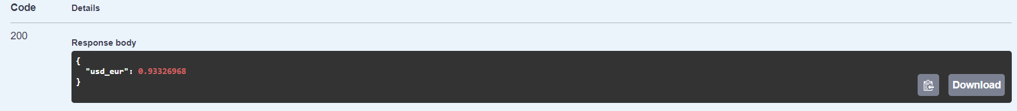

Case 2:

The inputs:

From: USD

To: EGP

The output:

48.37898808

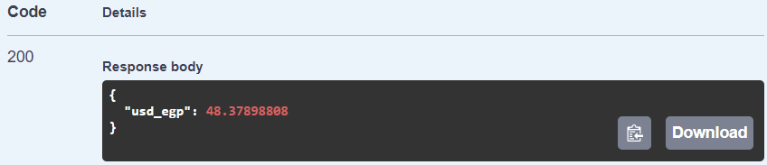

Case 3:The inputs:

From: EUR

To: AUD

The output:

1.61218082

