Hospital management System

The program consists of :

1-login frame

2-NewUser Creation ( New Registration).

3-Main frame

4-Patient frame

5-Doctor frame

6-Medicine Cabinet frame

7-View Doctors frame

Team Members: Section 14

1. محمد أنور محمد حسني عبدالمطلب
2. محمد أحمد راشد
3. محمد إبراهيم محمد الدسوقي
4. محمد احمد السيد السقطي
5. محمد أشرف أبو الفتوح
6. محمد أشرف حافظ

1-login frame

1- Username

The username that the user had entered in the New user page.

2-Password

The Password that the user had entered in the New user page

3-Show Password

View the Password

4-User Type

The user selects one choice that he had registered as a new user.

5-Login

When the user enters this button The program checks The information From the database if it is correct then the Main Page Appears.

6- Exit

Used to end the program.

7-New User

Used to Create a new user.

2-NewUser Creation ( New Registration).

On this page, you can create a new user, the information inserted in the database, and then you can enter the program.

------------------------------------------------------------------------------------------

3-Main Frame

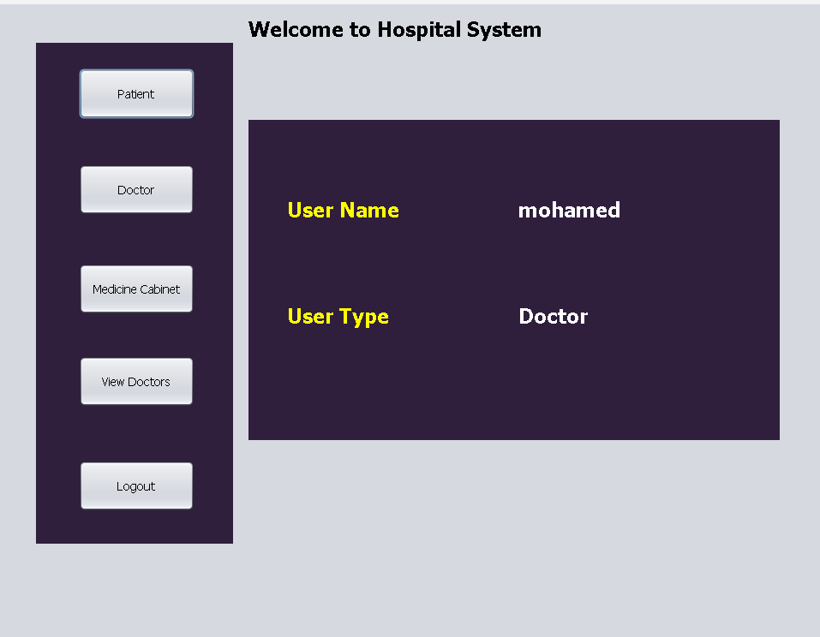

The User Name and Type appear in the frame, and he can select any choice he wants .

4-Patient frame

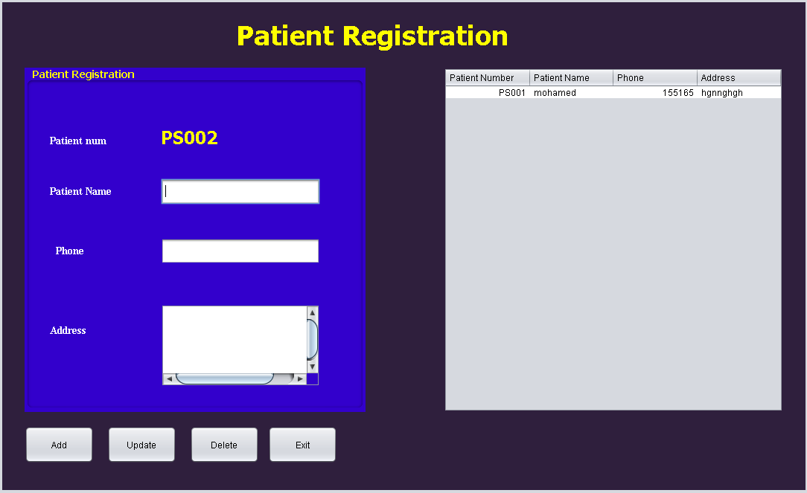

The user can add information about the patient or update or delete

Any patient.

The information about the user is displayed in the table after adding it.

--------------------------------------------------------------------------------------------

5- Doctor frame

On this page, you can add a new Doctor, then the information appears in the table, and you can update or delete any doctor information.

6-Medicine Cabinet frame

On this page, the user can add a new medicine to the hospital system and can update or delete any Medicine information.

--------------------------------------------------------------------------------------------

7-View Doctors frame

On this page, you can display all the doctor’s information.