Face Detection and Recognition
Mohamed Ahmed, Mohamed Ehab and Mostafa Hamad
mohamed1508208, mohamed1502458, mostafa1500342 - @miuegypt.edu.eg
Faculty Of Computer Science - Misr International University

May 21, 2018

Abstract – Project idea is a face detection and recognition. Face detection where a video is searched to find a face, then the video is processed to extract the person’s face for easier recognition. Face recognition where that detected and processed face is compared to a training data of known faces, to decide who that person is. These processes are implemented in four stages (Capture – Extraction – Comparison – Match/Non match).
I. INTRODUCTION

For the time being, face recognition is one of the most popular and important biometric systems as it is used in many applications. Facial recognition systems are commonly used for security purposes but are increasingly being used in a variety of other applications like Verification and identification. Facial recognition system is the only biometric that allow you to perform passive identification. South Wales Police admitted that "no facial recognition system is 100% accurate", but said the technology had led to more than 450 arrests since its introduction. There is an increasing pressure on image processing algorithms to support higher resolutions that requires denser sampling. As one of the most successful applications of image analysis and understanding, face recognition has recently received significant attention, especially during the past several years. At least two reasons account for this trend: the first is the wide range of commercial and law enforcement applications, and the second is the availability of feasible technologies after 30 years of research. Even though current machine recognition systems have reached a certain level of maturity, their success is limited by the conditions imposed by many real applications. There are four processes that we are follow which is Face detection, data gathering, and data comparison and face recognition.
II. RELATED WORK
First Paper: COMBINING CLASSIFIERS FOR FACE RECOGNITION.
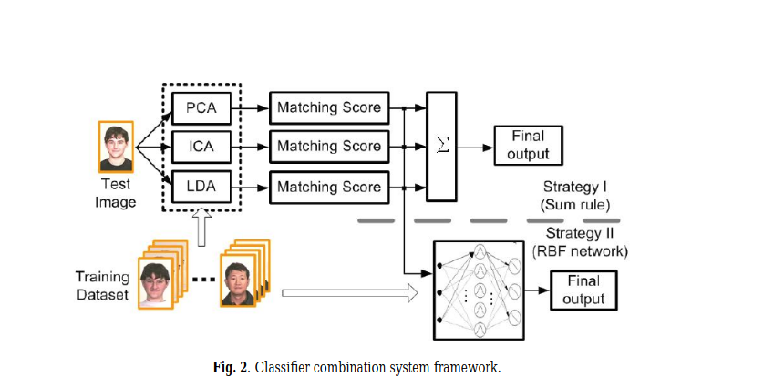
This article depends on recognizing the face of human on a two dimensional image, according to the article the approaches used obtained a good performance. It depends on integration of a group of classifiers to improve the accuracy, the author used a three classifiers in his project PCA, ICA and IDA. The following figure will illustrate how the project is combined. A lot of experiments and testing are mad for this project for example they used 40 subjects for the orl [16],15 for Yale[9]and the 120 for ar[17] one the other the accuracy of this different classifiers are PCA: 79%, ICA: 88.1%, LDA: 81.0%.

Second paper: Multi-Pose Face Recognition and Tracking System.
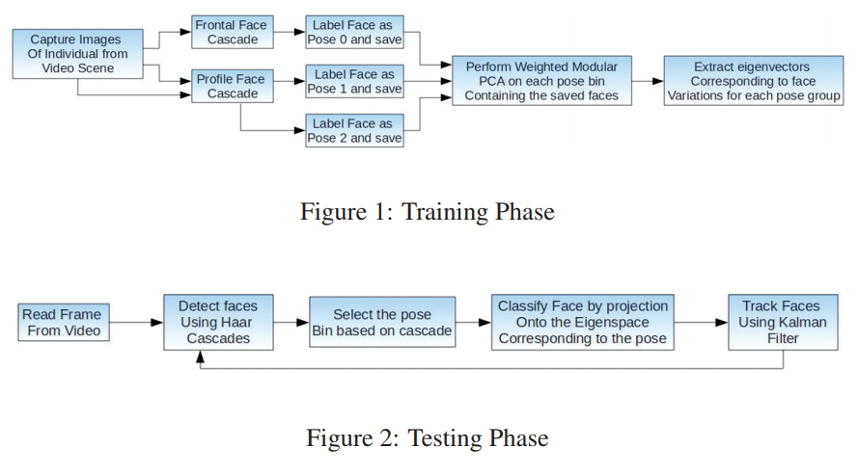
The system works on detecting, recognizing and tracking person face by detection algorithm. Detection of the face in an image region is done by first, computing the features known as the ’Haar’ features and then applying them to a cascade of boosted classifiers. Recognizing human faces is a challenging task as the facial features of an individual are prone to changes due to illumination, facial expression, head orientation and head pose. The ’Haar’ features which are computed from the region (set by scanning a window of size W × H) of interest can be classified as edge features, line features and center-surround features. Each ’Haar’ feature is computed by aligning it within the region of interest and calculating the weighted sum of pixels in the shaded rectangles of the feature with opposite weights assigned to the different shades. In this paper, we are proposing a real time system to identify humans in a video scene by detecting, recognizing and tracking faces which vary in pose.

Third paper: improving the performance of face recognition systems based on 3d features.

In this paper a suitable methodology for the improvement of the reliability of results in classification systems based on 3D images is proposed. More in detail, it is based on the knowledge of the uncertainty of the features constituting the 3D image (obtained processing a pair of two 2D stereoscopic images) and on a suitable statistical approach providing a confidence level to the classification result. These pieces of information are then managed in order to improve the classification performance in terms of correct classification and missed classification percentages. The experimental results, obtained applying the methodology on an Active Appearance Models algorithm, a popular method for face recognition based on 3D features, show that, compared with a traditional approach (which generally does not take into account the uncertainty on 3D features), the proposed methodology allows to significantly improve the classification performance even in scenarios characterized by a high uncertainty.

III. PROPOSED SYSTEM

the system depends on creating it’s own data-set and a ready made data-set. The first one depends on taking 51 picture for the face then adding 20 pictures containing rotation of the image then we use salt and paper filter to improve the accuracy, also we change the scale factor to improve the accuracy. the system is trained to detect the face and the second one which is the ready made data-set depends on a group of picture 500 picture then check the similarity between the picture used in the detection and picture used in recognition.
IV. EXPERIMENTS
At the beginning we decided to use face recognition using haar cascade in which we used two data sets one of them is a ready made data set and th other it's our own data set the project depended on taking a group of pictures for each person then add rotation to each of them then each picture is saved with an id which is known with the user id to detect the id and saved then the trainer function took the pictures which is saved in the data set and train it then it saves the training in file then we use function to detect the face after changing the face factor the accuracy reached 70%
V. CONCLUSION

In this paper, we have proposed a system which combined the face detection, face recognition and face tracking where we extended the face features through haar cascade algorithm to recognize profiles faces of individuals. The system was tuned to work at real-time and have a good accuracy in recognizing and tracking faces. But, some issues such as the lighting variations and small background inclusion into face recognition affects the performance.

VI. FUTURE WORK

Our future work is making facial recognition software more accurate for law enforcement purposes through a full body recognition software. In a study published in psychological science , Rice and her fellow researchers asked college students to discern whether two photos (which had stumped facial recognition software ) were indeed of the same person. They used eye-tracking equipment to discern how the participants were making the call. In the end, they found that students were far more accurate in their answers when the face and body of the subject was shown. And while participants reported judging based on facial features, their eyes were spending more time examining body build, stance, and other body features.
REFERENCES

- M. Turk, A. Pentland, Eigenfaces for recognition. J. Cogn. Neurosci. 3(1), 71–86 (1991), https://www.mitpressjournals.org/doi/10.1162/jocn.1991.3.1.71

- P. Grother, M. Ngan, Face recognition vendor test (FRVT 2013) performance of face identification algorithms. Technical Report (2013), http://www.biometrics.nist.gov/cs_links/face/frvt/frvt2013/NIST_8009.pdf

- IEEE, Combining classifiers for face recognition, 20-22 April 2017, https://www.researchgate.net/publication/4027886_Combining_classifiers_for_face_recognition

- Elsevier, Multi-Pose Face Recognition and Tracking System, (2011), https://ac.els-cdn.com/S1877050911005357/1-s2.0-S1877050911005357-
main.pdf? tid=0ed792f3-f694-432d-bda5-32a082986586&acdnat=1525470706_d9dcfe9397c884f7f0eced787129b255

- Bappaditya Mandal, Rosary Yuting Lim, Peilun Dai, Mona Ragab Sayed, Liyuan Li, Joo Hwee Lim, Trends in Machine and Human Face Recognition, 02 April 2016, https://link.springer.com/chapter/10.1007/978-3-319-25958-1_7

- X. Zou, J. Kittler, K. Messer, Illumination invariant face recognition: a survey, in Proceedings of International Conference on Biometrics: Theory, Applications, and Systems (2007),
https://www.sciencedirect.com/science/article/pii/S0031320312005067

- S.Z. Li, A.K. Jain (eds.), Handbook of Face Recognition, 2nd edn. (Springer, Berlin, 2011), https://link.springer.com/book/10.1007%2F978-0-85729-932-1

- J. Barr, K. Bowyer, P. Flynn, S. Biswas, Face recognition from video: a review. Int. J. Pattern Recognit. Artif. Intell. 26(5), (2012), https://www.worldscientific.com/doi/abs/10.1142/S0218001412660024

- Labeled faces in the wild (LFW) results (2015), http://www.vis-www.cs.umass.edu/lfw/results.html

- Face Recognition Homepage Databases (2015), http://www.face-rec.org/databases/
- The Telegraph News Statistics (05,2018), https://www.telegraph.co.uk/news/2018/05/05/police-defend-facial-recognition-technology-wrongly-identified/
- Psychological science study (10, 2013), https://www.utdallas.edu/news/2013/10/7-26661_Facial-Recognition-is-More-Accurate-in-Photos-Show_story-wide.html

