1. Design  and implement the UML diagrams with Code Skeleton for" PASSPORT AUTOMATION SYSTEM"

Use case diagram

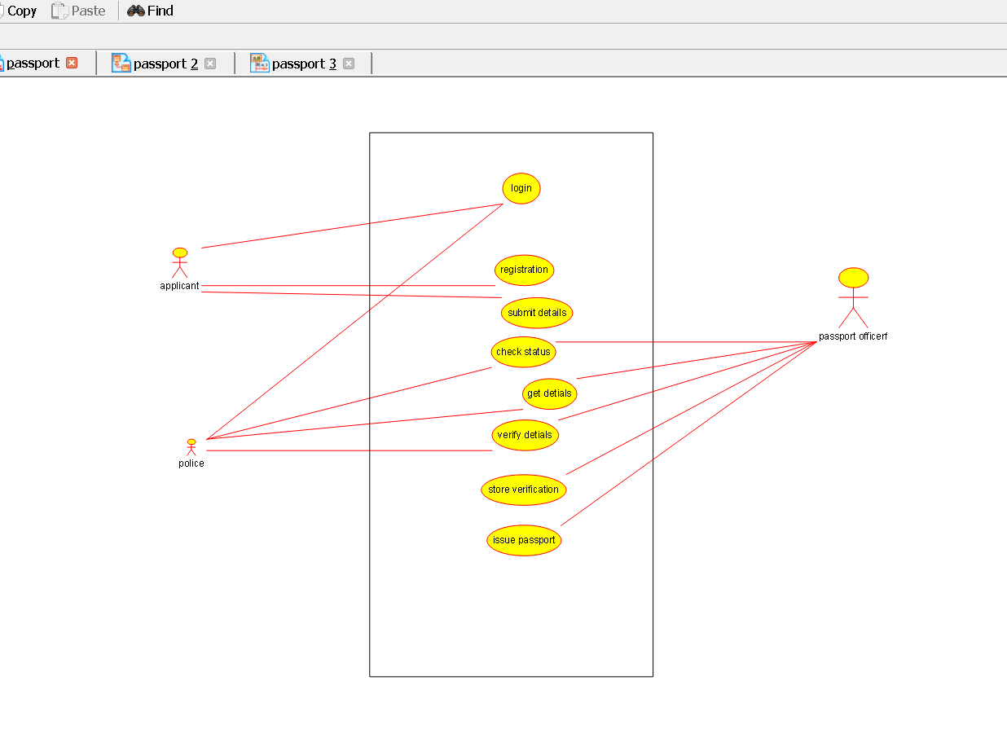

Class diagram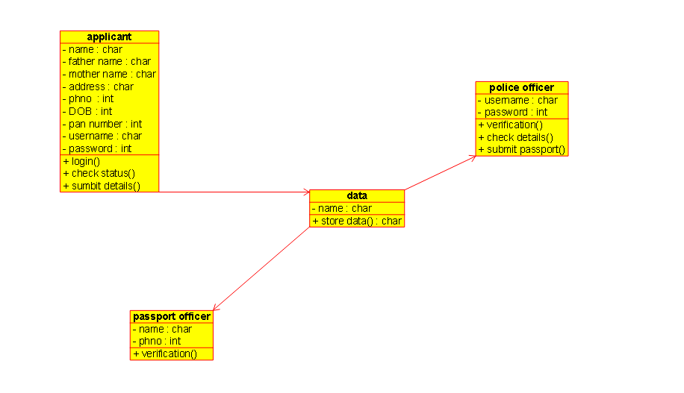

Interaction diagram

Sequence diagram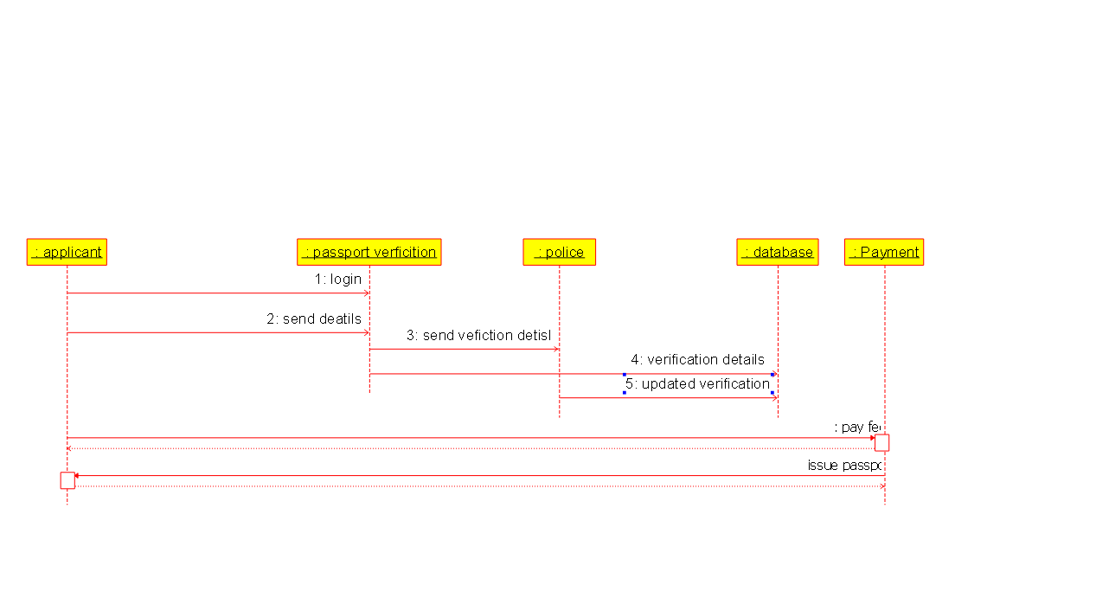

Collaboration diagram

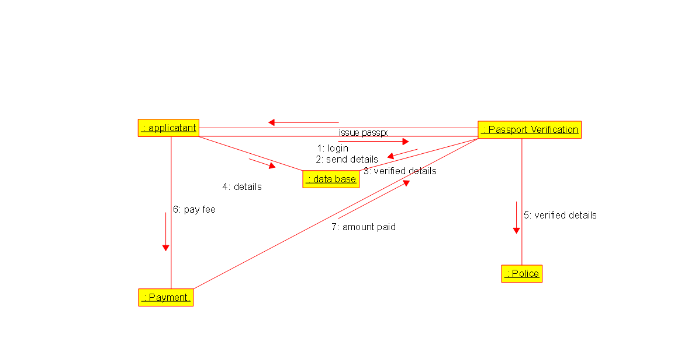

Activity diagram

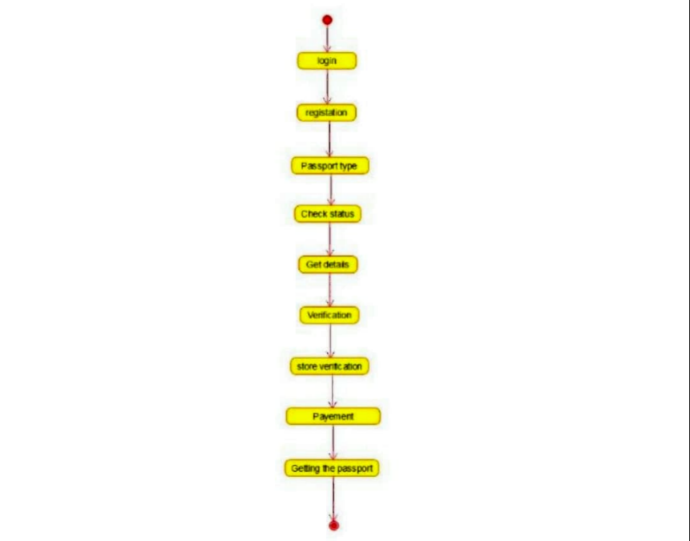

state chart diagram

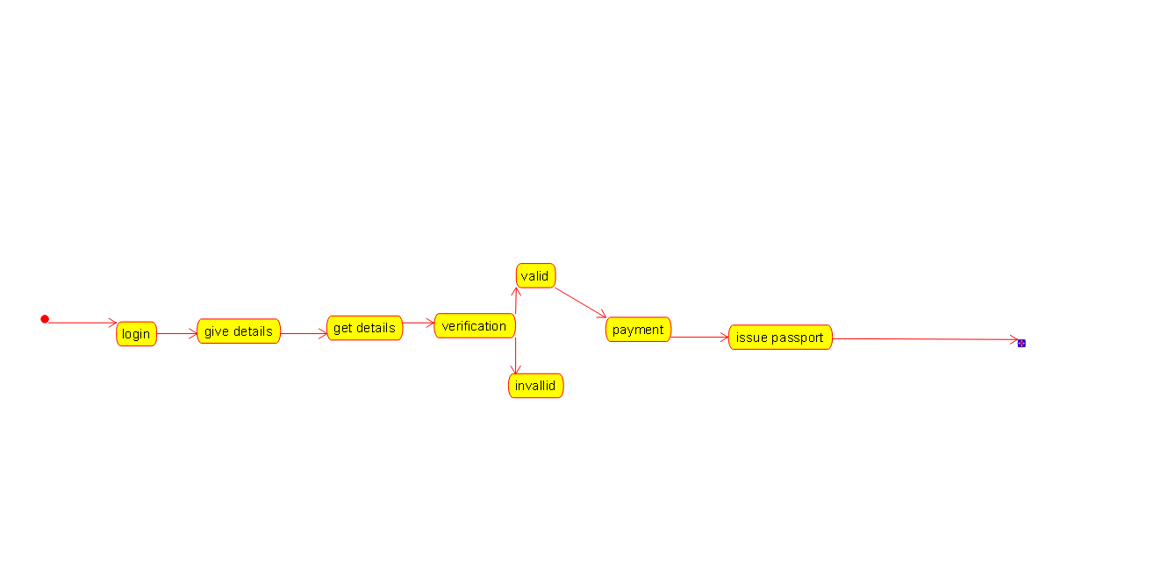

Component diagram

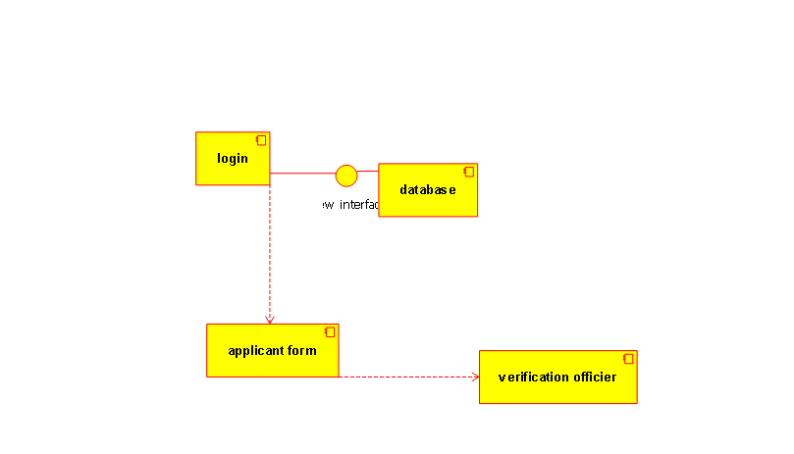

Package diagram

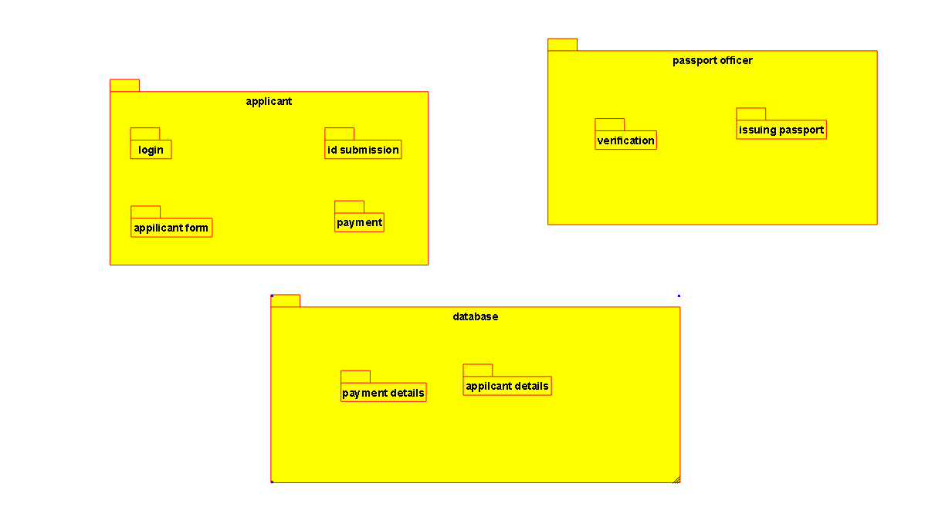

Deployment diagram

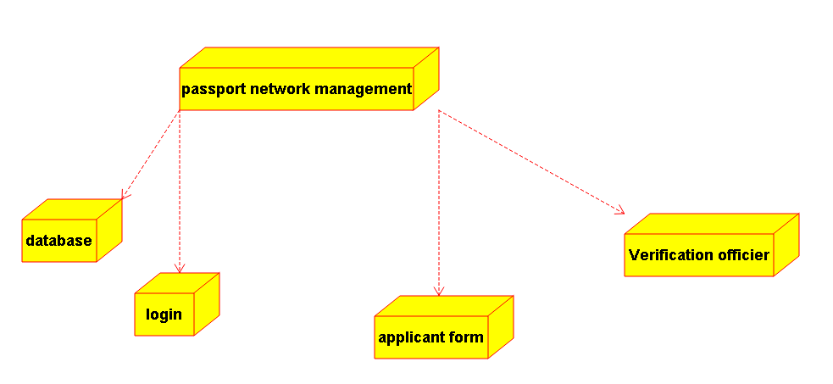

Code skeleton of classes

2.Design and  implement the UML diagrams with code skeleton for"BOOK BANK REGISTRATION SYSTEM"

Use case diagram

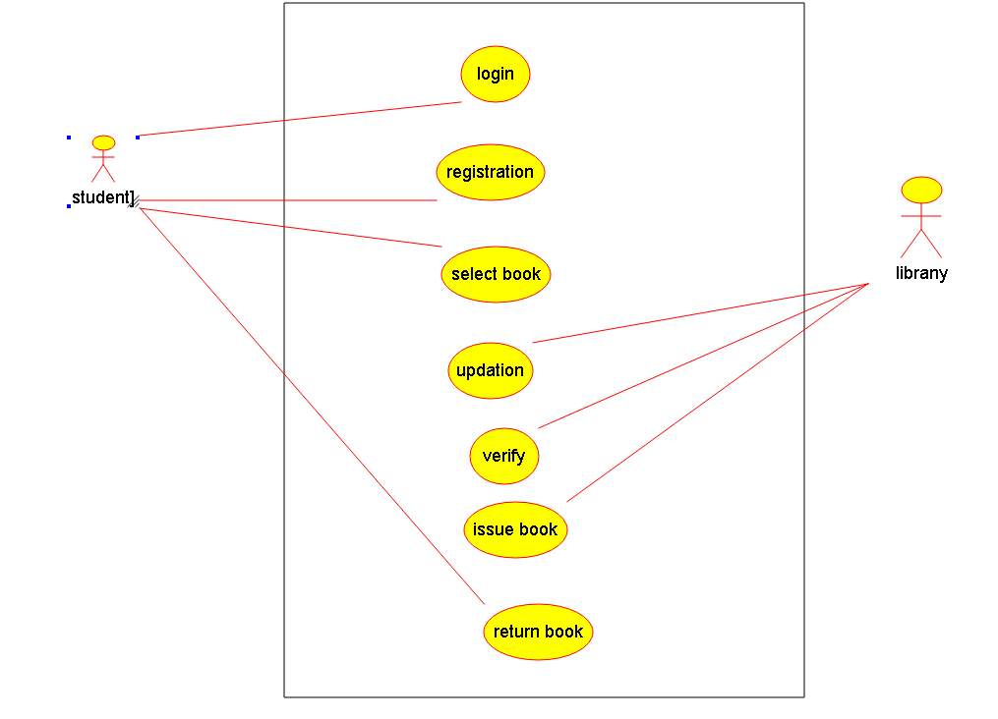

Class diagram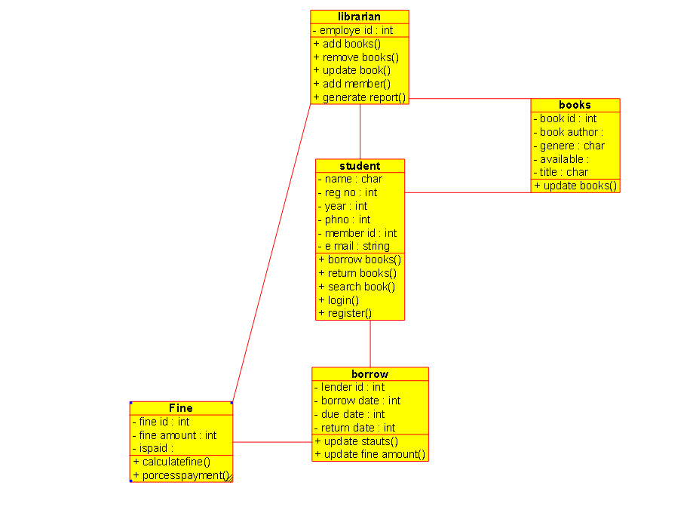

Sequence diagram

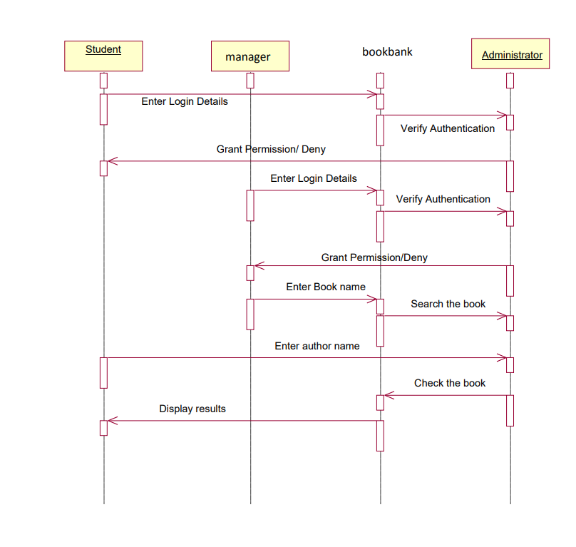

collabration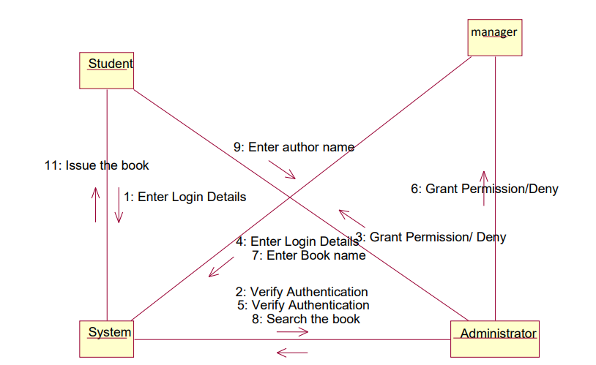

statechart diagram

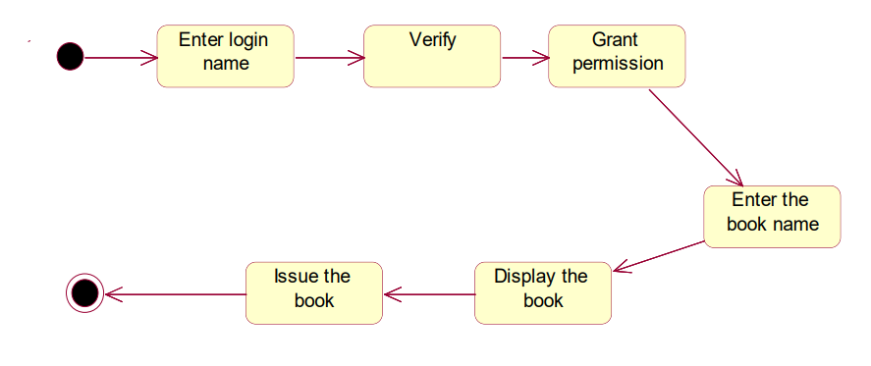

Activity diagram

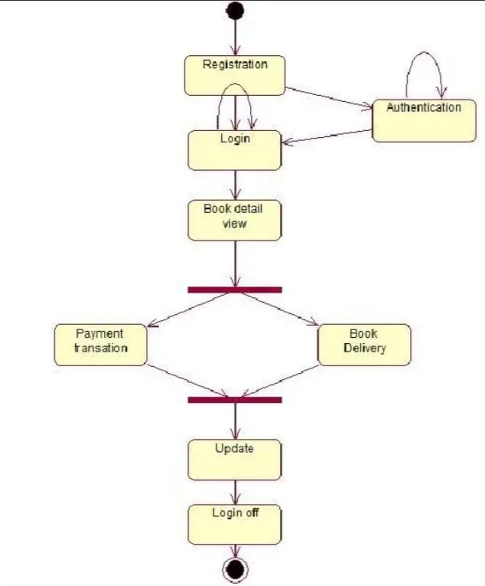

Package diagram

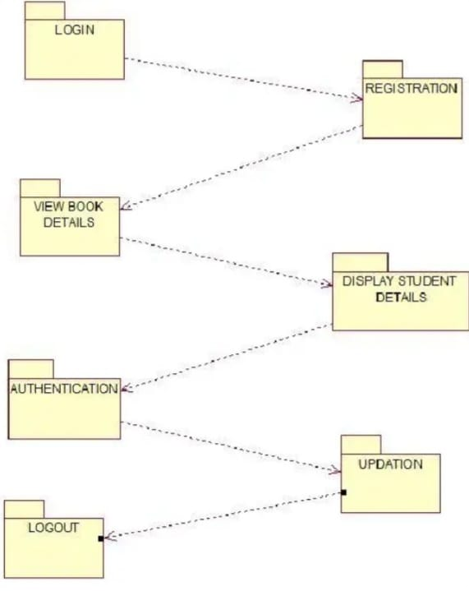

component diagram

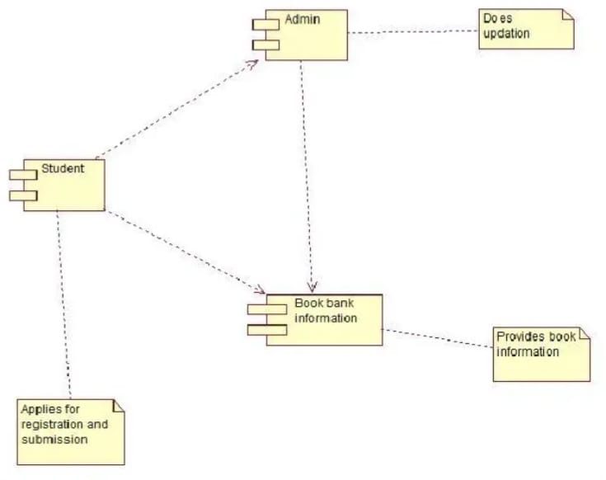

Deployment diagram

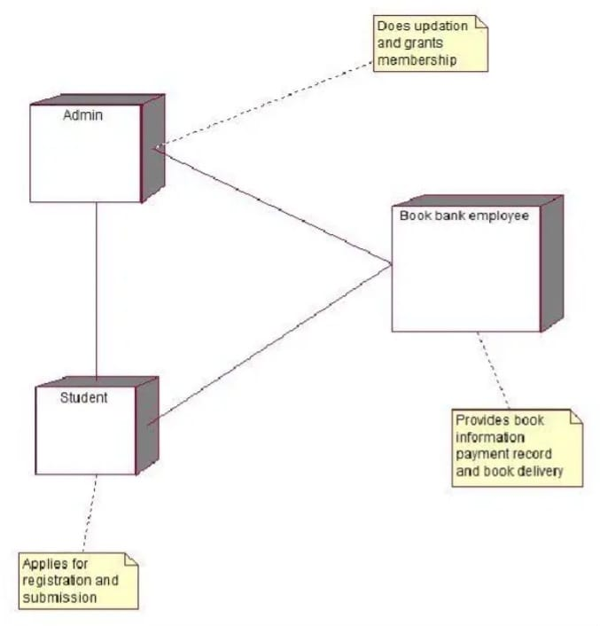

3.Design and implementation the UMl diagram with CODE skeleton for Exam Registration Syste.

Use case diagram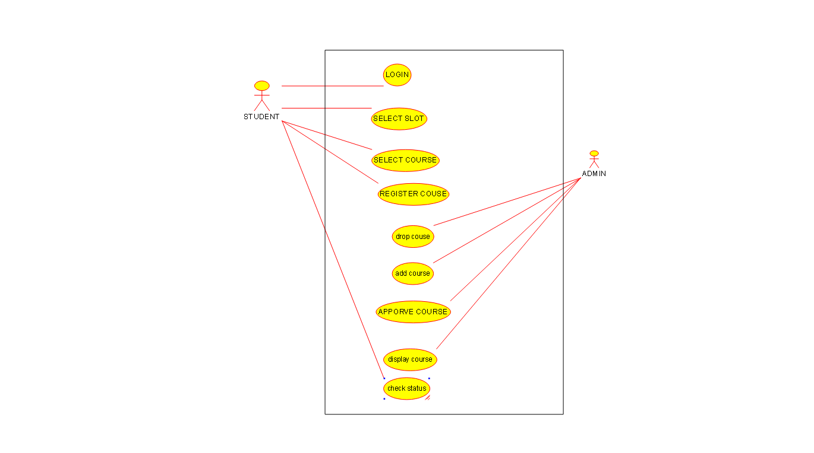

Class diagram

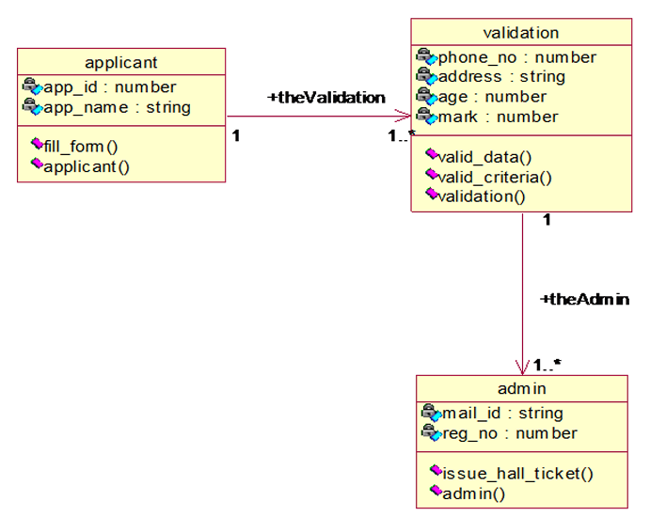

Activity diagram

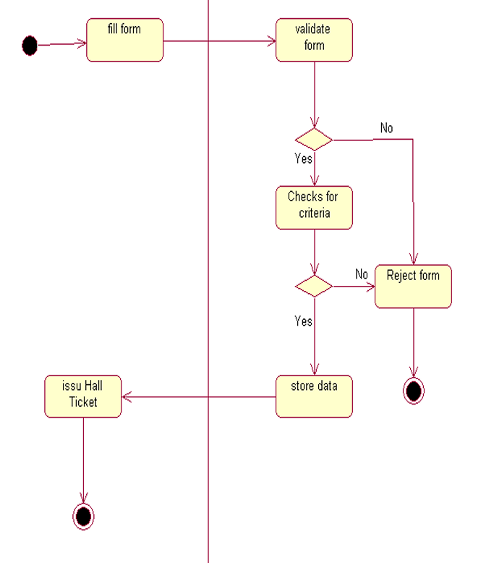

Sequence diagram

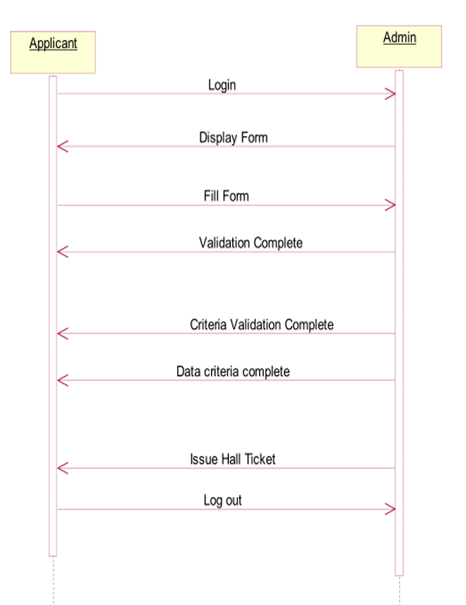

State transition diagram

COLLABORATION DIAGRAM:

COMPONENT DIAGRAM:

**DEPLOYMENT DIAGRAM:**

**4.Design and implementation the UMl diagram with CODE skeleton for Stock Maintainance System**

**USECASE DIAGRAM:**

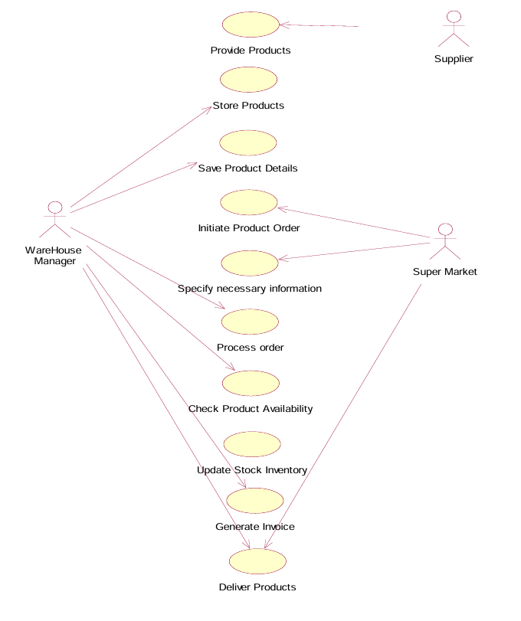

**ACTIVITY DIAGRAM:**

**CLASS DIAGRAM:**

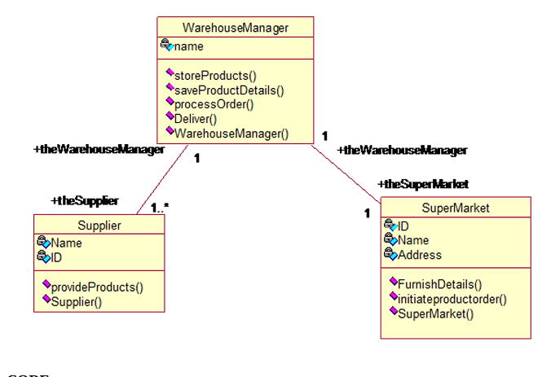

**SEQUENCE DIAGRAM:**

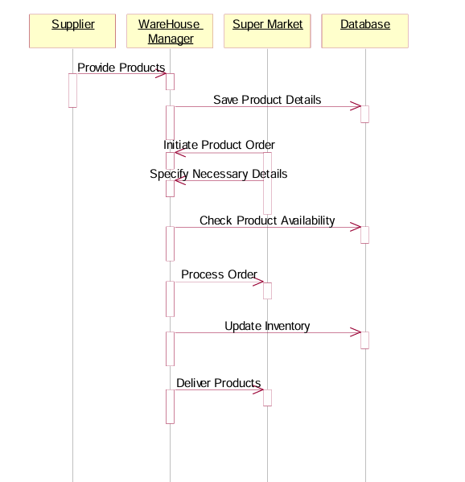

**COLLABORATION DIAGRAM:**

**COMPONENT DIAGRAM:**

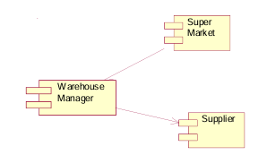

**STATECHART DIAGRAM:**

**DEPLOYMENT DIAGRAM:**

1. **Design and Develop  using UML Diagram for ONLINE  COURSE  RESERVATION   
   SYSTEM**

**USECASE DIAGRAM:**

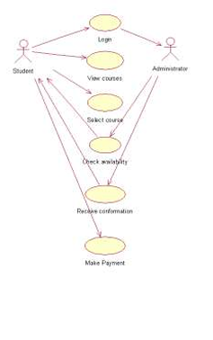

**ACTIVITY DIAGRAM:**

**CLASS DIAGRAM:**

**SEQUENCE DIAGRAM:**

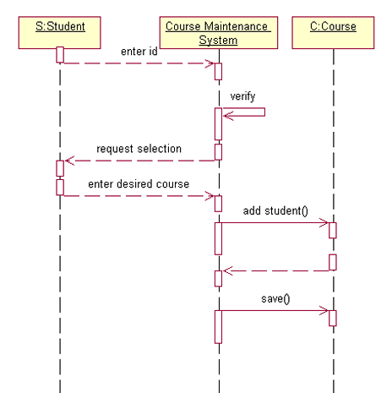

**COLLABORATION DIAGRAM:**

**STATE CHART DIAGRAM:**

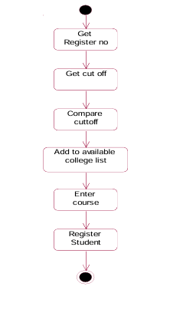

**COMPONENT DIAGRAM:**

**DEPLOYEMENT DIAGRAM:**

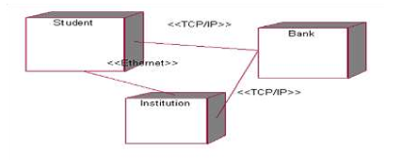

1. **Design and Develop  using UML Diagram for E-TICKETING**

**USE CASE DIAGRAM:**

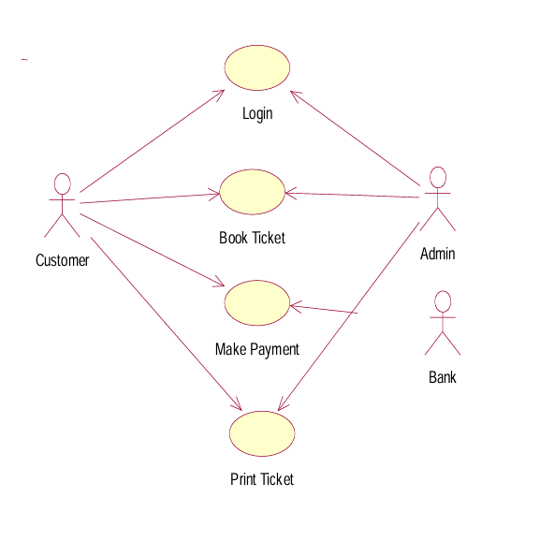

**ACTIVITY DIAGRAM:**

**CLASS DIAGRAM:**

**SEQUENCE DIAGRAM:**

**STATE CHART DIAGRAM:**

**COLLABORATION DIAGRAM:**

**COMPONENT DIAGRAM:**

**DEPLOYMENT DIAGRAM:**

1. **Design and Develop  using UML Diagram for CREDIT CARD PROCESSING SYSTEM**

**USE CASE DIAGRAM:**

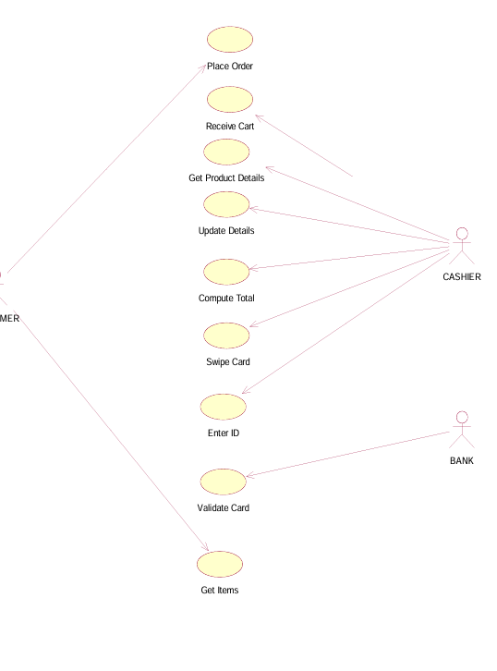

**CLASS DIAGRAM:**

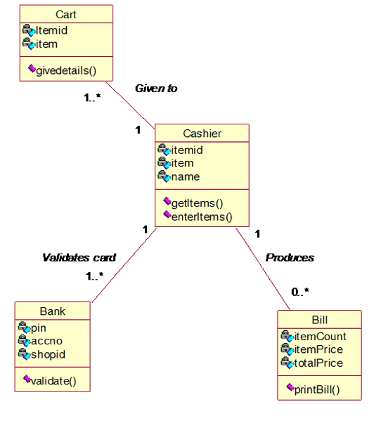

**SEQUENCE DIAGRAM:**

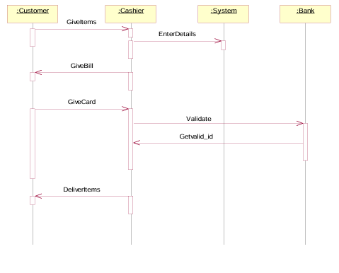

**COLLABORATION DIAGRAM:**

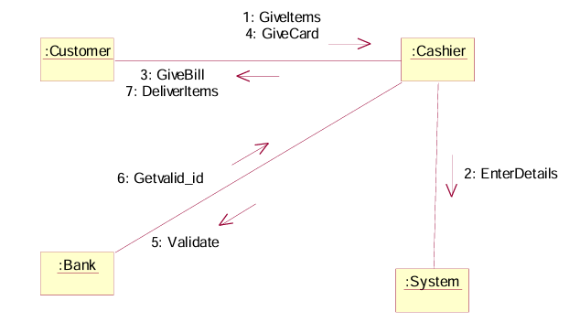

**STATE CHART DIAGRAM:**

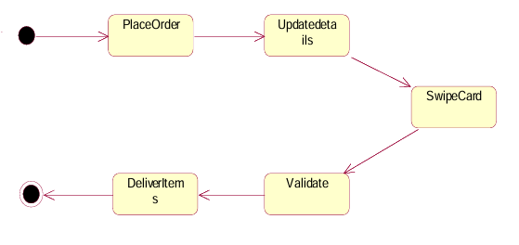

**COMPONENT DIAGRAM:**

**DEPLOYMENT DIAGRAM:**

**8. Design and Develop  using UML Diagram for SOFTWARE PERSONNEL MANAGEMENT SYSTEM**

**USECASE DIAGRAM:**

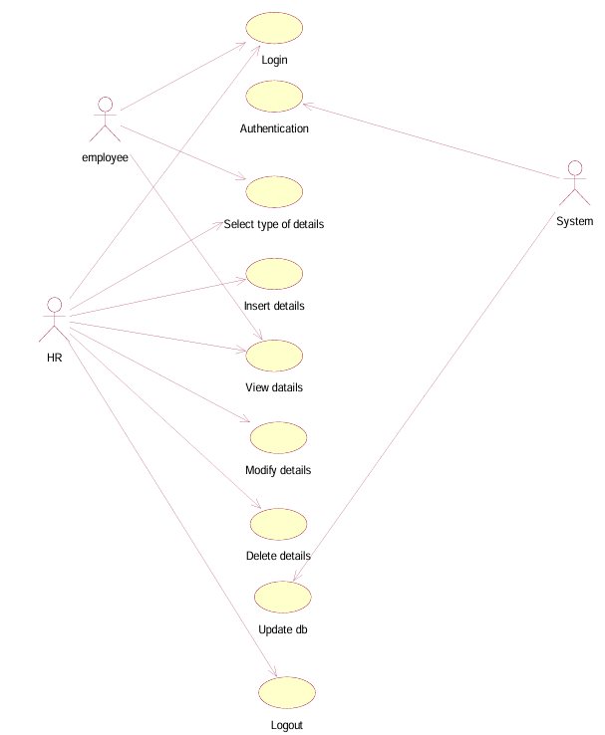

**CLASS DIAGRAM:**

**SEQUENCE DIAGRAM:**

**COLLABRATION DIAGRAM:**

**STATECHART DIAGRAM:**

**COMPONENT DIAGRAM:**

**DEPLOYMENT DIAGRAM:**

**9.Design and implement UML diagrams with code generation for E-Book Management system**

**USECASE DIAGRAM:**

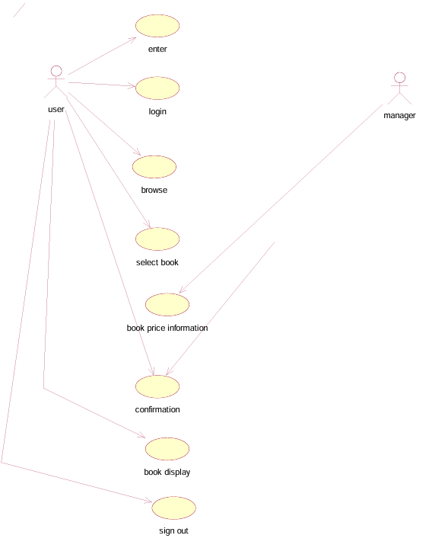

**ACTIVITY DIAGRAM:**

**CLASS DIAGRAM:**

**COLABORATION DIAGRAM:**

**SEQUENCE DIAGRAM:**

**STATECHART DIAGRAM:**

**COMPONENT DIAGRAM:**

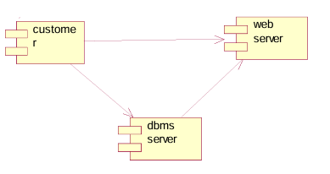

**DEPLOYMENT DIAGRAM:**

**10.Design and implement UML diagrams with code generation for RECRUITMENT SYSTEM**

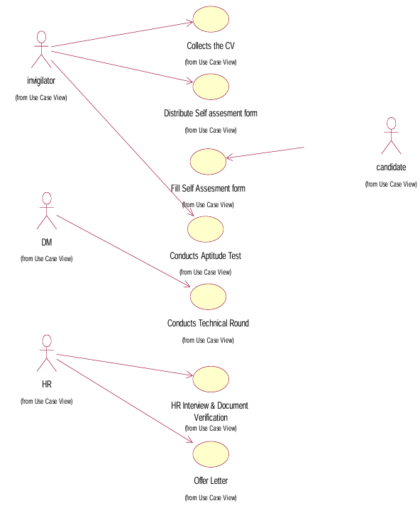

**ACTIVITY DIAGRAM:**

**CLASS DIAGRAM:**

**SEQUENCE DIAGRAM:**

**COLLABORATION DIAGRAM:**

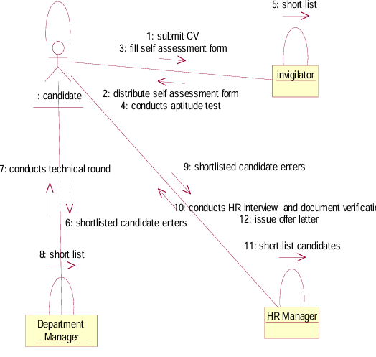

**STATE CHART DIAGRAM:**

**COMPONENT DIAGRAM:**

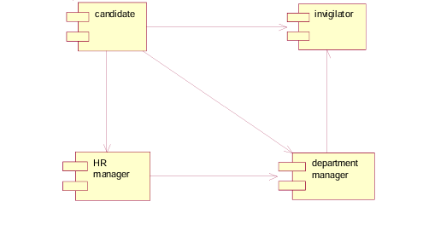

**DEPLOYMENT DIAGRAM:**

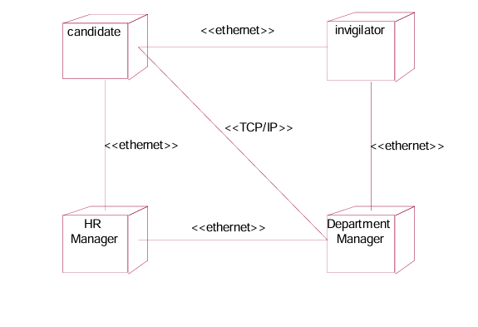

11..Design and implement UML diagrams with code generation for **CONFERENCE MANAGEMENT SYSTEM**

**USECASE DIAGRAM:**

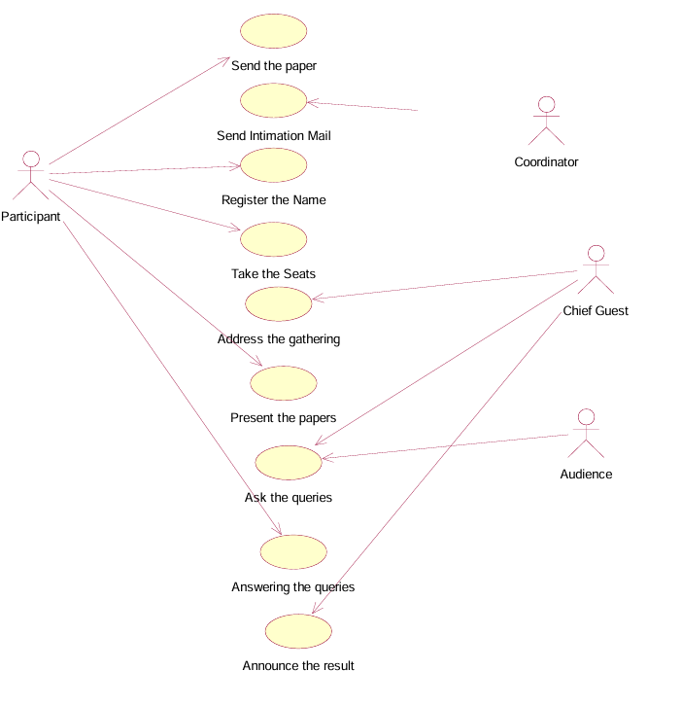

**CLASS DIAGRAM:**

**SEQUENCE DIAGRAM:**

**COLLABORATION DIAGRAM:**

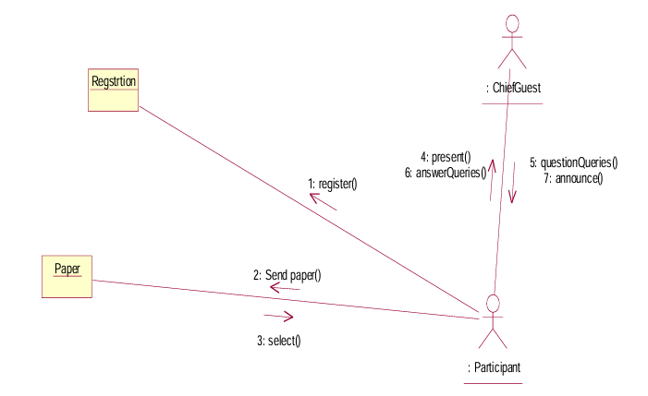

**STATE CHART DIAGRAM:**

**COMPONENT DIAGRAM:**

**DEPLOYMEMENT DIAGRAM**

12.Design the UML diagram with code skeleton for Foreign trading system

**Use case diagram**

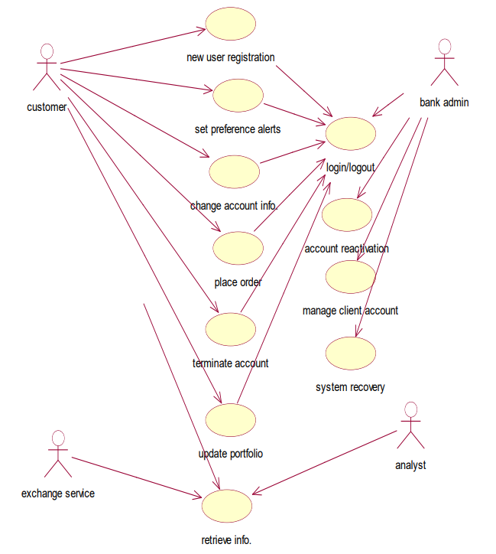

**Class diagram**

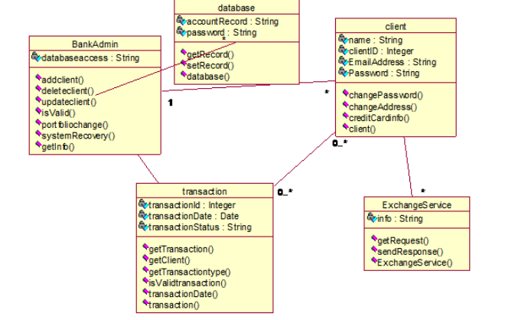

**Sequence diagram**

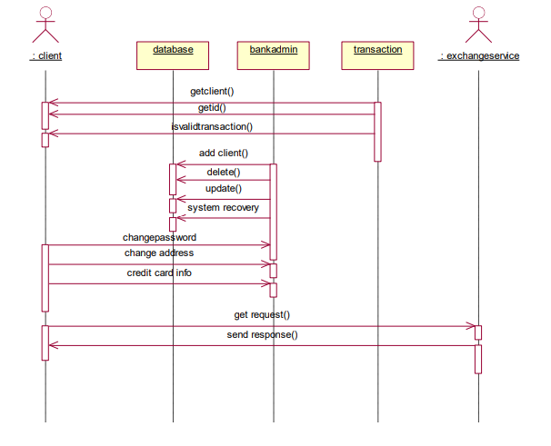

**Collaboration diagram**

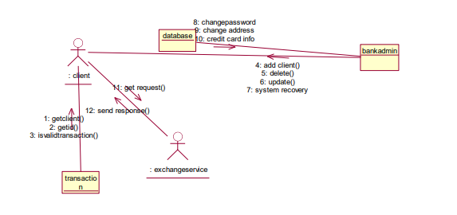

**State chart diagram**

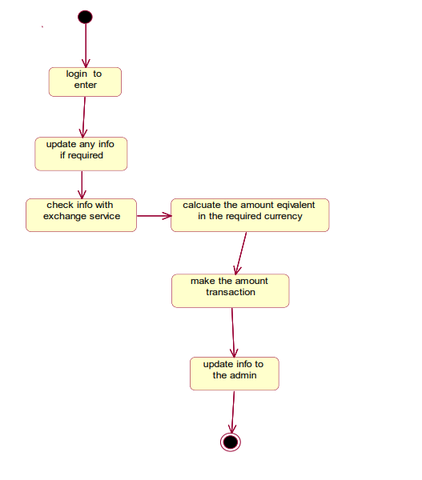

**Componenet diagram**

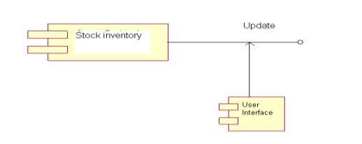

**Deployment diagram**

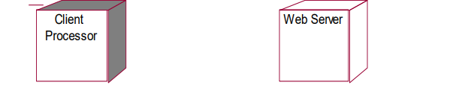

13.Design the UML diagram with code skeleton for  BPO Management system

Use case diagram

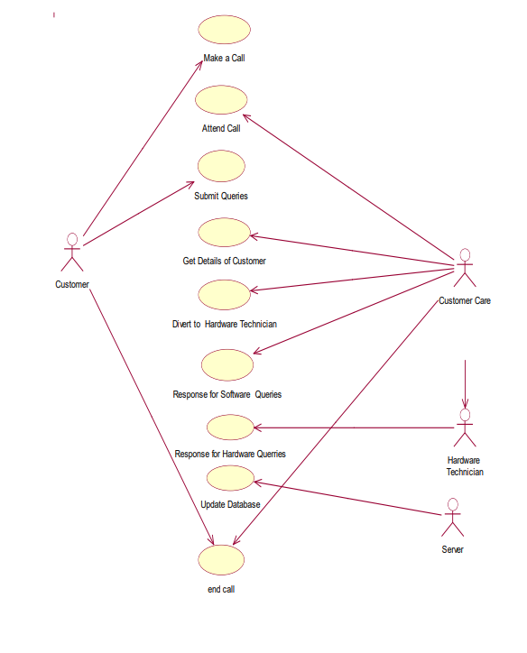

**Activity diagram**

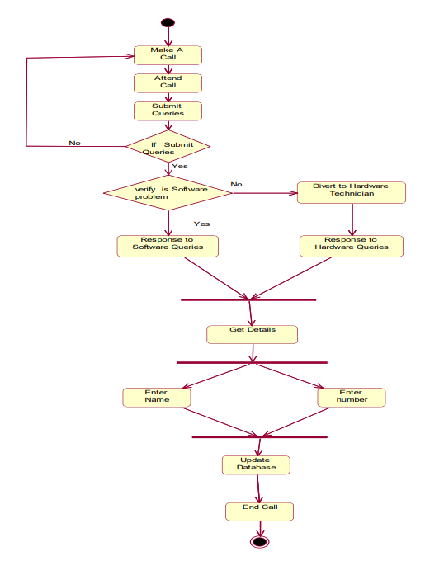

**Class diagram**

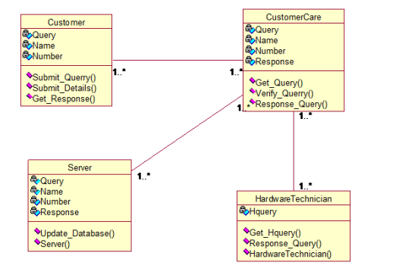

**Sequence diagram**

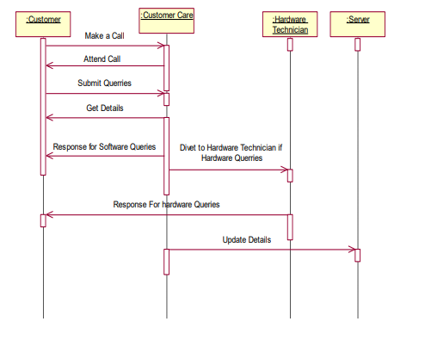

**Collaboration diagram**

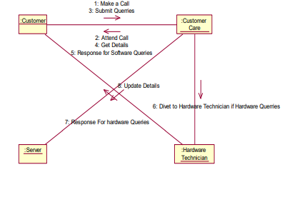

**State chart diagram**

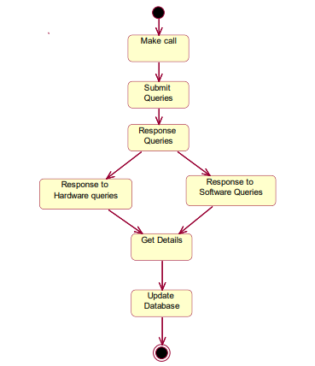

**Component diagram**

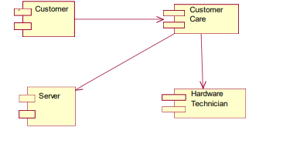

**Deployment diagram**

