

Design of an 8-Bit Accumulator-Based Microprocessor

Submitted By:
صموئيل مرزوق ناجح مرزوق
عمرو سعد عبد الجابر محمد
محمد طه عبد العزيز توني
هيا محمود محمد محمد
خالد حمدي الداودي

Under Supervision of: Eng. Mohamed Salah Abo Shosha

Date: September 2026

1. Introduction
This report details the design, implementation, and verification of an advanced 8-bit Accumulator-based Central Processing Unit (CPU). The processor is designed using Verilog HDL at the Register-Transfer Level (RTL). The architecture features a Harvard memory model, separating instruction and data memory to enhance structural clarity and datapath efficiency. Furthermore, the CPU integrates a dedicated Status Register to handle arithmetic flags (Carry, Zero, Negative), enabling complex conditional branching operations.

2. System Architecture
The microprocessor is composed of several critical hardware modules integrated within a top-level structural wrapper (cpu_top.v):
- ALU (Arithmetic Logic Unit): Performs 8 distinct operations including arithmetic, bitwise logic, and shift operations.
- Status Register: Captures ALU state flags to inform the Control Unit for branching.
- Control Unit: A combinational decoder responsible for instruction decoding and orchestrating internal control signals.
- Harvard Memory Subsystem: Independent read-only memory (ROM) for instructions and read/write memory (RAM) for data.
- Sequential Elements: An 8-bit Accumulator for primary data manipulation and a 4-bit Program Counter (PC) for instruction tracking.

3. RTL Module Implementations

3.1. Arithmetic Logic Unit (ALU.v)
The ALU is the computational core, enhanced to output state flags for advanced decision-making.
module alu (
input wire [7:0] acc_in,
input wire [7:0] data_in,
input wire [2:0] alu_op,
output reg [7:0] alu_out,
output reg C,
output reg Z,
output reg N
);
reg [8:0] temp_add;
always @(*) begin
C = 1'b0;
case (alu_op)
3'b000: begin
temp_add = acc_in + data_in;
alu_out = temp_add[7:0];
C = temp_add[8];
end
3'b001: alu_out = acc_in - data_in;
3'b010: alu_out = acc_in * data_in;
3'b011: alu_out = acc_in & data_in;
3'b100: alu_out = acc_in | data_in;
3'b101: alu_out = acc_in ^ data_in;
3'b110: alu_out = acc_in << 1;
3'b111: alu_out = data_in;
default: alu_out = 8'h00;
endcase
Z = (alu_out == 8'h00) ? 1'b1 : 1'b0;
N = alu_out[7];
end
endmodule

3.2. Status Register (Status_Register.v)
module status_register (
input wire clk,
input wire reset,
input wire update_flags,
input wire alu_C,
input wire alu_Z,
input wire alu_N,
output reg C,
output reg Z,
output reg N
);
always @(posedge clk or posedge reset) begin
if (reset) begin
C <= 1'b0; Z <= 1'b0; N <= 1'b0;
end else if (update_flags) begin
C <= alu_C; Z <= alu_Z; N <= alu_N;
end
end
endmodule

3.3. Control Unit (Control_Unit.v)
The Control Unit is designed as a fully combinational block, implementing conditional branching capabilities based on state flags.
module control_unit (
input wire [3:0] opcode,
input wire flag_Z,
input wire flag_C,
output reg pc_inc,
output reg pc_load,
output reg acc_load,
output reg mem_write,
output reg [2:0] alu_op
);
localparam LOAD = 4'b0000;
localparam ADD = 4'b0001;
localparam SUB = 4'b0010;
localparam SAVE = 4'b0011;
localparam JUMP = 4'b0100;
localparam JZ = 4'b0101;
localparam JC = 4'b0110;
localparam HALT = 4'b1111;

always @(*) begin
pc_inc = 1'b0; pc_load = 1'b0; acc_load = 1'b0;
mem_write = 1'b0; alu_op = 3'b000;
case (opcode)
LOAD: begin acc_load = 1'b1; pc_inc = 1'b1; alu_op = 3'b111; end
ADD: begin acc_load = 1'b1; pc_inc = 1'b1; alu_op = 3'b000; end
SUB: begin acc_load = 1'b1; pc_inc = 1'b1; alu_op = 3'b001; end
SAVE: begin mem_write = 1'b1; pc_inc = 1'b1; end
JUMP: begin pc_load = 1'b1; end
JZ: begin
if (flag_Z) pc_load = 1'b1;
else pc_inc = 1'b1;
end
JC: begin
if (flag_C) pc_load = 1'b1;
else pc_inc = 1'b1;
end
HALT: begin
end
default: pc_inc = 1'b1;
endcase
end
endmodule

3.4. Memory Subsystem (Harvard Architecture)
Instruction Memory (Instruction_Memory.v)
module instruction_memory (
input wire [3:0] address,
output wire [7:0] instruction
);
reg [7:0] rom [0:15];
initial begin
rom[0] = 8'b0000_1010;
rom[1] = 8'b0010_1011;
rom[2] = 8'b0011_1010;
rom[3] = 8'b0101_0101;
rom[4] = 8'b0100_0000;
rom[5] = 8'b1111_0000;
end
assign instruction = rom[address];
endmodule
Data Memory (Data_Memory.v)
module data_memory (
input wire clk,
input wire write_enable,
input wire [3:0] address,
input wire [7:0] data_in,
output wire [7:0] data_out
);
reg [7:0] ram [0:15];
initial begin
ram[10] = 8'd3;
ram[11] = 8'd1;
end
always @(posedge clk) begin
if (write_enable) ram[address] <= data_in;
end
assign data_out = ram[address];
endmodule

3.5. System Core Registers
Accumulator (Accumulator.v)
module accumulator (
input wire clk,
input wire reset,
input wire acc_load,
input wire [7:0] data_in,
output reg [7:0] acc_out
);
always @(posedge clk or posedge reset) begin
if (reset) begin
acc_out <= 8'h00;

end else if (acc_load) begin
acc_out <= data_in;
end
end
endmodule
Program Counter (Program_Counter.v)
module program_counter (
input wire clk,
input wire reset,
input wire pc_inc,
input wire pc_load,
input wire [3:0] load_addr,
output reg [3:0] pc_out
);
always @(posedge clk or posedge reset) begin
if (reset) begin
pc_out <= 4'h0;
end else if (pc_load) begin
pc_out <= load_addr;
end else if (pc_inc)begin
pc_out <= pc_out + 1'b1;
end
end
endmodule

3.6. Top Module (CPU_Top_Module.v)
module cpu_top (
input wire clk,
input wire reset
);
wire [3:0] pc_out;
wire [7:0] instruction, memory_data_out, alu_result, acc_out;
wire pc_inc, pc_load, acc_load, mem_write;
wire [2:0] alu_op;
wire alu_C, alu_Z, alu_N, flag_C, flag_Z, flag_N;

wire [3:0] opcode = instruction[7:4];
wire [3:0] address = instruction[3:0];

program_counter PC (.clk(clk), .reset(reset), .pc_inc(pc_inc), .pc_load(pc_load), .load_addr(address), .pc_out(pc_out));

instruction_memory ROM (.address(pc_out), .instruction(instruction));

data_memory RAM (.clk(clk), .write_enable(mem_write), .address(address), .data_in(acc_out), .data_out(memory_data_out));

control_unit CU (.opcode(opcode), .flag_Z(flag_Z), .flag_C(flag_C), .pc_inc(pc_inc), .pc_load(pc_load), .acc_load(acc_load), .mem_write(mem_write), .alu_op(alu_op));

accumulator ACC (.clk(clk), .reset(reset), .acc_load(acc_load), .data_in(alu_result), .acc_out(acc_out));

status_register SR (.clk(clk), .reset(reset), .update_flags(acc_load), .alu_C(alu_C), .alu_Z(alu_Z), .alu_N(alu_N), .C(flag_C), .Z(flag_Z), .N(flag_N));

alu ALU_UNIT (.acc_in(acc_out), .data_in(memory_data_out), .alu_op(alu_op), .alu_out(alu_result), .C(alu_C), .Z(alu_Z), .N(alu_N));

endmodule

4. Verification & Testbench Environment
A self-checking verification methodology was utilized to validate the CPU logic autonomously without relying strictly on manual waveform inspection.
Testbench (tb_cpu.v)
`timescale 1ns/1ps

module tb_cpu;
reg clk;
reg reset;

cpu_top UUT (.clk(clk), .reset(reset));

initial begin
clk = 0; forever #5 clk = ~clk;
end

initial begin
$display("========================================");
$display("Starting Advanced Verification (Loop Test)");
$display("========================================");

reset = 1; #15; reset = 0;
#250;

if (UUT.RAM.ram[10] == 8'd0) begin
$display(">> [PASS] Loop executed successfully. Counter reached 0.");
end else begin
$display(">> [FAIL] Loop failed. Final Counter = %d", UUT.RAM.ram[10]);
end

$display("Simulation Complete.");
$stop;
end
endmodule

5. Simulation Waveforms

5.1. Initialization and Datapath Activity

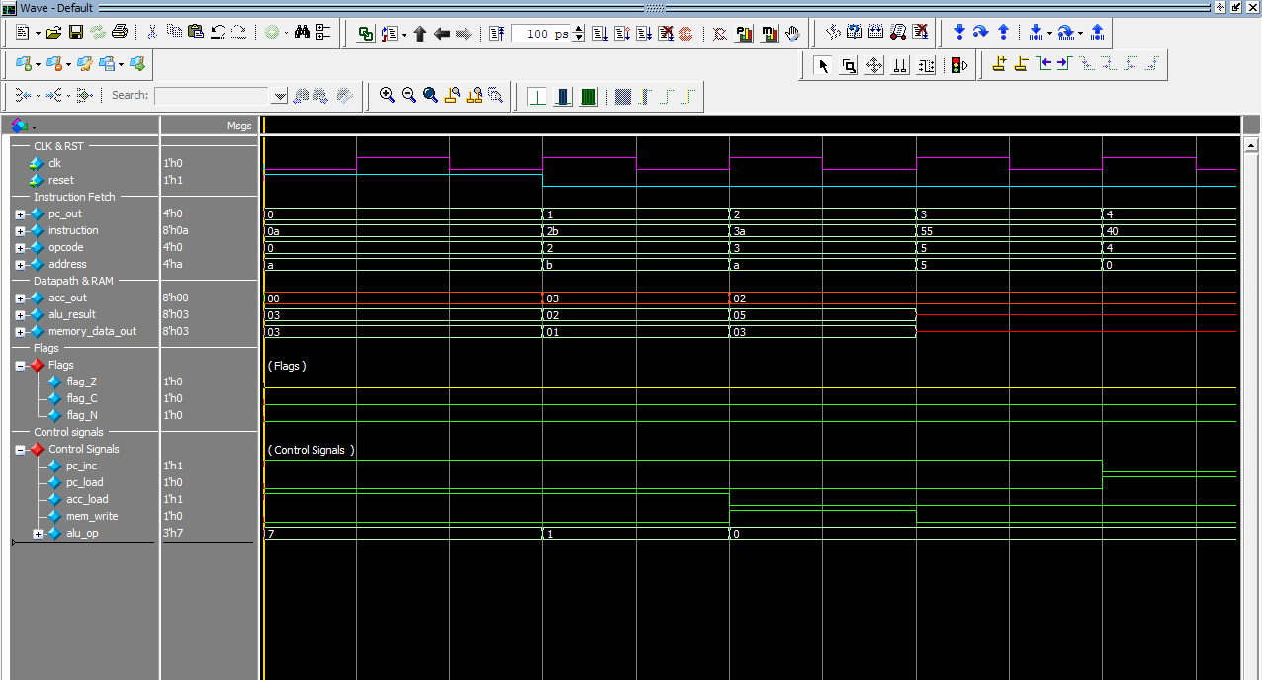

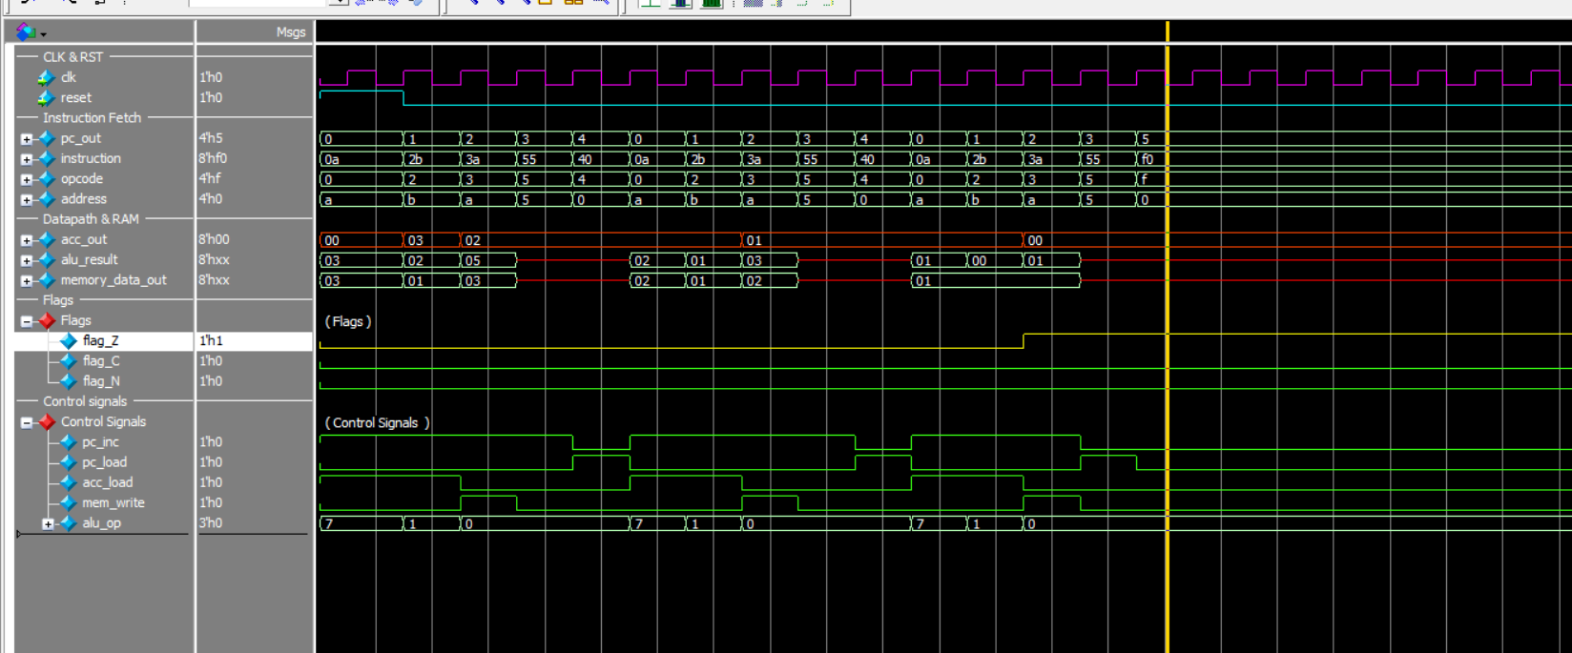

5.2. Conditional Branching Execution

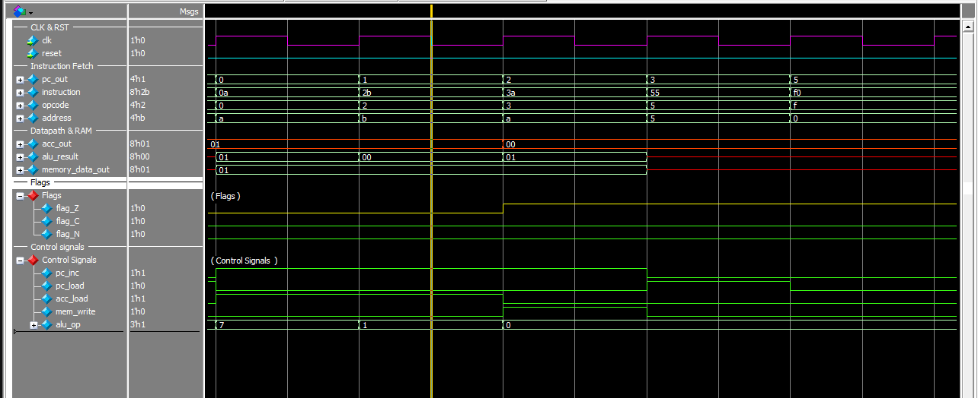

6. Conclusion
The implemented 8-bit architecture successfully demonstrates the core principles of digital IC design. By migrating to a Harvard memory structure and implementing a condition-aware data path, the processor can handle loops and branching logic efficiently. The logic synthesis simulation confirmed that all timing constraints and instruction executions operate reliably on clock edges.

