<Logo of the Company/Group might be here.>

Team 15

Easy C++
Software Design Specification (SDS)
Version: 2
CM Identifier: SDS_easy

Revision History

Sl. No. | Prepared/  Modified by | E-mail | Version | Date | Approved by | Descriptions/  Remarks
1. | Mohamed Talaat | Mohamedtalaat0111790@gmail.com | 1 | 1/4/2018 | <Name of the approving authority> | <The action performed on the document. Include a link to the modified part>

Distribution list
Name | E-mail | Notes
<List all persons/departments to which this document will be distributed> |  | <Any useful remarks like “reply needed”, “for approval”, etc…>

Table of Contents

1. Introduction 5
1.1 Purpose of this Document 5
1.2 Scope 5
1.3 Table of Acronyms and Definitions 5
1.3.1 Definition 5
1.4 References 5
1.5 Overview of Document 6
2. System Architecture 6
3. Design Models 6
3.1 Design Patterns Description 7
3.1.1 Design Pattern I 7
3.1.2 Design Pattern II 7
3.2 Class Diagrams 7
3.3 Interaction Diagrams 7
3.4 State Chart Diagrams (if needed) 7
3.5 Activity Diagrams (if needed) 7
3.6 Component Diagrams (if needed) 7
4. Data Models 7
5. System Deployment 7
6. Traceability to Requirements 7

List of Tables

List of Figures

Introduction
This SDS will cover the software easy c++.
Easy c++ will be a tool to help students to understand the concepts of the c++ programming language and provide a community to the students and their instructors.

Purpose of this Document
<This should define the goals of writing this document. Full description of the main objectives of the SDS document. For example, “The purpose of this document is to provide an overview of the proposed solution to the problems specified in the Software Requirements Specification Document”, etc >

Scope

Easy C++ is an educational android app used for explaining programming concepts
in C++ language. In it you can take lessons at your own pace, test your knowledge in its quizzes, interact with fellow learners and ask instructors for help.

Table of Acronyms and Definitions

<The purpose of this section is to define any technical/business acronyms/abbreviations in order to unify the vocabulary. If acronyms/abbreviations are stated below, it may be used later in the document, Be sure to alphabetize.>

Term | Definition

References

- “Software Engineering”, 10th Edition, Ian Sommerville
- www.SmartDraw.com
- “Mastering UML with Rational Rose 2002”, Wendy Boggs, Michael Boggs, SYBEX, 2002
- “Design Patterns Explained Simply”, Alexander shvits

Overview of Document
<A short description of how the rest of the SDS is organized and what can be found in the rest of the document. This is *not* simply a table of contents. Motivate and briefly describe the various parts!>

System Architecture
<The first phase of the software architectural design is concerned with decomposing the system into a set of interacting subsystems. Use one or more UML class diagrams to represent the system architecture. Each subsystem should be represented by a UML package symbol stereotyped as <<subsystem>>. Communications and dependencies between subsystems should be represented by dependencies relationships between packages [2].
Select the structural model that best describes your system here (e.g. the repository model, the layered model, etc). Refer to [1] for the discussion of these standard models>

/////
3la 7sb ele fhmto enn n3ml class diagrams l kol system fe el app w beden n4of byklmo b3d ezay.
Ana 3mlt bta3t elcontrollers
https://www.youtube.com/watch?v=UI6lqHOVHic&t=238s
4of el video da b3d kda e3ml el views w e4t8l ela 2d mt2dr w ana bokra hkml isa
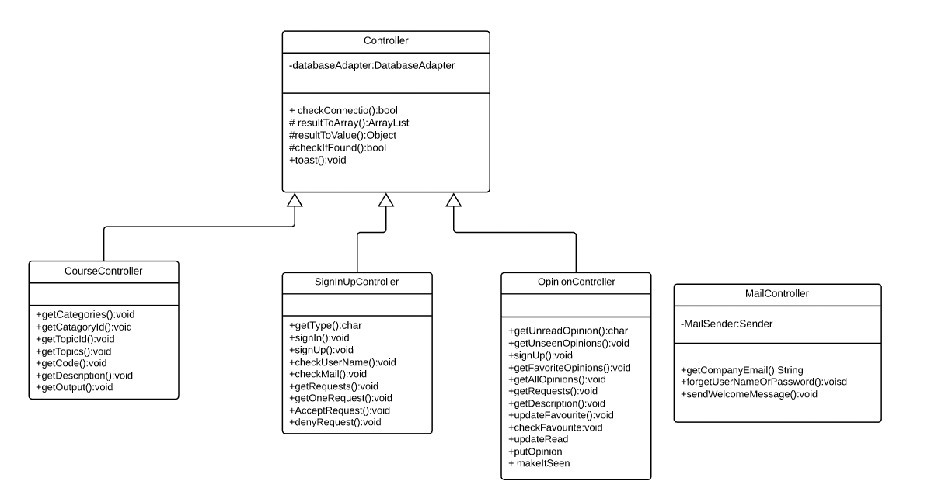
Figure 1 – System Architecture

<To work as a system, subsystems must be controlled so that their services are delivered to the right place at the right time. Control models are concerned with the control flow between subsystems. Refer to [1] for the discussion of control models. You should describe in one or two statements how the subsystems are controlled (e.g., centralized control, event-based control)>

Design Models
<This should contains class, interaction, activity and state chart diagrams that models your system. Diagrams may contain classes from different subsystem/layers. Remember that your design should be complete and no ambiguities should appear. Developers will have to translate these diagrams into code. Assign each design element (class, sequence) an ID that can be used in the traceability matrix>

Design Patterns Description
<You should illustrate which Design Patterns you've used, where and why? You've to use at least 2 Design Patterns>

Design Pattern I

Design Pattern II

Class Diagrams
<You should use one or more class diagram to model the relationships between the classes of the system. Each class diagram may contain classes from different layers.>

Interaction Diagrams
<For each service provided by the system, you should use sequence diagrams to model the interaction between objects to realize this service. Each sequence diagram may contain classes from different layers.>

State Chart Diagrams (if needed)
<You may use state chart diagrams to model how individual objects change their state in response to events or to model how the subsystem changes its sates.>

Activity Diagrams (if needed)
<You may use activity diagrams to model the work flow inside the subsystem or to model a specific operation/algorithm.>

Component Diagrams (if needed)
<You should use component diagrams to model the organization and dependencies among the source files of this system>

Data Models
<You should use entity-relationship diagrams to model the database relationships for the database maintained by the system.>

System Deployment
<You should use component and deployment diagrams to model how the system will be deployed. First, use component diagrams to model the organization and dependencies among the system executable components. Second, use deployment diagrams to model the configuration of run time processing nodes and the components that live on them>

Traceability to Requirements
<This should maintain a matrix similar to the Traceability Matrix in the Software Requirements Specification document. The purpose of this matrix is to map requirements to design elements. This will immediately point out requirements that have not been considered. It will also allow you to trace into the design elements that require to be changed if requirements change. Use requirement IDs as row headers and design element IDs as column headers>

