**727722EUIT511-D5-CE**

**TASK-01:Drag and drop the Element using the mouse action commands.**

**Code:-**

WebDriverManager.*chromedriver*().setup();

ChromeOptions co=**new** ChromeOptions();

co.addArguments("--remote-allow-origins=*");

WebDriver driver=**new** ChromeDriver(co);

driver.get("https://demoqa.com/droppable/");

driver.manage().window().maximize();

WebElement drag=driver.findElement(By.*id*("draggable"));

WebElement drop=driver.findElement(By.*id*("droppable"));

Actions act = **new** Actions(driver);

act.dragAndDrop(drag, drop).build().perform();

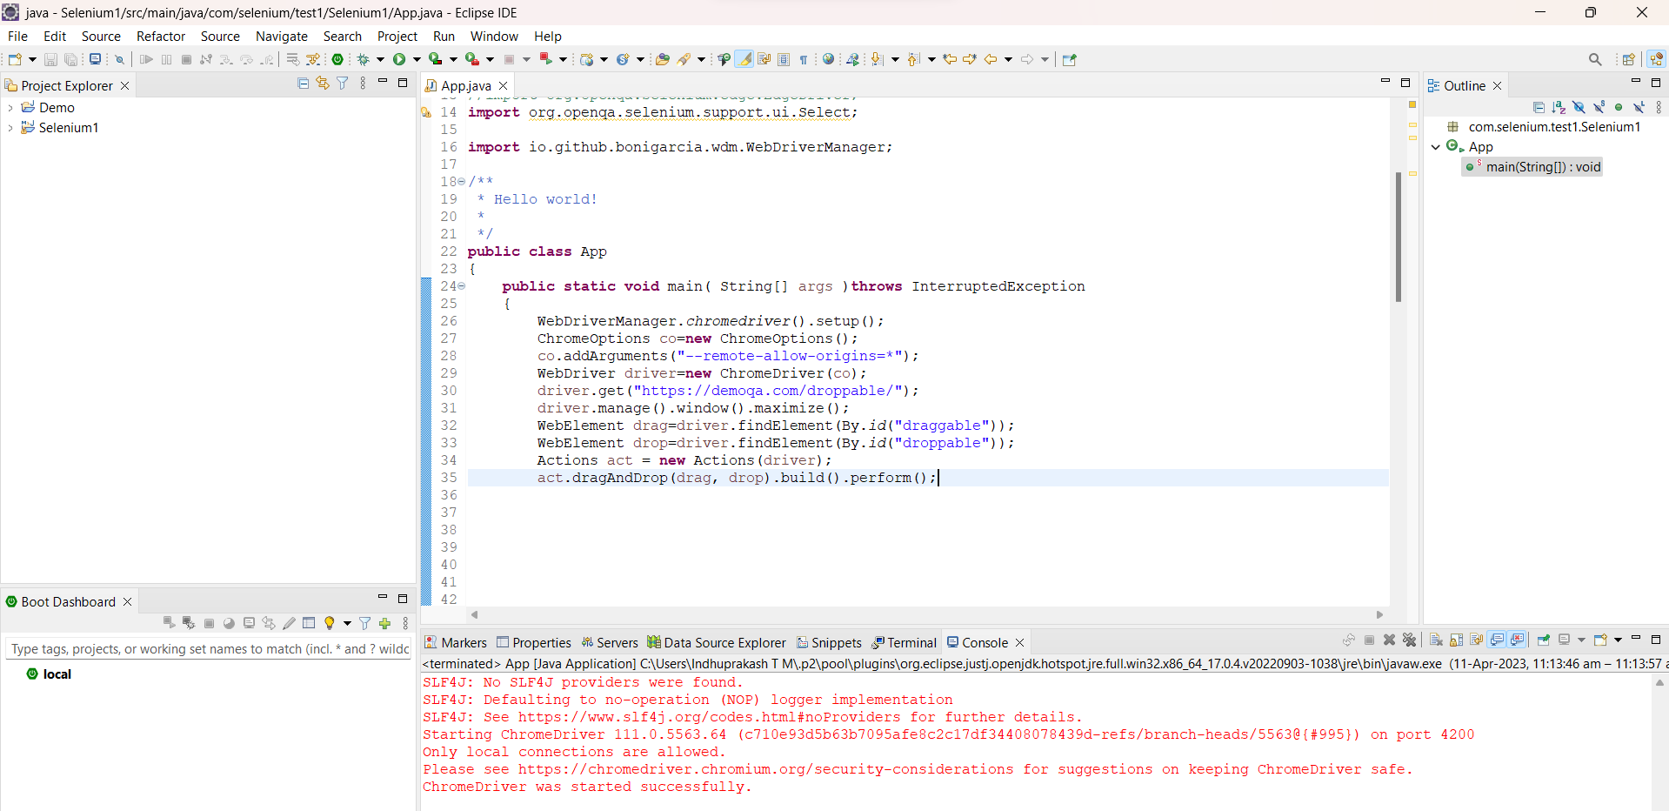

**TASK-02: Drag and drop the Element using the mouse action commands using Frame Handling.**

**Code:-**

WebDriverManager.*chromedriver*().setup();

ChromeOptions co=**new** ChromeOptions();

co.addArguments("--remote-allow-origins=*");

WebDriver driver=**new** ChromeDriver(co);

driver.get("https://jqueryui.com/droppable/");

driver.manage().window().maximize();

driver.switchTo().frame(0);

WebElement drag=driver.findElement(By.*id*("draggable"));

WebElement drop=driver.findElement(By.*id*("droppable"));

Actions act = **new** Actions(driver);

act.dragAndDrop(drag, drop).build().perform();

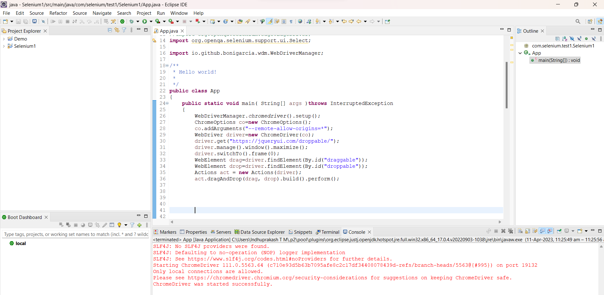

**TASK-03:Print the success message from alert box.**

**Code:-**

WebDriverManager.*chromedriver*().setup();

ChromeOptions co=**new** ChromeOptions();

co.addArguments("--remote-allow-origins=*");

WebDriver driver=**new** ChromeDriver(co);

driver.get("https://demo.guru99.com/test/delete_customer.php");

driver.manage().window().maximize();

WebElement txt1=driver.findElement(By.*name*("cusid"));

txt1.sendKeys("401");

driver.findElement(By.*name*("submit")).click();

//handling alert boxes

Alert alt=driver.switchTo().alert();

Thread.*sleep*(4000);

alt.dismiss();

txt1.clear();

txt1.sendKeys("402");

driver.findElement(By.*name*("submit")).click();

alt.accept();

Alert alt2=driver.switchTo().alert();

Thread.*sleep*(4000);

String txt=alt2.getText();

alt2.accept();

System.***out***.println(txt);

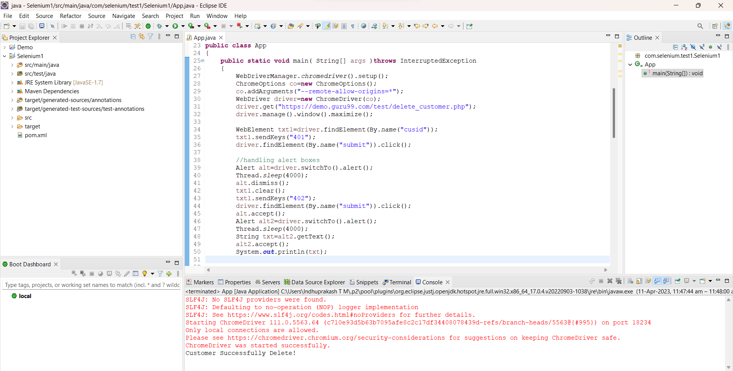

**TASK-04:Automate the booking Progress of AbhiBus.com**

**Code:-**

WebDriverManager.*chromedriver*().setup();

ChromeOptions co=**new** ChromeOptions();

co.addArguments("--remote-allow-origins=*");

WebDriver driver=**new** ChromeDriver(co);

driver.get("https://www.abhibus.com/bus-ticket-booking");

driver.manage().window().maximize();

WebElement d=driver.findElement(By.*xpath*("//*[@id=\"source\"]"));

d.sendKeys("Coimbatore");

//selecting and entering destination

driver.findElement(By.*xpath*("//*[@id=\"destination\"]")).sendKeys("Chennai");

//Datepicker

WebElement dp=driver.findElement(By.*xpath*("//*[@id=\"datepicker1\"]"));

JavascriptExecutor js=(JavascriptExecutor) driver;

js.executeScript("arguments[0].setAttribute('value', '04/10/2023')", dp);

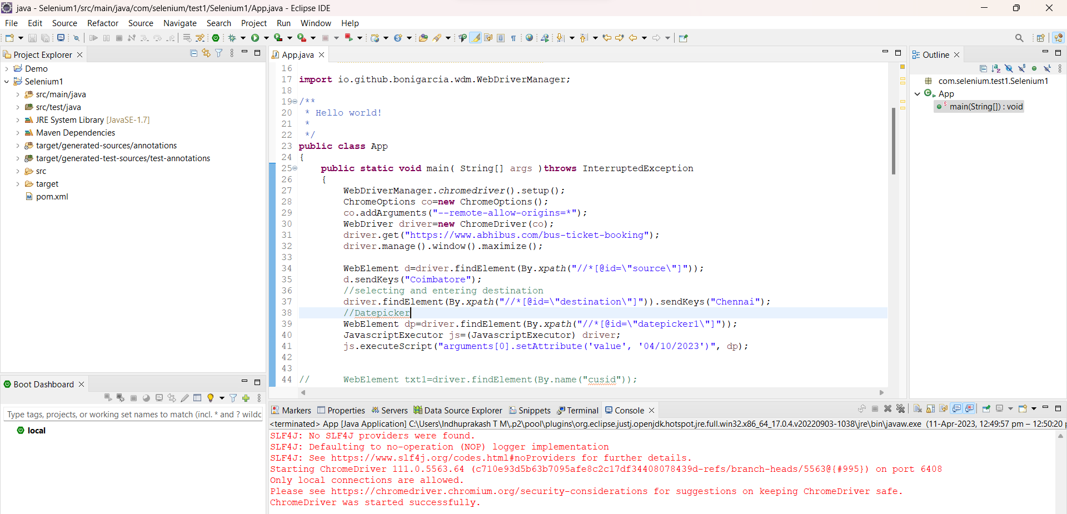

**TASK-05:Window Handler(Opening 3 browsers)**

**Method 1 :-**

**Code:-**

WebDriverManager.*chromedriver*().setup();

ChromeOptions co=**new** ChromeOptions();

co.addArguments("--remote-allow-origins=*");

WebDriver driver=**new** ChromeDriver(co);

driver.get("https://www.google.com/");

driver.manage().window().maximize();

driver.findElement(By.*name*("q")).sendKeys("Apple");

driver.findElement(By.*name*("q")).sendKeys(Keys.***ENTER***);

String parent=driver.getWindowHandle();

System.***out***.println(parent);

System.***out***.println(driver.getTitle());

driver.switchTo().newWindow(WindowType.***TAB***);

driver.get("https://google.com");

driver.manage().window().maximize();

driver.findElement(By.*name*("q")).sendKeys("Selenium");

driver.findElement(By.*name*("q")).sendKeys(Keys.***ENTER***);

driver.switchTo().newWindow(WindowType.***TAB***);

driver.get("https://google.com");

driver.manage().window().maximize();

driver.findElement(By.*name*("q")).sendKeys("Cucumber");

driver.findElement(By.*name*("q")).sendKeys(Keys.***ENTER***);

Set<String>s=driver.getWindowHandles();

Iterator<String> I1=s.iterator();

**while**(I1.hasNext())

{

String child=I1.next();

**if**(!parent.equals(child))

{driver.switchTo().window(child);

System.***out***.println(driver.switchTo().window(child).getWindowHandle());

System.***out***.println(driver.switchTo().window(child).getTitle());

}

}

**Method 2:-**

WebDriverManager.*chromedriver*().setup();

ChromeOptions co=**new** ChromeOptions();

co.addArguments("--remote-allow-origins=*");

WebDriver driver=**new** ChromeDriver(co);

driver.get("https://google.com");

driver.manage().window().maximize();

driver.findElement(By.*name*("q")).sendKeys("Apple");

driver.findElement(By.*name*("q")).sendKeys(Keys.***ENTER***);

String p=driver.getWindowHandle();

System.***out***.println(p);

String t=driver.getTitle();

System.***out***.println(t);

//edge

WebDriverManager.*edgedriver*().setup();

WebDriver driver1=**new** EdgeDriver();

driver1.get("https://google.com");

driver1.manage().window().maximize();

driver1.findElement(By.*name*("q")).sendKeys("Selenium");

driver1.findElement(By.*name*("q")).sendKeys(Keys.***ENTER***);

String p1=driver1.getWindowHandle();

System.***out***.println(p1);

String t1=driver1.getTitle();

System.***out***.println(t1);

//Firefox

WebDriverManager.*firefoxdriver*();

WebDriver driver2=**new** FirefoxDriver();

driver2.get("https://google.com");

driver2.manage().window().maximize();

driver2.findElement(By.*name*("q")).sendKeys("Cucumber");

driver2.findElement(By.*name*("q")).sendKeys(Keys.***ENTER***);

String p2=driver2.getWindowHandle();

System.***out***.println(p2);

String t2=driver2.getTitle();

System.***out***.println(t2);

