MediQueue Project Documentation

1. Project Name
MediQueue (Intelligent Medical Queue & Appointment Management System)

2. Project Idea
MediQueue is an integrated digital platform designed specifically for the healthcare sector. It aims to transform clinic management from traditional manual methods to a smart digital approach by providing tools for online appointment booking and real-time queue tracking. This reduces physical waiting time in clinics and enhances operational efficiency.

3. Problem Statement
The project addresses several challenges faced by patients and doctors:
- Waiting Room Overcrowding: Leading to poor patient experience and increased risk of infection.
- Appointment Inaccuracy: Traditional appointments are often delayed without the patient knowledge, causing frustration.
- Burdensome Manual Management: Reliance on paper records or simple spreadsheets leads to booking errors and scheduling conflicts.
- Accessibility Issues: Patients often need to call or visit the clinic just to check available slots.

4. Project Goals
- Queue Organization: Provide a live tracking system that allows patients to know their number in the queue and expected entry time from home.
- Enhanced Patient Experience: Minimize actual in-clinic waiting time to the lowest possible levels.
- Increased Doctor Efficiency: Provide a dashboard that enables doctors to manage their schedules and cases easily.
- Transparency: Make information about clinics, specialties, and available appointments clear and accessible to everyone.

5. Project Plan / Timeline
The project follows a structured 4-month timeline:
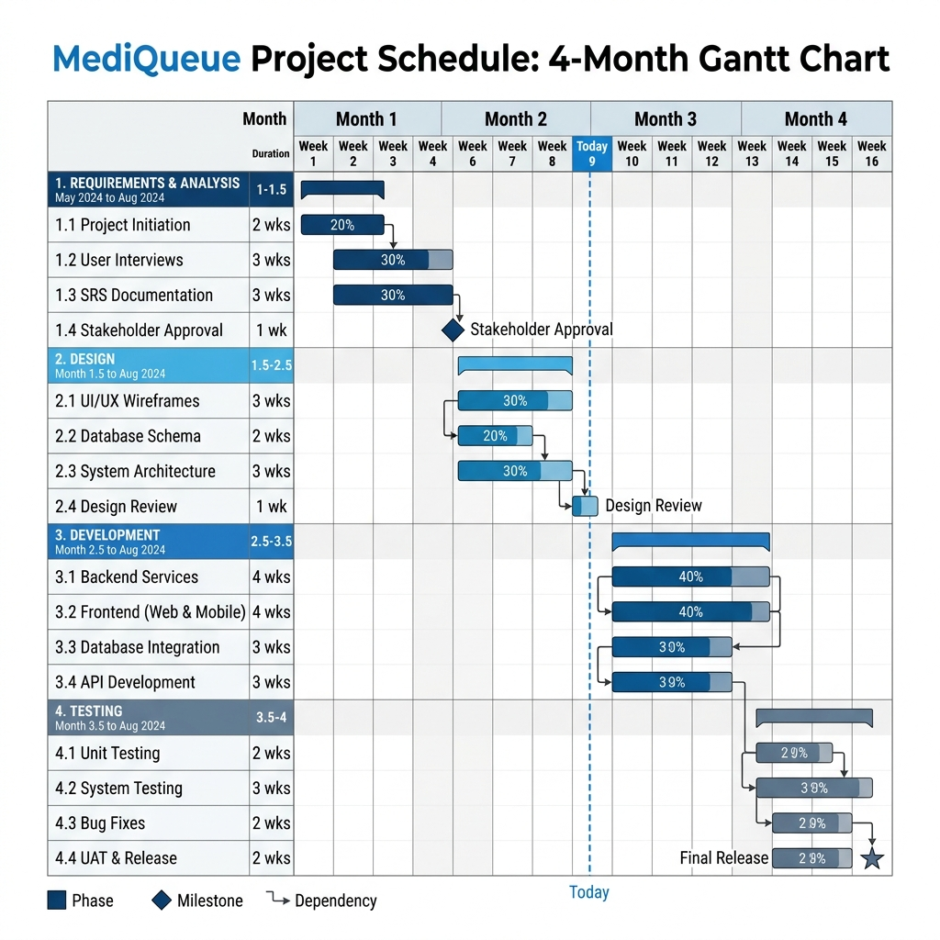
- Month 1: Planning & Design (Requirements Gathering, Database Design, UI/UX Design).
- Month 2-3: Development (Core Framework, Business Logic, Frontend Integration).
- Month 4: Testing & Deployment (System Testing, Bug Fixing, Beta Launch).

6. Users / Actors
- Patient: The person who searches for a clinic, makes a booking, and tracks their turn.
- Doctor: Responsible for providing the service and managing the patient queue.
- Admin: Responsible for overall system management, clinics, and user accounts.

7. Functional Requirements
- Patient Features: Search, Book, Cancel, Live Status.
- Doctor Features: Set Availability, Manage Queue (Call Next, End Session).
- Admin Features: User Management, Clinic/Doctor Management, Statistics.

8. Non-Functional Requirements
- Security: Data protection via Identity system and encryption.
- Performance: Fast search and real-time queue updates.
- Availability: 24/7 system uptime for bookings.

9. Use Case Diagram
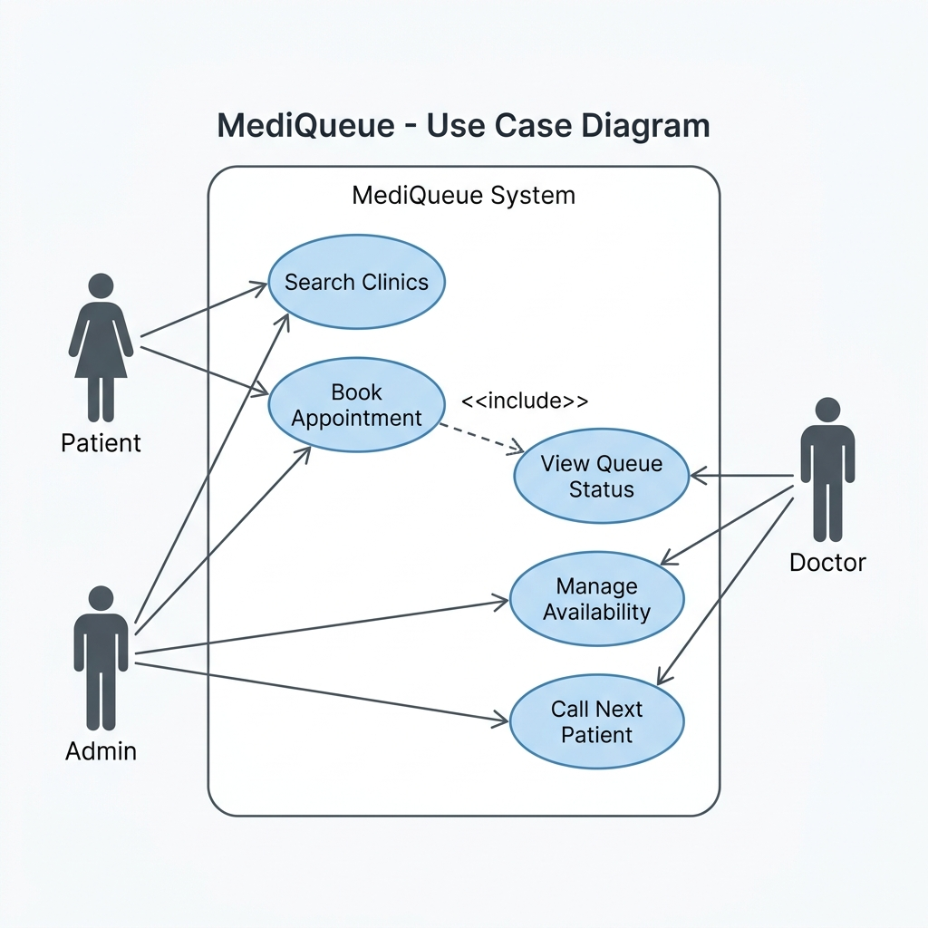
The system coordinates actions between three main actors. Patients interact with booking and tracking services, Doctors manage the live session and availability, while Admins handle the infrastructure and user database.

