Day 1
1. Install PostgreSQL
sudo apt install -y postgresql-16 postgresql-client-16
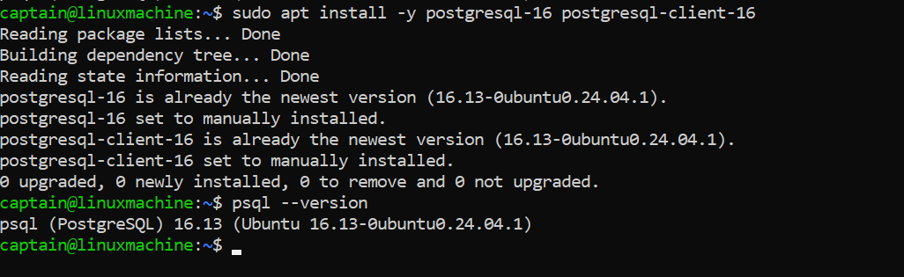

2. Connect Using psql
Sudo -I -u postgres
Psql

3. Create:
- 2 databases
- 2 users
4. Grant Permissions
psql -U postgres -h 127.0.0.1 -W -f /home/captain/PostgreSQl/DAY_1/Postgresql_RBAC.sql
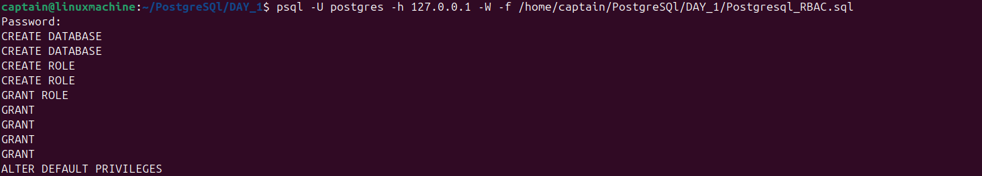

5. Create:
- one schema
- one table 
6. Insert Data
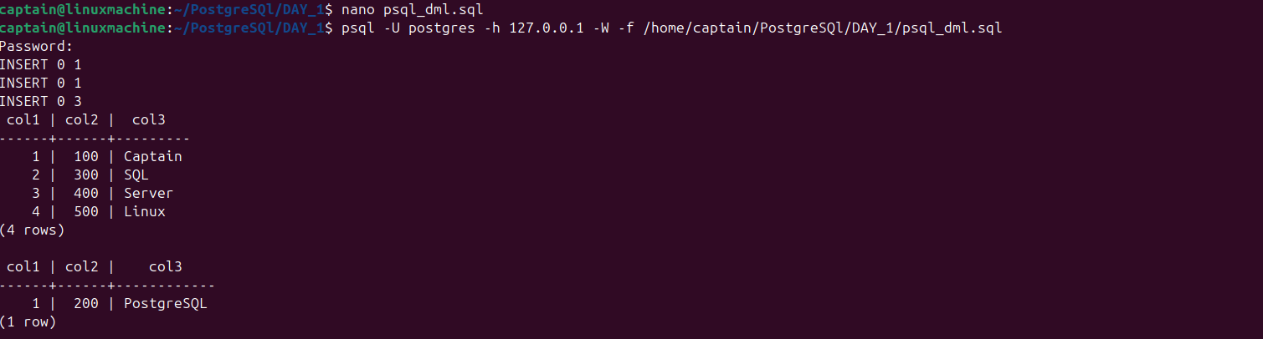

7. Query pg_stat_activity
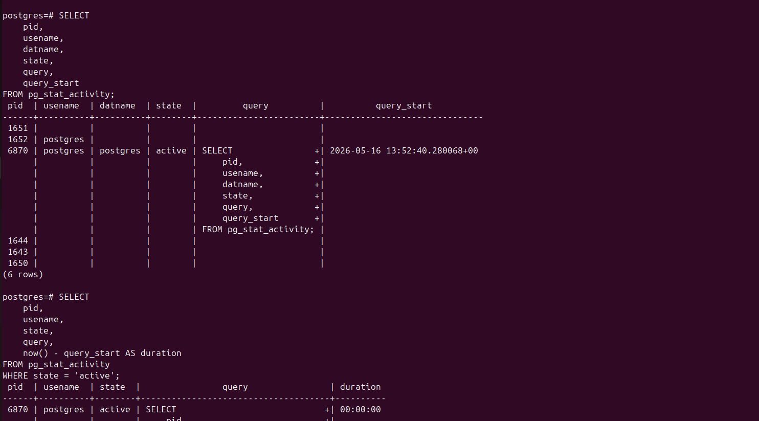

8. Restart PostgreSQL Service
