**ScreenShots of Result for File Handling**

**Before running the code**

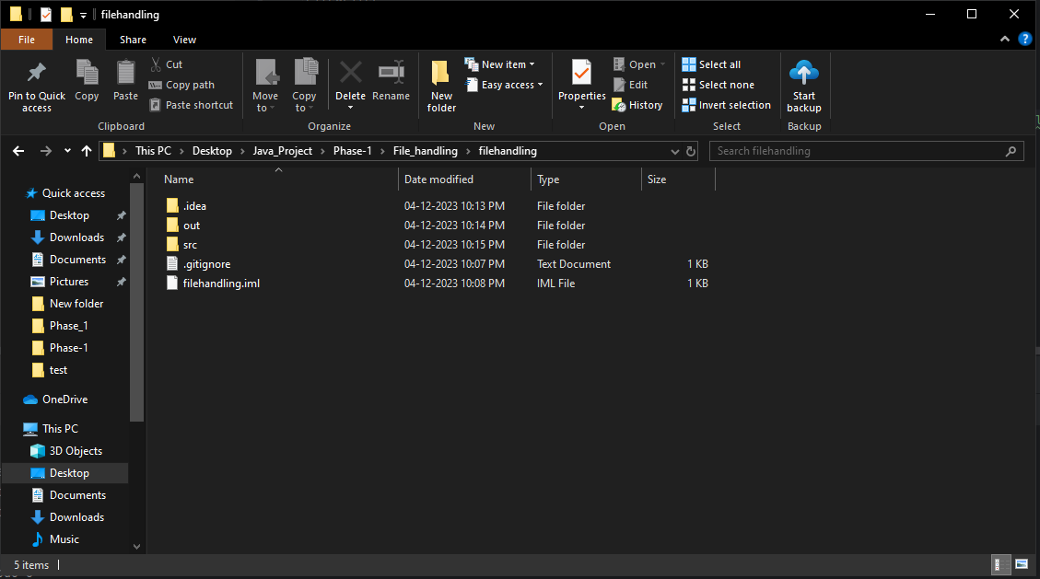

**After Running the code**

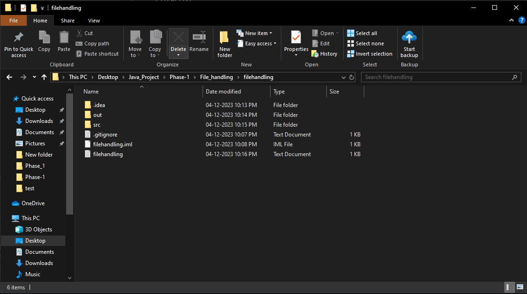

**Inside the text file**

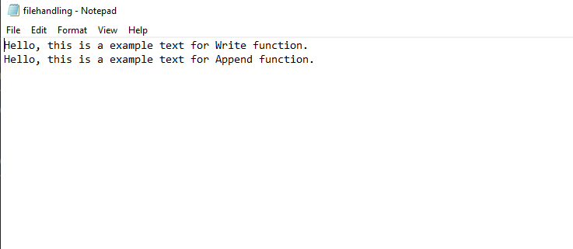

**Result in ide**

