Game Hanabi
user manual
2019/2020

Project by :
MAKENDI Bryan
YAHYAOUI Mohamed Yassine

How to Use the Build.xml and Hanabi.jar :

You can use the .jar file to start the game Hanabi.jar, already in the main repertory by using the command :
- java -jar Hanabi.jar

Also you can get the Hanabi.jar by using the build.xml file, first you need to compile the project, then use the command to creat the jar file :
- ant compile
- ant jar

PS : be careful of your Apache Ant version, as it needs to run class file version 57.0 of java Runtime (java 13), or the Jar file wont work, exemple of such erreur :
→ update your ant version, or use Java 11 (class file version 55.0) to get the Jar file

To clean your classes already compiled :
- ant clean

Finally to get generate the Javadoc of the project :
- ant javadoc
you can access the javadoc by using one of .html files in docs/doc/… , this will allow you to see all the documentation, classes , methods used in the project

How to Play the game :

At the start of the game you have to choose the number of player in the game, between 1 and 5 players, question will repeat as long as the entry is not valid !!

The game can be played in two modes, in graphic mode and in terminal mode :

- Terminal mode :
  - Start of the Game
choose c when asked which mode to choose, choice will countinue as long the entry is not valid
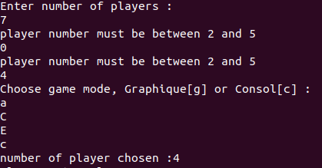

then enter the name of the players :
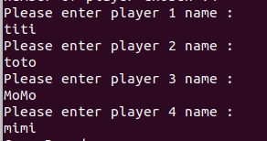

  - how to play :
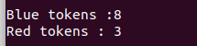
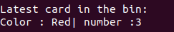
you can see the number of tokens left, same as the last card on the bin :

the current player can not see his card, so we show them as hidden,
when its titi turn for example, they can only see the number of the cards on their hand, but they
can see all the cards on other peoples’ hands
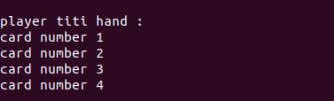
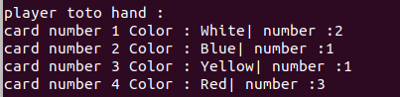
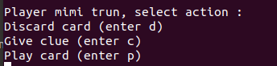
three actions are allowed, but if we have 8 blue tokens, only play and give clue are allowed

Clues and Player Names Must be specific, any invalid entry will be ignored, and the user must enter again !!!

The boad :
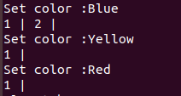

the game ends if there is non red tokens left or the board is full

- Graphic mode :
Same as terminal mode, it starts with the by choosing the number of players and the game mode, this time choose g

A game window will pop up, the game wont start unless you choose the players name on the terminal
the game interface :

the bin and deck, The Board Tokens

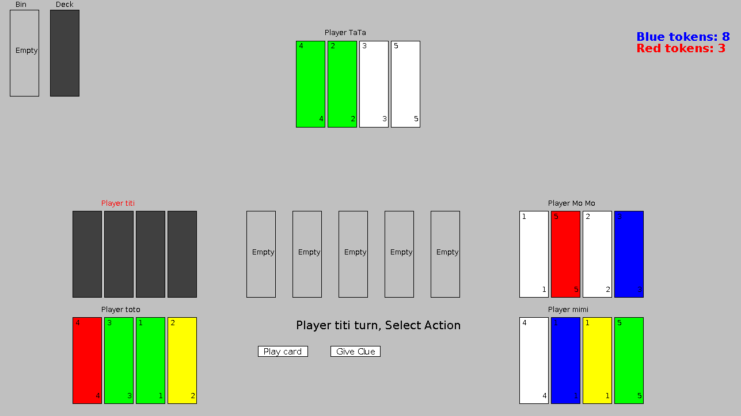

Players
Hands Current Player The Actions
Name in Red

At the end of the game, a score message will pop up :



