Sunny Day assignment

Day01

1. It’s required to create a PHP script that has a drop down menu of all Egyptian cities, when the user chooses a city he get a report of it’s weather that includes temperature (min and maximum and humidity)
2. **Before submit**

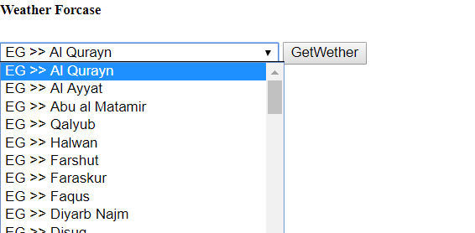

1. **After submit**

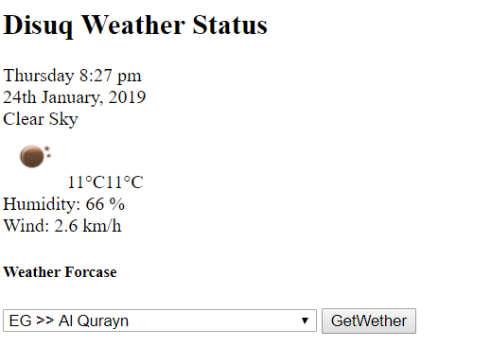

2**- Bonus :**

1. Make the project in oop .
2. Send the temperature by text local SMS gateway to yourself .

**Help :**

**Use the following link that has all cities in the world by the documentation of open weather**

**<http://cutescripts.net/api/city.list.json>**

**get the json locally and use it as a text file .**

**The API url :**

**Don’t forget that you need to register to the API and will have the URL to call and the options to use including the API key**

<https://openweathermap.org/api>

Finally there is attached an oop skeleton for the solution , you can use it , it will ease things for you

More Help :

1. You need json_encode($any_thing) to convert any thing to JSON
2. YOU need json_decode($any_json) to convert any json to object
3. YOU need json_decode($any_json,true) to convert any json to array

Good Luck