- Program 1
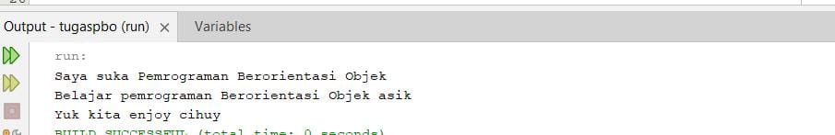

- Program 2
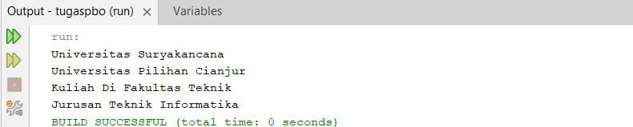

- Program 3
