**AIM;**

To Explore Azure Devops.

**ALGORITHM:**

Step 1: Open Google Chrome (or any Browser in your PC) .

Step 2: Search Azure Devops services in your searchbar and click the first link in your browser.

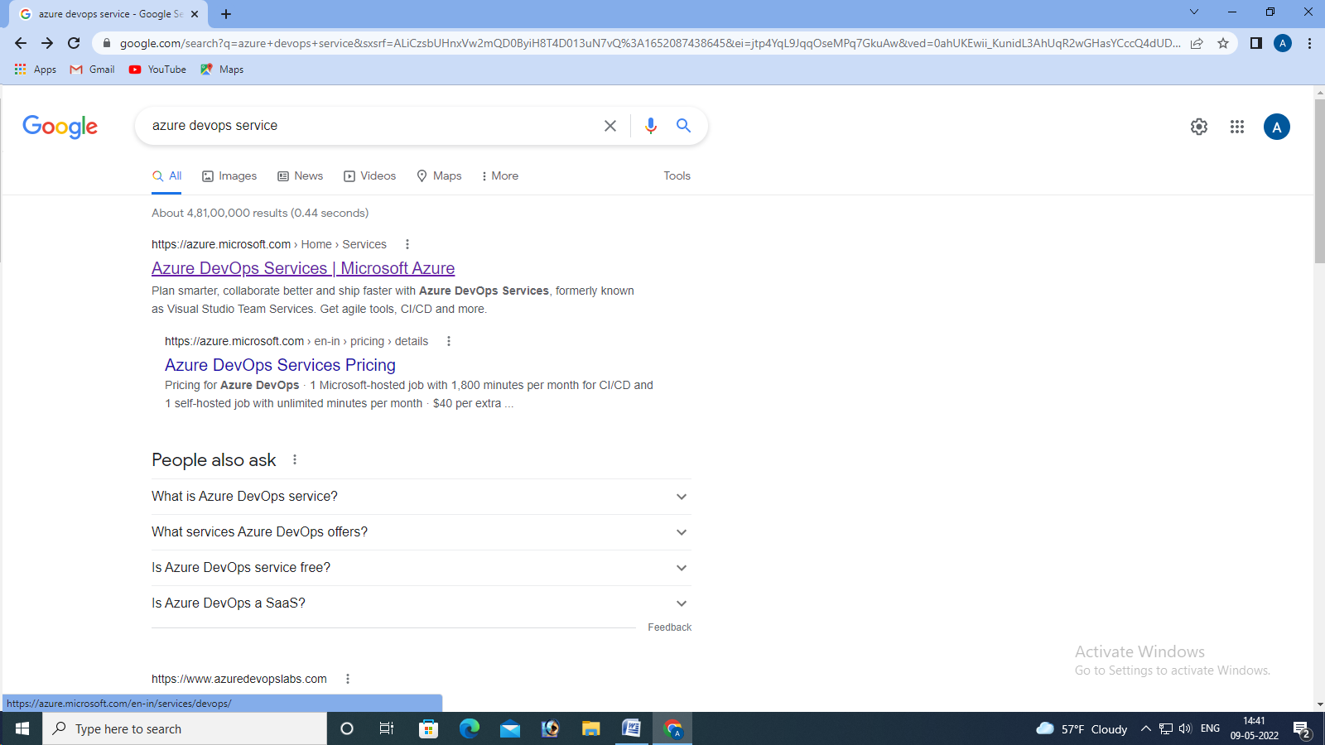

Step 3: click the sign in option in the right top corner.

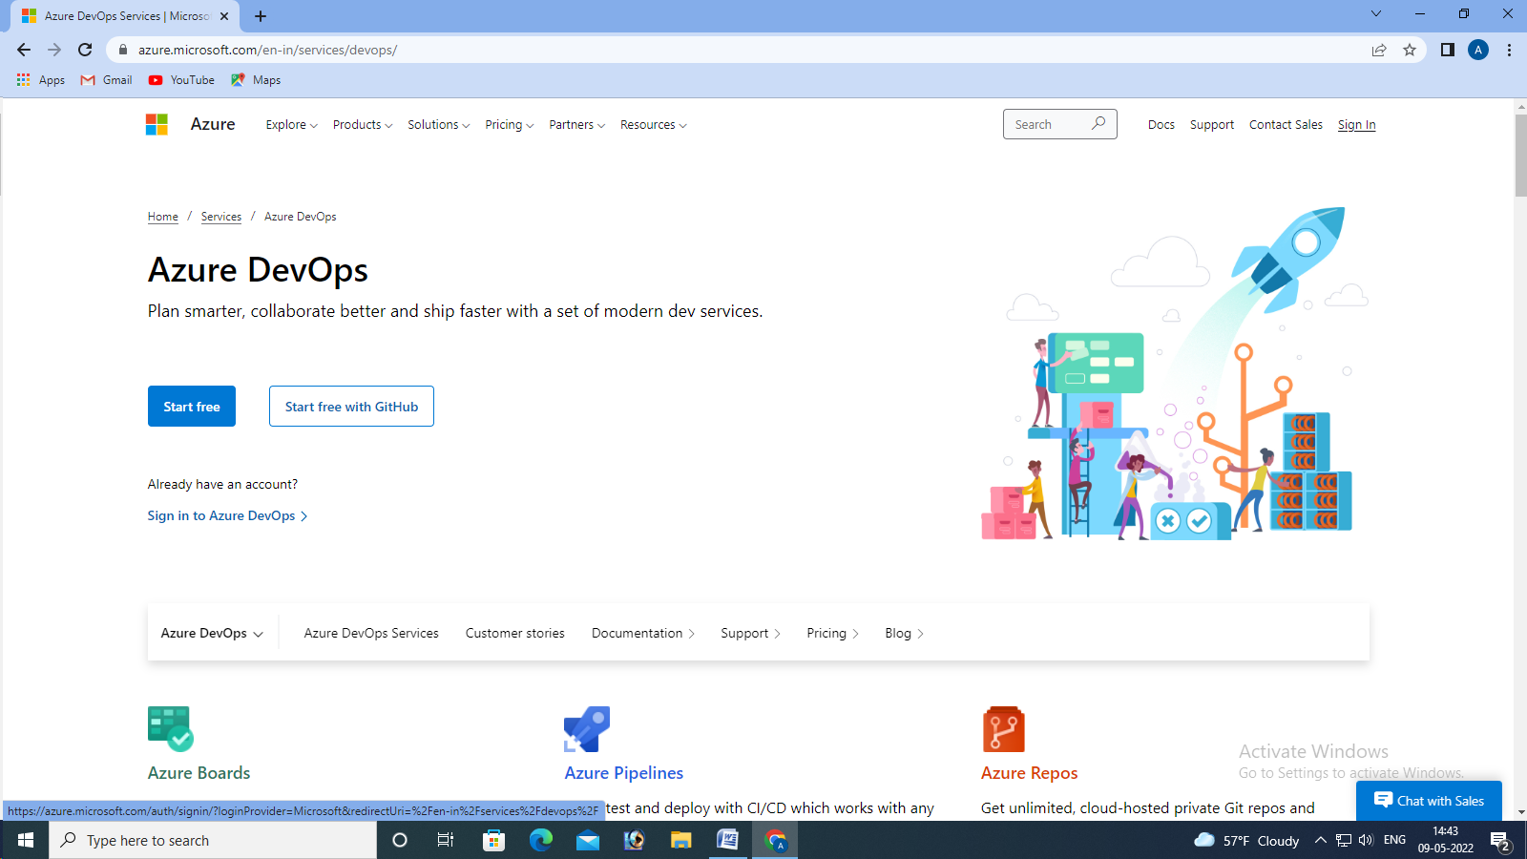

Step 4: After successful log in, Click “START FREE” option.

Step 5: Now create a project in your Azure, Fill all the necessary details, where make sure that the creation of the project is under private.

Exploring Azure Devops

Date:

EX NO:

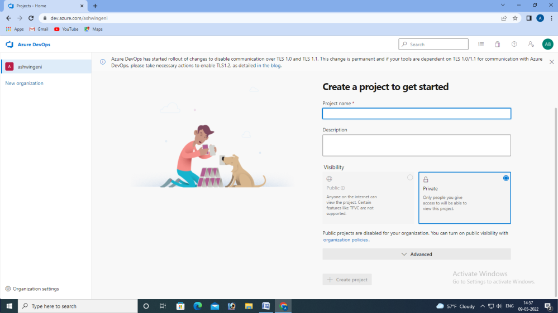

Step 6: Your current working project screen will be displayed.

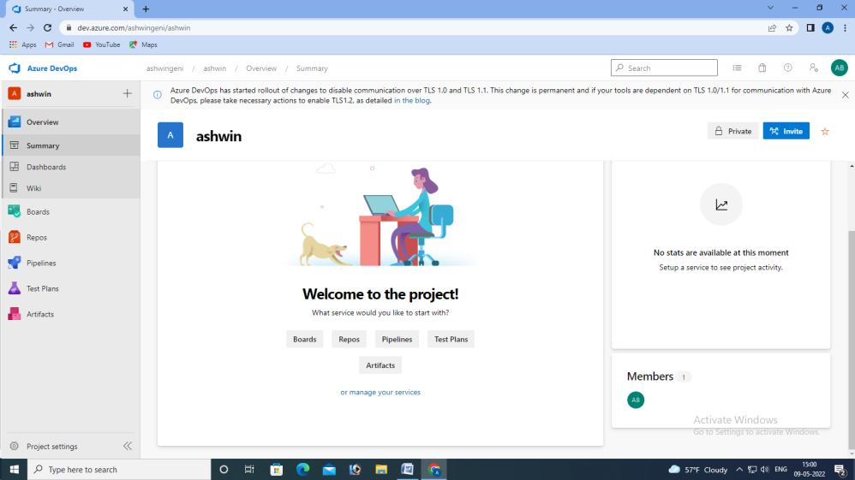

Step 7: Click “REPOS” tool to copy the URL in order to clone a repository in your Visual studio 2022 application.

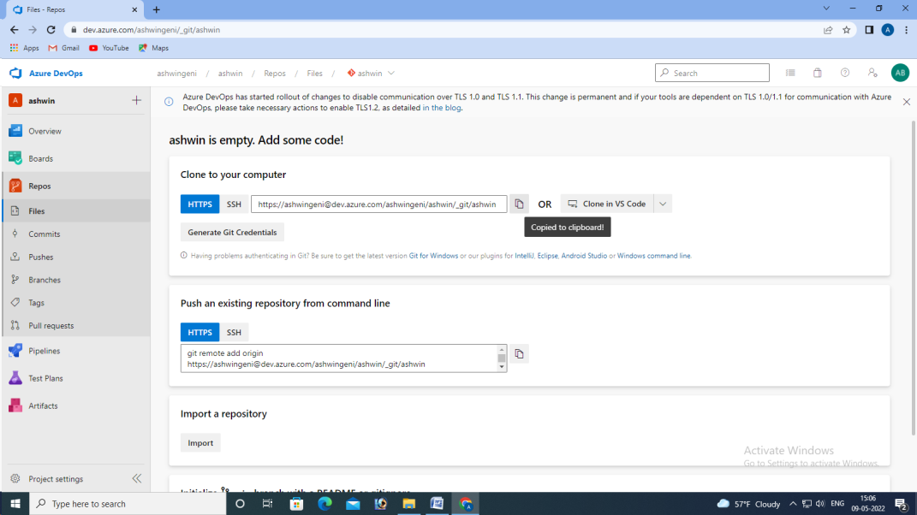

Step 8: Now Open Visual Studio 2022 application app in your PC(or download and install) and sign in using the same Mail Id, which you have given at the time of signing in, in the Azure Devops portal.

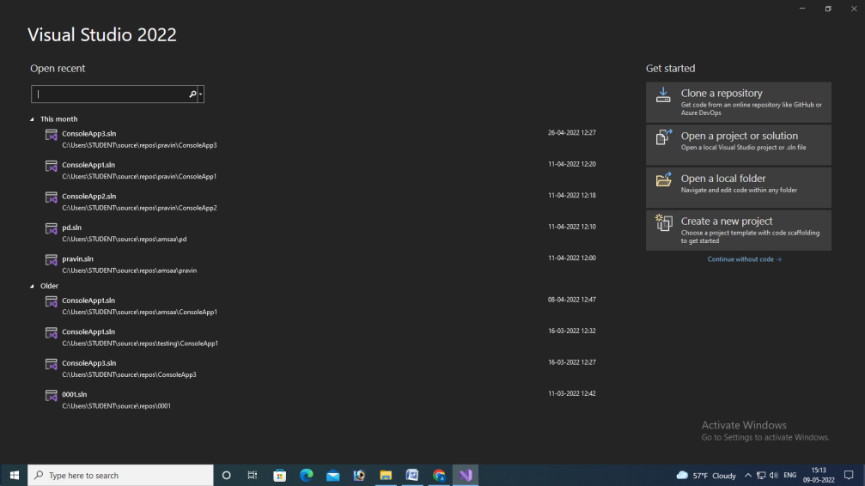

Step 9: Now Select “CLONE A REPOSITORY” option in the top right side

Step 10: After that, give the necessary repository location to clone the needed repository and click clone option to clone it.

Step 11: Now the repository which you have selected is now cloned in Visual Studio 2022 application.

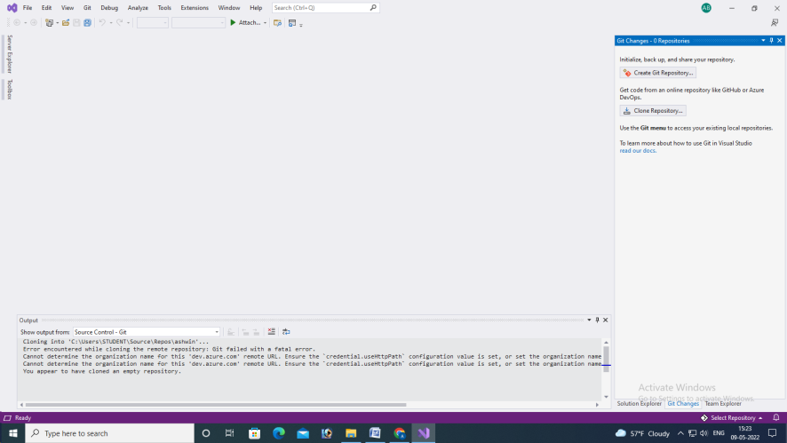

Step 11: Open a new Visual Studio app, and click on “CREATE A NEW PROJECT” and select console app with C# and click next.

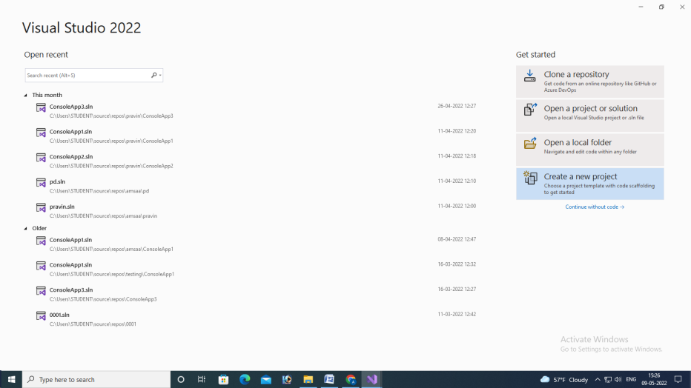

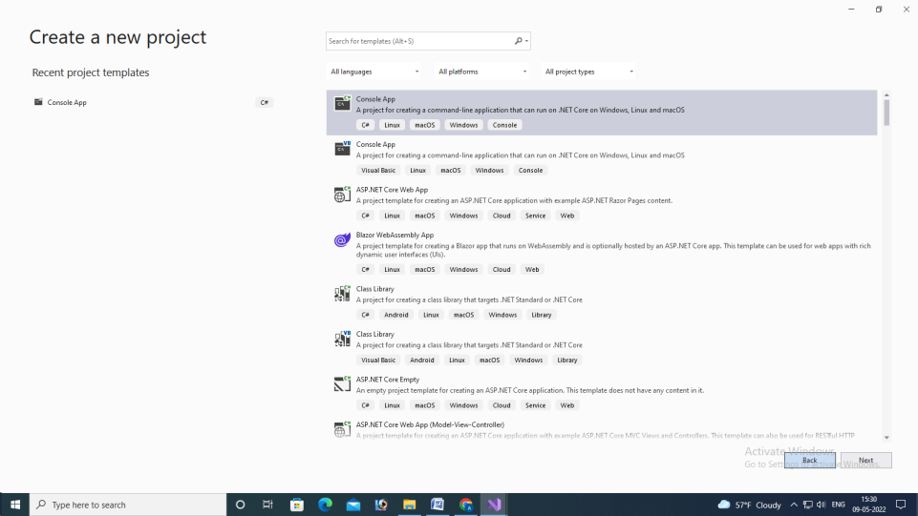

Step 12: Give a name for the new repository and also give the appropriate file location to store the datas(you can copy the path of the file location where you want to store). And proceed by clicking “CREATE”

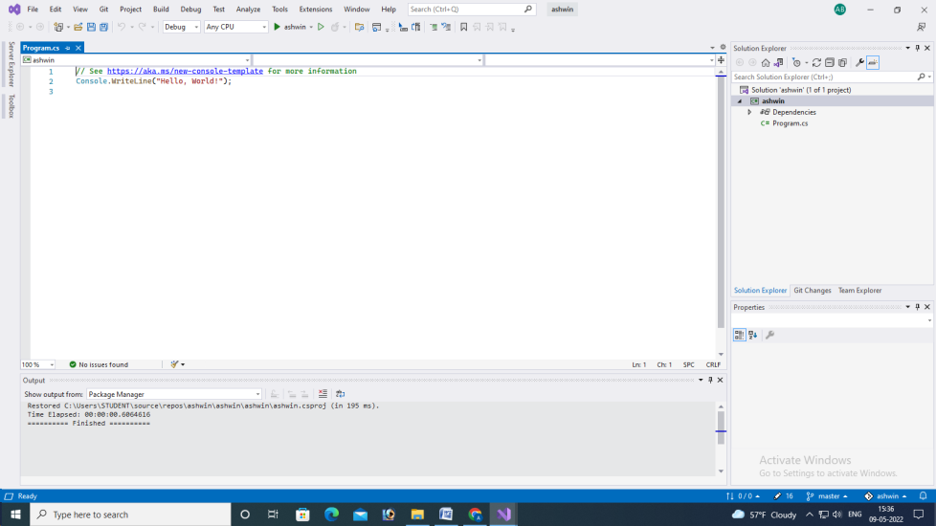

Step 13: