**EXERCISE-2**

**COMPUTER VISION**

**IMAGE 1:**

**IMAGE 2:**

**AND:**

**OR:**

**XOR:**

**AVERAGE BLUR:**

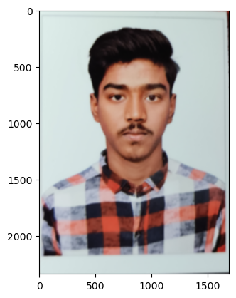

**MEDIAN BLUR:**

**GAUSSIAN BLUR:**

**CANNY EDGE DETECTION:**

